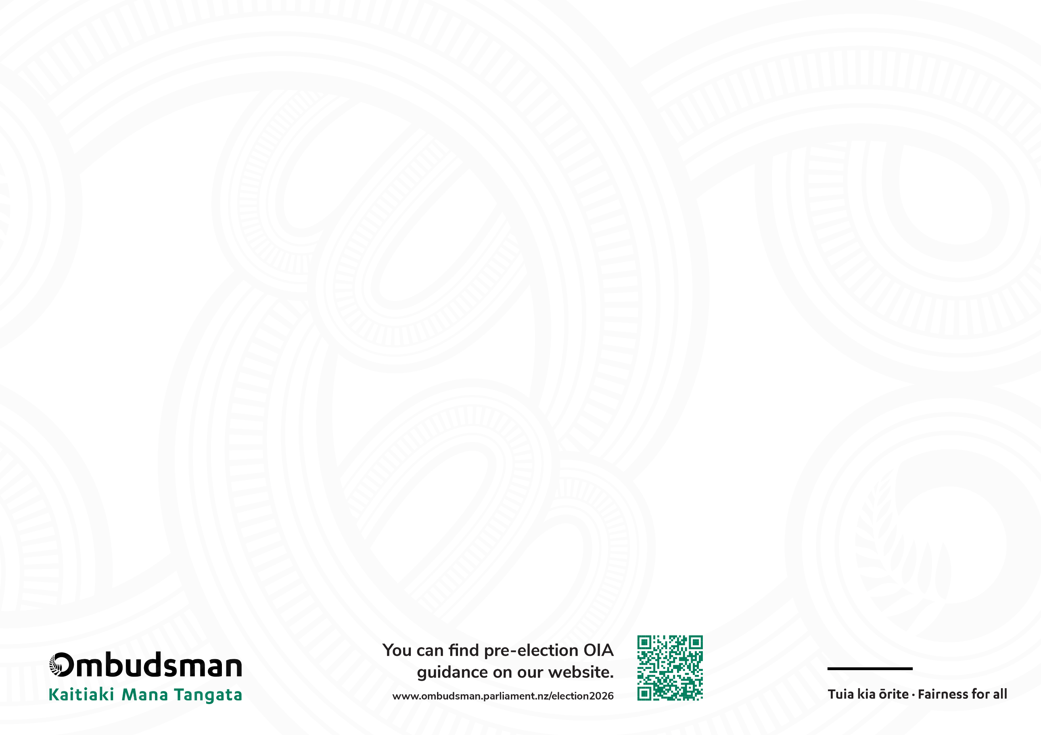

The OIA and you
Election 2026
Important advice for all users of the OIA
October 2026

Expect strong oversight from the Ombudsman in the weeks ahead
Parliament has dissolved, campaigning is underway – and Ministers and government agencies can expect strong oversight from the Ombudsman in the weeks ahead to ensure people are not denied access to sufﬁcient, reliable ofﬁcial information that will enable them to make an informed decision on November 7.
We know that some democratic elections overseas have been compromised by misinformation and disinformation campaigns. Social media can be vulnerable to manipulation with a view to inﬂuencing political outcomes. Disinformation campaigns can make it increasingly difﬁcult for voters to discern the truth from falsehood, potentially inﬂuencing voter behaviour, swaying election outcomes and undermining the democratic process.
For our own democracy to ﬂourish and remain legitimate, credible and effective, the public needs to have conﬁdence that we have a transparent and accountable Government and our electoral process can be trusted. Delays in access to information people are entitled to allows rumour, speculation and misinformation to take hold.
The Ombudsman’s role is to make sure the OIA is being administered properly by Ministers and government agencies. Throughout this pre-election period, we have been publishing key information and practice advice for requesters, Ministers, agencies, and complainants. In the weeks ahead, our investigators will be triaging and processing any OIA complaints we receive to make sure New Zealanders have access to sufﬁcient reliable information before polling day on November 7 to inform their vote. We expect Ministers, agencies and complainants to be co-operative with our investigators so we can obtain a resolution and complete our investigation quickly.
Protecting the integrity of New Zealand’s democratic process is in everyone’s interest. Both the OIA and the Ombudsman can play a vital role in ensuring voters are sufﬁciently and reliably informed when they exercise their right to vote on November 7.

Requesters | Ministers (and agencies) | The Ombudsman
- Ask for urgency. If you are requesting information to inform your vote, ask to receive it urgently  - Share why you want the information. Don’t be afraid to explain why you want the information – for example, to increase your understanding of an issue, or conﬁrm what you are being told.  - Contact us quickly – don’t wait. If you are unhappy with how your request is being processed and whether you will get a decision in time, come to the Ombudsman early. You can make a complaint online or call our team on 0800 802 602. Our services are free and independent. | Guiding principles  - Genuinely consider requests for urgency. Ministers and agencies have a legal duty to consider requests for urgency. Ensuring voters are reliably informed before voting day is a genuine consideration for prioritising a decision.  - Be available. The pre-election phase brings a surge of interest and high-impact, high-value requests. You must resource your ofﬁces properly and be available for any consultation and decisions.  - Timeliness matters most now. You are legally obliged to decide on an OIA request as soon as reasonably practicable. In the weeks ahead, you must work quickly and apply the law correctly to minimise the risk of information becoming outdated and irrelevant to voters before they hit the polls. Telling requesters a decision is going to be delayed because you’re prioritising election campaigning will not be acceptable.  - Keep political considerations out of OIA decisions. The OIA applies to Ministers in their ofﬁcial capacity. Do not confuse campaign politics with the statutory duty to release ofﬁcial information.  - Work with the Ombudsman constructively. Work with our ofﬁce to resolve complaints quickly. | What you can expect from the Ombudsman:  - A speedy response. You can expect the Ombudsman to move quickly to determine whether the decision on a request for information should have been refused before election day.  - Strict timeframes. We’ll apply strict timeframes and use the Ombudsman’s compulsion powers when needed if Ministers and agencies don’t work with us constructively. These include requiring information, explanations and responses urgently. We may want to meet a Minister or ofﬁcials within short timeframes so that we can form our opinion and make any recommendations in time.  - Recommendations. You can expect clear recommendations for release where its found that ofﬁcial information ought not to have been refused. It is a legal requirement to comply with an Ombudsman recommendation. You can ﬁnd examples of how we have carried out our oversight role under urgency in previous elections, in our FAQs.

