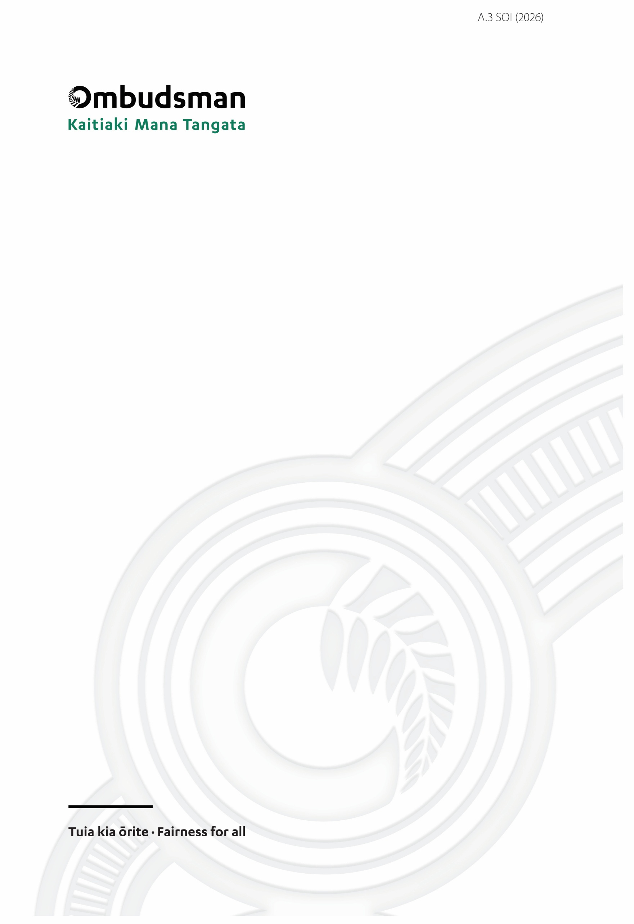
Ngā Koronga Rautaki Strategic Intentions
2026-2031

Kaitiaki Mana Tangata Aotearoa | Ombudsman New Zealand
Presented to the House of Representatives pursuant to section 39 of the Public Finance Act 1989

Ngā Koronga Rautaki | Strategic Intentions 2026-2031
ISSN 2624-2575 (PDF)
ISSN 2816-0614 (Print)
Published October 2026
All text and images copyright © Office of the Ombudsman
The unique aspects of the PĪTAU-A-MANAIA and PANEL logo have been carefully carved by digital whakairo at Ariki Creative in Ōtautahi, Taane Flanagan, for the exclusive use for the Office of the Ombudsman. All copyright and trade mark rights in the PĪTAU-A-MANAIA and PANEL Logo are owned by the Chief Ombudsman and authorised for use by the Office of the Ombudsman.
Office of the Ombudsman | Wellington, New Zealand | www.ombudsman.parliament.nz

Contents
Chief Ombudsman’s introduction 4
What we do matters 4
Who we are and why we exist 5
Our role and purpose 5
Our outcomes 5
What we do 6
Our functions and responsibilities 6
How we contribute 8
Where we fit in New Zealand’s accountability system 8
Who we work with and what they expect 9
How we influence change 10
Our guiding principles 10
Operating context 11
Our environment 11
Our strategic direction 12
Our vision 12
Objective 1: Drive lasting improvements to people’s experience of government 13
Objective 2: Protect and strengthen the conditions for open and accountable government 14
Objective 3: Provide a more accessible and responsive service 15
Our foundations 17
Building organisational capability 17
Our outcomes framework 19
Understanding our impact 20
How we will measure our progress and impact 20
Appendix 1. Alternative Text Version ‘Outcomes Framework’ Diagram 21
First level, titled: Purpose 21
Second level, titled: Outcomes 21
Third level, titled: Vision 21
Fourth level, titled: How we deliver 21
Column 1: our functions – what we do 22
Column 2: Strategic objectives – our focus 22
Column 3: The impacts we aim for 22
Fifth level, titled: Our guiding principles 23
Sixth level, titled: Foundations 24

Speaker’s Statement of Responsibility
I am satisfied that the information on strategic intentions provided by the Chief Ombudsman is in accordance with the Public Finance Act 1989 and is consistent with the policies and performance expectations of the Officers of Parliament Committee acting on behalf of Parliament.

Rt Hon Gerry Brownlee
Speaker of the House of Representatives
Responsible Minister for the Office of the Ombudsman

20 October 2026

Chief Ombudsman’s Statement of Responsibility
In signing this statement, I acknowledge that I am responsible for the information on strategic intentions for the Ombudsman. This information has been prepared in accordance with sections 38 and 40 of the Public Finance Act 1989.
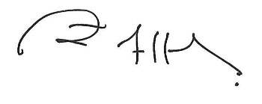
John Allen
Chief Ombudsman

20 October 2026

Chief Ombudsman’s introduction

What we do matters
When people run into a problem with the state, they are rarely on an even footing. The Ombudsman is a critical safeguard, providing an independent check on how government treats people.
We ensure there is somewhere for people to turn when things aren’t right, and we give people confidence that, when it matters, issues will be brought to light and public power held to account. Part of that is protecting people's ability to see and understand what government is doing. At a time when trust and confidence in public institutions is being eroded around the world, and society is facing new and complex challenges, this work matters more than ever.
Demand across our functions keeps growing, with no sign of that changing, and our responsibilities have expanded over recent years. Parliament has challenged us to build a sustainable model to manage this within current resourcing, without impacting our timeliness or quality. We are already working in new ways to meet that challenge and to do more with what we have, but there is still more to be done.
We have also listened to the people and communities we serve, the agencies we oversee, and the other organisations we work with, about what they need and what makes us most effective. We need to be out of Wellington and closer to those communities and agencies. We need to be an Ombudsman that listens and applies common-sense judgement about what is fair and reasonable. We need to be proportionate with our time and resources, so we have more capacity to be where we are really needed and to tackle the systemic problems that drive poor outcomes for people.
We must guard our independence fiercely too – but independence does not mean distance. To understand the context in which problems arise, we must stay connected to the people, communities and agencies we work with.
This Strategic Intentions sets out our plan to achieve our vision: an Ombudsman people know, can reach, and can count on to help put things right – focused on making the most impact for people.

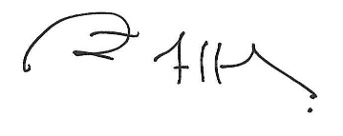

John Allen
Chief Ombudsman

Who we are and why we exist

Our role and purpose
The Ombudsman is an Officer of Parliament. This means we are responsible directly to Parliament and independent of the Government.
We are the Kaitiaki Mana Tangata |Guardian of the Mana of the People. Our purpose is to provide an independent check on how government treats people, helping to address the power imbalance between individuals and the state.
Where we find something has gone wrong our job is to identify remedies for people and ways to address the causes, so the same problems are less likely to happen again. It’s also part of our job to work proactively to try to prevent problems before they occur, and to monitor parts of the government system to protect people’s rights.
Our oversight helps strengthen public trust in government, both by ensuring accountability where things have gone wrong and by providing reassurance where we find that government has acted fairly and reasonably.

Our outcomes
Our outcomes are the long-term results we contribute to for New Zealand. They are enduring and reflect the Ombudsman’s purpose and what Parliament and the public expect of us.
  Fair treatment  People are treated more fairly, reasonably and humanely by government and have access to effective recourse when they are not. |   Open government  Government is transparent about what it does and people can access the information they need to be informed, to understand decisions and to participate.
  Robust oversight  The exercise of public power is subject to robust and independent scrutiny and matters of concern are brought to light. |   Better administration  Public sector capability and decision-making is enhanced, enabling government to be more responsive, effective and trusted.

What we do

Our functions and responsibilities
The Ombudsman has a range of functions and responsibilities given to us by Parliament. We oversee around 4,000 public sector agencies across our different functions. A lot of our work is driven by demand – like the many thousands of complaints and enquiries we receive each year. Other work is more self-directed, focusing our functions and resources on the areas where we think we are needed or can make a difference.
Respond to complaints about government
We resolve and investigate complaints about the actions and decisions of government agencies and the wider public sector. Where we find something has gone wrong, we work to put that right for the person affected. Where we identify administrative issues that contributed to the problem, we also make suggestions for improvement.
Review official information decision-making
We resolve and investigate complaints about decisions made by public sector agencies in response to requests for information. New Zealand's official information laws enable the public to request information held by Ministers and public sector organisations. People can complain to us if they are refused information or have other concerns about how an agency responded. We help make sure that requests are handled appropriately and that people can get the information they are entitled to.
Investigate issues proactively
In addition to responding to complaints, we also look into issues on our own initiative. We identify systemic problems in public sector administration and decision-making. We work to resolve those problems or investigate them and make recommendations for improvement. We also monitor public sector compliance and good practice in managing and responding to official information requests and make suggestions for improvement. This means we can target important issues impacting people’s experience of government without having to wait for complaints to reach us.
Monitor places of detention
We monitor the treatment and conditions of people in places of detention to help ensure that people who are deprived of their liberty are treated humanely.
This work is preventive, aiming to ensure that protections against ill-treatment are in place and that risks, poor practices, or systemic problems are identified and addressed. It also helps to ensure New Zealand meets international human rights standards.
The places we visit and inspect include prisons, court facilities, immigration detention, health and disability detention, and aged care facilities.
Protect and monitor disability rights
Tāngata whaikaha Māori, Deaf and disabled people face persistent barriers which prevent them from being able to participate fully in community and public life. As a part of the Independent Monitoring Mechanism, the Ombudsman helps to protect and monitor Deaf and disabled people’s rights. We monitor how those rights are being realised, report on what we find and make recommendations for improvement. We also share information that promotes good practice and raises awareness.
Enable serious wrongdoing to be reported safely
New Zealand’s whistleblower laws support people to report serious wrongdoing in their workplace, by creating a process for people to make disclosures and providing protection against retaliation. The Ombudsman has a key role providing independent advice and guidance to employees, employers and organisations who receive disclosures. This helps people to understand their rights and responsibilities and the legislation to work as intended. We also receive disclosures ourselves and can investigate disclosures made about conduct in the public sector.
Inform and empower the public
We help people understand their rights, what they can reasonably expect from government, and how to take constructive action on their concerns. We provide information and guidance and engage directly with communities across New Zealand so that people know who we are, what we do and how to reach us. We also empower people with information about how to resolve issues for themselves where that is possible.
Support and guide public sector agencies
We provide advice, guidance and training to public sector agencies to help them make good decisions, handle complaints well, improve practice, and comply with their obligations. Supporting good practice helps stop problems from arising in the first place, and helps government be more responsive, effective, fair and trusted.
We have oversight of approximately 4,000 agencies in the public sector, including:
- government departments and ministries;
- local authorities;
- school boards;
- tertiary education institutions;
- crown entities;
- state-owned enterprises; and
- Ministers of the Crown and Police (in relation to decisions on requests for official information).
We also have:
- oversight of Oranga Tamariki contracted care or custody providers; and
- the designation to monitor and inspect private sector facilities where aged care recipients and those in isolation are detained.

How we contribute

Where we fit in New Zealand’s accountability system
The Ombudsman is one part of New Zealand's wider accountability system. Parliament, the courts and other independent bodies provide their own checks on the exercise of public power. We make our own unique contribution alongside these other parts of the system.
We have distinct strengths. We are directly accessible to the public: anyone can raise a concern with us, at no cost and without formality. Our powers to consider matters, form opinions and make recommendations are broad and flexible. This allows us to be pragmatic and adapt our approach to the situation in front of us. Our oversight of more than 4,000 agencies gives us a wide view across the public sector.
As an Officer of Parliament, we are independent of the government. Not only is our independence an important constitutional protection, but it also has real practical value. Confidence in our independence means our findings carry weight with both agencies and the public. This allows us to bring resolution and finality to matters that might otherwise remain contested.

Te Tiriti o Waitangi | The Treaty of Waitangi
We acknowledge the constitutional significance of Te Tiriti o Waitangi | The Treaty of Waitangi, and the courts’ recognition of tikanga as a source of law in New Zealand. Te Tiriti and tikanga are part of the context in which public power is exercised and are relevant to how we assess fairness and reasonableness in our oversight work. Te Tiriti and tikanga also shape how we approach our own processes and practices, how we make decisions, and how we engage.

Who we work with and what they expect
We are accountable to Parliament and our work supports Parliament's own scrutiny of government. Parliament expects us to act independently, impartially, and to report reliably on how the public sector is treating people.
We exist for people, and particularly those in more vulnerable situations or who come to us for help because something has gone wrong. People expect us to provide a service that is fair, timely, accessible, culturally responsive, and that takes their concerns seriously. The wider public needs to know who we are, what we do, and how to reach us when they need to.
We work with the agencies we oversee to resolve specific issues and to help them respond to challenges that affect people. Agencies expect our interventions to be impartial, efficient and proportionate, and to reflect a sound understanding of their context and how they operate.
Where we have shared oversight responsibilities, we work with other oversight agencies to coordinate our efforts and strengthen our collective impact. This includes working with:
- our Independent Monitoring Mechanism partners – Te Kāhui Tika Tangata | Human Rights Commission, and the Disabled People’s Organisations Coalition, to protect and monitor disability rights;
- Aroturuki Tamariki | Independent Children’s Monitor and Mana Mokopuna | Children’s Commissioner, to provide oversight of the Oranga Tamariki System and help safeguard the rights and wellbeing of children and young people in care; and
- New Zealand’s other designated National Preventive Mechanisms – the Independent Police Conduct Authority, Mana Mokopuna | Children’s Commissioner, and the Inspector of Service Penal Establishment – and the Central Coordinating Mechanism, Te Kāhui Tika Tangata | Human Rights Commission.
We draw on the advice and insight of our two advisory panels: Pūhara Mana Tangata, our Māori advisory panel and Te Rōpū Kaiārahi Hauātanga, our disability advisory panel.
We also engage with other Ombudsmen, and oversight and integrity bodies, both in New Zealand and internationally, to share insights and learn from others who do similar work. This includes supporting the work of Pacific Ombudsmen, primarily through programmes delivered online or here in New Zealand, engaging with Australian Ombudsmen and Information Commissioners to share best practice and insights, and participating in relevant international bodies to support our ongoing work.

How we influence change
We influence change in different ways. We form independent, evidence-based opinions about issues and make recommendations to put things right for people and to improve systems and practices. We use learning and advice to guide good practice by agencies, and we make comment on proposed laws and policies that affect people. We engage directly with agencies to identify issues early and to help find ways to address them.
Our presence also has influence even where we haven’t yet taken any direct action. Agencies tell us that knowing the Ombudsman is paying attention can help encourage better practice and improve how decisions are made. The public being assured that there is robust independent oversight in place supports trust in government.
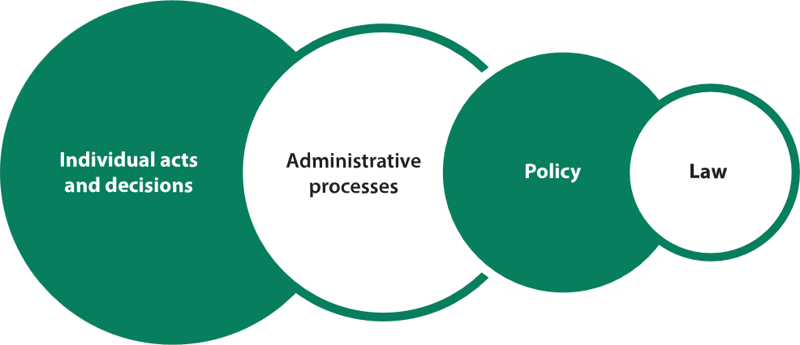
Figure 1: Where our work has impact
The most immediate results of our work are remedies for individuals. Beyond those immediate results, our opinions and guidance can lead agencies to improve their policies and practices. Over time, these effects should contribute to a public sector that acts more fairly, lawfully and openly. At this level, our contribution is one influence among many.
Our powers are primarily recommendatory, and we have limited ability to compel agencies to act or change outcomes. Our influence relies on our ability to persuade – through the strength of our evidence, the quality of our reasoning, and the weight of our independence and credibility.

Our guiding principles
Our ability to influence depends not only on what we do, but how we do it. There are four guiding principles that we need to follow in all our work. They are how we stay effective and how our independence and unique role is experienced in practice by those who interact with us.
We hold ourselves to these principles in the same way we hold others to the standards that we expect of them.

Impartiality
We are open-minded and objective in all our work.

Fairness
We are respectful, accessible, flexible, and consistent, and ensure that people are heard.

Accountability
We act with integrity, own our mistakes, and hold ourselves to the standards we expect of others.

Transparency
We are clear and open about how we work and what to expect, while making sure sensitive information shared with us is protected.

Operating context

Our environment
Our strategic direction is influenced by the complex and changing environment we work in. Several wider trends are shaping current demand for our services, what’s expected of us, and our priorities.
Declining trust in government integrity and openness
Trust and confidence in public institutions is declining internationally. While New Zealand consistently ranks among the most open and least corrupt public sectors in the world with comparatively high public trust in government, trust is slipping here too.
Timely access to official information and clear information about decisions are essential pillars for maintaining trust in government. The volume of information produced and held by government has grown drastically. At the same time, demand for information is growing. As the systems that support openness come under increasing pressure, ensuring access to information is enhanced and protected is becoming more challenging.
Shifting demographics and rapid technological change
An ageing population means there is a growing cohort of people who are more likely to rely on government services. New Zealand’s population is also becoming more diverse, which brings changing needs and expectations. These same people can also face greater barriers navigating complex administrative systems.
Technological advancements are reshaping how public services are delivered. Whether this improves people’s experience of government services depends on how well we harness the opportunities and safeguard against the risks, including ensuring that people with limited digital access or additional communication needs aren’t left behind.
Shifting demographics, increasing demand for government services, and technological shifts will transform the environment we operate in. We must be accessible to all, and our oversight must improve people’s experience of government.
A more complex and constrained operating environment
The world today is rapidly changing. The issues we see are varied and increasingly fast-moving, driven by more frequent external shocks including extreme weather events, pandemic risk, and geopolitical and supply chain instability. Some long-term issues faced by government are complex, deep-rooted and interconnected, involving multiple sectors and agencies, including in fundamental areas such as housing, health, the justice sector and child welfare. These distinct challenges often impact the same individuals and whānau as they move through different parts of the system.
At the same time, economic and fiscal conditions mean that public sector resourcing is constrained. Agencies are being asked to do more with less.
Together, these factors present new and evolving challenges for our work and are likely to see demand for our services continue to grow.

Our strategic direction

Our vision
Reach, focus and impact.
Our vision is to be an Ombudsman people know, can reach, and can count on to help put things right – focused on making the most impact for people.

Our strategic objectives
Our functions are set by Parliament, and carrying them out well, day to day, is our priority and the main way we contribute to the outcomes we work towards. Those functions are broad and varied and in a complex environment demand for our services continues to rise. Clear shared priorities across all our work help us align and coordinate our efforts where they make the greatest difference.
Our strategic objectives are where we will focus over the medium term to contribute to our outcomes and deliver our vision. They respond to what we are seeing in our work and to the changing environment around us. Each objective contributes to all our outcomes, either directly or indirectly.
1. Drive lasting improvements to people’s experience of government. We will focus on identifying and helping address the persistent and systemic issues that drive poor outcomes for people.
2. Protect and strengthen the conditions for open and accountable government. We will set clear expectations, provide responsive guidance, and use our oversight to support the systems, practice and culture that underpin transparency and accountability.
3. Provide a more accessible and responsive service. We will grow awareness of how we can help, make it easier for people to reach us, and provide a service fit for current needs and expectations.
The following sections explain each objective: why it matters, the impacts we are seeking, and how we will do this.

Objective 1: Drive lasting improvements to people’s experience of government
We will focus on identifying and helping address the persistent and systemic issues that drive poor outcomes for people.
Why
We know from our broad oversight functions and the thousands of complaints and enquiries we receive that many of the administrative issues that contribute to negative outcomes for people are persistent and recurrent. These issues often sit across multiple agencies or sectors and are not always straight-forward to diagnose or address.
The breadth of our oversight role and powers and the data we gather mean we are uniquely placed to identify where the system may be failing people and to help figure out why.
To have the greatest impact, we need to be targeted in how we carry out our functions. We need to use our perspective and influence to identify and bring attention to issues that are the causes of poor outcomes, and to help drive lasting improvements.
Impacts we aim for
- Our interventions and recommendations address the causes of problems and deliver durable solutions
- Insights we generate from our work help identify patterns and issues, enabling earlier and more strategic intervention
- Our support and advice promote good agency practice and decision-making, and help agencies respond to challenges effectively
How we will deliver
In addition to resolving the immediate issues that come up in our casework and inspections, we will strengthen our focus on getting to the underlying causes and finding resolutions or recommendations that address the causes of problems and drive systemic change.
We will build our capacity to turn the data from across our functions and engagements into timely, high-quality insights, and develop clear criteria for identifying and prioritising those issues where we can make the biggest difference.
We will use our relationships across government to help connect agencies on important issues, and intervene as early as we can, including through early input into the design of systems and processes that affect people’s experience.
We will use our platform to bring attention to persistent and difficult issues but also to promote examples of good practice so that is recognised and can help support agency learning.
We will track the implementation and outcomes of our recommendations, so we can understand what works and improve our own practice to deliver more effective remedies and improvements.

Objective 2: Protect and strengthen the conditions for open and accountable government
We will set clear expectations, provide responsive guidance, and use our oversight to support the systems, practice and culture that underpin transparency and accountability.
Why
Transparency and access to information are essential components of a strong democracy, and to people's ability to navigate government in their everyday lives. This depends not only on our official information legislation, but on the wider culture and practice of openness across government, including: clear reasons for decisions, information being made available proactively, appropriate consultation, and sound record-keeping.
The systems that support open and accountable government are under increasing pressure, driven in part by new technologies, economic and fiscal constraints and changing social conditions. These pressures are occurring at a time when trust in public institutions is declining.
We need to support the system to be sustainable and continue to serve people well, and give the public, Parliament and agencies confidence that the official information legislation is working as intended to make information progressively more available while protecting information where there is a genuine need to do so.

Impacts we aim for
- Our work contributes to a resilient official information system that continues to deliver on its purposes
- People can access information more easily and reliably
- Good information practices, including a culture of proactive release, are more consistently embedded across the public sector

How we will deliver
We will provide timely and pragmatic resolution of official information reviews to ensure outcomes are useful and deliver on the purposes of the legislation.
We will be a trusted source of advice – issuing clear and up-to-date guidance and offering responsive support to agencies on challenges they face.
We will set consistent expectations and support agencies to apply the law with greater confidence and less unnecessary caution.
We will focus our proactive interventions on the areas we see the greatest opportunity to help agencies improve their practice.
We will report on official information trends, risks and performance across the public sector, giving Parliament and the public assurance that the official information system is working as intended.
We will promote capability-building for agencies and requesters and support the responsible use of technology, including Artificial Intelligence (AI), to make official information administration more efficient.

Objective 3: Provide a more accessible and responsive service
We will grow awareness of how we can help, make it easier for people to reach us and provide a service fit for current needs and expectations.
Why
A core purpose of the Ombudsman is to help address the power imbalance between people and the state and to provide accessible and affordable recourse when things go wrong. To do that, we need to be genuinely accessible – particularly to those with the greatest need for our help. For some groups, the barriers to knowing about us or accessing our services are higher, including Māori, Pacific peoples, Ethnic communities, Deaf and disabled people, children and young people, and those in regional areas or communities with less digital access. These are often the same groups more likely to experience challenges engaging with public services. At the same time, government systems and complaint pathways can be complex and difficult to navigate.
People expect us to be fair and timely in the assistance we provide. Our ability to deliver impact for people depends on meeting those expectations, and the quality of our service shapes whether people are likely to seek our help or engage with us in the first place. We are managing significant and sustained growth in demand. Our services need to adapt and keep pace, including by making better use of technology to enhance our efficiency and respond to changing expectations.

Impacts we aim for
- More people, particularly in underserved communities, are aware of the Ombudsman and understand how we can help
- We are accessible and our processes and communications are adapted to people’s diverse needs
- People and agencies receive a timely and fair service, with clear communication about what to expect
- People receive useful assistance and meaningful remedies
How we will deliver
We will grow awareness of our role through planned and evaluated outreach focused on where awareness is lowest and need greatest. We will engage appropriately to best understand the issues affecting people.
We will work to reduce barriers people experience in reaching us, enhance our accessibility and work to understand and meet Deaf and disabled people’s access needs.
We will build our capacity to meet diverse cultural expectations and engage in ways that reflect Te Tiriti o Waitangi | The Treaty of Waitangi and tikanga, including engaging Māori to understand their views when considering matters that affect Māori and ensuring our own processes, practices, and decisions are consistent with Te Tiriti and tikanga.
We will take a trauma-informed and child-centred approach where the situation requires it.
We will look for opportunities to simplify our processes and make sure our communications are clear, accessible and tailored for different audiences and purposes, including being upfront about what we will and will not do, so people know what to expect.
We will make greater use of storytelling as a way of ensuring our work is visible, engaging, and builds awareness and understanding of our role and our work among the public and under-served communities.
We will keep improving the timeliness and proportionality of our service across all our functions and make better use of technology to increase accessibility and to make our service faster and easier to engage with.

Our foundations

Building organisational capability
Demand for our services continues to rise, Parliament has expanded our role in recent years, and we are working in a complex and rapidly changing environment. We have grown considerably to support the additional work now required of us. We need to continue to adapt and build our capability as an organisation to deliver on our purpose and our strategic objectives.
Our new organisational structure, introduced earlier this year, simplifies how we are organised, strengthens leadership and makes accountabilities clearer, and empowers our people to make timely and effective decisions.
That new structure provides a sound base, but to keep pace with the demands on us and deliver the objectives we have set, there are investments we need to make across our organisation – in our people, how we govern and lead, our technology and systems, and how we use data.

People and culture
Everything we do depends on our people, and the breadth and complexity of our work demands a lot from them. We want our people to be confident, capable and engaged – well equipped for the work we do now and will do in the future.
Building capability across the organisation is a priority, including investing in: digital skills, cultural capability, and leadership and decision-making skills at all levels of the organisation. We are also working with our staff to develop a programme of work focused on strengthening diversity, equity and inclusion in our workplace.
We are committed to enhancing our understanding of te ao Māori within our workplace. We are implementing Te Rautaki Māori a Kaitiaki Mana Tangata |the Ombudsman's Te Ao Māori strategy, to continue to develop our people’s capability and confidence in te ao Māori, te reo, tikanga, and Te Tiriti. This helps us to be more effective and provide a better service.
We will develop a new workforce strategy to ensure we recruit for the skills and perspectives we will need for the future. To enable our people to succeed, we are focused on fostering a culture of trust, collaboration, ownership and innovation, where capable people feel empowered to exercise judgement.
It is critical that we look after our people and support them to flourish by supporting their health, safety and wellbeing, growing resilience, and ensuring effective leadership through change.

Governance and leadership
To turn strategy into delivery we need strong governance. Along with our recent structural changes, we have introduced clearer accountabilities and decision-making arrangements. Our focus now is on embedding them so that decisions about priorities, resources and risk are well-informed, visible and made at the right level.
We are drawing on external expertise to test and enhance our accountability, bring greater cohesion and transparency to our work programme, strengthen strategic planning, and ensure a mature approach to managing risk and compliance.
As these arrangements are embedded, our leaders will have increased capacity to focus on the strategic work that drives improvement and delivery of our goals.

Technology and systems
We need to ensure we are making the best use of technology to enable our work and maintain systems that are integrated, secure and reliable.
Our immediate focus is on ensuring our core building blocks are right. This includes ensuring we have the right infrastructure in place to introduce a new Customer Relationship Management system, completing our shift to secure cloud-based platforms, and establishing the foundations to use artificial intelligence safely and effectively. From there, we will work towards better collaboration tools, building our analytics capacity, and moving quickly to trial new technologies where we think they may help us to work more effectively.
Alongside this, we will also be reviewing our business processes across the Office to make sure they are streamlined and fit for purpose. This will free up capacity and make it easier for our people to do their jobs.

Data and insights
Our work across all our functions generates a wealth of information about people's experience of government. Harnessed properly, it can help us identify the areas where we can have the most impact. We are not yet fully realising that potential.
We are working to build our capacity to capture, analyse and act on our data. This will enhance our ability to understand the impact of our work and to identify organisational and strategic needs. It will help us understand where we need to focus, how to intervene and what is effective.
Our new structure will ensure dedicated capacity to lead this work in close collaboration with the wider organisation, and we are developing a new insights strategy to guide our approach. We are also investing in the tools and capability to deliver this work and building a culture where surfacing insights is part of everyone's job. This capability underpins our first strategic objective and our ability to assess the impact of our work.

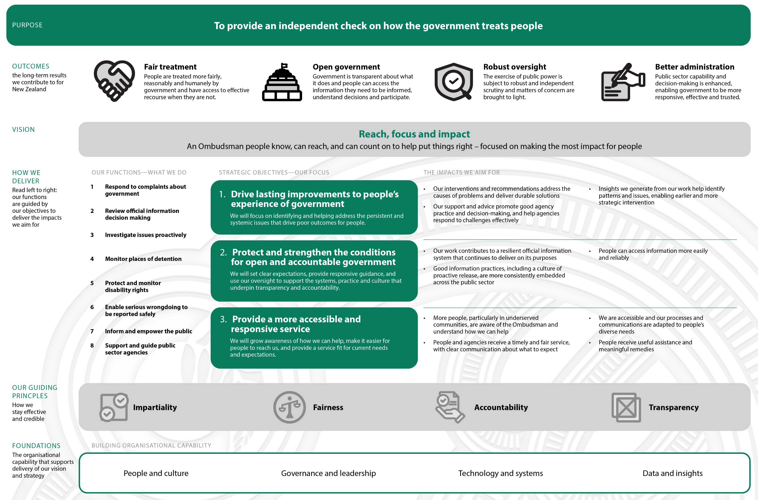
Our outcomes framework

Figure 2: See Appendix 1 for text alternative version of this diagram.

Understanding our impact

How we will measure our progress and impact
Understanding the impact of our work is essential to our ability to deliver on our strategic objectives and our vision for the Ombudsman. This helps us assess what is working, and whether we are focused on the right areas to achieve the objectives we are aiming for. It also allows Parliament and the public to hold us to account for the work we do.
We are developing a new set of impact measures aligned to the objectives in this strategy. These will show how we are progressing towards those objectives and indicate our contribution towards our strategic outcomes. We will begin measuring against them, and gathering the baseline information we need, over the second half of the financial year. The full set of new impact measures will be published separately.
We will also update our performance measures which track how effectively and efficiently we perform our core functions. These include measures for how much work we complete, our timeliness, and the quality of our work. We report on these measures, together with our impact indicators, in our Annual Report.
- Alternative Text Version ‘Outcomes Framework’ Diagram
A diagram structured vertically into six levels. Each level features a green title on the left (some with an explanatory statement directly beneath it and a corresponding content block extending to the right.

First level, titled: Purpose
The content is a wide green box spanning the top containing the Ombudsman’s purpose statement: ‘To provide an independent check on how the government treats people’.

Second level, titled: Outcomes
The explanatory statement notes: ‘The long-term results we contribute for New Zealand’.
The content contains the four outcomes:
- Fair treatment, the icon depicts two hands shaking: People are treated more fairly, reasonably and humanely by government and have access to effective recourse when they are not
- Open government, the icon depicts the beehive: Government is transparent about what it does and people can access the information they need to be informed, understand decisions and participate
- Robust oversight, the icon depicts a shield with a magnifying glass that has a tick in it: The exercise of public power is subject to robust and independent scrutiny and matters of concern are brought to light
- Better administration, the icon depicts a hand holding a pen and writing: Public sector capability and decision-making is enhanced, enabling government to be more responsive, effective and trusted

Third level, titled: Vision
The content is a grey box containing the Ombudsman’s vision statement under a bold green heading, ‘Reach, focus and impact’. The text reads: ‘an Ombudsman people know, can reach, and can count on to help put things right – focused on making the most impact for people’.

Fourth level, titled: How we deliver
The explanatory statement notes: ‘Read left to right: our functions are guided by our objectives to deliver the impacts we aim for’.
The content is split into three side-by-side columns:

Column 1: our functions – what we do
- Respond to complaints about government
- Review official information decision making
- Investigate issues proactively
- Monitor places of detention
- Protect and monitor disability rights
- Enable serious wrongdoing to be reported safely
- Inform and empower the public
- Support and guide public sector agencies

Column 2: Strategic objectives – our focus
Features three stacked green boxes where each objective statement is bolded and in a larger font, with its smaller explanatory statement directly below it.
- Drive lasting improvements to people’s experience of government
  - We will focus on identifying and helping address the persistent and systemic issues that drive poor outcomes for people
- Protect and strengthen the conditions for open and accountable government
  - We will set clear expectations, provide responsive guidance, and use our oversight to support the systems, practice and culture that underpin transparency and accountability
- Provide a more accessible and responsive service
  - We will grow awareness of how we can help, make it easier for people to reach us, and provide a service fit for current needs and expectations

Column 3: The impacts we aim for
Sets out intended impacts, in bulleted lists, visually aligned with their corresponding objective from column two, and separated by green lines. These are:

Strategic Objective 1:
- Our interventions and recommendations address the causes of problems and deliver durable solutions
- Our support and advice promote good agency practice and decision-making, and help agencies respond to challenges effectively
- Insights we generate from our work help identify patterns and issues, enabling earlier and more strategic intervention

Strategic Objective 2:
- Our work contributes to a resilient official information system that continues to deliver on its purposes
- Good information practices, including a culture of proactive release, are more consistently embedded across the public sector
- People can access information more easily and reliably

Strategic Objective 3:
- More people, particularly in underserved communities, are aware of the Ombudsman and understand how we can help
- People and agencies receive a timely and fair service, with clear communication about what to expect
- We are accessible and our processes and communications are adapted to people’s diverse needs
- People receive useful assistance and meaningful remedies

Fifth level, titled: Our guiding principles
The explanatory statement notes: ‘how we stay effective and credible’.
The content is a horizontal grey box listing the guiding principles, each accompanied by an icon. The four guiding principles are:
- Impartiality, the icon depicts a grey square with two white circles containing black checkmarks overlapping its top right and bottom left corners
- Fairness, the icon depicts a black and grey icon of balanced scales inside a circle
- Accountability, the icon depicts a hand holding a document with a checkmark symbol indicating approval or verification
- Transparency, the icon depicts two intersecting squares with black outlines and a grey fill where the squares overlap, which contains a black cross

Sixth level, titled: Foundations
The explanatory statement notes: ‘The organisational capability that supports delivery of our vision and strategy’.
The content is a horizontal white box with a green outline listing the key capabilities. The four key capabilities are:
- People and culture
- Governance and leadership
- Technology and system

Including some organisations providing services on behalf of government, such as Oranga Tamariki care or custody providers.
The Official Information Act 1982 and the Local Government Official information and Meetings Act 1987.
Under the Ombudsmen Act 1975.
The Ombudsman is a National Preventive Mechanism under the Crimes of Torture Act 1989. This Act fulfils New Zealand’s responsibilities under the United Nations Optional Protocol to the Convention Against Torture.
The Ombudsman, together with Te Kāhui Tika Tangata | the Human Rights Commission, and the Disabled People’s Organisations Coalition form the Independent Monitoring Mechanism (IMM). The IMM protects and promotes disability rights and monitors government implementation in New Zealand of the United Nations Convention on the Rights of Persons with Disabilities. The Ombudsman’s role in the IMM is to protect and monitor.
The Protected Disclosures (Protection of Whistleblowers) Act 2022.
We also have specific advice functions under s241 Land Transport Act 1998, s317 Customs and Excise Act 2018, and s40 Oversight of Oranga Tamariki System Act 2022.
We acknowledge that there are two texts with different meanings.
The Ombudsman is a National Preventive Mechanism under the Crimes of Torture Act 1989. This Act fulfils New Zealand’s responsibilities under the United Nations Optional Protocol to the Convention Against Torture.

