OPCAT Report on an unannounced follow up inspection of Te Whare Awhi Ora - Ward 11, Gisborne Hospital under the Crimes of Torture Act 1989
15 December 2025
John Allen
Chief Ombudsman
National Preventive Mechanism

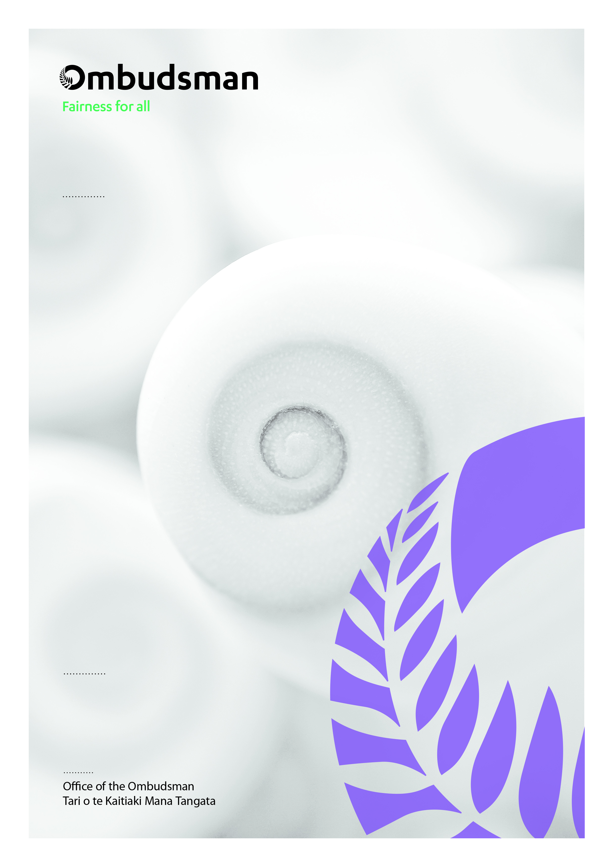



OPCAT report on an unannounced follow up inspection of Te Whare Awhi Ora – Ward 11, Gisborne Hospital under the Crimes of Torture Act 1989
ISBN: 978-1-0671271-5-2 (Digital)
Published September 2026
All text and images copyright © Office of the Ombudsman
Office of the Ombudsman | Wellington, New Zealand | www.ombudsman.parliament.nz

OPCAT report on an unannounced inspection of Te Whare o Matairangi Mental Health Inpatient Unit, Wellington Hospital, under the Crimes of Torture Act 1989
ISBN: 978-1-0671271-3-8 (Digital)
Published September 2026
All text and images copyright © Office of the Ombudsman

Office of the Ombudsman | Wellington, New Zealand | www.ombudsman.parliament.nz
OPCAT report on an unannounced inspection of Te Whare o Matairangi Mental Health Inpatient Unit, Wellington Hospital, under the Crimes of Torture Act 1989
ISBN: 978-1-0671271-3-8 (Digital)
Published September 2026
All text and images copyright © Office of the Ombudsman

Office of the Ombudsman | Wellington, New Zealand | www.ombudsman.parliament.nz

Introduction
The following report has been prepared in my capacity as a National Preventive Mechanism (NPM), as designated under the Crimes of Torture Act 1989 (COTA). Central to my role is conducting visits and inspections. My role is to form an independent opinion as to the conditions and treatment in these places, report my observations and if necessary make recommendations for improvement.

Inspection approach
From 7 October 2024 to 11 October 2024, a team of two inspectors, who have been delegated to carry out visits to places of detention on behalf of the Chief Ombudsman, made an unannounced five-day visit as part of the follow-up inspection to Te Whare Awhi Ora – Ward 11 (the Ward), an acute inpatient mental health unit. Inspectors were guided by the Chief Ombudsman’s Expectations for conditions and treatment of tāngata whai ora in health and disability places of detention.
The inspection was to follow up on the 18 recommendations made following the previous inspection in 2021 (final report date October 2023). All 18 recommendations were accepted.
Inspectors gathered and assessed a range of information, including reviewing documents, interviewing a number of people, and observing facility activities. Before leaving the facility, Inspectors met with Ward Management to outline their initial observations.

Consultation
A provisional copy of this report was sent to Health New Zealand – Te Whatu Ora (Health New Zealand) on 29 August 2025. On 19 September 2025, we received a response from Health New Zealand on behalf of the Unit. We have considered this feedback when finalising the report.

Facility facts
The Ward was based at Gisborne Hospital. It is an eight bed, mixed-gender, acute inpatient mental health unit. Tāngata whai ora could be admitted to the Ward under orders made under the Mental Health (Compulsory Assessment and Treatment) Act 1992 (the MHA), or on a voluntary basis.
At the time of inspection there were two voluntary tāngata whai ora in the Ward. Voluntary tāngata whai ora are under no legal compulsion to remain within a facility to receive mental health services. However, where there is a risk that arrangements in place could effectively mean voluntary consent is not given (including to treatment) or they are not free to leave at will, voluntary tāngata whai ora come within the scope of our OPCAT function.

Inspection outcome
We acknowledge that, at the time of the inspection, the Ward was preparing to move into a new facility. We have been advised that this had occurred in March 2025. Taking this into consideration we have not commented on the three recommendations relating to concerns about the Ward’s physical building. These included: ensuring improvements to the physical environment were completed; the Ward ceasing the use of the Low Stimulus Environment until safety improvements were completed; and the Ward ceasing the use of non-designated spaces as bedrooms. However, we note that the capacity of the new facility has only increased by two beds, and we continue to expect that tāngata whai ora are only accommodated in designated bedrooms.
Therefore, as a result of this follow up inspection, we consider that five recommendations were achieved and ten recommendations were not achieved. There are a number of areas in which I have concerns and recommendations. These are set out in the table below.

Recommendations

Recommendations to Te Whare Awhi Ora – Ward 11
I recommend Ward Management:
- re-establish the practice work to eliminate the use of seclusion and restraint. This is an amended repeat recommendation.
- implement robust processes to ensure that tāngata whai ora are only secluded or restrained as a last resort. This is an amended repeat recommendation.
- accurately and comprehensively record all seclusion and restraint events. This is a repeat recommendation.
- carry out comprehensive reviews of all seclusion and restraint events. I expect this would take place within seven days of each event. This is a repeat recommendation.
- formally record each instance of locking the door to the Ward as environmental restraint in official reporting. This is a repeat recommendation.
- ensure voluntary tāngata whai ora are fully informed about voluntary admission and that they have the right to exit the Ward at will. This is an amended repeat recommendation.
- ensure informed consent to remain on the Ward and receive treatment is obtained from all tāngata whai ora and the signed consent is retained on their file. This is an amended repeat recommendation.
- ensure that evidence of the legal status of tāngata whai ora is on file, up to date, and easily accessible. This is a repeat recommendation.
- provide all tāngata whai ora with accessible information about their rights and options to make complaints. This is a repeat recommendation.
- ensure all tāngata whai ora receive an initial health assessment in a timely manner. This is a repeat recommendation.

2024 Follow Up Inspection

2023 recommendations achieved
2023 recommendation | Observations
The Ward ensure that only appropriately trained staff are involved in seclusion and restraint of tāngata whai ora. | At the time of the inspection training records showed that all staff, including security staff and orderlies, were Safe Practice Effective Communication (SPEC) trained, and those due for a refresher had been booked to attend in October 2024. In addition four Ward staff were SPEC trainers.  Ward staff confirmed that any staff involved in seclusion or restraint events must be SPEC trained. One staff member explained that they had only recently been able to participate in restraints and seclusion after they completed SPEC training.
Te Whatu Ora clearly document the role of security staff in health settings. | The Hospital provided inspectors with Ward specific and general Hospital Security Guard Position Descriptions. The Ward specific Position Description clearly documented security staff’s role on the Ward. It referred to restraint and seclusion, stating there was an expectation that Ward security will ‘assist with restraints and transfer of patients from the open ward to LSE [Low Stimulus Environment]’. Essential Health and Safety Skills were outlined in the documents and stated the Security Guard must ‘Remain up to date with SPEC Training’.  The general hospital Position Description also required Security Guards to ‘complete SPEC training on orientation and complete refresher training’.
The Ward ensure all medication errors are reviewed within one week of the incident. | Medication incident management forms provided by the Ward for the three medication errors occurring during the six month period April to September 2024 showed that review was completed within seven days for two of the three. The third appeared to be reviewed and closed 11 days after the incident.
Te Whatu Ora and the Ward ensure there are sufficient numbers of appropriately trained staff available to the Ward. | At the time of inspection it appeared there were sufficient staffing levels for the capacity and acuity of tāngata whai ora in the Ward. The Director of Area Mental Health Services (DAMHS) told inspectors the Ward was consistently well resourced. There were no concerns raised by staff or tāngata whai ora in relation to staffing levels.
The Ward ensure complaint forms, in accessible formats, are available to tāngata whai ora without staff assistance. | Inspectors observed that the Ward had one complaints box which was located in the foyer of the main Ward. This box was accessible to tāngata whai ora. However, the box was not labelled to specify its purpose. At the time of inspection, the complaints box was unlocked. A feedback form was seen in the box which was dated August 2024. When asked about the clearing of the complaints box, Ward management confirmed that the box was not checked or cleared regularly.  Inspectors also observed that there were no complaint forms available in the Ward. Staff were aware that these forms were not available to tāngata whai ora independently of staff. Staff were also unable to locate any copies of the complaints forms when asked by inspectors.  In response to the provisional report, Health New Zealand advised that complaint forms are now available in the tāngata whai ora lounge. We acknowledge this change, and we will continue to engage with the Ward on its processes for reviewing complaints received.

2023 recommendations not yet achieved
2023 recommendation | Observations | 2025 recommendation
The Ward develop a plan to eliminate the use of seclusion and restraint. | Restraint, in all its forms, is recognised as a serious intervention with potentially harmful effects on tāngata whai ora. We expect that there is proactive work to achieve a restraint free environment, as well as to reduce and minimise its immediate use. Policies and practices, including site and service specific plans, evidence this.  Inspectors were provided with the Ward’s Restraint Minimisation and Safe Practice Committee Terms of Reference, dated April 2019, with a review date of March 2022. However, the document remained in draft format and was not in practice at the time of inspections. In addition, the Restraint Minimisation and Safe Practice Policy for Te Ara Maioha (Te Whatu Ora Tairāwhiti Mental Health and Addiction Services), also appeared to be in draft. In response to the provisional report, Health New Zealand provided us with a recently updated, finalised copy of the Te Ara Maioha Restraint Minimisation and Safe Practice Policy. We are pleased to see that restraint minimisation is being progressed at the regional level.  Ward Management confirmed there were no Ward-specific plans to eliminate seclusion and restraint and referred inspectors to the national policies, and advised that this was all that the Ward had regarding minimisation of seclusion and restraint. Inspectors were also told there had been no meetings for the Zero Seclusion Committee between 1 April 2024 – 30 September 2024 and limited meetings for the Organisational Restraint Committee between the same dates.  We are disappointed that pro-active Ward specific work towards eliminating seclusion and restraint had paused at the time of inspection, and encourage Ward Management to re-establish Ward specific practice work in line with Te Ara Maioha’s Restraint Minimisation and Safe Practice Policy. | I recommend Ward Management re-establish the practice work to eliminate the use of seclusion and restraint.  This is an amended repeat recommendation.
Te Whatu Ora and the Ward implement robust processes to ensure that tāngata whai ora are only secluded or restrained as a last resort. | We expect that in the event that practices amounting to seclusion or restraint are used, it is only for the immediate safety of tāngata whai ora or others, as a last resort and ends at the earliest opportunity.  Ward Management told inspectors that staff go to restraint and/or seclusion too quickly, when other techniques could have been attempted in the first instance. They also explained that care plans were not always completed.  In a number of seclusion reviews, it was noted care plans and alternative interventions such as sensory modulation had not been considered or attempted prior to the seclusion event. For example, some reviews noted that care plans were not followed or not available.  Inspectors’ review of tāngata whai ora files found that care plans were incomplete or not always present. In addition not all files included risk assessments or sensory plans.  Inspectors also noted that clinical governance meeting minutes dated 24 July 2024 stated that staff had not completed sensory modulation training. Some staff confirmed that they were not trained in how to use sensory equipment, and some were not aware it was available. There was also no sensory modulation room available in the Ward. | I recommend Ward Management implement robust processes to ensure that tāngata whai ora are only secluded or restrained as a last resort.  This is an amended repeat recommendation.
The Ward accurately and comprehensively record all seclusion and restraint events. | We expect that every seclusion and restraint incident is individually authorised, documented and comprehensively reviewed.  In response to the 2023 recommendation we were advised that ‘The manual book entry process has ceased and all seclusion events are entered in the reportable events system’ However at the time of inspection the manual book entry was still in place. Staff told inspectors that restraint and seclusion events were recorded in the paper form restraint register and seclusion register.  Review of the restraint and seclusion paper-based records for the five month period April to August 2024 identified that some were not completed fully. For example, events recorded in the paper-based seclusion register did not always record the end time for seclusion.  Team meeting minutes recorded that there had been instances of staff locking doors without completing seclusion paper work, and staff were reminded of the importance of completing seclusion documentation. | I recommend Ward Management accurately and comprehensively record all seclusion and restraint events.  This is a repeat recommendation.
The Ward carry out comprehensive reviews of all seclusion and restraint events. I expect this would take place within seven days of each event. | We expect that every seclusion incident is individually authorised, documented and comprehensively reviewed.  Inspectors were provided with eight examples of seclusion reviews from within the six month period of April to September 2024. Some reflections were brief, with limited details regarding learnings taken from seclusion events. Six of these reviews were completed more than seven days after the event. Two were competed more than a month after the event. | I recommend Ward Management carry out comprehensive reviews of all seclusion and restraint events. I expect this would take place within seven days of each event.  This is a repeat recommendation.
The Ward record each instance of locking the door to the Ward as environmental restraint. | We expect restraint is only used as a last resort and only when strictly necessary for the immediate safety of tāngata whai ora or others. Where restraint is used, it is authorised on a case-by-case basis, documented, reviewed, and followed-up appropriately. Use of restraint is reported to the appropriate authority.  The Ward was locked every day of the inspection, although the Ward sign still advised that it is an open ward. Staff confirmed that the doors to the Ward were routinely locked.  The locked doors were recorded in a spreadsheet, however this was not recorded in the restraint book. This resulted in the locked door information only being shared with Ward Management. This information was not included in any restraint data provided to the DAHMS, Ministry of Health or any other oversight bodies.  Recording of locking the doors to the Ward must be included in formal restraint reporting. | I recommend Ward Management formally record each instance of locking the door to the Ward as environmental restraint in official reporting.  This is a repeat recommendation.
The Ward ensure voluntary tāngata whai ora are fully informed of their right to exit and enter the Ward at will, and of any processes in place to facilitate this. | Voluntary tāngata whai ora are under no compulsion to receive treatment, nor to remain in the Unit should they wish to leave. No leave restrictions should be placed on voluntary tāngata whai ora.  There was no signage displayed in the Ward specifically informing voluntary tāngata whai ora of their right to exit the Ward.  Inspectors noted that the induction brochure and the Ward’s consent form did not contain any information regarding voluntary tāngata whai ora and their right to leave the Ward.  Staff told inspectors that voluntary tāngata whai ora were aware of their right to exit the Ward and knew the process to facilitate this. The District Inspector confirmed that in their experience voluntary tāngata whai ora understood their status and that they could exit the Ward at will.  While tāngata whai ora were being verbally told about their right to leave the Ward, and how to do this, this information should be displayed in the Ward and included in other documents such as induction booklets and consent forms that are provided to voluntary tāngata whai ora and their whānau. | I recommend Ward Management ensure voluntary tāngata whai ora are fully informed about voluntary admission and that they have the right to exit the Ward at will.  This is an amended repeat recommendation.
The Ward ensure informed consent to remain on the Ward and receive treatment is obtained from voluntary tāngata whai ora and recorded. | We expect that consent to treatment from the relevant party is sought, recorded and adhered to. Tāngata whai ora consent should always be regularly sought even if a refusal may, according to the law, be overridden. Where informed consent is not deemed possible, there are robust processes in place to ensure that any treatment is necessary, appropriate and authorised and that tāngata whai ora have been involved in decision-making to the fullest extent possible.  Inspectors’ review of voluntary tāngata whai ora files saw that one consent form was unsigned, but stated that the tangata whai ora ’did not consent’ to engage with inpatient services. The consent form for another voluntary tāngata whai ora was signed by whānau consenting on their behalf; inspectors were told whānau were acting as their EPOA. Evidence of an activated EPOA was unavailable at the time of inspection, but this was subsequently provided to inspectors.  A staff member told inspectors that consent forms could be difficult, because when tāngata whai ora arrive they can be unwell and unwilling to sign consent forms. Ward management said that obtaining informed consent was not always done. They shared that the Ward had completed random audits of files, and found that initial consents to be on the Ward and Consent to Treatment forms were not being filled out.  Inspectors saw that consent forms to remain on the Ward weren’t always completed and there were no Consent to Treatment forms seen in the files for tāngata whai ora admitted under the MHA. The lack of consent and the decision to provide treatment under the MHA should be retained on tāngata whai ora files.  The MHA states that after the first month of a Compulsory Treatment Order, written consent to treatment is required (unless specific circumstances are met). It also states that a patient’s consent should be obtained wherever practical, even if treatment is authorised under the MHA without the patient’s consent. A Consent to Treatment form, retained on the files of tāngata whai ora, provides an easily accessible document demonstrating that a consent process has been adhered to. | I recommend Ward Management ensure informed consent to remain on the Ward and receive treatment is obtained from all tāngata whai ora and the signed consent is retained on their file. In circumstances where tāngata whai ora are unable or refuse to sign, this is documented.  This is an amended repeat recommendation.
The Ward ensure that evidence of the legal status of tāngata whai ora is on file, up to date, and easily accessible. | In the response to the previous 2023 recommendation, the Ward stated that they would audit files accordingly to ensure legal status is stored in the hard copy file and electronic file.  Inspectors reviewed all tāngata whai ora files and noted that these were generally paper-based, disorganised and incomplete.  When asked for evidence of legal status for tāngata whai ora staff were not always able to direct inspectors to the detaining paperwork. Despite efforts by staff, detaining paperwork could not be located for one tāngata whai ora during the time of inspection. This was however, provided to inspectors after the on-site inspection. | I recommend Ward Management ensure that evidence of the legal status of tāngata whai ora is on file, up to date, and easily accessible.  This is a repeat recommendation.
The Ward provide all tāngata whai ora with accessible information about their rights and options to make complaints. | We expect that complaints systems are accessible to tāngata whai ora and others, well communicated, culturally safe, confidential and effective.  Inspectors saw an Office of the Health and Disability Commissioner poster displayed in the Ward. The District Inspector’s name was also displayed in the Ward but a contact phone number was not provided and in one instance the information advertised was out of date, referring to a previous District Inspector.  There was no information about complaint processes displayed in the Ward or in the induction booklet.  The DAMHS told inspectors they didn’t know if anything formal about the complaints process was given to tāngata whai ora. They also stated that there were low numbers of complaints ‘because we don’t advertise, maybe’. | I recommend Ward Management provide all tāngata whai ora with accessible information about their rights and options to make complaints.  This is a repeat recommendation.
The Ward ensure all tāngata whai ora receive an initial health assessment in a timely manner. | We expect that tāngata whai ora have a comprehensive health assessment as soon as practicable on admission and regularly thereafter.  A number of staff described completing initial assessments as a constant challenge and that they can take a long time to complete given the availability of House Officers, particularly when patients were not admitted through the Emergency Department. Inspectors were also told that at times tāngata whai ora would refuse to consent to an initial health assessment. Inspectors noted this refusal was not always captured in their files.  Some tāngata whai ora files were missing health assessments and admission checklists indicating if an initial health assessment had been completed. One file included an admission checklist that noted that medical assessment was requested but there was no indication that this had been completed.  Easily retrievable records of health assessments must be kept on tāngata whai ora files. If there are delays in completing this assessment, the reasons for the delay, and attempts to complete the assessment, should form part of the record. | I recommend Ward Management ensure all tāngata whai ora receive an initial health assessment in a timely manner.  This is a repeat recommendation.

Acknowledgements
We appreciate the co-operation extended by the Ward management and staff to inspectors. We are also grateful to the tāngata whai ora their whānau, and to those people who took the time to speak with inspectors. We also acknowledge the work involved in collating the information requested.
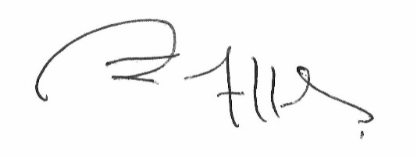

John Allen
Chief Ombudsman
National Preventive Mechanism

Appendix 1. Legislative Framework
In 2007 the New Zealand Government ratified the United Nations Optional Protocol to the Convention against Torture and Other Cruel, Inhuman or Degrading Treatment or Punishment (OPCAT).
The objective of OPCAT is to establish a system of regular visits undertaken by an independent national body to places where people are deprived of their liberty, in order to prevent torture and other cruel, inhuman or degrading treatment or punishment.
The Crimes of Torture Act 1989 (COTA) was amended by the Crimes of Torture Amendment Act 2006 to enable New Zealand to meet its international obligations under OPCAT.

Places of detention
Section 16 of COTA defines a “place of detention” as:
…any place in New Zealand where persons are or may be deprived of liberty, including, for example, detention or custody in…
(d) a hospital:
Ombudsmen are designated by the Minister of Justice as a National Preventive Mechanism (NPM) to inspect certain places of detention under OPCAT, including hospitals and the secure facilities identified above.
Under section 27 of COTA, an NPM’s functions include:
- to examine the conditions of detention applying to detainees and the treatment of detainees; and
- to make any recommendations it considers appropriate to the person in charge of a place of detention:
  - for improving the conditions of detention applying to detainees;
  - for improving the treatment of detainees; and
  - for preventing torture and other cruel, inhuman or degrading treatment or punishment in places of detention.

Carrying out the OPCAT function
Under COTA, Ombudsmen are entitled to:
- access all information regarding the number of detainees, the treatment of detainees and the conditions of detention;
- unrestricted access to any place of detention for which they are designated, and unrestricted access to any person in that place;
- interview any person, without witnesses, either personally or through an interpreter; and
- choose the places they want to visit and the people they want to interview.
Section 34 of COTA provides that when carrying out their OPCAT function, Ombudsmen can use their Ombudsmen Act (OA) powers to require the production of any information, documents, papers or things (even where there may be a statutory obligation of secrecy or non-disclosure) (sections 19(1), 19(3) and 19(4) OA). To facilitate the OPCAT role, the Chief Ombudsman has delegated authority to inspectors to exercise these powers on their behalf.

More information
Find out more about the Chief Ombudsman’s OPCAT role, and read their reports online: ombudsman.parliament.nz/opcat

More information about the United Nations Optional Protocol to the Convention against Torture (‘OPCAT’) and my National Preventive Mechanism (NPM) function can be found at: https://www.ombudsman.parliament.nz/what-we-can-help/monitoring-places-detention/why-ombudsman-monitors-places-detention.
A person who uses mental health and addiction services. This term is often used interchangeably with consumer or client. In the 2023 report, the term ‘patient’ was used to reflect the language used at the Ward at the time.
OPCAT Expectations Mental Health Services
OPCAT Report on an announced targeted inspection of Te Whare Awhiora, Ward 11, Gisborne Hospital, under the Crimes of Torture Act 1989. October 2023
I am empowered by section 27 of the Crimes of Torture Act 1989 to make recommendations for improving the conditions and treatment of detention applying to detainees and for preventing torture and other cruel, inhuman or degrading treatment or punishment in places of detention
If, after the first month of the order, a tangata whai ora does not consent to treatment, treatment can only be provided where it is considered to be in their best interests by an independent approved psychiatrist.
Consent to treatment must also be regularly reviewed with tāngata whai ora, with these reviews recorded.

