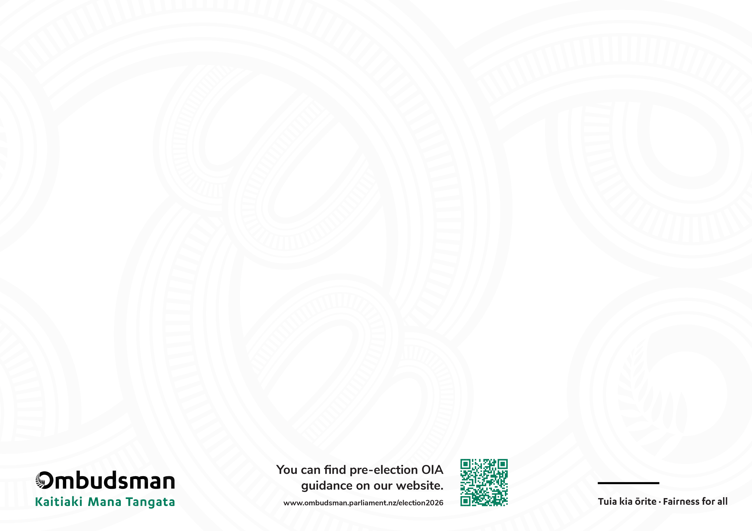

The OIA and you
Election 2026
Getting it right
September 2026

Requesters | Ministers (and agencies) | The Ombudsman
- You can request urgency. Ask for your request to be prioritised if the information will help people decide who to vote for.  - Provide context. Explain why you want the information urgently, to help the agency make a decision on whether your request will be prioritised.  - Be open to alternatives. Tell the agency you are open to receiving information in a different way – such as a summary – if it will enable quicker access.  - Be aware that not all information is official information. There is a difference between Ministerial official information – which is covered by the OIA – and party campaign information – which generally isn’t covered.  - If something’s not right, come to the Ombudsman quickly. If you’re unhappy with the response to your request, go to the Ombudsman as soon as you can, using our complaint form. | - Apply the public interest test. Consider if there is a public interest in releasing the information to help inform voters ahead of the election  - Consider proactive release. Make information available without waiting for requests.  - Be up front. Keep the requester informed - and consider requests for urgency properly.  - Do the right thing. Don’t let politics interfere with your decision-making on official information requests.  - Avoid any perception of ‘gaming’ the OIA. Here’s how:  - Acknowledge you have received a request – don’t ignore it.  - Don’t prioritise responses just because the request comes from a ‘friendly’ requester.  - Avoid excuses – if the information is ready to be released, then release it. Don’t hold up responses unnecessarily, including when sending an FYI for ‘no surprises.’  - Don’t overly rely on information soon being publicly available to refuse requests.  - Don’t extend the time to decide on the basis that a Minister is not available during the election period. Plan ahead to ensure availability.  - Don’t transfer requests to someone else to deal with when it should be you making the decision. | - Agencies and Ministers can expect the Ombudsman to ask: why can’t the information be released now? And, is release in the public interest?  - We will prioritise looking into complaints of high public interest and may investigate these urgently. This includes in cases where an agency or Minister’s office hasn’t yet given a substantive response to the requester.  - The Ombudsman will expect agencies to prioritise providing responses as soon as reasonably practicable when there is a delay complaint.

