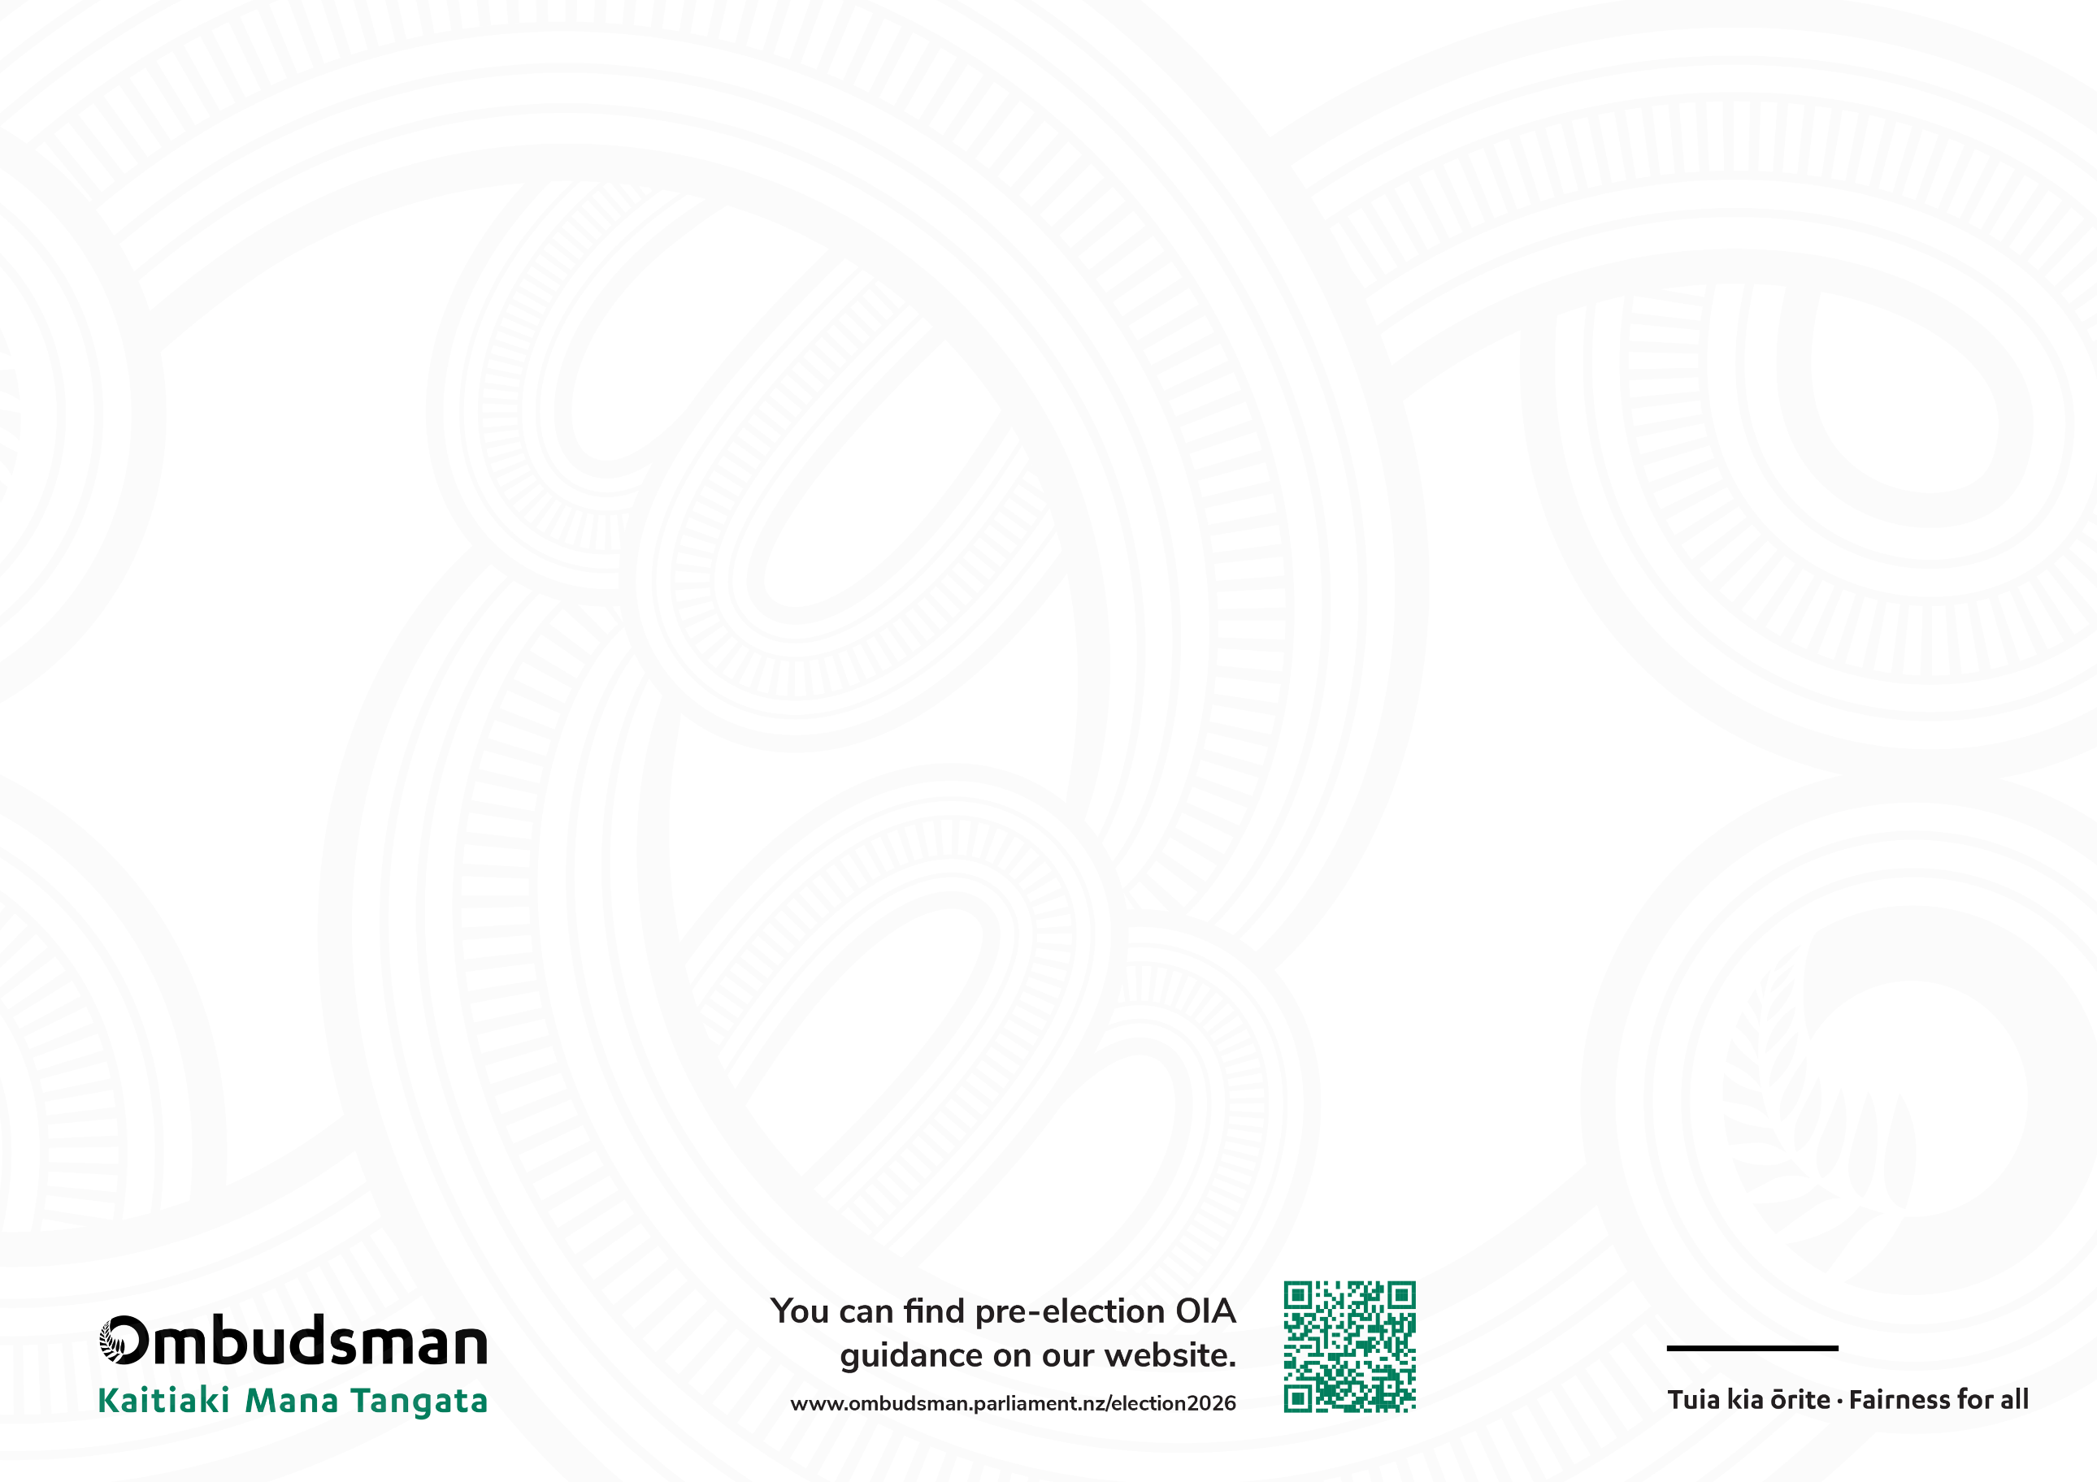

The OIA and you
Election 2026
Important advice for all users of the OIA
August 2026

Requesters | Ministers (and agencies) | The Ombudsman
- Be clear and specific in what you want to know from Ministers and their agencies. Avoid vague, or overly broad or complex requests, which risk delays or refusals. Take a look at our  Making Good OIA requests guide.  - Request information, not opinions.  The OIA only applies to requests for information held by a Minister or public sector agency. It will not apply if you want to ask a Minister to express an opinion, respond to assertions, or ask for political party positions  - If you use AI, check for accuracy. Check all AI generated drafts are clear, concise, and truly reflect the information you want. Check and remove any incorrect or outdated information. Keep an eye out for our Practical advice for requesters using AI guide, to be published on our website soon.  - Engage directly, if asked. Be open to talking to the Minister’s office, or agency, if they need to clarify your request. Keep a record of all your interactions.  - Be assured the public interest matters. You may not be entitled to everything you ask for but be assured there will always be a public interest in you having access to sufficient, reliable, information where that is necessary to inform your vote.  - Contact the Ombudsman quickly if you need help. If you disagree with the answer or decision, or you have had no response from the Minister or agency, contact us using our online complaint form. Tell the Ombudsman if it needs urgency. | Guiding principles  - Be lawful. As Ministers, uphold don’t break the law when you are seeking the public’s vote to be making our laws in the next three years.  - Be transparent. Don’t fear transparency. As Ministers, this is why you are in politics and why you are seeking to be re-elected. We see more ministers and agencies criticised, and lose public trust, for mishandling OIA requests than releasing information.  Be ready  - Prepare early. Set up systems and staff now. Campaigning is not an excuse for delayed OIA responses.  - Assist requesters. If it’s not clear what information is being requested, you are legally required to help clarify the request.  - Know the law. Apply the principle of availability. Decide as soon as possible; 20 working days is the absolute maximum, not the target. You can find the Ombudsman OIA guides, OIA calculators, and pre-election FAQs on our website.  - Search thoroughly. This includes private email accounts and messaging apps as well as record management systems and any AI tools used (including prompts and responses).  - Publish proactively. Don’t wait to be asked. If you spot a trend, or if people are requesting information on a similar topic, consider publishing it proactively.  Managing large requests  If a single requester sends large or repetitive requests in a short timeframe:  - Seek clarification and explain the administrative impact.  - Consider offering alternative formats (eg summaries, oral briefings) or charging. Only refuse as a last resort based on substantial collation or vexatiousness.  Complaint made?  - Engage early. Expect the Ombudsman to investigate under strict pre-election timeframes. Work with our office to resolve complaints quickly. | The Ombudsman and his staff are here  to help.  - Requesters. We have guidelines on how to use the OIA, and how the Ombudsman can help, on our website. This aims to help ensure you have timely access to sufficient and reliable information which may inform who you will vote for on 7 November 2026.  - Ministers’ offices and public sector agencies. We have guidelines, practical advice, and FAQs, on our website to help ensure you handle requests right first time.  - Requesters, Ministers and agencies. You can contact us and seek our advice. Call or email us. Our teams are ready to take complaints – use our online form.  - Monitoring the pre-election period. Our team is ready to respond swiftly to OIA complaints during the lead-up to the election. For transparency, each week we will publish the total number of Minister-related OIA requests we receive, what they're about (extension, refusal, delay), and the number of complaints closed.

