6 May 2026
Mr Miles Anderson
Chair
Primary Production Committee

Dear Chair

Ombudsman’s comments on Fisheries Amendment Bill
Thank you for the opportunity to submit on the Fisheries Amendment Bill (the Bill).
My staff were consulted by the Ministry for Primary Industries on certain aspects of the policy papers underpinning the Bill as they developed, where they appeared likely to impact on the application of the Official Information Act 1982 (OIA) to certain information, including on-board camera footage (‘camera recordings’) and catch and position reporting data.
Having now reviewed the Bill in its entirety, I wish to reiterate some of the observations made to the Ministry, and also to provide comments on aspects of the Bill that I have not seen previously.

Proposed carveout from the OIA and statutory secrecy obligations
Subpart 5 of the Bill proposes an array of new legislative measures. Clause 57 of the Bill proposes the insertion of new sections 227B to 227H which will, in the round:
- Permanently remove on-board camera recordings from the scope of the OIA;
- Prohibit the chief executive of the Ministry from disclosing camera recordings, except in certain limited circumstances (mainly for law or regulatory enforcement purposes, or to the owner or operator of the vessel in question). Even where disclosure appears to be permitted, the chief executive must first:
  - have regard to the privacy of natural persons shown in the footage, the commercial position of the supplier, as well as any other relevant considerations;
  - be satisfied that the request could not be satisfied by providing the information in another format (eg a written summary only) and that, having regard to the circumstances, disclosure is reasonable.
- In disclosing footage, the chief executive of the Ministry may impose conditions on the use, storage, and destruction of camera recordings. Such conditions are binding on the Crown and its employees, as well as any other party who receives the footage. Non-compliance with the conditions is an offence under the principal Act, and the non-compliant party is liable on conviction to a fine not exceeding $50,000.
- The Crown or any other person is protected from civil or criminal proceedings if it discloses footage in good faith pursuant to the proposed new section 227D.
I understand the public policy reason behind these proposed clauses is to limit the risk that fishing operators would be inhibited from providing camera recordings or other meaningful information, including information about adverse interactions with protected species, to the Ministry—notwithstanding their statutory obligations to do so—out of fear that adverse publicity of such footage under the OIA would detrimentally impact themselves as operators, or the fishing industry more widely.

Ombudsman’s observations on the proposed carve-outs
It appears to me that the draft Bill goes much further than is necessary to achieve the stated public policy aim.
The array of protective measures for such information proposed in the Bill—including removal of camera recordings from the scope of the OIA, but also bespoke provisions criminalising unauthorised disclosure of such footage caveats on disclosure to other government agencies even where that disclosure is for a proper purpose, and the imposition of binding conditions as well as punitive measures for non-compliance—are quite extraordinary, and go well beyond the protections afforded to information provided to other regulators. By way of example, I note:
- Section 130 of the Deposit Takers Act 2023 provides that the Reserve Bank may make an order prohibiting the publication or communication of certain information, including information was provided or obtained in connection to an inquiry, investigation, or other proceeding of the Bank under that Act. However, such an order must not exceed 3 years (section 130(4) of the Act), and the OIA will re-apply to the information at the end of the prohibition period.
- Section 44 of the Financial Markets Authority Act 2011 provides that the Financial Markets Authority may, at its own initiative or on application of any person, make an order prohibiting the publication or communication of information received in performing its functions, including information provided by informants. However, such an order only exists, at most, for the duration of the investigation, inquiry, or proceeding in question, and at its conclusion the OIA reapplies to the information at issue.
- Section 198 of the Civil Aviation Act 2023 permits the Minister to make an order prohibiting the publication or communication of information obtained by the Ministry while investigating whether to grant an authorisation for international carriage by air. However, any such order lapses no later than 20 working days after the Minister determines the matter, or when an application is withdrawn by the applicant, and the OIA re-applies to that information.
In this context, the proposed array of protections afforded to camera recordings under the Bill appears to be an extraordinary interference with the rights of New Zealanders. This is because:
- The OIA has long been recognised by the courts as being constitutional in nature, and the ability to request information under the OIA is one of the ways individuals may exercise their freedom to seek and receive information, enshrined in section 14 of the New Zealand Bill of Rights Act 1990. As a constitutional mechanism reflecting fundamental human rights, the OIA should not be departed from lightly. The Legislation Design and Advisory Committee observes that the OIA should apply to information held by government agencies ‘unless there are compelling reasons for [it] not to’. In circumstances where the OIA already protects the relevant interests, only an extraordinary harm to those interests would justify a permanent exclusion of information from the scope of the OIA.
- In the case of on-board camera footage, the OIA already provides mechanisms to withhold information where it is in the public interest to do so:
  - Section 9(2)(ba) of the OIA protects material held confidentially by government agencies, including footage and data that fishing operators are compelled by law to supply to the Ministry, where its disclosure would be likely to prejudice the future supply of same or similar information, or would be likely otherwise to prejudice the public interest. The need to protect on this basis is subject to the public interest test.
  - There may also be other reasons why it is necessary, on a case-by-case basis, to withhold camera recordings. This may include the need to protect the privacy of individuals shown in the footage; where disclosure of camera recordings would be likely to prejudice an operator’s commercial position (for instance, by revealing where they undertake their fishing activities or how they configure their equipment); or to prevent the disclosure or use of official information for improper gain or improper advantage. These reasons are subject to the public interest test.
  - Withholding camera recordings also may be justified where doing so is necessary to protect the maintenance of the law, including where court proceedings are in train or are reasonably in contemplation. This ground is not subject to the public interest test. Its application is often time-limited, and the need to withhold on this basis may disappear at the conclusion of an investigation or prosecution.
- In addition, I observe:
  - The OIA already permits the release of official information subject to conditions on the use, communication, or publication of information. While the ability to impose such conditions is not expressly provided for in the OIA, it is implicitly contemplated, as the parties upon whom conditions are imposed may ask the Ombudsman to review those conditions under the OIA;
  - The OIA already protects the Crown from liability for disclosure made pursuant to the OIA, where that disclosure is done pursuant to a request and in good faith.
  - Conversely, unauthorised disclosure of official information is already prohibited under the Summary Offences Act 1981, and corrupt use of official information is criminalised under the Crimes Act 1961.
  - Section 8 of the Fisheries Act states the legislation is intended to ‘provide for the utilisation of fisheries resources while ensuring sustainability’. The Act recognises the strong public interests both in the proper utilisation of the fishing resource, and in ensuring the intergenerational sustainability of the resource. Precluding the public even from requesting on-board camera footage means that the public cannot assure itself—either through release of information (including through the requester viewing it under conditions), or through the opinion of the Ombudsman that withholding it is justified because the public interest in disclosure of the raw footage does not outweigh the need to protect it—that the summary of the incident or event published by the Ministry under its current policy settings sufficiently reflects the reality of the event. The public is thereby deprived of an opportunity to satisfy itself that the Act is working as intended and that the Ministry is properly discharging its regulatory functions under the Act.
  - The Crown is already the final arbiter of what is ultimately released under the OIA. Even if an Ombudsman were to investigate the Ministry’s withholding of camera recordings on complaint under the OIA and was inclined to recommend release of it:
    - If the government believes that disclosure would prejudice the maintenance of the law, the Attorney-General may certify that the making available of the footage would be likely to prejudice the prevention, investigation, or detection of offences, and thereby preclude the Ombudsman from recommending its release, pursuant to section 31(b) of the OIA;
    - If the Ombudsman ultimately recommends release of information, including camera recordings, the Minister may ask Cabinet to resolve that the Governor-General, by Order in Council, direct the Ministry not to follow the Ombudsman’s recommendation, pursuant to section 32(1)(a) of the OIA.
In the circumstances set out above, the blanket carve-out from the OIA and other express prohibitions from disclosure appear unnecessary and excessive.
I therefore suggest the Committee consider recommending the removing of these clauses. The OIA has proven itself capable of affording sufficient protection to such information where it warrants protection, particularly where the Ministry otherwise has a regime for release of information—including information in reports on about adverse species interactions—which appears to meet in the public interest in all but the most extraordinary (and, thus far, solely theoretical) cases. The fact is that, while this regime has been in existence, there have been only a handful of complaints under the OIA, and the Ombudsmen have not been required to recommend the release of any camera recording in full.
I have already made it clear to the Ministry and Minister that, if the fishing industry needs an additional assurance that private or commercially sensitive material will be afforded proper protection under the OIA, I am prepared to publish guidance material to that effect, explaining how the OIA applies to such information and what grounds are available to protect information. I have already socialised an early version of such guidance with the Ministry during discussions on the policy underpinning the Bill. I have appended some thoughts on the possible contents of such guidance, should the OIA continue to apply to camera recordings.
By affording absolute protection to all camera recordings—including the footage the OIA already protects but also footage that the on-board camera footage OIA would not protect because its release is in the public interest—the Bill will achieve nothing more than preventing the public from assessing the most manifest of regulatory failures by the Ministry and/or the most egregious breaches of the law by the fishing industry. This appears to run contrary to the purposes of the OIA, as well as the purposes of the Fisheries Act noted above.
If the Committee considers it necessary for the legislation to provide more concrete assurances to the fishing industry about when and how that their camera footage is protected—including by ensuring that any conditions imposed by the Ministry on the subsequent use, communication, or publication of footage released under the OIA are sufficiently enforceable—section 227E(5) and F(3) could be modified to give effect to conditional release under the OIA, by making such conditions enforceable. This may strike a more appropriate balance between protection of the fishers’ interests in camera recordings while also providing a sufficient assurance to the public that New Zealand’s fisheries resource is being managed appropriately, and that its protected species are, in fact, being protected.
Thank you for considering my submission. I would like to speak to it, should the opportunity arise.
Yours sincerely

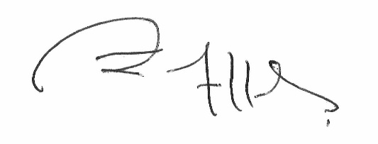

John Allen
Chief Ombudsman
Appendix: Outline of how the OIA will apply to on-board camera recordings

- Outline of how the OIA will apply to on-board camera recordings

The regulatory framework
The Ministry of Primary Industries (Ministry) administers the Fisheries Act 1996 (the Fisheries Act) and its regulations. The Act intends to strike a balance between providing commercial, recreational, and customary fishers access to public resources while also ensuring that New Zealand’s fish stocks are managed sustainably, including through imposing total allowable catch quota, mandatory reporting of catch and bycatch, and placement of fisheries observers on vessels. More recently, the Ministry introduced a digital monitoring regime for commercial fishing vessels, including electronic catch and position reporting, and on-board cameras. On-board camera footage (‘camera recordings’) collected by the Ministry primarily will be used to verify commercial fishing operators’ self-reporting of their catch. The footage could include any bycatch events, as well as incidental and unintended interactions with seabirds and marine mammals.

Video footage and the Official Information Act
The OIA applies to information held by public sector agencies, including the Ministry. The OIA applies to any camera recordings and associated data provided by fishing operators to the Ministry.
Protection of footage

Obligation of confidence – section 9(2)(ba)(i) of the OIA
Fishing operators are under legal obligations to supply the Ministry with camera recordings and information about catch, by-catch, and protected species interactions. The Ministry may come to hold thousands of hours of camera recordings, and it would be challenging for officials to review all footage against what was reported. To meaningfully use the information it holds, the Ministry is reliant on accurate self-reporting by fishing operators.
In these circumstances, sections 9(2)(ba)(i) of the OIA appears to be relevant. If the Ministry routinely released on-board camera footage, fishing operators may be inhibited from providing the Ministry with footage or with accurate information about what the footage reveals. This in turn would undermine the usefulness of camera recordings as a fisheries management tool.
Sections 9(2)(ba)(i) of the OIA are subject to the public interest test.

Other withholding grounds – sections 9(2)(a), 9(2)(b), 9(2)(k) of the OIA
There may also be other reasons why it is necessary, on a case-by-case basis, to withhold parts of camera recordings. This can include the need to protect the privacy of individuals shown in the footage where they are visible; where disclosure would be likely to prejudice an operator’s commercial position (for instance, by revealing where they undertake their fishing activities or how they configure their equipment); or to prevent the disclosure or use of official information for improper gain or improper advantage. These reasons are subject to the public interest test.

Maintenance of the law – section 6(c) of the OIA
Withholding footage may also be justified where it is necessary to protect the maintenance of the law, including where court proceedings are in train or are reasonably in contemplation. This ground is not subject to the public interest test. It is often time-limited, and the need to withhold on this basis may disappear at the conclusion of an investigation or prosecution.

Public interest in disclosure
The purpose of the Fisheries Act is to ‘provide for the utilisation of fisheries resources while ensuring sustainability.’ Utilisation is defined as ‘conserving, using, enhancing, and developing fisheries resources to enable people to provide for their social, economic, and cultural well-being’. Ensuring sustainability is defined as ‘maintaining the potential of fisheries resources to meet the reasonably foreseeable needs of future generations; and avoiding, remedying, or mitigating any adverse effects of fishing on the aquatic environment’.
There is a public interest in release of information to provide transparency that the Act is working as intended, and to promote the accountability of the Ministry and demonstrate the Ministry is properly discharging its regulatory functions under the Act.
The question under the OIA, however, is not whether a public interest in disclosure exists, but whether it outweighs the need to withhold the information requested.

The public interest may be met in other ways
The OIA recognises that where requested information is contained in a ‘document’, there are a number of ways an agency can make that information available.
The Ministry’s published guidance material, entitled Guidelines for the Release of Fisheries information, indicates that when the Ministry receives a request for footage, it:
- generally will be able to release summary information of the footage;
- may release still photos of an incident; and/or
- may allow a requester to inspect footage at a Ministry office.
Disclosure of this information by the Ministry may be sufficient to meet the public interest in release. Accordingly, there may be good reason to withhold a copy of the video footage itself.
Only in the worst cases, involving the most egregious regulatory failures or outrageous fishing operator behaviour, would the public interest require release of the camera recording in full, rather than the release of a written summary, still photos, and / or facilitating a viewing.
For illustrative purposes, a visualisation of this advice is as follows:
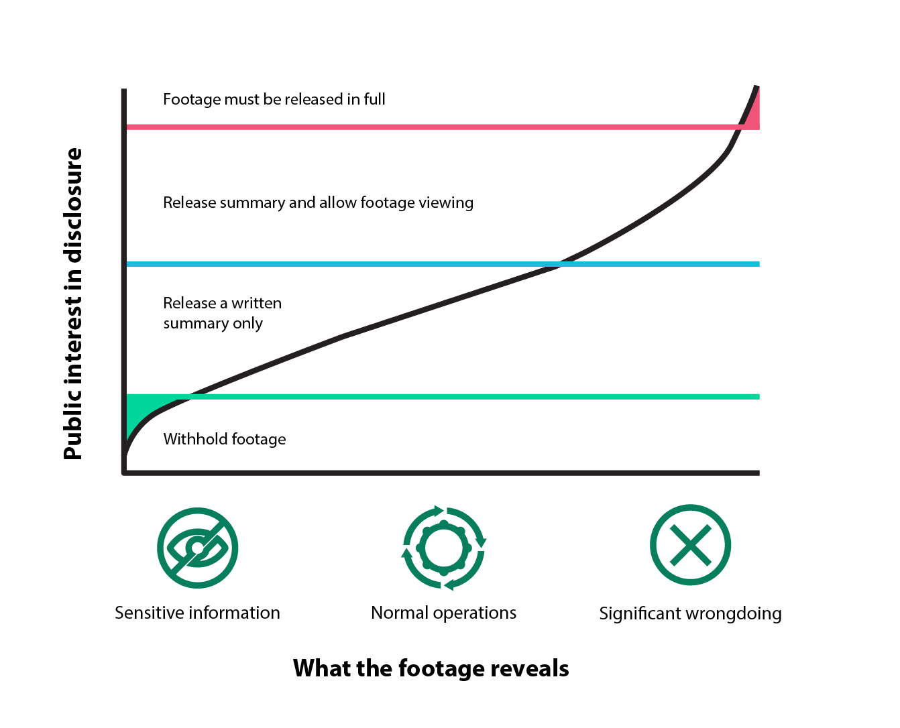

Proposed new section 227H.
Proposed new section 227C.
Proposed new section 227D.
Proposed new section 227D(2) and (3).
Proposed new section 227E and F.
Proposed new section 227E(3) and (4).
Proposed new section 227E(5) and 227F(3).
Proposed new section 227G.
Most recently in Kelsey v Mnister of Trade [2015] NZHC 2497.
Legislative Design and Advisory Committee, Legislation Guidelines 2021 edition, available at: https://www.ldac.org.nz/guidelines/legislation-guidelines-2021-edition
The Ministry inevitably will come to hold thousands of hours of on-board footage, and it would be challenging for officials to review all footage against what was reported. To meaningfully use the information it holds, the Ministry therefore is and would continue to be reliant on accurate self-reporting by fishing operators to identify incidents or adverse interactions with protected species. Were the Ministry to routinely released such footage, fishing operators may be inhibited from providing the Ministry with accurate information about what the footage reveals. This in turn would undermine the usefulness of on-board camera footage as a fisheries management tool.
Section 9(2)(a) of the OIA.
Section 9(2)(b)(ii) of the OIA.
Section 9(2)(k) of the OIA.
Section 6(c) of the OIA.
Section 28(1)(c) of the OIA.
Section 48 of the OIA.
Section 20A of the Summary Offences Act.
Section 105A of the Crimes Act.
Section 8 of the Fisheries Act. Utilisation is defined as ‘conserving, using, enhancing, and developing fisheries resources to enable people to provide for their social, economic, and cultural well-being’. Ensuring sustainability is defined as ‘maintaining the potential of fisheries resources to meet the reasonably foreseeable needs of future generations; and avoiding, remedying, or mitigating any adverse effects of fishing on the aquatic environment’.
Ministry for Primary Industries, On-board cameras for commercial fishing vessels, available at: https://www.mpi.govt.nz/fishing-aquaculture/commercial-fishing/digital-monitoring-of-commercial-fishing/on-board-cameras-for-commercial-fishing-vessels.
Section 9(2)(a) of the OIA.
Section 9(2)(b) of the OIA
Section 9(2)(k) of the OIA.
For more information on the public interest, see our guide Public interest, June 2017, available at: http://www.ombudsman.parliament.nz/system/paperclip/document_files/document_files/1991/original/public_interest_june_2017.pdf?1498081531.
The definition of ‘document’ in section 2 of the OIA includes: any information recorded or stored on a computer or other device as well as any information derived from such; and any ‘photograph, film, negative, tape, or other device in which visual images are embodied’ so as to be capable of being reproduced.
For more information, see the section ‘Deciding how to release information’ in the Ombudsman’s guide, The OIA for Ministers and agencies, 14 May 2019, available at: https://www.ombudsman.parliament.nz/resources/oia-ministers-and-agencies-guide-processing-official-information-requests.
Ministry for Primary Industries, Guidelines for the Release of Fisheries Information, May 2023, available at: https://www.mpi.govt.nz/dmsdocument/34803-Guidelines-for-Release-of-Fisheries-Information.
Section 16(2) of the OIA states that where a requester has specified how they wish to receive information, the agency must make it available in that way unless doing so would, among other things, prejudice the interests protected by sections 6, 7 or 9 of the OIA (and, in respect of interests protected by section 9, there is no countervailing public interest).

