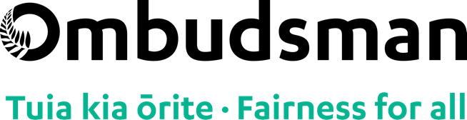
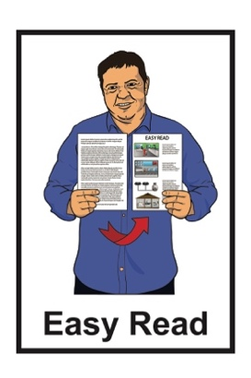

Reporting serious wrongdoing at work (whistleblowing)
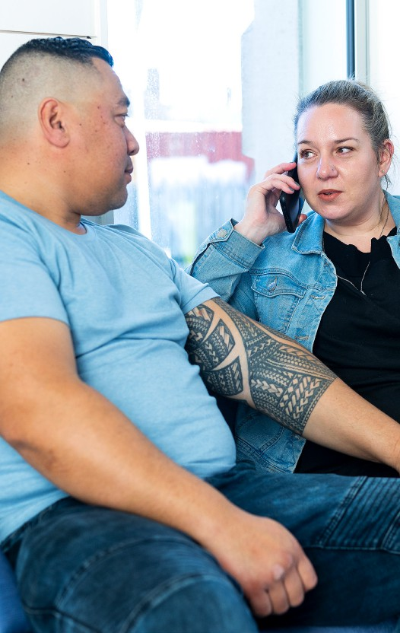

Published: April 2025

Before you start

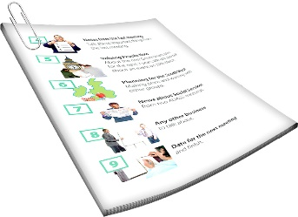
This is a long document.

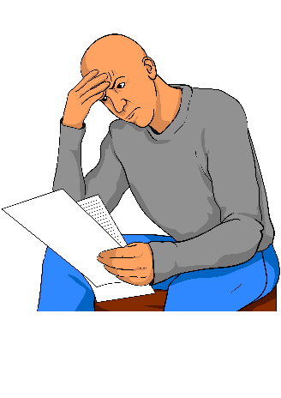
It can be hard for some people to read a document this long.

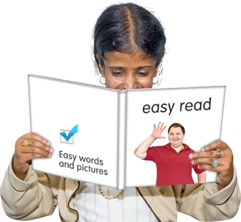
Some things you can do to make it easier are:
read it a few pages at a time
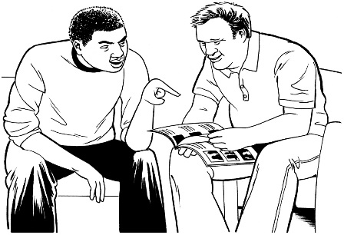
set aside some quiet time to look at it
have someone read it with you to support you to understand it.

What is in here

Page number:
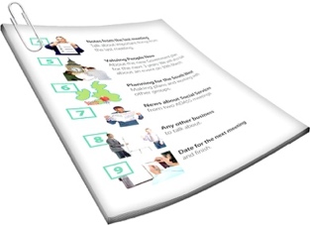

About this document 4
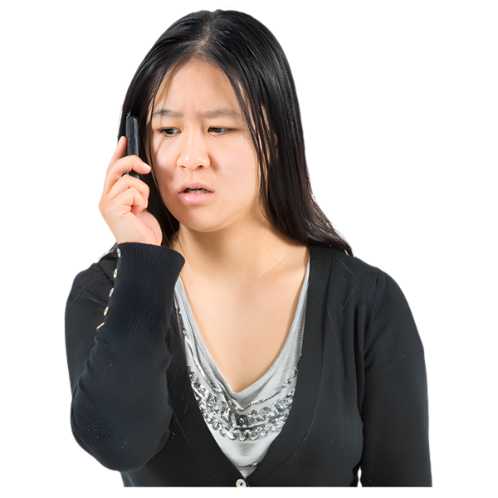
What is serious wrongdoing? 7

What is a whistleblower? 10

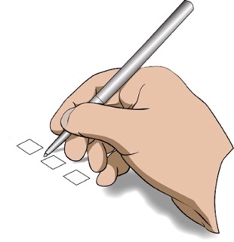
How are whistleblowers protected?... 17


How to make a
protected disclosure 22

How the Ombudsman
can help whistleblowers 24
Page number:

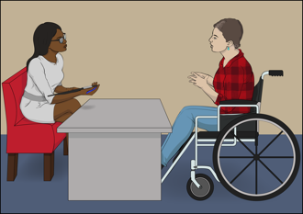
Places you can make a
protected disclosure to 27
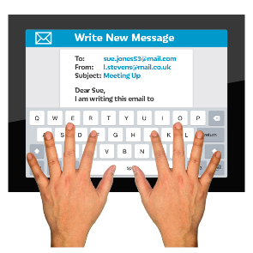

Contact the Ombudsman 29

About this document

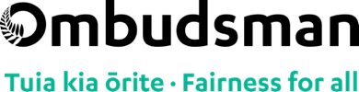
This Easy Read document is from the Ombudsman.


The Ombudsman works to make sure all New Zealanders are treated fairly by the Government.

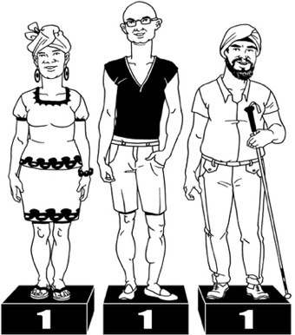
Being treated fairly means being treated:
with respect
the same way as everybody else.

This includes whistleblowers.


Whistleblowers are people:
who see something very bad happen at work
and
tell somebody about it so that it will stop happening.

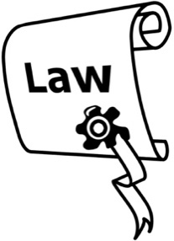
This document tells you:
about the law that protects whistleblowers
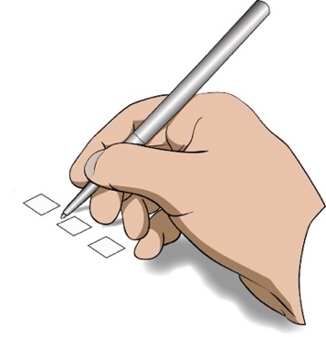
what to do if you want to report something bad that has happened at your work.

This document also tells you:
places you can go to report something bad that has happened at work
how the Ombudsman can help you.

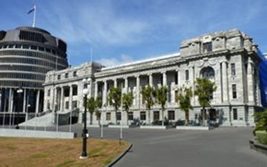
Laws:
are rules made by the Government
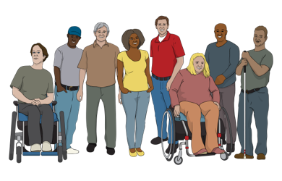
and
have to be followed by everyone.

The Ombudsman may be able to help you if you decide to be a whistleblower.

Where it says we / our this means the Ombudsman.

What is serious wrongdoing?

Serious wrongdoing is when something very bad happens at work.


Serious wrongdoing can be things like:
somebody breaking the law:
  - like hurting somebody
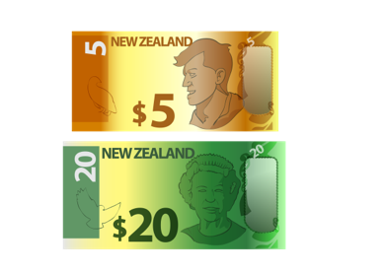
  - stealing something
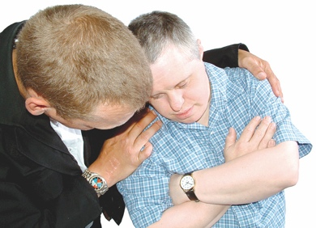
putting a person / people in danger
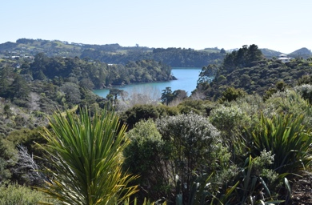
putting the environment in danger
putting the people of New Zealand in danger.

Serious wrongdoing can also be things like:
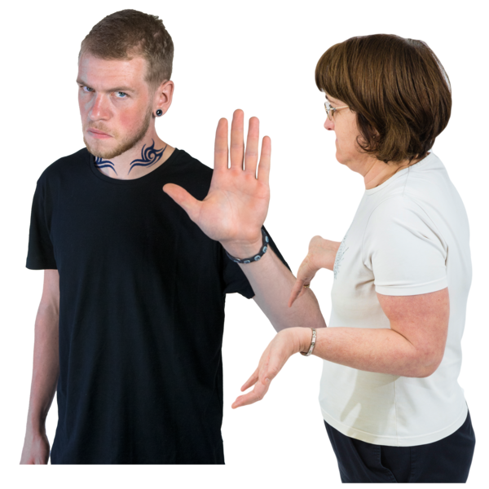
using public money or things for the wrong reason
very bad behaviour by a
public official such as discrimination.

A public official is somebody who works for a government agency.

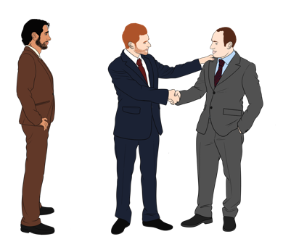
Discrimination is when people are treated unfairly because of things like being:
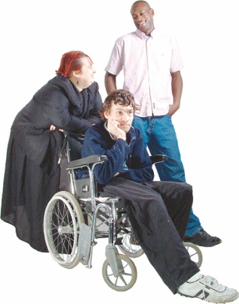
Māori
a man / woman / someone of another gender
disabled.

Whistleblowers report serious wrongdoing.

This means whistleblowers:

tell somebody about what has happened
and
are protected for speaking up.

What is a whistleblower?

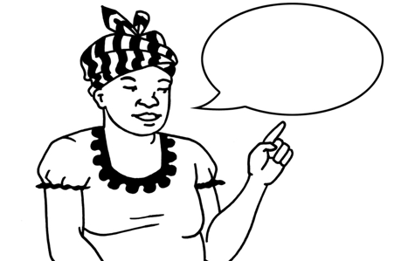
Whistleblowers report serious wrongdoing at their work.

Reporting serious wrongdoing is called making a
protected disclosure.


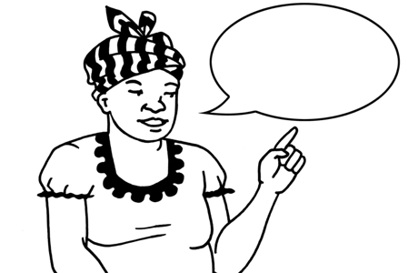
A protected disclosure is when you:
do not get in trouble or lose your job for telling someone about something very bad that has happened at work.

There is a law that says how to keep whistleblowers safe.

This law is called the Protected Disclosures Act 2022.
This Protected Disclosures Act 2022:
- became a law on 1 July 2022

supports whistleblowers to report serious wrongdoing at work
keeps whistleblowers safe
supports organisations to look into reports about whistleblowing.

This law:
- tells whistleblowers the right authority to report serious wrongdoing to
- allows whistleblowers to report to the right authority at anytime rather than having to go to their employer first.

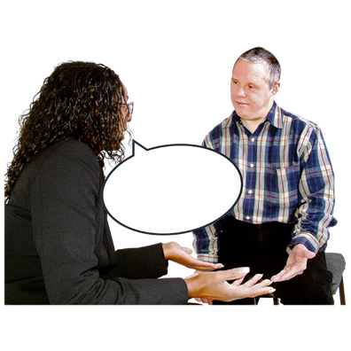
Here authority means the places you can go to make a protected disclosure.

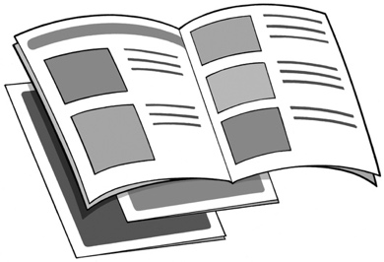
Go to page 27 to find out a list of some of these authorities.

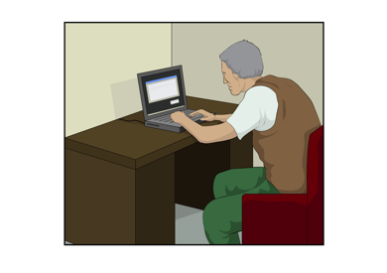
You can make a protected disclosure if you:
are working at a place
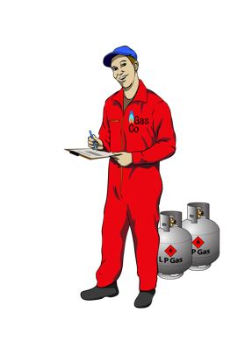
used to work at a place
are doing some work for a place as a contractor
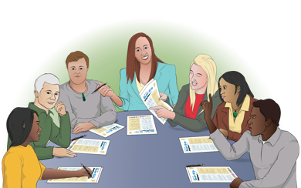
do volunteer work at the place
are a board member.

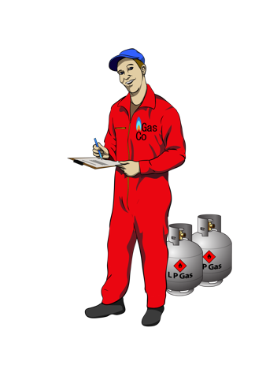
A contractor is someone who works for a place for a set or short time.

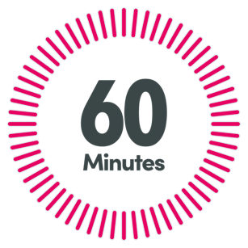
The organisation / company pays a contractor:
by the hour
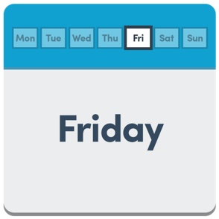
or
for each day
or
when the work is finished.

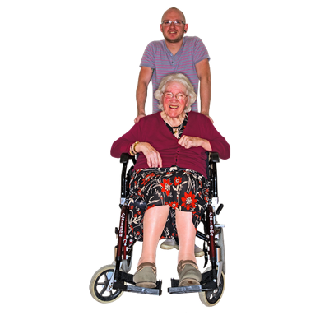
Here volunteer means you:
say yes to doing some work at a place
and

do not get money for the work you do.

Board member means somebody is a member of a board of directors.

It is called a board for short.

A board is a group of people at an organisation who:

- know a lot about the
organisation / company
- make decisions for the organisation / company.
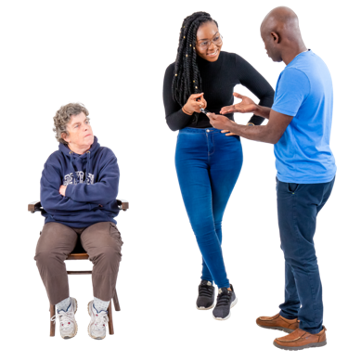
Protected disclosures can be made about a:
public organisation like a government agency

private organisation.

A private organisation is a business that is not run by the Government.

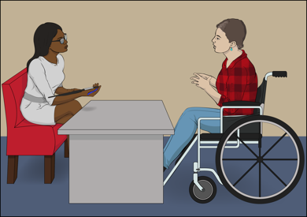
The Ombudsman can help whistleblowers to make a protected disclosure.

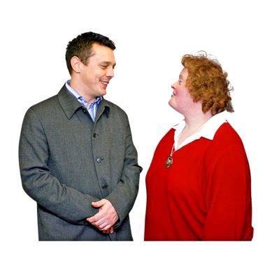
The Ombudsman can also tell organisations the best way to deal with protected disclosures.

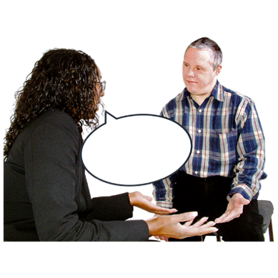
You can talk to us if you want to find out more information about:
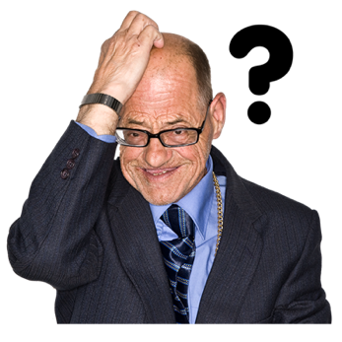
- what it means to be a whistleblower
- if you are worried about making a protected disclosure.


The Ombudsman will tell you:
what you need to think about
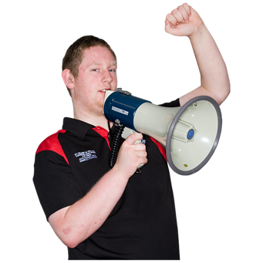
how to speak up
which authority to speak to.

Go to page 29 to find out all the ways you can contact the Ombudsman.

How are whistleblowers protected?

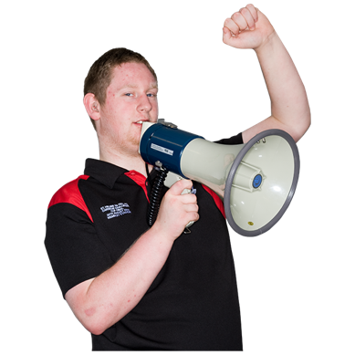
The Protected Disclosures Act protects whistleblowers.

When you make a protected disclosure:
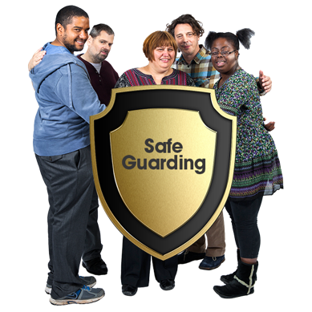
the organisation you work for cannot punish you
you will not be punished for speaking up
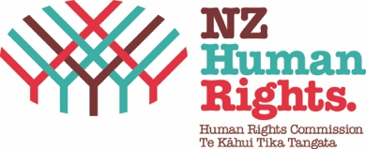
you are protected by the
Human Rights Act law.

Here punish means whistleblowers can not:
- get into trouble at work

- lose their job

- go to jail.

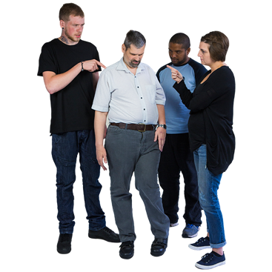
You are protected if your protected disclosure:
is about serious wrongdoing at an organisation


is about serious wrongdoing by an organisation
you believe what you are reporting is very likely to be true
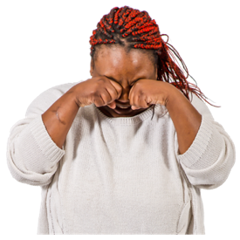
you are very worried about what is happening.

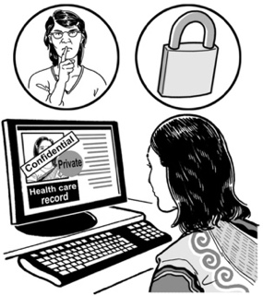
Keeping your
information private


Most of the time if you make a protected disclosure your:
name will be kept secret
information will be kept secret.

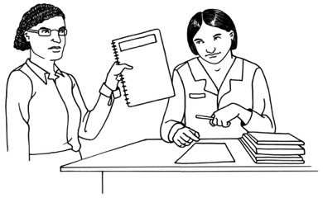
You can say yes to your information being shared with someone else.

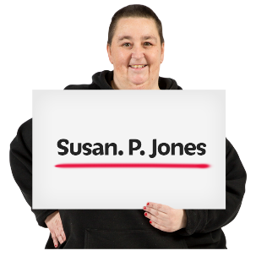
Sometimes your name will have to be shared.

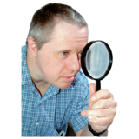
This will happen if it:

is needed for an investigation to find out more about what has happened
stops something bad happening to somebody
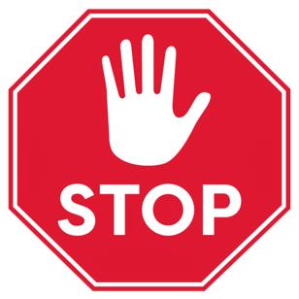
stops something bad happening to the envirionment
is needed for an investigation to take place by an agency that protects the law like:
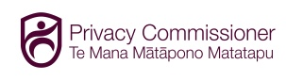
- Health and Disability Commissioner
- Privacy Commissioner
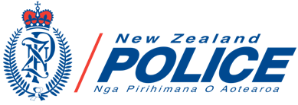
- NZ Police.
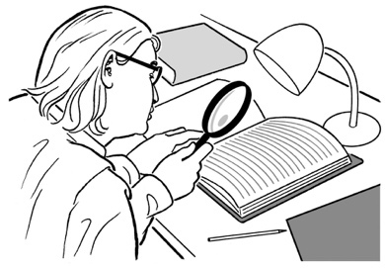
An investigation means looking into something like a complaint to find
out what has happened.

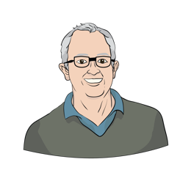
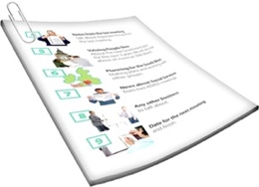
You will be told if your information has to be shared.
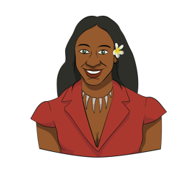

How to make a protected disclosure
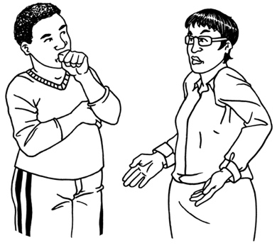

There are different ways you can make a protected disclosure or report serious wrongdoing.

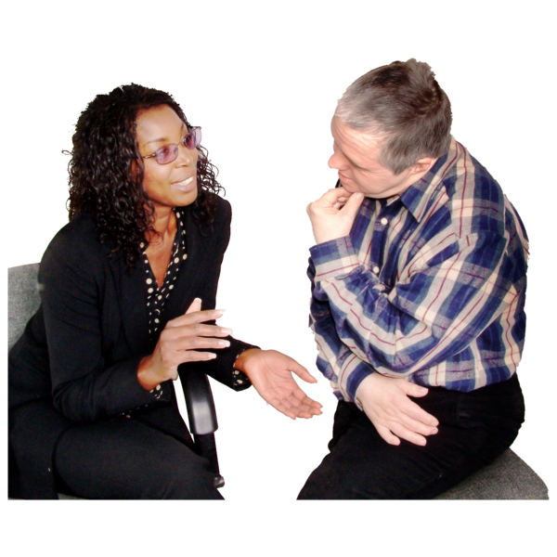
You can report it to the person in charge of your organisation.

You do not have tor report it to the person in charge of your organisation if you do not want to.

All government agencies must have a process for dealing with serious wrongdoing.

You can also report it to an authority that handles protected disclosures like the Ombudsman.

The Ombudsman can help you to find the right place.

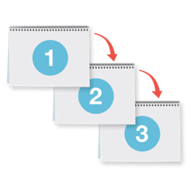
You will need to follow the right process for reporting serious wrongdoing at your work.

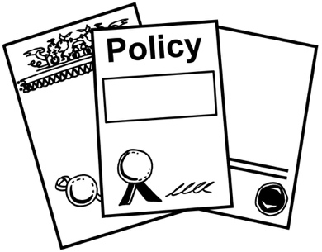
Here a process means the right way to make a protected disclosure at your work.

Go to page 27 to find out the places you can make protected disclosures to.

How the Ombudsman can
help whistleblowers

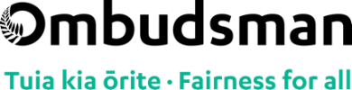
The Ombudsman is independent of the Government.


Independent of the Government means:

we do our own work
the Government does not tell us how to do our work.

The Ombudsman can do things to help whistleblowers like tell you:
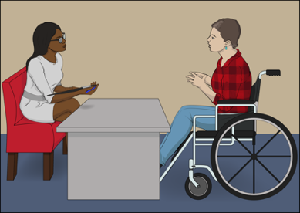
- what protected disclosures are
- how to make a protected disclosure
- who you can make protected disclosures to about serious wrongdoing
- what each authority does
- how you can be kept safe if the place you work at tries to punish you for being a whistleblower.

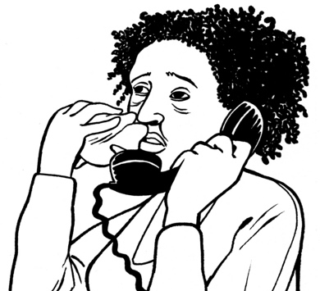
You can contact the Ombudsman if you:

- think serious wrongdoing has happened at your work
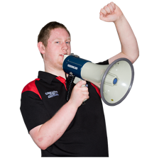
- want to find out more information about whistleblowing
- want to find out the right authority to make a protected disclosure to.

The Ombudsman services are:
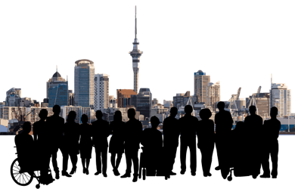
free to all New Zealanders
available to all New Zealanders.

Places you can make a
protected disclosure to

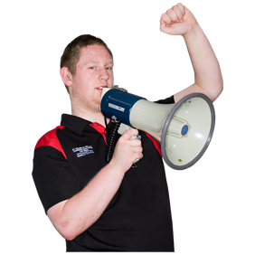
Here are some of the places a whistleblower can make a protected disclosure to:
Ombudsman
Health and Disability Commissioner
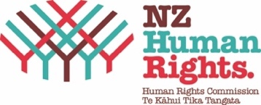
Human Rights Commissioner
NZ Police Commissioner
Privacy Commissioner.

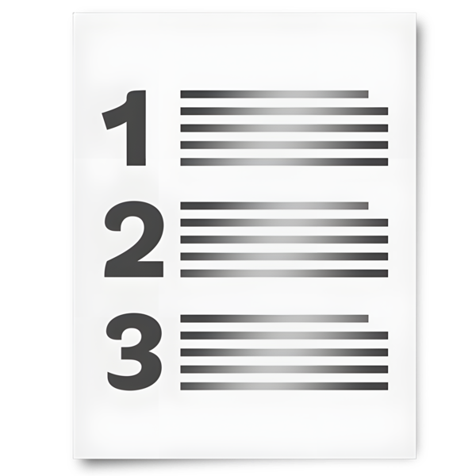
The Protected Disclosures Act includes a list of examples of which authority to go to for different types of wrongdoing.
Contact the Ombudsman:
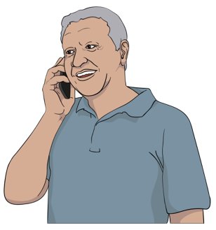
to find out the right place you can make a protected disclosure to
for more information about being a whistleblower.

Go to page 29 to find out all the ways you can contact the Ombudsman.

Contact the Ombudsman
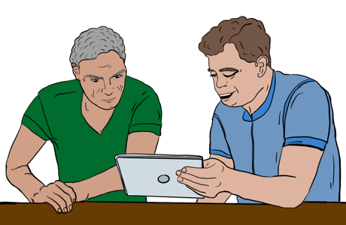

You can contact the Ombudsman by:

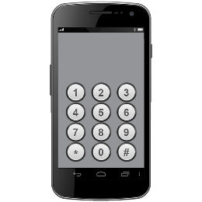
Free phone on:

0800 802 602

Email at:

info@ombudsman.parliament.nz

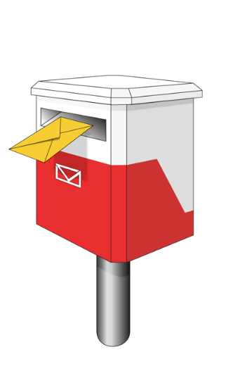
You can also send a letter to:

Office of the Ombudsman
PO Box 10152
Wellington 6143

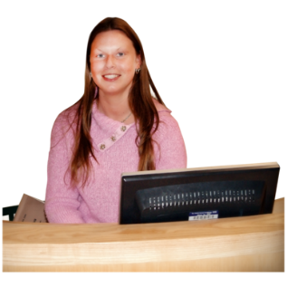
You can also visit our office.

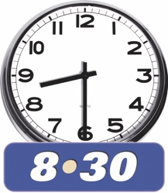
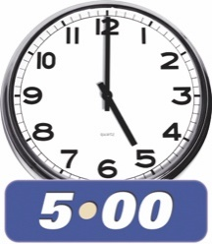
Our offices are open:

- 8:30 am to 5 pm
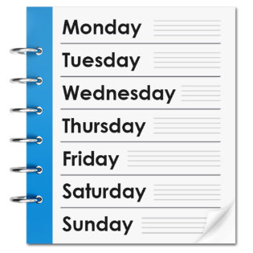
- Monday to Friday.

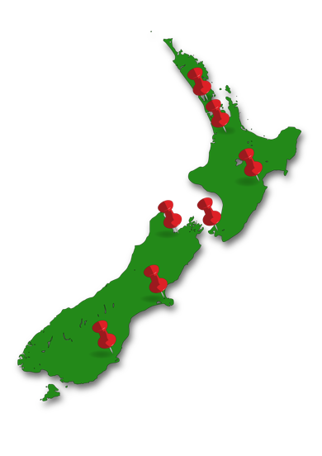
There is an office in Auckland:

Level 6
55 – 65 Shortland Street.

There is also an office in Wellington:

Level 7

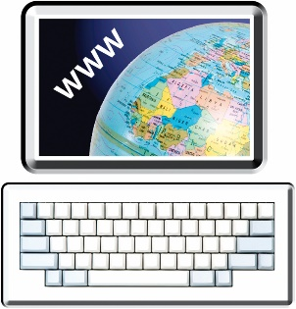
70 The Terrace.
You can find more information about the Office of the Ombudsman on their website at:

www.ombudsman.parliament.nz


Facebook
@ombudsmannz


X

@Ombudsman_NZ

Scan this QR code to link you to:
- more information about the Ombudsman
- information in accessible formats
- information in other languages.
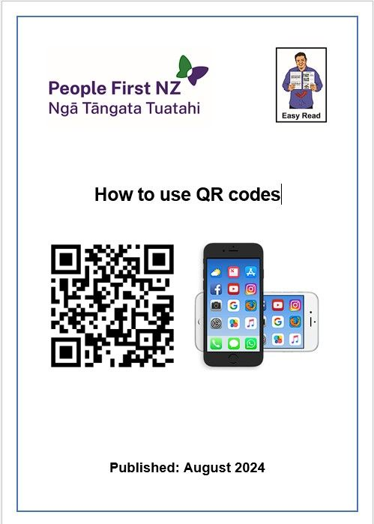
You can read how to use a QR code here:

www.peoplefirst.org.nz/easy-read-library/resource/how-to-use-qr-codes


If you find it hard to use the phone the New Zealand Relay service is for people who are:
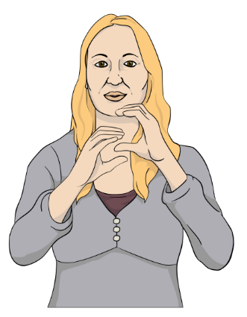
- Deaf / hard of hearing
- deafblind
- speech impaired / find it hard to talk.

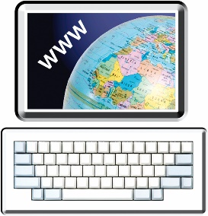
You can find out more about the
New Zealand Relay service on their website at:

www.nzrelay.co.nz
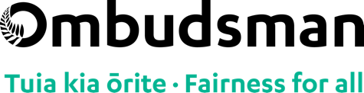
This information has been written by the Office of the Ombudsman.

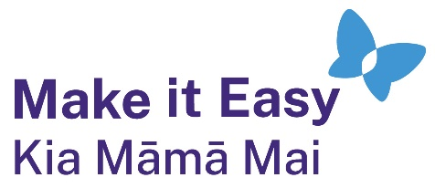
It has been translated into Easy Read by the Make it Easy Kia Māmā Mai service of People First New Zealand Ngā Tāngata Tuatahi.
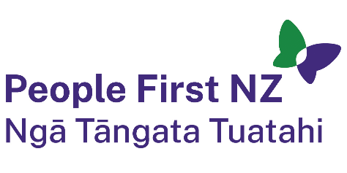
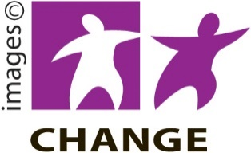
The ideas in this document are not the ideas of People First New Zealand Ngā Tāngata Tuatahi.

Make it Easy uses images from:


- Changepeople.org


            - Photosymbols.com

- SGC Image Works
- Huriana Kopeke-Te Aho

- T. Wood.

All images used in this Easy Read document are subject to copyright rules and cannot be used without permission.

