


Official information requests

Tono mō te pārongo ōkawa


Published: April 2025

Before you start


This is a long document.


It can be hard for some people to read a document this long.


Some things you can do to make it easier are:
read it a few pages at a time
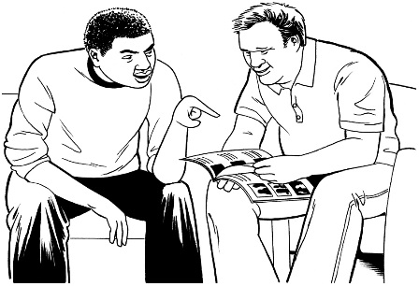
set aside some quiet time to look at it
have someone read it with you to support you to understand it.

What is in here

Page number:


About this document 4
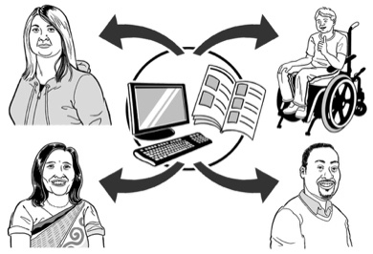
What is official information? 7

How to get official information 12


What happens when you make a request 16


How the Ombudsman
can help you 20

Page number:

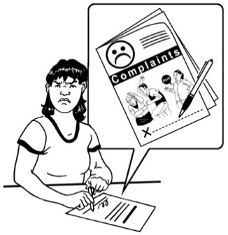
How to make a complaint
to the Ombudsman 23


What happens when the
Ombudsman gets your complaint 26

Contact the Ombudsman 32

About this document

This Easy Read document is from the Ombudsman.


The Ombudsman works for fairness for all New Zealanders.


Fairness means being treated:
with respect
the same way as everybody else.


The Ombudsman works to make sure New Zealanders are treated fairly by the Government.


The Ombudsman can look into complaints about government agencies.


This includes complaints about official information.


This document tells you:
what official information is

how to ask for official information
how to make a complaint to the Ombudsman about your request for official information.

Official information is information the Government has that is not about you.

Where it says we / our this means the Ombudsman.

What is official information?


Anyone can ask for official information.

The laws about getting official information are the:
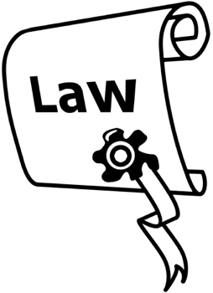
Official Information Act 1982
Local Government Official Information and Meetings Act 1987.

Laws:
are rules made by the Government
and
have to be followed by everyone.
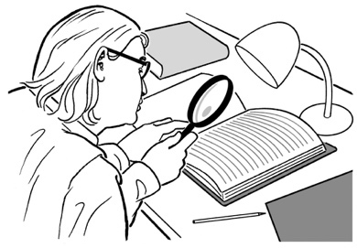
These laws about official information tell government agencies things like:
what to do about requests for official information

how long they have to get the information to you.
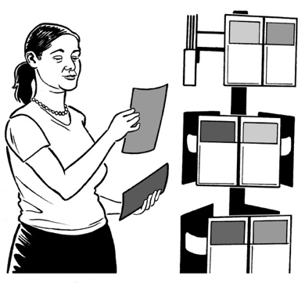

If you ask for official information it should be given to you.




It will not be given to you if one of the laws says there is a good reason not to.


You can ask for official information from:
Ministers such as the Minister for Disability Issues

government departments like the Department of Internal Affairs
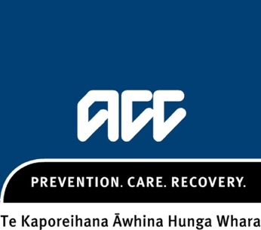

government ministries such as Ministry of Disabled People – Whaikaha
organisations owned by the state like ACC

education for adults like:
- universities

- wānanga
- polytechnics
- institutes of technology.

You can also ask for official information from:
local councils

school boards
the Police.


You cannot ask a government agency for your personal information.

Personal information is information about you.


If you want to get personal information you need to ask the Privacy Commissioner.


Contact the Privacy Commissioner for more information:
Freephone: 0800 803 909


Freephone means it will not cost you any money.

How to get official information

You need to make an official information request to a government agency.


A request is when you ask for something.


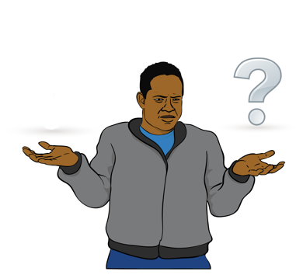
Make sure:
you are clear about the information you want


you know which government agency has the information you want.


If you are not sure call the government agency to find out if they have the information you want.

You need to request the official information from:
the government agency that has the information you want
and
not from the Ombudsman


Government agencies have to:
follow the laws about official information
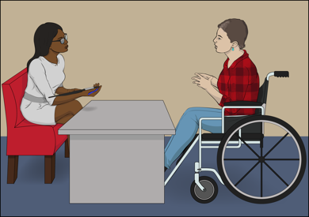
support you with your request where they can.


The best way is to write your complaint in:
an email

or
a letter
or

a text message.

You can also request the information:
by visiting the government agency
calling the government agency.

The government agency may still ask you for the request in writing.

In your request it is good to name the laws that government agencies have to follow such as:
- Official Information Act

- Local Government Official Information and Meetings Act.

This can help to make sure the right rules are applied.

Keep a copy of all the information you have about your request.


This means you have a record of your complaint.

Here a record means you have the information to show someone that you have made a complaint.

What happens when you
make your request?

The government agency will tell you that it has received your request.


It has 20 working days to get back to you.

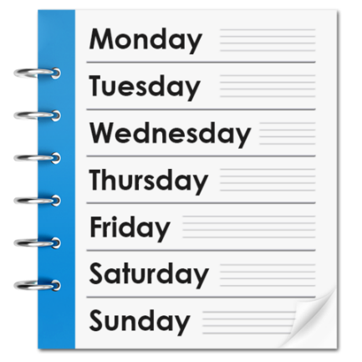

A working day includes days
Monday to Friday.

A working day does not include:

Saturday
Sunday
public holidays.


Sometimes the government agency will take longer than 20 days to get the information you need.

They must tell you:

if it will take longer than 20 days
why it is taking longer.


If you are unhappy with this you can contact the Ombudsman.


If you need your information very fast you:
need to let the agency know

and
tell them why you need the information quickly.

Sometimes you may have to pay some money to get official information.


This is because it may take a long time to find all the information you have asked for.

The government agency will tell you if it is going to cost money.

The amount it costs must be fair.

You can use the online calculator to find out the latest date for a response to your request at:

www.ombudsman.parliament.nz



The government agency will give you:
all of the information you asked for
or
some of the information you
or


none of the information you asked for.

The government agency has to tell why it did / did not give you the information you asked for.

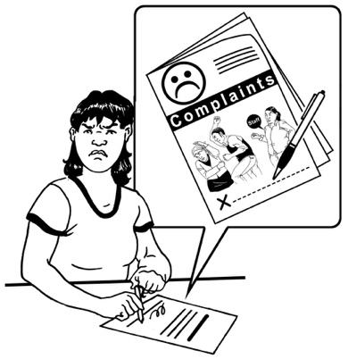
You can complain to the Ombudsman if you are not happy with what the government agency has done about your request.

How the Ombudsman can help you

The Ombudsman can help to resolve complaints.



Resolve means to sort out a problem.

These complaints may be about:
not getting the official information you have asked for

waiting more than 20 days to get the official information you have asked for.


not being given the information in a way that you can:
- read
- understand.
These complaints may also be about:


- the government agency is charging too much money to give you the official information
- the government agency telling you how you should use the official information.

The Ombudsman may ask the government agency to release all or some of the information to you as a result of your complaint.

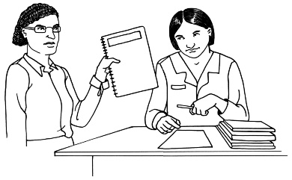
Here release means to give you the official information you have asked for.


In most cases the agency must release the information when asked to by the Ombudsman.

The Ombudsman is independent of the Government.


Independent of the Government means:
we do our own work
the Government does not tell us how to do our work.


The Ombudsman services are:
free to all New Zealanders

available to all New Zealanders.

How to make a complaint
to the Ombudsman


Get all the information you have about your complaint including:

- a copy of the written information in your request including things like:

- emails

- letters
- text messages

- details of the information you gave in your spoken complaint
tell us why you are unhappy.

You should also include information about what the government agency said about your request if you have it.

If you have not got a reply to your request tell us:
where you made the request
and
when you made the request.

Here are the ways you can make a complaint to us:

fill out the form on our website:
www.ombudsman.parliament.
nz/get-help-public

call us to make a complaint.
email your complaint to us
write a letter to us.


Go to page 32 to find the contact information for the Ombudsman.

You can contact the Ombudsman if you have any questions before you make your complaint.

What happens when the Ombudsman
gets your complaint?


We will tell you when we get your complaint.

The Ombudsman will look at your complaint to decide if we:


can investigate your complaint.
cannot investigate your complaint.


Investigate means looking into something like a complaint to find
out what has happened.


A complaint about official information does not always have to be investigated.


Sometimes the Ombudsman can sort out your complaint by talking:
to you

and
the government agency.

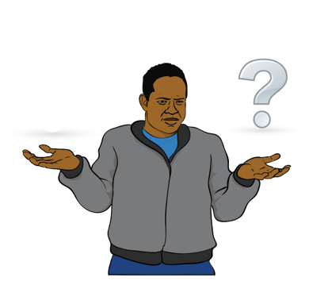
If we cannot investigate your complaint we will tell you why we cannot investigate it

If the Ombudsman decides to investigate your complaint we will talk to:
you
and
the government agency you have made your official information complaint about


The Ombudsman will look at any information the agency does not want to give you.


The Ombudsman will ask you for more information if we need it.


We will tell you what is happening about your complaint.

At the end of the investigation the Ombudsman can decide if the agency:

acted in a reasonable way / the right way

or
acted in an unreasonable way / the wrong way.


If the Ombudsman thinks the agency did the right thing we will:
- tell you.
- give you a chance to respond

If the Ombudsman thinks the agency did the wrong thing we can suggest they give you:
all of the information you have requested
some of the information you have requested.


Sometimes a complaint is about a problem a lot of people may have with a government agency.

If we think it will be useful for other people to know about your complaint we may publish information about it.

We will tell you first.

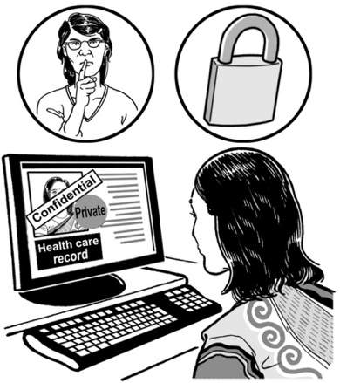
The Ombudsman will protect your privacy.

This means we will not give your personal information to somebody else.

Contact the Ombudsman


You can contact the Ombudsman by:

Free phone on:

0800 802 602

Email at:

info@ombudsman.parliament.nz

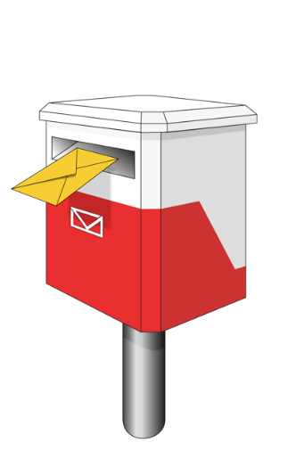
You can also send a letter to:

Office of the Ombudsman
PO Box 10152
Wellington 6143


You can also visit our office.

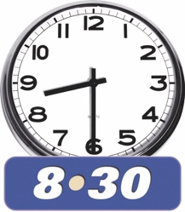
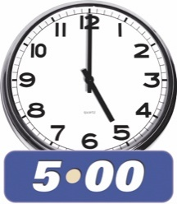
Our offices are open:

- 8:30 am to 5 pm
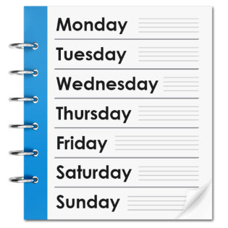
- Monday to Friday.

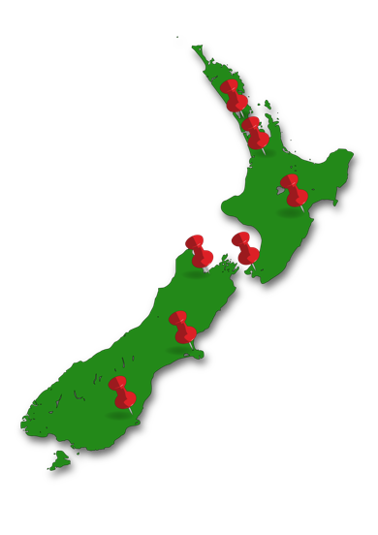
There is an office in Auckland:

Level 6
55 – 65 Shortland Street.

There is also an office in Wellington:

Level 7

70 The Terrace.

You can find more information about the Office of the Ombudsman on their website at:

www.ombudsman.parliament.nz


Facebook
@ombudsmannz


X

@Ombudsman_NZ

Scan this QR code to link you to:
- more information about the Ombudsman
- information in accessible formats
- information in other languages.
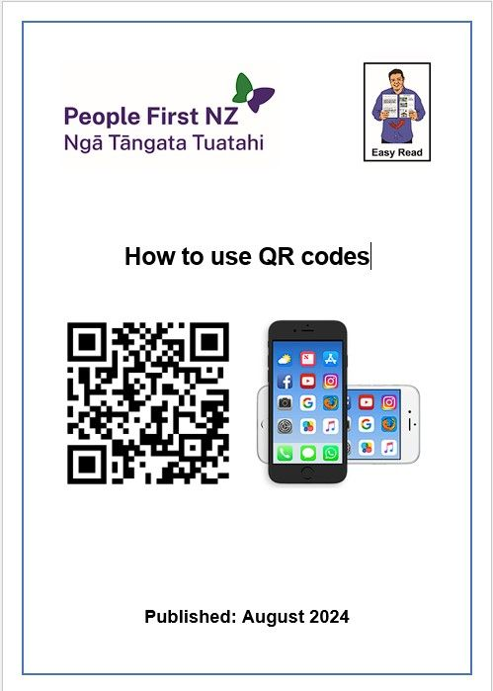
You can read how to use a QR code here:

www.peoplefirst.org.nz/easy-read-library/resource/how-to-use-qr-codes


If you find it hard to use the phone the New Zealand Relay service is for people who are:

Deaf / hard of hearing
deafblind
speech impaired / find it hard to talk.


You can find out more about the
New Zealand Relay service on their website at:

www.nzrelay.co.nz

This information has been written by the Office of the Ombudsman.


It has been translated into Easy Read by the Make it Easy Kia Māmā Mai service of People First New Zealand Ngā Tāngata Tuatahi.


The ideas in this document are not the ideas of People First New Zealand Ngā Tāngata Tuatahi.

Make it Easy uses images from:


- Changepeople.org


            - Photosymbols.com

- SGC Image Works
- Huriana Kopeke-Te Aho

- T. Wood.

All images used in this Easy Read document are subject to copyright rules and cannot be used without permission.

