OPCAT Report
Report on an unannounced inspection of Upper Prison (Arohata)
Under the Crimes of Torture Act 1989
22 March 2018
Peter Boshier
Chief Ombudsman
National Preventive Mechanism ISSN 2538-1296

PLEASE NOTE: Some elements may differ slightly from the PDF / printed version to allow for accessibility, and page numbers may also differ from the PDF / printed version.
Contents
Foreword 5
Facility facts (Upper Prison) 7
Region 7
Operating capacity 7
Acting Prison Director 7
Regional Commissioner 7
Last inspection 7
The Visit 8
Visit methodology 8
Inspection criteria (the criteria) 8
Evaluation 9
Criterion 1: Treatment 11
Assessment 11
Use of Force 11
Management Unit 11
At-Risk Unit (ARU) 12
Disciplinary procedures/ misconducts 14
Personal safety 14
Criterion 2: Lawful custody 16
Assessment 16
Reception and induction 17
Information for prisoners on arrival 17
Criterion 3: Decency, dignity and respect 19
Assessment 19
Equality and Diversity 19
Staff/prisoner relationships 19
Clothing for prisoners 20
Cultural support 20
Chaplaincy 21
Facilities 21
Regime 21
Double-bunking 22
Sanitary conditions 23
Food 23
Consultation with prisoners 24
Criterion 4: Health and wellbeing 26
Assessment 26
Health care 26
Criterion 5: Protective measures 28
Assessment 28
Complaints process 28
Voluntary Segregation 28
P119 (prison shop) 29
Criterion 6: Purposeful activity and transition to the community 30
Access to work/education and programmes 30
Library facilities 32
Outdoor exercise – leisure activities and gymnasium 32
Visits 33
Access to telephones/mail 34
Case Management (including Right Track) 35
Guided Release/Out of Gate services 35
Acknowledgements 36
Appendix 1. Corrections’ general comments and comments on recommendations that were accepted 37
General Comments 37
Comments on recommendations that were accepted 38
Appendix 2. The inspection team 49
Appendix 3. Upper Prison – prisoner population 50
Appendix 4. Questionnaire feedback 53
Section 1: About you 53
Section 2: Respect and dignity 54
Section 3: Complaint process 54
Section 4: Safety 55
Section 5: Health 56
Section 6: Purposeful Activity 58
Appendix 5. Overview of OPCAT – Prisons 60

Foreword
In July 2015, the Upper Prison at Rimutaka Prison was closed as new, more suitable facilities became available for prisoners across the estate. In February 2017, due to the significant increase in the women’s muster at Arohata Prison, Corrections reopened two of Rimutaka Upper Prison’s four wings.

In May 2017, two of four wings were operational at the Upper Prison, accommodating 56 women. At the time of the five-day inspection in September 2017, all four wings were open to accommodate up to 112 women. All wings were occupied.

It was clear that the Upper Prison was facing considerable challenges. Resources, infrastructure and staffing were under pressure, which was compounded by the geographical separation from the administrative centre at Tawa. Day-to-day operating systems and arrangements for dealing with women were not fully embedded. Reception and induction processes were poor, and information for foreign prisoners was not available. Significant delays in access to personal property were a source of frustration for many women, reflected in the growing number of complaints and misconducts.

Cells were small, and ancillary services appeared to be operating close to capacity. Communal space was limited and not fit for purpose. Acoustics on the wing were poor and recreation yards were dirty. The 8am to 5pm unlock regime was more suited to managing high-security prisoners, yet the Upper Prison housed women with low security classifications. The quality of hot food was good, but meals were not being served at usual or appropriate meal times.

The Upper Prison was in the process of establishing a new health facility. Delivery of health services was reasonably good overall, although staff levels were impacting on some areas, particularly the development of health promotion activities. There was no structured analysis of health needs, and consequently no prisoner health development plan to determine priorities and identify emerging trends. Dental treatment provision was insufficient.
There was an acknowledged lack of meaningful and constructive activities. Programmes and employment were not well established, with nearly two-thirds of women not engaged in any purposeful activities.

A lack of programmes and planned progression was having a detrimental effect on prisoner motivation, although staff were actively engaged with the women. Privacy was often compromised due to a lack of appropriate meeting rooms. Social work and counselling services were stretched and religious and cultural support limited. There was little evidence of the implementation of the Department’s newly released Women’s Strategy.

Opportunities for maintaining family contact were inadequate. Inspectors found that many women did not receive visits due to distance and associated travel costs, and the earlier lock up prevented most women from telephoning their children after they had finished school. Limited visits combined with restricted access to telephones and an unsatisfactory mail system affected the women’s mental wellbeing. Audio Visual Link provision for family contact was underdeveloped.

Inspectors returned to the facility in October 2017 to review progress. I was disappointed to learn that a consultation process had begun on a proposal to double-bunk cells in the Upper Prison due to continuing muster pressures. Without significant improvements and additions to the current inadequate regime, I do not consider the facility suitable for double-bunking; even with these additions and improvements, the Upper Prison would be suitable for double-bunking only as a temporary measure.

In mid-February 2018, the Department informed my Office that a final decision has been made to double-bunk 44 cells at the Upper Prison.

The Upper Prison currently faces considerable challenges, and priority must be given to establishing a purposeful regime for these low-security prisoners to alleviate distress and boredom.
We will continue to monitor and report on the Upper Prison’s progress with follow-up visits.

Peter Boshier
Chief Ombudsman
National Preventive Mechanism
Back to contents

Facility facts (Upper Prison)
Originally called Wi Tako, the facility was established in 1919, on the Trentham site now known as Rimutaka. In 1967 the prison was completely rebuilt and referred to as the ‘top camp’ or ‘upper jail.’ It operated as a minimum security, adult first-offenders institution until the 1980s. At that time, it was converted to a regional prison for male prisoners of varying security levels.
Use of the Upper Prison for male offenders was discontinued in 2015. It was reopened in February 2017 to cater for the overflow of women prisoners from Arohata Prison and from the wider female prison estate, as a result of the rapidly increasing prison muster.
Currently the Upper Prison is a satellite site of Arohata Women’s Prison. It is located on the grounds of Rimutaka Men’s Prison, but entirely separate from the male site and located within a separate perimeter fence.
The Upper Prison does not have a functional At-Risk Unit (ARU) or Separates area. Women who are assessed as being at risk, or who are placed on voluntary or directed segregation, are transferred to Arohata. Other essential support services such as the Receiving Office are located in Arohata Prison.

Region
The Upper Prison is part of Corrections’ Lower North Region.

Operating capacity
112

Acting Prison Director
Vivien Whelan

Regional Commissioner
Paul Tomlinson

Last inspection
This is the first unannounced inspection of the facility in its current role as part of a women’s estate.
An informal visit was conducted by Inspectors in May 2017. At that time, the facility accommodated approximately 56 women, and only two wings were operational.

The Visit
In 2007, the Ombudsmen were designated as one of the National Preventive Mechanisms (NPMs) under the Crimes of Torture Act (COTA), with responsibility for examining and monitoring the general conditions and treatment of detainees in New Zealand prisons.
From 18 to 22 September and on 30 October 2017, a team of five Inspectors (to whom I have delegated authority to carry out visits to places of detention under COTA) visited the Upper Prison at Rimutaka. Since February 2017, the Upper Prison has been an extension of Arohata Women’s Prison.

Visit methodology
At the start of the visit the inspection team (the team) met with the Acting Prison Director before inspecting the site. On the first day of the inspection there were 96 prisoners in the Upper Prison. A breakdown of the prisoner population is attached at Appendix 2.
A voluntary, confidential and anonymous prisoners’ questionnaire was distributed. The questionnaire is designed to capture prisoners’ experiences and perceptions. The team spoke with prisoners individually and in groups to explain the purpose of the questionnaire. Results of the questionnaire are just one of several sources of evidence used and triangulated by Inspectors to help them form judgements about the Upper Prison.
Ninety-two questionnaires were distributed to the women and 75 were returned (82 percent). A copy of the questionnaire and responses is at Appendix 4.
On the second day of the inspection, five focus groups were facilitated by Inspectors, with 64 women participating (67 percent of the prison population).

Inspection criteria (the criteria)
I have developed six core criteria, each of which describes the level of treatment and conditions a prison is expected to achieve. These criteria are underpinned by a series of indicators that describe the evidence Inspectors look for to determine whether there is anything that could be considered to be torture, or cruel, inhuman or degrading treatment or punishment, or any other issues impacting adversely on detainees. The list of indicators underpinning the criteria is not exhaustive, and does not exclude an establishment demonstrating that the criteria has been met in other ways.
This was the fourth full inspection undertaken using my new inspection criteria. These will be trialled and refined as necessary. On completion of the trial we will publish the final inspection criteria on the Ombudsman’s website.
The following criteria were examined during the six-day inspection:
Criterion 1: Treatment
Criterion 2: Lawful custody
Criterion 3: Decency, dignity and respect
Criterion 4: Health and wellbeing
Criterion 5: Protective measures
Criterion 6: Purposeful activity and transition to the community

Evaluation
Inspectors assess information resulting in evidence-based findings, using a number of different techniques. These include:
- obtaining information and documents from the Department of Corrections and the Prison;
- conducting a questionnaire with prisoners;
- shadowing and observing Corrections Officers and other specialist staff as they perform their duties within the Prison;
- interviewing prisoners, visitors and staff on a one-to-one basis;
- conducting focus groups with prisoners and staff;
- observing the range of services delivered within the Prison at the point of delivery;
- inspecting a wide range of facilities impacting on both prisoners and staff;
- attending and observing relevant meetings impacting on both the management of the Prison and the future of the prisoners, such as case conferences and advisory panels;
- reviewing policies, procedures and performance reports produced both locally and by the Department of Corrections; and
- observing early morning and evening routines.
Follow-up visits will be made on future dates as necessary to monitor implementation of the recommendations.
Back to contents

Criterion 1: Treatment

Expected outcomes: treatment
The Prison has robust oversight measures and standards in place for preventing torture, and other cruel, inhuman or degrading treatment or punishment. Such protection measures are subject to regular review by senior managers to ensure standards are consistently achieved.
The Prison takes all reasonable steps to ensure the safety of all prisoners. Prisoners live in a safe and well-ordered environment where positive behaviour is encouraged and rewarded. Unacceptable behaviour is dealt with in an objective, fair and consistent manner. There is a regular and responsive consultation with prisoners about their safety.

Assessment

Use of Force
The use of force in prisons is regulated by section 83 of the Corrections Act 2004. Under section 83 physical force can only be used in prescribed circumstances and if reasonably necessary. The level of force used must be reasonable. Where force has been used prisoners must be examined by a registered health professional.
Inspectors examined the paperwork for the five instances where the use of force was reported in the period 17 March to 29 August 2017. The five incidents involved seven prisoners; consequently seven separate sets of paperwork should have been completed (two prisoners had been included on the same paperwork).
Use of force paperwork was incomplete due to missing names, dates and times. Not all incident reports, follow-up or summary reports had been completed. At-risk reviews and the staff debrief were missing in some instances.
The new Custodial Systems Manager (CSM), who had been in the post for two days, informed Inspectors that new processes would be developed to ensure the robust recording of documentation.
A previous OPCAT recommendation that ‘A more robust system should be put in place to ensure all segregation and use of force paperwork is completed to the required standard’ was made to the Prison Director, Arohata Prison in December 2015 and repeated in May 2017. The Department accepted both recommendations.

Management Unit
At the time of the inspection, the Acting Prison Director informed the team that the Management Unit cells in the Upper Prison were decommissioned and a prisoner placed on segregation would be transferred to Arohata Prison.
Inspectors visited the Management Unit at Arohata Prison and noted that it could accommodate eight prisoners undergoing a period of segregation or cell confinement. The cells used for cell confinement (as punishment following a misconduct hearing) had no power outlets. Cells were self contained, with a toilet and shower. Other facilities and arrangements served to minimise interactions with prisoners in the unit; for example, access to a small exercise yard, and feeding slots built into cell doors through which meals were passed into the cell. All cells were monitored on camera, including the unscreened toilets.
While the Unit (and cells) were clean, tidy and free from graffiti, it was cold and austere with little natural light and no communal space. There was no provision for staff to be rostered in the Unit under the site roster; therefore it was largely unmanned except when staff were deployed to issue meals and for routine checks. The constraints of the physical environment and staffing arrangements made it difficult for staff to engage purposefully and meet the needs of the often vulnerable women being detained there. Changes in the use of management and separation will be necessary to reflect the Department’s new Women’s Strategy, particularly to avoid triggering trauma reactions due to social isolation.
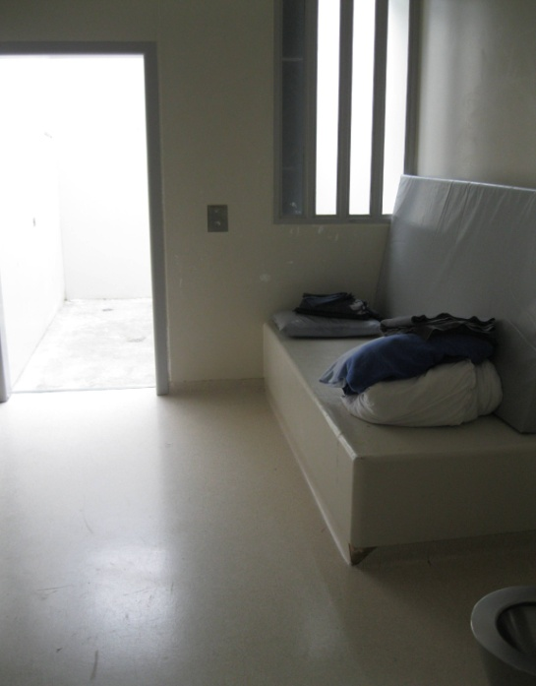 |  | 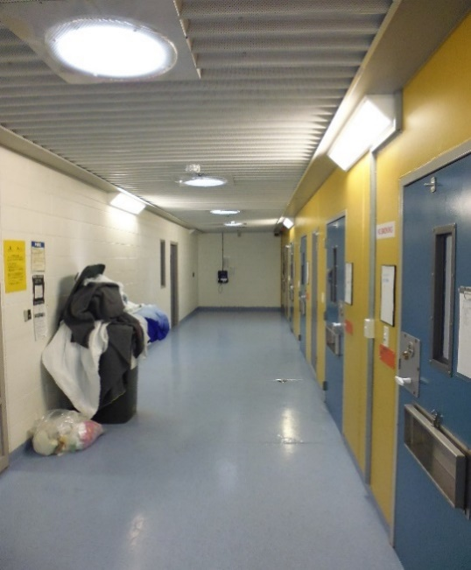
Figure 1: Management cell, Arohata |  | Figure 2: Management Unit, Arohata

At-Risk Unit (ARU)
At the time of the inspection, the ARU cells in the Upper Prison were decommissioned. If a prisoner was considered to be at risk of harm or requiring a period on segregation, she would be transferred to Arohata Prison.
The ARU at Arohata Prison had three safe cells and one round room. The safe cells had toilet and hand washing facilities, and a table and chair. The round room was an empty room with a mattress on a raised plinth. Rooms had limited natural light and little fresh air. Prisoners were constantly monitored by CCTV, even when using the toilet, which was unscreened. The camera feed was displayed on TV monitors in the ARU office and master control. A consequence of Corrections’ policy for toilets in ARU cells to be unscreened is that prison staff (and others) have the ability to observe prisoners, either directly or through camera footage, undertaking their ablutions or in various stages of undress. I consider this amounts to degrading treatment or punishment for the purpose of the Convention Against Torture. However, I note that Schedule 2 Part C of the Corrections Regulations provides that cells for prisoners at risk of self-harm must have ‘no privacy screening or other barrier that prevents a full view of the cell from the door window’, which constrains Corrections’ ability to fully address this issue.
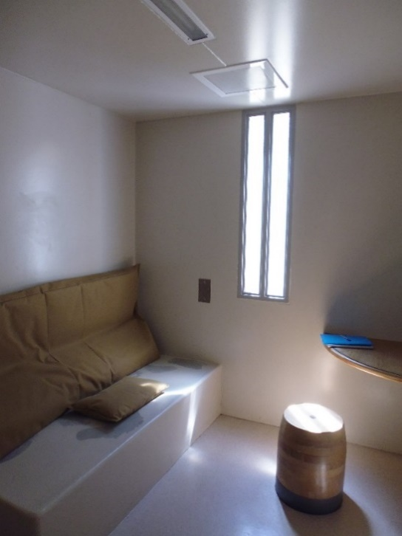 |  | 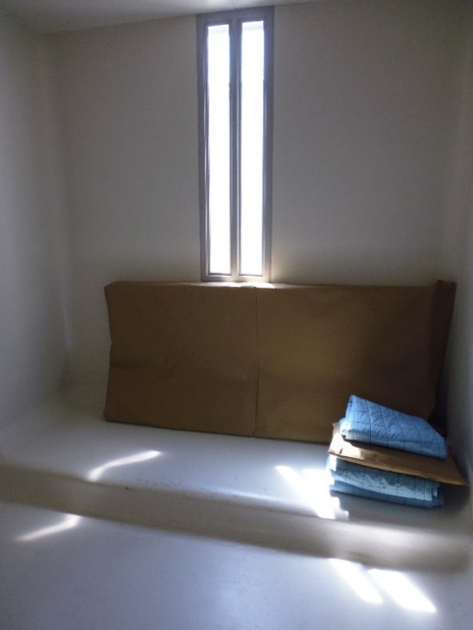
Figure 3: Safe cell, Arohata ARU |  | Figure 4: Round room, Arohata ARU
Corrections set up a comprehensive working party in May 2017 to address balancing the privacy rights of prisoners with the need for prisoner observation, and have engaged with the Office of the Ombudsman to this end. While the working group undertook some initial work in this area, it has since highlighted the need for a specific project led by the Corrections Chief Custodial Officer. It is expected this will identify potential options around prisoner privacy and any expected funding required. This project is expected to report back in August 2018.
I consider that amending Schedule 2 Part C should be considered in the context of this project.

Disciplinary procedures/ misconducts
At the time of the inspection there had been 77 incidents of misconduct in the Upper Prison since it opened in February 2017. Analysis indicated that the initial, low rate of misconducts was consistent with the low-security classification of the prisoners (56 prisoners/18 misconducts). As the population increased and all four wings became operational, the rate of misconducts rose steeply (95 prisoners/59 misconducts). This may have been as a result of increased prisoner boredom and frustration at the lack of purposeful activities or a change in the type of prisoners being sent to the Upper Prison.
Senior managers reported that there appeared to be inconsistency in some Corrections Officers’ approach to maintaining discipline. Some staff members placed prisoners on misconduct, in circumstances which could be better managed by warning the prisoner in the first instance and noting marginally unacceptable behaviour on the prisoner’s file.

Personal safety
When asked if they had ever felt unsafe in the Prison, 38 percent of questionnaire respondents reported that they had. When asked if they currently felt unsafe, 16 percent of respondents said ‘yes’. When asked if they’d been assaulted in the Prison, 16 percent of respondents said they had and 73 percent said they had reported the assault.
Inspectors did not observe any forms of violence, intimidation or bullying amongst the women during the initial inspection and were encouraged to note that staff had a visible presence in the four wings. There did not appear to be a visible gang presence in the wings. However, at the time of the follow-up visit (30 October 2017) Inspectors observed, and were informed by prisoners and staff that there were a number of women self isolating and eating meals in their cells. The dining areas had become more territorial with some women being intimidated and ‘stood over’ by small groups of women.
Recommendation – treatment
- I recommend that:
  - A more robust system should be put in place to ensure use of force paperwork is completed to the required standard. This is a repeat recommendation.
  - Measures be undertaken to better protect the privacy of prisoners in the Management Unit and ARU and when they are naked, partially naked, or undertaking their ablutions. This is a repeat recommendation.
  - The Prison Director establish the circumstances and locations where prisoners feel unsafe, and address the findings in an arena that includes prisoner representation.

Corrections accepted recommendations 1a and 1c.
Corrections partially accepted recommendation 1b and stated:
We acknowledge balancing the privacy of prisoners and ensuring vulnerable prisoners are safely managed in our care is difficult. Whilst we endeavour to ensure the privacy of all prisoners is maintained, there are instances where vulnerable prisoners are observed for their own safety. To address this, a National Working Group (established last year) will consider changes to provide vulnerable prisoners with greater personal dignity and privacy. I understand your office is aware of the work underway around this.
Update: February 2018 – While the working group undertook some initial work in this area, it has since highlighted the need for a specific project led by the Corrections Chief Custodial Officer to consider other factors such as current international practice, Justice Sector partner practice and also engage with Mental Health facilities. It is expected this will identify potential options around prisoner privacy and any expected funding required. This project is expected to report back in August 2018.
Back to contents

Criterion 2: Lawful custody
Expected outcomes: lawful custody
Within each court there is a strategic focus on custody issues, which promotes the safe, secure and decent delivery of escorts, custody and court requirements.
The Prison complies with administrative and procedural requirements of the law. There is a structured process to provide every prisoner with all necessary information about their rights, responsibilities and entitlements, the prison’s expectations of them and the operating and administrative arrangements pertaining to their detention.
Prisoners transferring to and from prison are safe and treated decently. On arrival prisoners are safe and treated with respect. Risks are identified and immediate needs met before prisoners move to their allocated units.

Assessment
The Upper Prison held sentenced women with security classifications ranging from low-medium to minimum. There were no women on remand, although information on the Corrections Business Reporting and Analysis (COBRA) system incorrectly indicated that small numbers of remand prisoners were accommodated in the Upper Prison.
Prisoners were being detained lawfully. No women raised concerns regarding their sentence calculations or their security classification.
All women accommodated in the Upper Prison were processed through the Receiving Office (RO) at Arohata Prison (Tawa). Although transfers to Wellington were scheduled in advance, escort vehicles from Auckland often arrived later in the day, which placed additional pressure on RO staff to carry out essential procedures before the women were driven to the Upper Prison.
At the time of inspection, no additional staff had been allocated to the RO to manage the increase in muster and subsequent transfers. Experienced staff reported that the interim measures put in place were inadequate to deal with the significant increase in work. Priority was given to compliance with legal and procedural issues. Arrangements for receipt, recording, storage and issue of property were secondary, resulting in considerable delays and frustration for prisoners.
At the time of the initial inspection, the Upper Prison did not have an Audio Visual Link (AVL) facility. On the follow-up visit on 30 October 2017, Inspectors were encouraged to note that the AVL facility was functional and being used for parole board hearings. The AVL facility was located in a room within the visits room. Sound proofing was not adequate, and individuals in the visits room could overhear interactions in the AVL facility.

Reception and induction
Women transferring from Auckland and Christchurch often faced long waits in Arohata RO (between three and four hours), which further delayed their onward journey to the Upper Prison. The Chief Inspector observed seven women being received at the Upper Prison at 9.45pm, having left Auckland Region Women’s Corrections Facility at 6am. They received no induction or refreshments at the Upper Prison before being secured for the night. There was no effective handover from Arohata staff to Upper Prison night staff coming on duty. Women informed the Chief Inspector that they were unable to shower when they arrived at Arohata. Women arrived with a small bag of personal items; the rest of their property remained at Arohata to be processed.
Women expressed concern about the process for transfer and what they described as misleading information that they were given at the ‘sending’ prison about the regime in the Upper Prison, particularly access to purposeful activities and opportunities to return to their home region. A number of questionnaire respondents stated that they were only given very short notice of their transfer.
Inspectors observed the induction for the group of women who arrived the previous evening. It was delivered in the busy communal dining area following breakfast. There was no opportunity for women to have a private conversation with an officer to identify and address any personal issues or concerns. There were no suitable rooms available at the Upper Prison for Inspectors to have private conversations with prisoners.
Inspectors observed two women being released (sentence complete) from the Upper Prison at 10.30am. They were taken to Arohata to pick up their property and complete the necessary discharge paperwork before making their way to Palmerston North and Hastings. The release process for these two women was not streamlined or well-coordinated. Information between case management and the custodial team had not been passed on to the women, causing avoidable anxiety and distress on their release day.

Information for prisoners on arrival
Not all foreign language-speaking prisoners received comprehensive information about the Prison rules and regime in a format and language they understood. Translation services were not used for reception, induction or medical appointments. Inspectors raised the issue with prison management at the time of the inspection.
Recommendations – lawful custody
- I recommend that:
  - The staffing levels in the Receiving Office be reviewed and adjusted as necessary to accommodate the increase in prisoner numbers.
  - Prison management review procedures to ensure prisoners can readily access their property.
  - Prison management review induction arrangements for foreign nationals, speakers of other languages and those with literacy issues to ensure these prisoners are fully briefed on prison procedures.

Corrections accepted recommendations 2a, 2b and 2c.
Back to contents

Criterion 3: Decency, dignity and respect
Expected outcomes: decency, dignity and respect
The Prison employs fair processes whilst ensuring it meets the distinct needs of all prisoner groups irrespective of age, disability, gender and sexual orientation, race, religion and belief. A climate of mutual respect exists between staff and prisoners.
Prisoners live in a clean and decent environment which is in a good state of repair and fit for purpose. Each prisoner has a bed, bedding and clean suitable clothing, has good access to toilets and washing facilities, is provided with necessary toiletries and cleaning materials, and is properly fed. The prison supplies the basic requirements of decent life to the prisoners.

Assessment

Equality and Diversity
The Upper Prison did not have an Equality or Diversity policy, although elements of equality practice are referred to across various Prison and Corrections policies.
No prisoners reported, or were identified by prison staff or Inspectors as having significant mobility issues. However, eight questionnaire respondents indicated that they had a physical disability, seven reporting that they did not feel supported in this respect.
At the time of the inspection, ACC counselling sessions for women were taking place in the visits area. While makeshift partitions had been erected in an attempt to give a degree of privacy, they were inadequate. Inspectors could overhear sensitive and confidential information when walking through the visits hall. Not all women understood the process for requesting trauma counselling.
Sixty-two percent of questionnaire respondents had a child under the age of 18. The Upper Prison regime was not responsive to the needs of mothers and their children. (This will be addressed in Criterion 6).

Staff/prisoner relationships
The majority of interactions between staff and prisoners were positive and appropriate. Staff reported that they were trying to facilitate requests for mail and property (addressed in Criterion 6) to ease the anxiety that the women were feeling. It was recognised that many of the women had been disadvantaged by their transfer to the Upper Prison, and staff were attempting to mitigate associated issues. Many of the women expressed awareness that staff were trying to make a problematic situation work as well as possible and appreciated their efforts.
Eighty-nine percent of questionnaire respondents reported that most staff treated them with respect while 86 percent of respondents stated that there was a member of staff they could turn to for help with a problem.
Generally, staff were present on the wings and were working to build positive, pro-social relationships with the women. A number of women complained about a lack of consistency in the application of rules, which was a source of frustration and irritation.
There was a complement of 35 Corrections staff rostered to work at the Upper Prison, 24 of whom (70 percent) were female. Several staff stated that they had not previously worked with women and had not received any training other than that received during their initial training course. They commented on the differences in working with male and female prisoners.
The recently published Corrections Women’s Strategy 2017-2021 recognises the importance of trauma-informed practice when working with female prisoners. Inspectors witnessed occasions where trauma-informed care was required, but not implemented.

Clothing for prisoners
Additional prisoner clothing had been ordered for the increase in the Upper Prison population. Seventy-nine percent of questionnaire respondents reported that they were normally offered enough clean, suitable clothing for the week. Senior staff were aware that the increase in population was placing pressure on laundry facilities and that there was a shortage of prisoner clothing in smaller sizes.
The delay in property delivery meant that some women from out of region had not received their personal underwear. Some women reported to Inspectors that they only had a couple of sets of underwear and were washing them in the sink in their cell each night.

Cultural support
At the time of the initial inspection, Māori made up 57 percent of the Upper Prison’s population. Numerous women, particularly in the focus groups, expressed concern about a lack of cultural support. This was reflected in the questionnaire results, with 77 percent of respondents reporting they were unable to access cultural services.
During the May 2017 visit, Inspectors sighted a sign-up sheet for a Mana Wahine programme which was scheduled to start in September. At the time of the October inspection, the programme had not commenced. Prisoners stated that they had not been updated on the commencement date for the programme and staff who were asked were unsure as to the status of the programme.
No cultural advisors or Kaiwhakamana were seen at the Upper Prison during the six days Inspectors were on site. Inspectors were advised that cultural support is primarily provided by volunteers and limitations existed around their availability.

Chaplaincy
Inspectors were unable to locate any representatives from the chaplaincy service at the Upper Prison during the course of the inspection. Forty-four percent of questionnaire respondents said they could not access religious support and services.
Chaplaincy services were conducted in the visits centre. The system for women to access chaplaincy services was flawed due to the lack of a formalised process; the chaplaincy team were unable to ascertain who had requested to see them. As a result of the ad-hoc process, the chaplains were finding it increasingly difficult to have easy access to prisoners.

Facilities
Although old and dated, the wings and cells were clean and tidy, freshly painted and free from graffiti. Cells, which were small, had their own toilets and hand-washing facilities. Toilet privacy screens were made from perforated metal sheeting, which somewhat undermined their purpose. Not all cells had curtains. Inspectors were informed that new curtains had been ordered, but they had not yet arrived at the time of the October inspection.
Acoustics on the wings were extremely poor. The corridors were noisy and it was difficult to conduct conversations. Inspectors had concerns around the noise levels and the women’s ability to study and conduct self-directed learning. Recreational space was limited.

Regime
The Prison operated an 8am to 5pm unlock regime, which is the norm for high-security prisoners. There were no high-security prisoners held in the Upper Prison. Most women had longer unlock periods at their original prison due to their low-security classification. They felt disadvantaged by the regression to an 8am to 5pm unlock regime.
Fifty percent of questionnaire respondents indicated that they spent between fewer than six hours unlocked on a weekday.
There was sufficient time in the regime for prisoners to attend the limited range of available activities and still have time for domestic routines such as showering, collecting medication, cell cleaning and telephone calls. It was reported that there had been some ‘friction’ about using the telephone at times of peak demand.

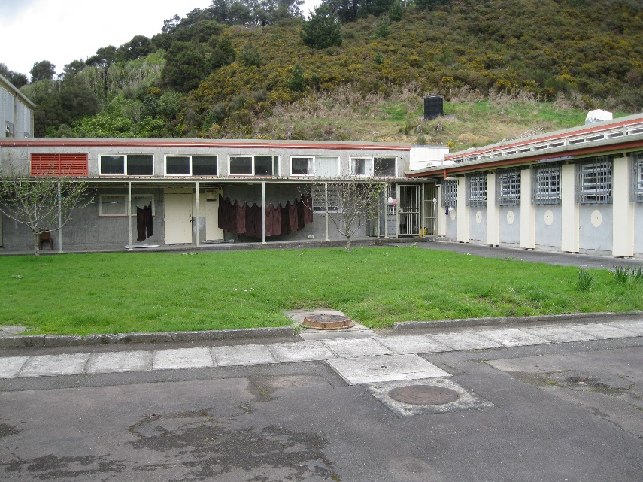 |  | 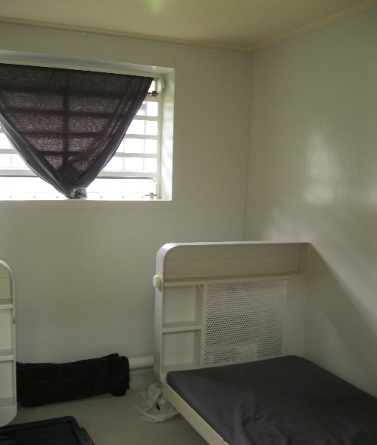
Figure 5: Internal grounds |  | Figure 6: Typical cell

Double-bunking
At the time of inspection, all cells were single occupancy. Inspectors recorded measurements of a standard cell, including sanitary facilities, as: width 2.13 meters, length 2.67 meters and height 2.35 meters, totalling 5.7m.²
Rule 13 of the Mandela Rules requires that cells meet acceptable requirements for health, space, lighting, heating and ventilation:
All accommodation provided for the use of prisoners and in particular all sleeping accommodation shall meet all requirements of health, due regard being paid to climatic conditions and particularly to cubic content of air, minimum floor space, lighting, heating and ventilation.
The European Committee for the Prevention of Torture and Inhuman or Degrading Treatment or Punishment (CPT) defines minimum standards for living space per prisoner as 6m² of living space for a single-occupancy cell plus sanitary facility. Cells at the Upper Prison do not meet this standard.
A consultation process on a proposal to double-bunk cells in the Upper Prison was about to commence at the time of the inspection. Staff and prisoners expressed concerns about plans to double-bunk and the impact it would have on both staff and prisoner safety and wellbeing. It was considered that placing two women in a small, single cell would be detrimental to their physical and mental wellbeing.
The CPT has also published desirable cell size standards for two prisoners as ‘at least 10m² (6m² + 4m²) of living space plus sanitary annexe’.
While there is no minimum standard in New Zealand, regulations require that, as far as is practicable, prisoners are accommodated in individual cells. Given the limited space and facilities, and inadequate regime opportunities, I do not consider the facility suitable for double-bunking.
In mid-February 2018, the Department informed my Office that a final decision has been made to double-bunk 44 cells at the Upper Prison.

Sanitary conditions
Good levels of cleanliness and hygiene were observed across the prison. The women kept their cells and the ancillary areas in the prison clean and tidy.
Women could shower regularly, although some reported problems with the temperature of the water. Inspectors checked the temperature of the water and found it fluctuated. According to staff and prisoners, there were problems with the drains, which may be further exacerbated by double-bunking. There were no issues with the drains during the course of the inspection.
Sanitary products were provided to the women upon request. Some women reported in their questionnaire feedback that sanitary products were not consistently available. Inspectors did not assess stocks of sanitary products.

Food
Rule 22 of the Mandela Rules states that:
Every prisoner shall be provided by the prison administration at the usual hours with food of nutritional value adequate for health and strength, of wholesome quality and well prepared and served (emphasis added).
Meals were not served at the usual hours. Breakfast took place at 8.30am and lunch (a hot meal) at approximately 11am. The evening meal, consisting of sandwiches, was distributed at 4pm. Breakfast and lunch were eaten in communal dining areas rather than in cells, which was appropriate. Staff advised that they were making attempts to provide the lunch at a later time (approximately 11.30am), but this had yet to be implemented.
Hot meals were prepared in the kitchen at Rimutaka Prison and delivered to the serveries in the Upper Prison. Inspectors noted that the quality of the hot meals was good. This was reflected in questionnaire responses, with 82 per cent of respondents stating the food was very good, good or average.
Some women preferred having the hot meal at lunchtime as this permitted them to eat their evening meal at a time to suit them. The evening meal comprised of sandwiches, yoghurt and fruit. Other women stated they preferred a hot meal early evening as this is what they were used to, it prevented them getting too hungry overnight and was more ‘normal’.
At the time of the May visit, there were no microwaves in the wings for the women to heat food, or to make porridge purchased through the prison shop (P119). The situation had been partly addressed when Inspectors returned to the Prison in late October, with microwaves located in the communal areas on two of the wings.

Consultation with prisoners
Prisoners were not able to take an active role in influencing decisions about services, routines and facilities in the prison and managing their day-to-day life.
Some women reported that they had attended a prison-run focus group, but had not received feedback on their contributions. Staff were unable to inform inspectors of the focus group feedback process.
Recommendations – decency, dignity and respect
- I recommend that:
  - Prisoners should be advised how to access ACC counselling.
  - Counselling sessions for prisoners should be undertaken in comfortable, private surroundings.
  - Staff working with women offenders should receive specific training to understand the unique characteristics and needs of women in prison.
  - Prisoners have access to sufficient, clean, appropriately sized clothing.
  - The Prison makes greater efforts to engage with their local iwi to better support the needs of Māori prisoners.
  - Chaplaincy services should be regularly provided in the Prison.
  - Meals should be served at the usual times. This would involve lunch being served any time between midday and 1.30pm and dinner to be served any time between 5pm and 7pm.
  - When prisoners participate in departmental focus groups they are provided with feedback on their input.

Corrections accepted recommendations 3a, 3b, 3c, 3d, 3e, 3f, 3g and 3h.
Back to contents

Criterion 4: Health and wellbeing
Expected outcomes: health and wellbeing
The Prison takes all necessary steps to ensure the wellbeing of all prisoners. Patients are cared for by services that assess and meet their health, social care and substance use needs and promote continuity of care on release. Patients are treated with dignity, respect and compassion, and their right to privacy is respected.

Assessment

Health care
The minimum standard for the health care of prisoners is set out under section 75 of the Corrections Act, which states that a prisoner is entitled to receive reasonably necessary medical treatment, of a standard reasonably equivalent to the standard of healthcare available to the public.
Health services were provided by the Department of Corrections. There was no analysis of annual health needs or development planning to identify priorities and emerging trends to inform future health delivery.
There were some clinical governance arrangements in place, although the service at the Upper Prison had yet to attain Cornerstone accreditation. Corrections have since informed my inspectors that accreditation assessment will take place in April 2018.
Health service staff were clearly identifiable and interactions the inspector observed, although cursory, were professional.
Prisoners received a health screening assessment by a registered nurse on their admission to Arohata before being transferring to the Upper Prison. Follow-ups were carried out by a member of the health staff, or referred to the appropriate specialist. The range of services available were appropriate and waiting times, with the exception of the dentist, were reasonable. There was evidence of referrals for breast and cervical screening.
Thirteen percent of questionnaire respondents identified as having a physical disability. The lay-out of the prison presented challenges to prisoners with mobility issues.
At the time of the May visit, most health services were provided in a small, cramped office. The lack of consulting rooms resulted in some women undergoing assessment and counselling sessions in the visits room. Inspectors noted when they returned in October that a more appropriate environment for health treatment was in the process of being established.
Inspectors observed, and overheard, conversations of a sensitive nature taking place on a number of occasions. Health promotion material was limited.
A broad range of policies informed and directed healthcare staff on delivery of health services, including communicable diseases, consent and information sharing. The entries in clinical records examined by the Inspector were good, including for women with complex needs. Nursing cover was provided on site from 6am to 8pm. An on-call nurse covered from 8pm to 6am with emergencies being transferred to the A&E department at Hutt Hospital. The location of the defibrillator was not ideal and not all staff were aware of its placement. Well-stocked first aid boxes were available in the offices of each four wings.
Forensic services were provided by Te Korowai-Whāriki, Capital and Coast District Health Board. There were three women under the forensic service at the time of the inspection. Forensic staff document consultations and reviews in Medtec notes.
Fifty-eight percent of questionnaire respondents identified as having mental health/emotional wellbeing issues. Of those, 71 percent did not feel supported with their needs. Several women suggested that their mental wellbeing was undermined by the lack of structured activities, inconsistencies in the application of rules, and difficulties due to separation from families and support networks.
Women were generally critical of dental services, and 61 percent of questionnaire respondents said it was difficult to access the dentist. The average waiting time for urgent referrals (priority one) was three months. Dental services were available once a week at Rimutaka Prison and accommodated between four and five women. The waiting list was created and maintained by the dental nurse. There were 66 women across both sites on the waiting list at the time of the inspection, and evidence that several women had fallen off the Arohata waiting list when they moved to the Upper Prison.
Women can make complaints through a confidential system - Health Service Manual (section 2.3.1). However, there were 14 complaints relating to health service on the general complaint system (PCO1) for the period February to October 2017. All complaints were reviewed and response times considered satisfactory.
Health request forms were available in each unit and collected (from a locked box) daily by health staff. Following a triage process, women were generally seen by a member of the health team within one or two days. Forty-seven percent of questionnaire respondents said it was easy to see the nurse. Nine percent said it was easy to see the doctor.
Recommendations – health and wellbeing
- I recommend that:
  - An annual health needs analysis be carried out to inform the health development plan.
  - Women’s access to dental services needs to improve.
  - Health complaints should not be recorded in the general complaints system.

Corrections accepted recommendations 4a, 4b and 4c.

Criterion 5: Protective measures
Expected outcomes: protective measures
The Prison performs the duties both to protect the public by detaining prisoners in custody and to respect the individual circumstances of each prisoner by maintaining order effectively, with courtesy and humanity. Prisoners are encouraged to take responsibility for themselves, their environment and their future. Their rights to statutory protections and complaints processes are respected.
The Prison takes appropriate action in response to the findings and recommendations of monitoring, inspectorial, audit or judicial authorities that have reported on the performance of the Prison.

Assessment

Complaints process
Under sections 152 and 153 of the Corrections Act there must be a fair, effective, comprehensive and prompt internal complaints system prominently displayed in each prison unit, including the right to seek assistance from an Inspector of Corrections or an Ombudsman. Under section 154, assistance for prisoners to make complaints must be available.
The complaints process was not prominently displayed in all of the wings. Contact details for key agencies such as the Health and Disability Commissioner and Children’s Commissioner were not displayed by telephones in some wings.
Since the Upper Prison opened in February 2017, 114 complaints have been lodged by prisoners. Forty-one percent of questionnaire respondents said they had made a complaint at the Upper Prison. Fifty-two percent of respondents did not feel that complaints were dealt with promptly, and 65 percent of respondents did not have confidence in the complaints system. Inspectors spoke to a number of women to understand why there was limited confidence in the complaints process. Among the reasons offered were concerns about ‘consequences’ for complaining and a perceived lack of effective action to address the issues.

Voluntary Segregation
The Upper Prison did not hold prisoners subject to voluntary segregation. At the time of the inspection, there were no plans to introduce voluntary segregated prisoners to the site.

P119 (prison shop)
Women were critical of the P119, particularly the high prices, lack of healthy options and an apparent reluctance to consider prisoners’ views and preferences in the choice of goods on offer. Prisoners’ lack of access to employment and wages compounded their frustration about prices. Eighty-one percent of questionnaire respondents said the P119 did not sell a wide enough range of goods to meet their needs.
During the inspection, a number of P119 orders were not delivered to the Prison, due to a problem with a dual ordering system. Staff were aware of the negative impact this had, and worked hard to address the issue. They ensured P119 orders were delivered to the women later that day.
Recommendations – protective measures
- I recommend that:
  - The Prison Director conducts an analysis of prisoner complaints, and implements improvements that address the underlying reasons why prisoners have such little faith in the complaints process.
  - The range of healthy goods available through the P119 be improved.

Corrections accepted recommendations 5a and 5b.
Back to contents

Criterion 6: Purposeful activity and transition to the community
Expected outcomes: purposeful activity and transition to the community
All prisoners are encouraged to use their time in prison constructively and this is facilitated by the Prison. Prisoners’ sentences are managed appropriately to prepare them for returning to their community. The Prison provides a broad range of activities, opportunities and services based on the profile of needs of the prisoner population. There are sufficient and suitable education, skills and work places to meet the needs of the population. Prisoners are consulted in planning the activities offered. Prisoners have the opportunity to participate in recreational, sporting, religious and cultural activities.
Prisoners are prepared for their successful return to the community.

Access to work/education and programmes
The Corrections Act requires that prisoners are provided with an opportunity to make constructive use of their time as detailed in a management plan, which outlines an assessment of needs and how these needs may be met, including preparation for release and successful reintegration into the community.
Inspectors undertook two muster checks during the course of the inspection, one during the morning and one in the afternoon, to determine how many women were undertaking education, work or programmes. Just over two thirds of women (69 percent) were not involved in any constructive activities, programmes or work. The majority of women were unlocked on their respective wings but had little to occupy themselves. Recreation took place predominantly in the wing corridors, which were cramped and noisy. The wing communal (dining) areas were small and lacking in provisions other than a set of tables and chairs.
The lack of constructive activities for women at the Upper Prison was reflected in questionnaire responses. Forty percent of respondents reported that they did not participate in a prison job, vocational or skills training, education, offending behaviour programmes, offender employment, or Release to Work (paid work outside the Prison). Women expressed their frustration and powerlessness at being unable to access programmes and activities that had been identified in their sentence plans, which would adversely affect their prospects of parole and early return to whānau.

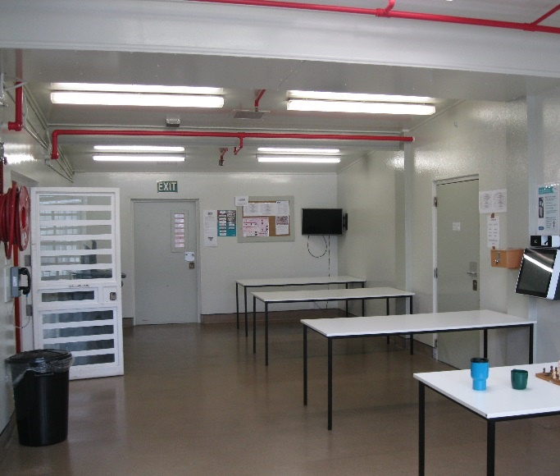 |  | 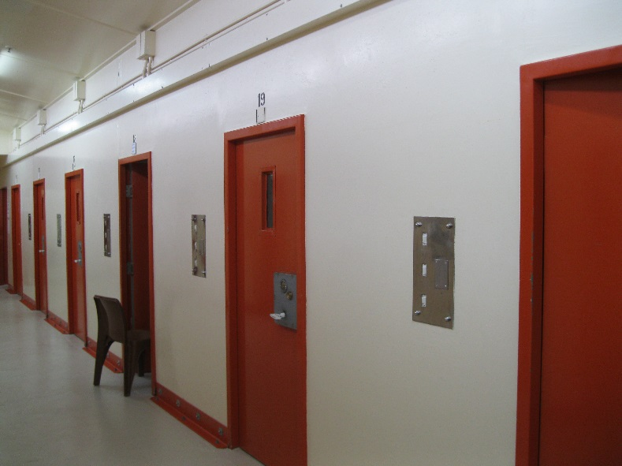
Figure 7: Communal area/dining room |  | Figure 8: Wing corridor

During the inspection, Inspectors sighted five women attending a weekday horticulture course. Another group of approximately six prisoners were employed in a painting group, decorating the visits centre. Approximately five prisoners were attending literacy and numeracy courses and some women were enrolled on a parenting course. Prisoners were very complimentary and enthusiastic about the courses that were provided and stated they would like to be involved in more purposeful and constructive activities.
A signup sheet for a budgeting course had been posted in the recreation areas of each wing, but prisoners and staff were unaware when this short course would commence.
A large number of women reported they had been involved in constructive activities and employment at their original (transferring) prison and felt significantly disadvantaged by their transfer to the Upper Prison.
There were no organised hobby groups for the women. The hobby shop sold limited hobby materials. One particular issue was that the shop sold colouring pencils but not pencil sharpeners, which further limited options for occupying time productively. There were few leisure activities available to the women. Staff assisted with a knitting programme to try and keep the women occupied. There were few puzzles and board games for the women, who spent the majority of their time playing cards or wandering around in the wing.
Custodial staff and management were aware that constructive activities were limited and that prisoners were frustrated at being unable to use their time in a meaningful way. During the May visit, Inspectors were informed of plans to develop the Upper Prison’s facilities to provide more education and training programmes. During the October inspection, Inspectors were provided with copies of building plans which indicated an expansion of programmes facilities. No additional activities had been implemented for the women between the two inspections, although pencil sharpeners had been purchased in the interim for each wing.
There were very few work opportunities available to the women other than wing cleaners or laundry workers. Three women worked in the Upper Prison kitchen preparing sandwiches and breakfasts.
No women at the Upper Prison were involved in Release to Work, although there were 32 minimum security prisoners at the facility at the time of inspection.

Library facilities
Prisoners were able to access the library at least once a week.
There was a well-stocked library which was run by two prisoners. The library area had been decorated by prisoners and staff and felt welcoming, comfortable and offered a rare quiet space. The two library workers reported that there was a demand for books on addiction, abuse and self-help. An informal peer-support system appeared to have evolved in the library whereby older women provided younger women with positive guidance and assistance with selecting reading material that was tailored to their needs. There were opportunities to develop more peer support systems at the Upper Prison.
A copy of Corrections’ Women’s Strategy, ‘Wahine – E Re Ana Ki Te Pae Hou’, was not available in the library or sighted anywhere in the Prison at the time of inspection. Legal reference materials were photocopied and some required updating. Some legal material was available on the new kiosks, but kiosks were located in the busy and noisy recreation/dining area, which was not a conducive environment for concentration and reflection.

Outdoor exercise – leisure activities and gymnasium
Under sections 69(1)(a) and 70(1) of the Corrections Act, prisoners (other than those engaged in outdoor work) are entitled to a minimum of one hour of physical exercise each day, in the open air if the weather permits. This reflects Rule 23 of the Mandela Rules.
Three yards were available for the women to access fresh air. At the time of inspection the yards required maintenance work, including cleaning and painting. The walkway outside the yards was uneven and broken. The yards did not have water fountains. Urinals were still installed from the Prison’s previous role as a men’s facility. There was no means of raising the alarm in the yards, and prisoners reported having to call out for staff assistance when incidents occurred. Waterproof coats were not available for access to yards in wet weather.
There was a raised open grassed area between the wings. At the time of the initial inspection this space was not being utilised. However, the space was being used for recreation when Inspectors returned in October. Staff were available and interacting with prisoners in the open yard area.
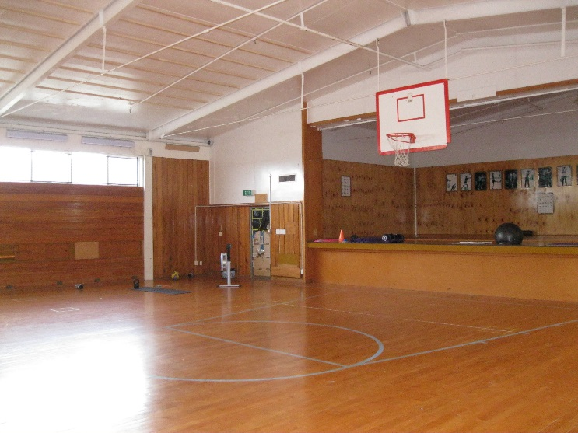 |  | 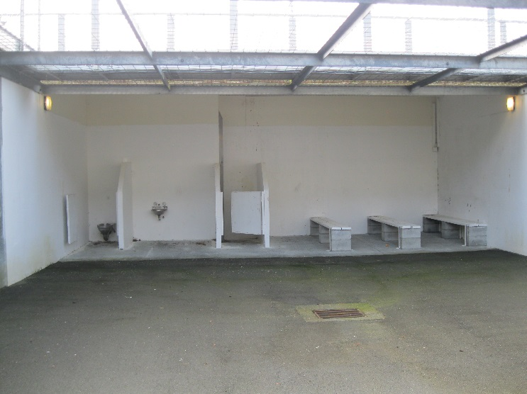
Figure 9: Gymnasium |  | Figure 10: One of three exercise yards

Some wings were operating a yard to lock, gym to lock regime although the prisoners’ security classification ranged from low-medium to minimum. In wings 1 and 2, women had elected to be locked in their cells when the cleaners were doing their duties.
Prisoners were able to use the gymnasium for recreation at least weekly; however, there was minimal gym equipment and no structured training programme. Time in the gym was self-directed, other than once a fortnight when the gym instructor came over from Arohata.
Opportunities for custodial, health and activities officers to implement a broad approach to health promotion and recovery at the prison had yet to be realised.
Despite cell yoga programmes being rolled out at the three main women’s prisons, the programme was yet to be established at the Upper Prison.

Visits
Inspectors found that women had very limited opportunities for visits at the Upper Prison. Dislocation from whānau and support networks was evident. There was no evidence that women who did not receive visits were provided with additional support to help maintain their family relationships, which is concerning.
Sixty-seven percent of women had been transferred out of their home region. Sixty-eight women were from the South, Central and Northern regions; 34 women were from the Lower North Region. This presented significant barriers in terms of distance and finances for family and whānau to visit. Many women reported feeling dislocated from their families and support networks.
Visitors were able to attend visits in a clean and safe environment (which had been recently painted by prisoners). Both visitors and prisoners had access to toilet facilities in the visits area. There was no ability for visitors to have any refreshments during the visits and there was no feedback system in place for visitors to report on their experience. There were no activities to help keep children entertained.
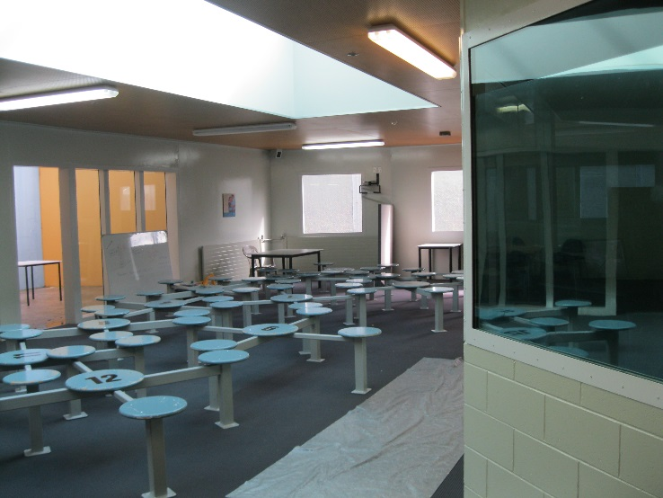 |  | 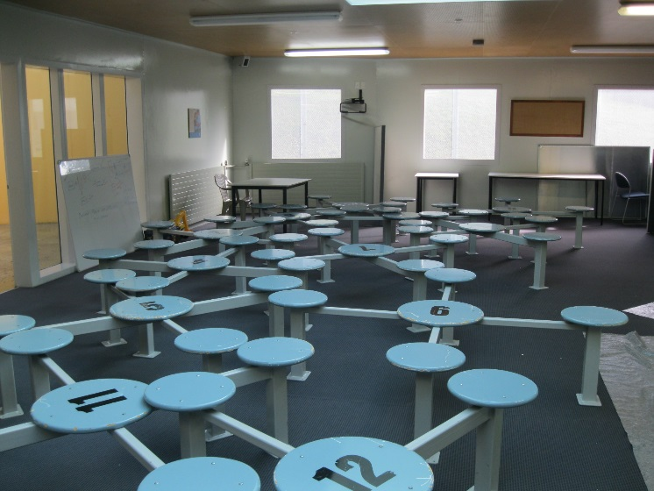
Figure 11: Visits room – being repainted |  | Figure 12: Visits room

At the time of the inspection the visits area was also used being used for programmes, counselling, and assessments.
Some women were advised that they were able to have a 20 minute AVL contact at Arohata once a month, if it could be arranged and staff escorts provided. However, other women were unaware of the option for AVL contact.
At the time of the October inspection, there was one functioning AVL suite, being used for parole board hearings. Inspectors did not observe the AVL being used for family contact.

Access to telephones/mail
Each wing had one telephone in the main corridor. There was no privacy for women using the phone. The poor acoustics on the wing and a lack of privacy affected the quality of telephone conversations.
Many women reported that they could only call their children at weekends as the unlock regime did not align with their children returning home from school. It was reported that there had been some ‘friction’ about using the phone at times of peak demand. It was suggested by senior staff that such difficulties could be addressed by providing more phones or extending unlock times to reflect the usual regime for low-security prisoners.
The mail system was not working effectively. Mail addressed to Arohata (Tawa) was processed and then forwarded to the Upper Prison. This process resulted in a number of delays.
Mail received at Rimutaka Prison was redirected to Arohata (Tawa) for processing and checking by the dog handler after which it would be returned to the Upper Prison. This process was protracted and seemed to cause significant delays. Inspectors saw a number of women receiving large quantities of mail in one day (8 to 12 letters). Some women reported receiving mail up to a month after it was sent.
Women were given an induction pack which had information on how their family and friends could email them if they wished. Women could respond via handwritten letters.

Case Management (including Right Track)
It was reported by both custodial staff and prisoners that the process to see a Case Manager was protracted and slow. Case Managers reported that due to the increase in population, not all women (30) had been allocated a Case Manager. The Case Management team stated they were working towards establishing better communications with the Upper Prison to ensure more collaborative working with wing staff.
Although women who had been allocated a Case Manager had programmes scheduled, there were no programmes delivered at the Upper Prison. Sentence plan progression was stalled by placement at the Upper Prison. Inspectors were told that sufficient funding for programmes had yet to be secured in light of the increased muster.
The Right Track process had not been formalised and Right Track meetings were not occurring on a regular basis.
At the time of inspection, there was one Social Worker covering both sites. The recruitment process for a second position was underway. Social work provision at the time of the inspection did not meet demand. Not all women were familiar with the referral process to see a Social Worker.
A lack of infrastructure and staffing resources was impacting on the programme delivery and consequent progression, which was having a detrimental effect on prisoner engagement and motivation.

Guided Release/Out of Gate services
Guided Release was only available to those women who were being released locally. As two- thirds of the women were from out of district, this impeded their release planning or ability to secure support to address their reintegration needs. At the time of inspection, no women at the Upper Prison were involved in Guided Release or engaged in Release to Work.
Recommendations – purposeful activity and transition to the community
- I recommend that:
  - More support is provided for prisoners to address their immediate needs.
  - The Prison provides a broad range of activities, opportunities and services based on the profile of needs of the prisoner population. Prisoners are consulted in planning the activities offered.
  - The regime for low-security prisoners should facilitate and enable family contact and support networks, especially for women from out of region.
  - All prisoners are allocated a Case Manager within standard timeframes.
  - Prisoners are prepared for their successful return to the community.
  - Suitable prisoners should be engaged in Release to Work.

Corrections accepted recommendations 6a, 6b, 6c, 6d, 6e and 6f.

Acknowledgements
I appreciate the full co-operation extended by the managers and staff to the Inspectors during their visit to the Prison. I also acknowledge the work that would have been involved in collating the information sought by the Inspectors.
Back to contents

- Corrections’ general comments and comments on recommendations that were accepted

General Comments
Corrections acknowledges the difficulties surrounding the opening of the ‘Upper Prison’ on the grounds of Rimutaka Prison to house women prisoners. This facility was originally closed in 2015 and was to be re-purposed as a training facility. The rapid and unforeseen growth of the women’s prison population has made recommissioning the Upper Prison as a female facility necessary to ensure Corrections can accommodate women as required. Continued growth in the women’s prison population has also led Corrections to propose increasing the capacity of this facility through double-bunking. It should be noted that the growth in the women prison population has been far more acute than the growth in the male prison population (there are approximately 40 percent more women in prison than there were two years ago).
Corrections is working to ensure the facility is of a standard appropriate for accommodating women prisoners. Significant work is planned, with over $10 million being invested to ensure prisoners are housed in a facility that is fit for purpose.
Given there will be a large concentration of women accommodated in the Upper Prison, Corrections has planned a number of improvements to ensure their wellbeing through:
- an extended unlock regime.
- expanding the range of constructive activities available to prisoners.
- building two more fit for purpose yards (including drinking fountains and prisoner phones).
- the installation of additional prisoner phones in units.
- working with Spotless (our facilities service provider) for solutions to ensure prisoners are given access and privacy for lawyers calls.
- the refurbishment of the Administration building as a programmes hub.
- a room for New Zealand Parole Board hearings to lessen the impact on escorts to Arohata Prison in Tawa.
- the refurbishment of the secure entry.
- the refurbishment of the At Risk Unit and separates cells.
- an upgrade of the gym and its facilities.
- additional space for prison industries.

Comments on recommendations that were accepted
Criteria 1 – Treatment
- I recommend that:
  - A more robust system should be put in place to ensure use of force paperwork is completed to the required standard. This is a repeat recommendation.
  - Measures be undertaken to better protect the privacy of prisoners in the Management Unit and ARU and when they are naked, partially naked, or undertaking their ablutions. This is a repeat recommendation.
  - The Prison Director establish the circumstances and locations where prisoners feel unsafe, and address the findings in an arena that includes prisoner representation.

Corrections accepted recommendation 1a, and commented as follows:
Corrections accepts that use of force paperwork is a required standard and acknowledges at time of the inspection not all paperwork was complete. Following this visit a more comprehensive system was developed and embedded to ensure this standard is met.
The Custodial Systems Manager at Rimutaka records all use of force incidents in the register. All incidents are then reviewed by a Senior Manager including CCTV footage and incident reports
Corrections accepted recommendation 1c, and commented as follows:
Prisoners need to feel safe whilst in our care and we have implemented monthly unit meetings to ascertain where they feel unsafe. Arohata Prison (Tawa) commenced this process on 16 January 2018 with a meeting scheduled for the week of 22 January 2018 at the Upper Prison. Initially this meeting will have the Prison Director or Deputy Prison Director as chair. This will then be handed over to the Residential Managers and Principal Corrections Officer to continue.
The set-up of these meetings will include both scheduled meetings and allow for flexibility to ensure meetings can also be scheduled when situations arise. Sharing the outcomes with prisoners will also be considered where appropriate.

Criteria 2 – Lawful custody
2. I recommend that:
- The staffing levels in the Receiving Office be reviewed and adjusted as necessary to accommodate the increase in prisoner numbers.
- Prison management review procedures to ensure prisoners can readily access their property.
- Prison management review induction arrangements for foreign nationals, speakers of other languages and those with literacy issues to ensure these prisoners are fully briefed on prison procedures

Corrections accepted recommendation 2a, and commented as follows:
We acknowledge that on occasion prisoners have been delayed in the Arohata Prison Receiving Office. Interim measures were in place; however with an additional staffing resource now seconded to the Receiving Office, this will address the additional pressure ensuring essential procedures are completed prior to prisoners travelling to the Upper Prison.
Corrections accepted recommendation 2b, and commented as follows:
Since your visit, property process maps have been developed to streamline and outline necessary processes. These will be reviewed in March 2018 to ensure prisoners are readily accessing their property. As outlined above, additional staffing resource in the Receiving Office will also support improvements in property processes.
Corrections accepted recommendation 2c, and commented as follows:
Since Inspectors raised this issue with prison management, this has been reviewed on site to ensure all foreign language-speaking prisoners are given comprehensive information in a language they understand. Any need for a translator, specific dietary requirements, or religious considerations is managed during their induction into prison. When a prisoner identifies as a foreign national, or where staff believe that they could be, they are advised of their rights under the Corrections Act 2004. They are also advised of their rights under the Vienna Convention on Consular Relations to have the diplomatic representative of their country advised of their imprisonment and to have access to a consular representative.
Staff on site are utilised to assist with translation for prisoners that have no understanding of English. This process is now embedded and working well. This has been successful with a recent example of placing an officer with Spanish and Portuguese language skills in a wing at the Upper Prison along with assigning an English language tutor to support a prisoner placed at Arohata. The prisoner has been assigned a lawyer by the Consulate and local support networks that is based locally and visit regularly.
In 2018 the custodial practice team will work to develop resources available to the entire prison network to support staff inductions for speakers of other languages. Written resources in other languages and translation service directories will be considered.
Criteria 3 – Decency, Dignity and Respect
3. I recommend that:
- Prisoners should be advised how to access ACC counselling.
- Counselling sessions for prisoners should be undertaken in comfortable, private surroundings.
- Staff working with women offenders should receive specific training to understand women’s unique characteristics.
- Prisoners have access to sufficient, clean, appropriately sized clothing.
- The Prison makes greater efforts to engage with their local iwi to better support the needs of Māori prisoners.
- Chaplaincy services should be regularly provided in the Prison.
- Meals should be served at the usual times. This would involve lunch being served any time between midday and 1.30pm and dinner to be served any time between 5pm and 7pm.
- When prisoners participate in Departmental focus groups they are provided with feedback on their input.

Corrections accepted recommendation 3a, and commented as follows:
Whilst prisoners have access to ACC counselling, Corrections is in the early stages of reviewing and further developing, in conjunction with ACC, a Memorandum of Understanding which will improve a formalised pathway for referrals, consultations, information sharing and relationship management. Improvements on how prisoners are advised about access to this counselling will be undertaken as part of this review.
Corrections accepted recommendation 3b, and commented as follows:
We acknowledge the visits hall was not appropriate for counselling sessions and, since the inspectors visited, have made the old Health room available for counsellors. A second room in the new Health Unit will also be available until the refurbishment of the site which will involve repurposing rooms to support private counselling sessions for prisoners. Office space and interview rooms, which can also be used for counselling, will be separate spaces.
Work at the site is staged and it is planned for repurposed rooms to be delivered as part of the first stage. Timeframes at this stage cannot be confirmed. However it is expected this will be confirmed by the end of February 2018.
Corrections accepted recommendation 3c, and commented as follows:
Nationally, in the past five years a total of 263 staff have completed a two day training course on working with women covering topics such as mother-child issues, understanding women’s offending, effects on staff working with women in prison, issues for young female offenders, power and control, and interpersonal relationships in prison. To ensure alignment with Corrections’ Women’s Strategy and a new Frontline Learning Hub, this training is scheduled to be re-designed and will be available for staff from April 2018.
The additional recruitment of Social Workers and Counsellors will allow Arohata to run internal training / practice sessions while the training package is being developed. Additionally, the Deputy Prison Director has distributed the women’s strategy to all staff on site.
Corrections accepted recommendation 3d, and commented as follows:
Additional clothing had been ordered for the increase in the prisoner population and was received in October 2017. Prisoners were matched with suitable sizes.
Corrections accepted recommendation 3e, and commented as follows:
Since March 2017, the Wellington District Leadership Team (DLT), including representatives of Rimutaka and Arohata Prisons along with Community Corrections, had established a relationship with a Māori Advocacy Group who are made up of representatives from local iwi. This group meets on a quarterly basis and work in an advisory capacity, providing the DLT with practical advocacy, strategic support, advice and guidance on specific initiatives and, on occasion, cultural training and support services. They work together under the shared goals to reduce re-offending, provide visible leadership, work more effectively for Māori, and the Wellington District specific goals to:
- establish a Māori Advocacy Group to support the seamless reintegration of Māori prisoners.
- provide a multi-disciplinary approach when interacting with vulnerable people to improve public safety and reduce re-offending.
- strengthen case management by engaging the whānau of offenders in the planning of their rehabilitation and reintegration, especially for our young offenders.
The prison will further enhance this by re-establishing monthly meetings with Kaiwhakamana from February 2018.
Corrections accepted recommendation 3f, and commented as follows:
Chaplaincy provides Sunday Service and Pastoral Care and Counselling at both Arohata Upper Prison and the Tawa site. Chaplaincy provide 16 hours per week but rely on faith based volunteers to provide additional services to the women.
Whilst prisoners are made aware of services provided by Chaplaincy, further information will be placed on prisoner notice boards by the end of January 2018 to ensure prisoners are aware of this.
Corrections accepted recommendation 3g, and commented as follows:
We are aware of meal times being an issue and, in order to mitigate the impact this has on the prisoner population, we endeavour to serve a hot meal at lunch time when prisoners are generally unlocked. A cold evening meal is provided in the afternoon for prisoners to consume at their leisure. We acknowledge that some prisoners choose to eat their evening meal early. Given the provision of sufficient quantity of nutritional food, alongside the ability for prisoners to purchase additional food items, we consider this mitigates concerns of hunger between dinner and breakfast.
Work is underway to review the shift regimes in the custodial environment in order to align meal times more closely with the hours suggested. This is a major project which requires significant consultation with a number of parties, as well as technology upgrades.
Corrections accepted recommendation 3h, and commented as follows:
As highlighted it is important for prisoners to participate in focus groups and have feedback on their input. Staff across Corrections have been trained to facilitate focus groups in prisons. Arohata was included in the pilot and staff including Corrections Officers, Case Managers and Programmes Facilitators were trained in facilitating focus groups in May and December 2017. This training and framework for focus groups included a process for giving feedback to participants.
Criteria 4 – Health and wellbeing
4. I recommend that:
- An annual health needs analysis be carried out to inform the health development plan.
- Women’s access to dental services needs to improve.
- Health complaints should not be recorded in the general complaints system.

Corrections accepted recommendation 4a, and commented as follows:
The template for a health needs analysis is currently being developed and is due for completion at the end of February 2018. A draft was provided to your office and we have now received your feedback. Once finalised this will be disseminated to all Health Centres for completion with the relevant data for each site.
Corrections accepted recommendation 4b, and commented as follows:
Dental services are provided to women prisoners at Rimutaka once a week and we accept these services need to be improved. To this end, a new Dental suite is being built at Arohata Prison (Tawa) in May 2018 and will provide dental services to women from both sites.
Corrections accepted recommendation 4c, and commented as follows:
We acknowledge that sensitive health information should not be recorded in IOMS or in the general complaints system. However we consider all first-level complaints should be recorded in one centralised system and that the PC.01 system is the simplest and most appropriate avenue for all complaints. The PC.01 system is easily accessible to prisoners and Corrections encourages this system for all first-level complaints as it enables monitoring of responses and timeliness.
To ensure no sensitive health information is recorded in IOMS or on the actual form, updates will be made to the prisoner complaint form (PC.01) to ensure there are clear prompts to staff to exclude health information when inputting the information provided by prisoners into IOMS. The response in IOMS will note where the response may be found, e.g. in the health complaints file.
Once changes are made, frontline staff will be provided with guidance on the updates.
Criteria 5 – Protective measures
5. I recommend that:
- The Prison Director conducts an analysis of prisoner complaints, and implements improvements that address the underlying reasons why prisoners have such little faith in the complaints process.
- The range of healthy goods available through the P119 be improved.

Corrections accepted recommendation 5a, and commented as follows:
We agree that prisoners need to be aware of the complaints process and need to have faith that complaints are being dealt with in a fair, prompt and effective manner. To ensure prisoners are reminded of the complaints process, this has been added to the unit induction packs with a copy of the form.
Corrections accepted recommendation 5b, and commented as follows:
In order to ensure prisoners have healthier options to purchase, a national review of the P119 canteen catalogue is scheduled for the first quarter of 2018. A key component of the review will be to introduce a limited range of healthier products. Preparation for the review has already commenced with some samples of healthier products being sent to the four regional P119 distribution centres for sampling by prisoners and feedback.
It is planned to give prisoners the opportunity to have input into the review by way of suggestion forms that will be collected from the units and returned to the catalogue review. This form will be distributed in late January 2018.

Criteria 6 – Purposeful activity and transition to the community
6. I recommend that:
- More support is provided for prisoners to address their immediate needs.
- The Prison provides a broad range of activities, opportunities and services based on the profile of needs of the prisoner population. Prisoners are consulted in planning the activities offered.
- The regime for low-security prisoners should facilitate and enable family contact and support networks, especially for women from out of region.
- All prisoners are allocated a Case Manager within standard timeframes.
- Prisoners are prepared for their successful return to the community.
- Suitable prisoners should be engaged in Release to Work.

Corrections accepted recommendation 6a, and commented as follows:
To address your concerns regarding prisoners’ immediate needs, all prisoners received have their immediate needs assessed at induction (I.04 Form 02 – Immediate needs checklist). An immediate needs assessment must be completed within four hours of a prisoner’s arrival if they are:
- first received into a prison on remand
- newly sentenced
- received on transfer from another prison.
On completion of the immediate needs assessment (where possible) the needs are addressed and results documented, and referrals are immediately made to the appropriate person if needs are identified.
Support for immediate needs is available through Health, Case Managers, Mental Health Clinicians, Social Workers and Counsellors to support prisoners and Arohata will benefit from the additional Social Worker and Counsellor. Custodial staff completing the immediate needs assessment will be reminded about the range of support available through referrals. In addition, a new Social Worker and Counsellor will assist with this and custodial staff have been reminded about completing the immediate needs assessment.
With an additional staff member in the Receiving Office as well as streamlined processes, property will be received in a timely manner for those prisoners being transferred in from another area. The increased use of AVL links, as well as a second AVL facility being built, will enable these prisoners to remain in contact with whānau and support networks.
Case management staff also work alongside prisoners to identify and address their rehabilitation and reintegration needs. Initial contact of all prisoners, including those that have transferred from other areas, occurs within 10 days of entry into prison to ensure prisoners have the opportunity to address their offending behaviour.
Corrections accepted recommendation 6b, and commented as follows:
There is significant development work planned for Arohata Upper Prison which, on completion, will support the delivery of a broader range of activities, opportunities and services available to prisoners. With additional programme rooms and dedicated rooms for industry/employment training planned as part of the Upper Prison’s refurbishment, more activities are being made available to prisoners.
The following activities have been delivered and will continue to run at Arohata Upper Prison;
Employment;
- Painting
- Grounds maintenance
- Kitchen work
- Unit employment
- Electrical testing
- Gardening
Education & Training;
- Intensive Literacy and Numeracy
- Self directed learning
- Education assessments, learning pathway development
- Creative writing
- Horticulture Training Program (Level 2)
Rehabilitation/Treatment;
- Short Rehabilitation Programme for women (SRP-W)
- Short Motivational Programme (SMP)
- Individual psychological treatment
- Tikanga programme
- Kowhiritanga (starting 22 January 2018)
Constructive Activities;
- NZ Royal Ballet (phase one completed)
- Yoga
- Weaving
- Art, including the white ribbon art completion
- Board Games
- Sewing
- Kapa Haka which was facilitated by Corrections staff for Christmas show. This is planned to continue.
The following activities are planned:
Employment;
- Manufacturing of circuit boards
- Photocopy Machine projects
- Laundry
- Grounds maintenance, scrub cutting and tree planting
- Recycling
- Release to Work
Education and Training;
- Financial Literacy
- Hair and Beauty Industry Training
- Rehabilitation/Treatment;
- Alcohol and Other Drugs Programme
- Mothers and Babies Parenting Programme
- Driver Licencing
- Out of the Gate
- Constructive Activities;
- Mindfulness
- Book Club
- Peace Education
- Sewing and Quilting
- Physical Education training
- Vegetable Gardening (supplying produce for charity groups)
Arohata has appointed a Counsellor, Social Worker, and Intervention Coordinator at the Upper Prison. Additionally, a Fitness and Wellbeing Trainer started on 28 December 2017.
Corrections accepted recommendation 6c, and commented as follows:
We consider it is vital for women prisoners to maintain contact with their whānau and support networks and, to lessen the impact on prisoners; AVL facilities are available to enable women prisoners to have contact with their whānau. Arohata Prison will put up posters to ensure prisoners understand the steps they can take to maintain contact through the AVL facility. A second AVL resource is included in the refurbishment plans for the site.
Plans are in to enhance facilities including an increased number of phones, unlock hours and additional staff.
Corrections accepted recommendation 6d, and commented as follows:
All prisoners are allocated a Case Manager and are generally allocated within the standard timeframe. We consider this important to ensure prisoners are being met face-to-face, and activities/programmes are discussed to provide prisoners with a clear treatment pathway. Both sites have Weekly Case Management drop in clinics to further improve prisoners access to case managers.
The Director Case Management is preparing a practice reminder on the benefits of early engagement. The team is also developing a set of standards for Principal Case Managers which will include allocations. It is anticipated both will be ready and distributed in February 2018.
Corrections accepted recommendation 6e, and commented as follows:
We have increased the use of AVL to link the prisoners in with their whānau and continuous work is occurring to increase the applications for outside the wire activities.
Both the Short Rehabilitation Programme for women (SRP-W) and Short Motivational Programme (SMP) were delivered at Arohata Upper Prison, finishing in November 2017. The Kowhiritanga and SRP-W programmes are scheduled to re-commence in January 2018. These programmes support prisoners to address their offending related needs and build skills in preparation for release. Following completion of these programmes, prisoners will attend Maintenance programme group sessions in prison and in the community on release to support them to maintain the gains they made. The SMP is an individual programme supporting participants to build motivation to address their offending.
These programmes along with others will continue to be delivered along with other rehabilitation programmes at Arohata Upper Prison including the Alcohol and Other Drugs and Parenting Programme as scheduling permits.
Not being released locally does not exclude prisoners from guided release. Relevant guided release activities can be facilitated for women in an area different to their release, for example establishing a bank account.
Corrections accepted recommendation 6f, and commented as follows:
Prior to engaging in the Release to Work programme, prisoners must be found to be suitable. Continuous work is occurring to increase the applications for Outside the Wire activities for women identified as suitable. This is a continuous process with the current list of eligible prisoners being reviewed during January 2018.
Back to contents

- The inspection team
Emma Roebuck – Team Leader
Tessa Harbutt – Inspector (Nurse)
Jacki Jones – Chief Inspector (Nurse)
Sue Silva – Inspector (Social Worker)
Eric Fairbairn – Inspector

Back to contents

- Upper Prison – prisoner population
Please note: the following figures were supplied by Corrections and any errors are their own.
Based on a snapshot of data – 18 September 2017
Status | Under 18 years | 18-20 year olds | 21 -65 year old | 66 and over
Sentenced | 0 | 8 | 95 | 0
Recall | 0 | 0 | 0 | 0
Remand convicted | 0 | 0 | 0 | 0
Remand accused | 0 | 0 | 0 | 0
Civil prisoners | 0 | 0 | 0 | 0
Awaiting deportation | 0 | 0 | 0 | 0
TOTAL | 0 | 8 | 95 | 0

Ethnicity | Under 18 years | 18-20 year olds | 21 -65 year olds | 66 and over
Pākehā | 0 | 2 | 30 | 0
Māori | 0 | 6 | 53 | 0
Pasifika | 0 | 0 | 4 | 0
Asian | 0 | 0 | 4 | 0
Other | 0 | 0 | 4 | 0
TOTAL | 0 | 8 | 95 | 0

Security Category | Under 18 years | 18-20 year olds | 21 -65 year olds | 66 and over
Minimum | 0 | 0 | 33 | 0
Low | 0 | 7 | 35 | 0
Low-Medium | 0 | 1 | 27 | 0
High | 0 | 0 | 0 | 0
Maximum | 0 | 0 | 0 | 0
TOTAL | 0 | 8 | 95 | 0

Duration of sentence | Under 18 years | 18-20 year olds | 21–65 year olds | 66 and over
Less than 12 months | 0 | 4 | 21 | 0
12 months to less than 2 years | 0 | 1 | 22 | 0
2 years to less than 4 years | 0 | 3 | 26 | 0
4 years to less than 10 years | 0 | 0 | 21 | 0
10 years and over (not life) | 0 | 0 | 3 | 0
Preventative Detention | 0 | 0 | 0 | 0
Life |  |  | 2
TOTAL | 0 | 8 | 95 | 0

Gangs (including affiliated) | Under 18 years | 18-20 year olds | 21 to 65 year olds | 66 and over
Black Power | 0 | 0 | 3 | 0
Mongrel Mob | 0 | 0 | 13 | 0
TOTAL | 0 | 0 | 16 | 0

Main Offence | Under 18 years | 18-20 year olds | 21 to 65 year olds | 66 and over
Violence | 0 | 3 | 22 | 0
Violence against the person | 0 | 3 | 22 | 0
Sexual offences | 0 | 0 | 1 | 0
Burglary | 0 | 3 | 12 | 0
Robbery | 0 | 1 | 7 | 0
Theft and handling | 0 | 0 | 10 | 0
Fraud and Forgery | 0 | 1 | 8 | 0
Weapons | 0 | 0 | 7 | 0
Drugs | 0 | 0 | 23 | 0
Driving offences | 0 | 0 | 11 | 0
Arson | 0 | 0 | 1 | 0
TOTAL | 0 | 8 | 95 | 0

Back to contents
- Questionnaire feedback
Percentages have been rounded and therefore may not add up to 100 percent.
Ninety-two questionnaires were distributed to the women and 75 were returned (82 percent).

Section 1: About you
Q1.2 How old are you? (73 responses)
Under 21 | 21-29 | 30-39 | 40-49 | 50-59 | 60-69 | 70 and over
8% (6) | 24% (18) | 39% (29) | 9% (7) | 13% (10) | 4% (3) | 0% (0)

Q1.3 What is your ethnicity? (75 responses)
NZ European/Pākehā (24%) 18 Māori/Pākehā (23%) 17
Pasifika & Asian (4%) 3 Kiwi/New Zealander (12%) 9
Other (5%) 4 Māori (32%) 24

Q1.4 Is English your first language? (75 responses)
Yes (95%) No (5%)

Q1.5 Are you sentenced/on remand? (75 responses)
Sentenced | Remand
100% | 0%

Q1.6
 | Yes | No | Responses
Is this your first time in prison? | 52% | 48% | 75
Do you have children under 18? | 62% | 38% | 68

Section 2: Respect and dignity
Q2.1 Please answer the following questions about the wing/unit you are currently living on:
 | Yes | No | Don’t know | Responses
Are you normally offered enough clean, suitable clothes for the week? | 79% | 21% |  | 71
Are you normally able to have a shower every day? | 96% | 4% |  | 74
Do you normally receive clean sheets every week? | 77% | 23% |  | 73
Do you normally get cell cleaning materials every week? | 84% | 16% |  | 75
Can you normally get your stored property? | 43% | 51% | 6% | 75
Q2.2
 | Very good | Good | Average | Bad | Very bad | Responses
What is the food like here? | 11% | 25% | 46% | 15% | 3% | 72
Q2.3
 | Yes | No | Responses
Does the shop (P119) sell a wide enough range of goods to meet your needs? | 18% | 81% | 73

Section 3: Complaint process
Q3.1
 | Easy | Difficult | Don’t know | Responses
Is it easy or difficult to get a complaint form (PCO1) | 42% | 32% | 26% | 74
Q3.2
 | Yes | No | Don’t know | Responses
Do you know how to make a complaint? | 92% | 8% |  | 73
Have you made a complaint in this prison? | 41% | 59% |  | 73
Do you feel complaints are dealt with fairly? | 23% | 48% | 29% | 75
Do you feel complaints are dealt with promptly? (within three days) | 24% | 52% | 24% | 75
Do you have faith in the complaints system? | 17% | 65% | 17% | 75
Would you make a complaint if the situation warranted it? | 76% | 12% | 12% | 75

Section 4: Safety
Q4.1
 | Yes | No | Responses
Have you ever felt unsafe in this prison? | 38% | 62% | 74
Do you feel unsafe in this prison at the moment? | 16% | 84% | 73

Q4.2 Victimisation
 | Yes | No | Responses
Have you been victimised or bullied in this prison? | 36% | 64% | 70

Q4.3 Assaults
 | Yes | No | Responses
Have you been assaulted while in this prison? | 16% | 84% | 70
If yes, did you report the incident? | 73% | 18% | 10
Have you been sexually assaulted while in prison? | 5%  (3) | 95%  (62) | 65
If yes, did it happen at this prison? | -%  (0) | 100%  (2) | 2
If yes, did you report the incident? | -%  (0) | 100%  (2) | 2

Q4.4 Please answer the following questions about staff in this prison:
 | Yes | No | Responses
Is there a member of staff you can turn to for help with a problem? | 86% | 15% | 69
Do most staff treat you with respect? | 89% | 11% | 71
Did you meet with your case officer within the first week? | 39% | 61% | 72
Do you meet with your case officer at least once a week? | 22% | 78% | 73
Do you know who your case manager is? | 79% | 21% | 71

Section 5: Health
Q5.1 When you first arrived in this prison, did staff ask you if you needed any help with any of the following:
 | Yes | No | Responses
Reading and writing? | 23% | 77% | 70
Not being able to smoke? | 52% | 49% | 68
Loss of property? | 27% | 73% | 67
Feeling scared? | 37% | 63% | 70
Gang problems? | 27% | 73% | 70
Contacting family? | 48% | 52% | 69
Money worries? | 19% | 81% | 70
Feeling worried/ upset/ needing someone to talk to? | 37% | 63% | 70
Health problems? | 51% | 49% | 70
Getting phone numbers approved? | 49% | 51% | 70
Did you have any problems when you first arrived? | 48% | 52% | 69
Other problems noted: Property problems – not following prisoners ++, mail and family contact, washing facilities, fear of isolation due to no family contact

Q5.2
 | Yes | No | Responded
When you arrived in this prison were you given an initial phone call? (within 24 hours) | 56% | 43% | 72
Q5.3
 | Yes | No | Don’t know | Responses
Did you have any problems with alcohol? | 19% | 81% |  | 70
Have you received any help with any alcohol problems here? | 18% | 82% |  | 67
Did you have any problems with drugs when you first arrived? | 33% | 67% |  | 70
Do you have any problems with drugs now? | 10% | 90% |  | 70
Have you received any help with any drugs here? | 28% | 72% |  | 68
Is it easy to get illegal drugs here? | 9% | 63% | 28% | 75
Is it easy to get tobacco/ cigarettes here? | 16% | 57% | 27% | 75

Q5.4 How easy or difficult is it to see the following people? (75 responses)
 | Don’t know | Easy | Difficult
The doctor | 20% | 9% | 71%
The nurse | 12% | 47% | 41%
The dentist | 33% | 5% | 61%

Q5.5 What do you think of the quality of the health service from the following people?
(75 responses)
 | Don’t know | Good | Bad
The doctor | 41% | 27% | 32%
The nurse | 19% | 35% | 47%
The dentist | 56% | 11% | 33%

Q5.6 What do you think of the overall quality of health service? (75 responses)
 | Don’t know | Good | Bad
Overall healthcare quality | 16% | 29% | 55%

Q5.7 Physical disability
 | Yes | No | Responses
Do you have a physical disability? | 13% | 87% | 71
If yes; Do you feel supported with your disability needs? | 11%  (1) | 78%  (7) | 8

Q5.8 Emotional/mental health issue
 | Yes | No | Responses
Do you feel you have an emotional wellbeing/mental health issues? | 58% | 42% | 71
If yes; do you feel supported with your mental health needs? | 29% | 71% | 38

Section 6: Purposeful Activity
Q6.1 Are you currently involved in any of the following activities? Tick all that apply
(65 responses)
 | All
Prison job | 34%
Vocational or skills training | 7%
Education (including basic skills) | 15%
Offending behaviour programmes | 7%
CIE employment | 5%
Release to work | 1%
Not involved in any of these | 40%

Q6.2 Cultural/Religious Services (64 responses)
 | Yes | No
Are you able to access Cultural services? | 23% | 77%
Are you able to access Religious services? | 56% | 44%

Q6.3 Fresh air (68 responses)
 | Yes | No
Do you get one hour’s fresh air daily? (minimum entitlement) | 72% | 28%

Q6.4 Library (71 responses)
 | Don’t want to use it | Never | Less than once a week | Once a week | More than once a week
How often can you use the library? | 9% | - | 18% | 48% | 24%

Q6.5 Gym (70 responses)
 | Don’t want to use it | Never | 1-2 | 3-5 | More than 5
On average how many times do you go to the gym each week? | 14% | - | 30% | 23% | 33%

Q6.6 Time out of cell (68 responses)
 | Less than 2 hours | 2 to less than 4 hours | 4 to less than 6 hours | 6 to less than 8 hours | 8 hours +
On average how many hours do you spend out of your cell on a weekday? (Please include hours at education, at work etc.) | 10% | 25% | 15% | 31% | 19%

Q6.7 External communication
 | Yes | No | Responses
Have you had any problems with sending or receiving mail? | 81% | 19% | 70
Have you had any problems getting access to the telephones? | 36% | 64% | 70
Do you usually have one or more visits per week from family and friends? | 9% | 91% | 70
Is it easy for your family and friends to visit you here? | 19% | 81% | 68
If yes; Do your visits start on time? | 42% | 58% | 31

Back to contents

- Overview of OPCAT – Prisons
In 2007 the New Zealand Government ratified the United Nations Optional Protocol to the Convention against Torture and Other Cruel, Inhuman or Degrading Treatment or Punishment (OPCAT). The objective of OPCAT is to establish a system of regular visits undertaken by an independent national body to places where people are deprived of their liberty, in order to prevent torture and other cruel, inhuman or degrading treatment or punishment.
The Crimes of Torture Act 1989 (COTA) was amended by the Crimes of Torture Amendment Act 2006 to enable New Zealand to meet its international obligations under OPCAT. Section 16 of COTA identifies a “place of detention” as:
“…any place in New Zealand where persons are or may be deprived of liberty, including, for example, detention or custody in…
(a) a prison …
(c) a court cell.
Pursuant to section 26 of COTA, an Ombudsman holding office under the Ombudsmen Act 1975 was designated a National Preventive Mechanism (NPM) for certain places of detention, including prisons and court cells.
Under section 27 of COTA, an NPM’s functions, in respect of places of detention, include:
- to examine, at regular intervals and at any other times the NPM may decide, the conditions of detention applying to detainees and the treatment of detainees; and
- to make any recommendations it considers appropriate to the person in charge of a place of detention:
  - for improving the conditions of detention applying to detainees;
  - for improving the treatment of detainees;
  - for preventing torture and other cruel, inhuman or degrading treatment or punishment in places of detention.
To facilitate the exercise of their NPM functions, the Ombudsmen have delegated their powers to inspect places of detention to Inspectors (COTA). This is to ensure that there is a clear distinction between the Ombudsmen’s preventive monitoring function under OPCAT and the Ombudsmen’s investigation function under the Ombudsmen Act.
Under COTA, NPMs are entitled to:
- access all information regarding the number of detainees, the treatment of detainees and the conditions of detention;
- unrestricted access to any place of detention for which they are designated, and unrestricted access to any person in that place;
- interview any person, without witnesses, either personally or through an interpreter; and
- choose the places they want to visit and the persons they want to interview.
Back to contents

Eleven cells in each wing will be double-bunked.
Arohata Women’s Prison is located in Tawa, Wellington. It takes approximately 25 minutes to drive from the Upper Prison to Arohata.
See Appendix 2 for list of inspectors.
Acting under delegation of the National Preventive Mechanism, Chief Ombudsman Peter Boshier.
The terms ‘prisoner’ and ‘women’ are used interchangeably throughout this report.
The prisoner population on the last day of the inspection was 103 prisoners.
The questionnaire gives prisoners the opportunity to raise their concerns as well as acknowledging what is working well. Responses to the questionnaire are used as a tool toward open communication with the client group (prisoners) and predicting future behaviour and feeling.
The prisoner questionnaire is based on Her Majesty’s Inspectorate of Prisons (HMIP) prisoner survey.
Our inspection methodology is informed by, but not limited to, the Standard Minimum Rules for the Treatment of Prisoners (the Nelson Mandela Rules), the Association for the Prevention of Torture’s publication Monitoring Places of Detention, the NZ Bill of Rights Act 1990 (NZBORA) and the Corrections Act 2004 and Regulations.
Wahine – E Rere Ana Ki Te Pae Hou: Women’s Strategy 2017 - 2021. Page 13.
Photographs taken from 2014 COTA report.
Cells for the management of at-risk prisoners in the privately operated Auckland South Corrections Facility afford prisoners an appropriate degree of privacy and dignity.
Photographs taken from 2014 COTA report.
Corrections’ comments on recommendations 1a and 1c can be found in Appendix 1.
Corrections’ comments on recommendations 2a, 2b and 2c can be found in Appendix 1.
While Corrections does not presently have a separate Equality and Diversity policy, the Department states that provisions are included throughout other policies. Equality for prisoners is provided for in the Prison Operations Manual (POM).
Working with women is part of the officer induction programme, but for some staff it had been a significant number of years since they attended the training college.
Wahine – E Rere Ana ki Te Pae Hou: Women’s Strategy 2017-2021.
This issue was raised with the Unit manager at the time of the follow-up inspection.
Data provided by the Department.
Inspectors spoke with members of the chaplaincy team by telephone following the Upper Prison inspection.
These are the hours Officers are on duty for unlock, although in reality unlock happened around 8.20am, women were locked up again for lunch, and final lockup usually took place around 4.30pm.
European Committee for Prevention of Torture and Inhuman or Degrading Treatment or Punishment ‘Living space per prisoner in prison establishments: CPT standards’. CPT/Inf (2015) 44.
There is no minimum standard in New Zealand.
In their response to recommendation 6b in Appendix 1, Corrections details plans to mitigate the impact of double-bunking with plentiful out-of-cell activities.
Eleven cells in each wing will be double-bunked.
The women’s meals were prepared by Corrections catering staff and not by male prisoners.
In the other two wings, staff advised that they had moved the microwaves to the staff offices. Corrections stated in their report response that ‘the site has confirmed all four wings have microwaves. Additionally Wings 3 and 4 have a toasted sandwich machine and another has been ordered for Wings 1 and 2.’
Corrections’ comments on recommendations 3a, 3b, 3c, 3d, 3e, 3f, 3g and 3h can be found in Appendix 1.
Corrections’ comments on recommendations 4a, 4b and 4c can be found in Appendix 1.
This information may be contained on the new prisoner kiosks but the kiosks were not in close proximity to the wing telephones.
As at 20 November 2017.
Some orders were made on the electronic kiosks and some on the paper system.
Corrections’ comments on recommendations 5a and 5b can be found in Appendix 1.
Sections 50 and 51.
Inspectors undertook a full muster check of the Upper Prison on Tuesday afternoon and Thursday morning to identify how each prisoner was spending their time (including if they were locked or unlocked).
Hot meals were prepared at Rimutaka Prison as the kitchen facility at Upper Prison was not equipped to provide hot meals to over 90 women.
See Prison Population, Appendix 3.
The muster was 106.
Right Track is about supporting staff to take the right action with offenders at the right time, by knowing what is going on in their lives and encouraging them to make positive use of their time in custody.
Corrections’ comments on recommendations 6a, 6b, 6c, 6d, 6e and 6f can be found in Appendix 1.
The Office of the Ombudsman did not provide comprehensive feedback on the Department’s draft health needs analysis. The Chief Inspector acknowledged receipt of an unsolicited draft and commented that it was ‘a good starting point.’

