OPCAT Report
Report on an announced inspection of Pohutukawa Forensic Intellectual Disability Unit, Mason Clinic, under the Crimes of Torture Act 1989
September 2022

Peter Boshier
Chief Ombudsman
National Preventive Mechanism

OPCAT Report: Report of an announced inspection of Pohutukawa Forensic Intellectual Disability Unit, Mason Clinic, under the Crimes of Torture Act 1989
ISBN: 978-1-99-115923-6 (PDF)
Published: September 2022

This work is licensed under the Creative Commons Attribution 4.0 International Licence. To view a copy of this licence, visit https://creativecommons.org

Office of the Ombudsman | Wellington, New Zealand | www.ombudsman.parliament.nz

Contents
Executive summary 7
Background 7
A note about terminology 7
Summary of findings 8
Recommendations 10
Feedback meeting 10
Consultation on provisional report 10
Facility facts 11
Pohutukawa Unit 11
The inspection 13
Inspection methodology 13
Inspection focus 14
Treatment 14
Protective measures 14
Material conditions 14
Activities and programmes 14
Communications 15
Health care 15
Staff 15
Evidence 15
Recommendations from previous report 15
Treatment 16
Torture or cruel, inhuman or degrading treatment or punishment 16
Barriers in care recipients’ rehabilitation pathways 16
Service-wide restrictive practices 18
Seclusion facilities 19
Seclusion policies and events 20
Night Safety Procedures 22
Restraint 23
Environmental restraint 25
Restraint training for staff 26
Electro-convulsive therapy 27
Sensory modulation 27
Care recipients’ and whānau views on treatment 28
Recommendations – treatment 29
Good practice 29
Protective measures 29
Complaints process 29
Records 30
Recommendations – protective measures 31
Good practice 31
Material conditions 31
Accommodation and sanitary conditions 31
Food 32
Recommendations – material conditions 33
Activities and programmes 33
Outdoor exercise and leisure activities 33
Programmes 35
Cultural and spiritual support 35
Recommendations – activities and programmes 36
Communications 36
Access to visitors 36
Access to external communication 37
Recommendations – communications 37
Health care 37
Primary health care services 37
Recommendations – health care 37
Staff 38
Staffing levels and staff retention 38
Workforce training 38
Recommendations – staff 39
Acknowledgements 40
Appendix 1. List of people who spoke with Inspectors 41
Appendix 2. Legislative framework 42

Tables
Table 1: Seclusion events 1 October 2020 to 31 March 2021 21
Table 2: Restraint data (exclusive of seclusion data) 1 October 2020 to 31 March 2021 24
Table 3: List of people who spoke with Inspectors 41

Figures
Figure 1: Seclusion room 19
Figure 2: Seclusion courtyard 19
Figure 3: High Care Area – de-escalation lounge 20
Figure 4: High Care Area – bathroom 20
Figure 5: Sensory Modulation Room – activities 27
Figure 6: Sensory Modulation Room 27
Figure 7: Cluster hallway 32
Figure 8: Bedroom 32
Figure 9: Dining room 33
Figure 10: Occupational Therapy Kitchen 33
Figure 11: Unit Gym 34
Figure 12: Small secure courtyard 34

Executive summary

Background
Ombudsmen are designated as one of the National Preventive Mechanisms (NPMs) under the Crimes of Torture Act 1989 (COTA), with responsibility for examining and monitoring the conditions and treatment of care recipients detained in secure units within New Zealand hospitals.
Care recipients receive treatment and rehabilitation services provided by Waitematā District Health Board’s (DHB’s) Mason Clinic Regional Forensic Psychiatric Services (the Service).
The services are contracted by the Ministry of Health’s Regional Intellectual Disability Secure Services (RIDSS).
Between 12 and 15 April 2021, three Inspectors — whom I have authorised to carry out visits to places of detention under COTA on my behalf — made an announced inspection of Pohutukawa Forensic Intellectual Disability Unit (the Unit), within the Mason Clinic, located in Point Chevalier, Auckland.

A note about terminology
I acknowledge the importance of language around disability, and that people have differing views on the meaning, accuracy, and effects of particular terms. I have chosen to use the term ‘intellectual disability’ in this report.
There is no single definition of ‘intellectual disability’. People with intellectual disabilities are a diverse group who may experience challenges understanding new or complex information, learning new skills, and living independently. The Intellectual Disability (Compulsory Care and Rehabilitation) Act 2003 (the IDCCR Act) provides a legal definition and, relevant to this report, a framework for the compulsory care, rehabilitation, and special rights of people with intellectual disabilities.
Other terms used to refer to people with intellectual disabilities include ‘tangata whaikaha hinengaro’, ‘intellectually impaired people’, or ‘people with a learning disability’.

Summary of findings
My findings are:
- There was no evidence that care recipients had been subject to torture or other cruel, inhuman or degrading treatment or punishment.
- The use of seclusion had reduced in the last 12 months, which staff attributed to the integration of the Positive Behavioural Support (PBS) training in conjunction with the Good Lives model of care.
- The treatment of care recipients in seclusion was based on a therapeutic approach with the use of sensory items, activities and cultural support provided.
- The Sensory Modulation room was therapeutic, and well-utilised.
- Care recipients’ views of the Unit were positive, and they felt staff treated them with dignity and respect. Whānau spoken with were also positive towards staff and the treatment their whānau received.
- Information on the complaints process was clearly displayed throughout the Unit and in accessible format. It was pleasing to see that this matter had been rectified since my previous inspection in 2017.
- Staff and care recipients spoken with understood the complaints process and knew how to contact the District Inspector.
- Files contained the necessary paperwork to detain and treat care recipients on the Unit.
- The Unit was clean, tidy and well maintained throughout.
- All care recipients had good access to the courtyard, fresh air and outdoor exercise.
- Nearly all care recipients had some form of leave, and staff were proactive in facilitating leave for care recipients as part of their transition pathway.
- A range of activities and occupational therapy input was available on the Unit, including during evenings and weekends.
- Care recipients had regular contact and access to whānau, including via Zoom.
- Care recipients did not raise any concerns with Inspectors regarding access to primary health care services.
- Inspectors observed a supportive and cohesive team environment and culture. Staff also felt supported by, and were complimentary of, the Unit’s leadership.
The issues that needed addressing are:
- The lack of step-down options or transition pathways for care recipients.
- The long-term placement of care recipients on the Unit due to lack of other appropriate accommodation.
- The inappropriate placement of care recipients, particularly female care recipients, in other units across the wider forensic service.
- The use of service-wide restrictive practices on the Unit.
- Night Safety Procedures were not being recorded as seclusion events.
- The Unit did not record when a care recipient was choosing to self-seclude in their bedroom (or ‘cluster’).
- The Unit did not record when a care recipient was prevented from leaving their cluster.
- The Unit was still applying wrist locks and prone (floor) restraints, despite the DHB’s Restraint Policy stating its use be eliminated by 2020.
- The Unit did not track the use of the Sensory Modulation Room, outside of recording in clinical notes.
- Consent to treatment forms were not completed.
- There was no independent Consumer Advisor on the Unit, however work was underway to engage with an external provider.
- The lack of a secure fit-for-purpose van meant that one care recipient was unable to take community leave.
- The Clinical Psychologist vacancy meant that programmes and individual sessions were not available to care recipients.
- There was no Cultural Advisor available on the Unit, however both a Taurawhiri and a Pasifika Advisor were providing interim support to some individuals on the Unit.
- There was insufficient staffing resource for both a Nurse Educator, with a focus on disability specific interventions, and a Care Manager.

Recommendations
I recommend that:
- The use of service-wide restrictive practices on the Unit cease.
- The use of Night Safety Orders be recorded and reported as seclusion events. This is an amended repeat recommendation.
- The Unit record when Care Recipient A is alone in their cluster with the door locked.
- The Unit record when Care Recipient B is able to leave their cluster.
- The Service eliminate the use of wrist lock and prone (floor) restraints, in line with the DHB’s Restraint Policy.
- The Unit record the use of the Sensory Modulation Room.
- Consumer Advocate support is available to care recipients.
- Care recipient Consent to Treatment forms be completed.
- A secure fit-for-purpose van is provided to facilitate care recipients’ leave.
- Cultural support is available to all care recipients on the Unit.
- The DHB provide additional:
  - Nurse Educator resource, with focus on disability specific interventions; and
  - Care Manager resource.

I intend to monitor the implementation of my recommendations, including conducting follow-up inspections at future dates.

Feedback meeting
On completion of the inspection, my Inspectors met with representatives of the Unit’s leadership team, to outline their initial observations.

Consultation on provisional report
My provisional report was forwarded to the Service for comment. A copy of my provisional report was also sent to the Ministry of Health for comment. I have had regard to the feedback when preparing my final report.

Facility facts

Pohutukawa Unit
Pohutukawa Unit (the Unit) is a 12-bed medium secure facility, located at the Mason Clinic in Point Chevalier, Auckland. At the time of inspection, the Unit was a male-only facility.
The Unit provided treatment and rehabilitation services for people over the age of 18 with an intellectual disability (ID), who have committed criminal offences, and who demonstrate behaviour that poses a serious risk to themselves or others. Care recipients may also have a comorbid mental illness.
Care recipients admitted to the Unit had to be assessed as having an ID as defined under the IDCCR Act. Care recipients may be admitted under the Mental Health (Compulsory Assessment and Treatment) Act 1992 (MHA), the Criminal Procedure (Mentally Impaired Persons) Act 2003 (CPMIP Act), or the IDCCR Act. Once an order is made under one of these Acts, care recipients were placed at the Unit by the Forensic Coordination Services – Intellectual Disability (FCS-ID).
The Unit consisted of four ‘clusters’ containing 12 bedrooms in total. The High Care Area contained two seclusion rooms.
The Unit accepts admissions from Taupō to the top of the North Island.
District Health Board
Waitematā

Operating capacity
On the first day of the inspection the Unit had:
- 10 care and rehabilitation beds
- 2 assessment beds
- 2 seclusion rooms in the High Care Area
As of 12 April 2021, the Unit contracted five additional supernumerary beds from the Ministry of Health to accommodate care recipients across the wider forensic inpatient service, outside of the Unit.

Last inspection
Unannounced inspection – March 2017
Unannounced inspection – April 2012
Announced inspection – May 2008

The inspection
Three Inspectors conducted the inspection of the Unit between 12 and 15 April 2021. On the first day of the inspection, there were 10 male care recipients on the Unit. The ages of those care recipients ranged from 21 to 48. The average length of stay at the time of inspection was 1768.5 days.
At the time of inspection, New Zealand was at COVID-19 Alert Level 1.

Inspection methodology
At the beginning of the inspection, Inspectors met with the Unit Manager before being shown around the Unit.
Inspectors were provided with the following information during and after the inspection:
- a list of care recipients and the legal authority for their detention (at the time of the inspection);
- the seclusion and restraint data from 1 October 2020 to 31 March 2021, and the DHB’s seclusion and restraint policies;
- any meetings/reports relating to restraint, seclusion minimisation, and adverse events;
- records of staff mandatory training, including ‘Calming and Restraint’;
- complaints received from 1 October 2020 to 31 March 2021, a sample of responses and associated timeframes, and a copy of the DHB’s complaints policy;
- copy of minutes of care recipient community meetings from 1 October 2020 to 31 March 2021;
- activities programme;
- information provided to care recipients and their whānau on admission;
- incident reports relating to medication errors from 1 October 2020 to 31 March 2021;
- staff sickness and retention data for the previous three years;
- staff vacancies at time of inspection (role and number); and
- data on staff, categorised by profession.

Inspection focus
The following areas were examined to determine whether there had been torture or other cruel, inhuman or degrading treatment or punishment, or any other issues impacting adversely on care recipients.

Treatment
- Torture or other cruel, inhuman or degrading treatment or punishment
- Seclusion
- Seclusion policies and events
- Night Safety Procedures
- Restraint
- Environmental restraint
- Restraint training for staff
- Electro-convulsive therapy (ECT)
- Sensory modulation
- Care recipients’ and whānau views on treatment

Protective measures
- Complaints process
- Records

Material conditions
- Accommodation and sanitary conditions
- Food

Activities and programmes
- Outdoor exercise and leisure activities
- Programmes
- Cultural and spiritual support

Communications
- Access to visitors
- Access to external communications

Health care
- Primary health care services

Staff
- Staffing levels and staff retention

Evidence
In addition to the documentary evidence provided, Inspectors spoke with a number of managers, staff, and care recipients and their whānau.
Inspectors also reviewed care recipients’ records and additional documents provided by staff, and observed the facilities and conditions.

Recommendations from previous report
The Inspectors followed up on two recommendations following an inspection to the Unit in March 2017, which were:
  - Where patients are locked in their room, this should be recorded as a use of force event on the restraint register in accordance with the December 2016 draft MOH guidelines, and the reasons comprehensively documented.
  - The DHB’s internal complaint process be displayed in all areas of the Unit.
The Unit’s adoption, or not, of these prior recommendations is referred to in the relevant sections of this report.

Treatment

Torture or cruel, inhuman or degrading treatment or punishment
There was no evidence that any care recipient had been subject to torture or other cruel, inhuman or degrading treatment or punishment.

Barriers in care recipients’ rehabilitation pathways
During the inspection, I found a number of issues that were negatively impacting on care recipients’ rehabilitation and creating significant pressure on both Unit and inpatient forensic service staff.
Within the Service, there were a number of barriers that negatively impacted care recipients’ admission to the Unit and their successful transition into the community, specifically:
- A lack of step-down options or transition pathways for care recipients;
- The physical layout of the Unit meant that some care recipients required significantly modified and highly resourced living environments, subsequently ‘blocking’ other rooms for admission or assessment; and
- Care recipients, and specifically female care recipients, were being accommodated in other mental health units across the wider forensic inpatient service.
Senior management acknowledged these concerns at the time of inspection and told Inspectors that building transitional cottages on-site would be an ‘ideal future scenario’, if the Service could secure long-term funding for additional beds from the Ministry of Health. The Unit was initially designed to utilise the four separate living clusters to operate a step-down model. However, due to a number of long-term care recipients requiring individual clusters, the Unit was unable to effectively apply this model. I encourage the Unit and DHB to work with the Ministry of Health to provide effective, reliably available step-down or transitional accommodation options for care recipients.
Many of the care recipients, due to high and complex needs, required significant levels of support and care in daily living, including two care recipients who required separate living spaces. Due to the physical layout of the Unit, these individuals resided in individual clusters, subsequently ‘blocking’ two additional bedrooms for admission or assessment.
Given the extensive waitlists and over occupancy issues, the Service was accommodating care recipients, and specifically female care recipients, in other mental health units across the wider inpatient forensic service. During the inspection, two care recipients were moved to Rata Forensic Acute Inpatient Unit as a result of urgent court admissions.
Senior management told Inspectors that female care recipients were routinely placed in other units due to capacity issues, the physical layout of the Unit and lack of gender separation, and the significant risk factors posed by other male care recipients.
As a result, all female care recipients (and others placed across the wider service) were receiving different models of care, and care within a mental health, rather than an intellectual disability, framework. Both staff and senior management raised concerns that this option was not ideal as it involved different treatment models, staff training, understanding of legislative frameworks and reporting processes. In order to address this issue, Inspectors were told that all unit managers across the Service had received PBS training and in-service training would be made available to staff that supported these care recipients.
While I acknowledge efforts have been made to support care recipients in other units due to capacity and safety concerns, I consider this to be a sub-optimal arrangement for care recipients who require ongoing specialist support and the attention of staff with the necessary experience and expertise. In my view, it is inappropriate for care recipients to be placed in other units due to operational and environmental constraints within the Service. I will be monitoring this in future inspections.
I also acknowledge that these multiple barriers to care recipients’ care and rehabilitation were further compounded by issues external to the Service, specifically:
- A lack of appropriate accommodation in the community for care recipients; and
- Significant capacity issues in the region with extensive waitlists.
Senior management told my Inspectors that at least half of the care recipients on the Unit could potentially reside in a community setting. However, these care recipients could not be discharged due to a lack of available or adequately resourced supported accommodation in the Auckland region.
The Service had been unable to find suitable accommodation in the community for these care recipients due to a number of factors, involving funding, staffing and resources. I have concerns that a lack of appropriate accommodation in the community meant that care recipients were not receiving care in the least restrictive environment that would allow care recipients’ independence, quality of life and autonomy over their living environment. I expect care recipients to be accommodated appropriately according to their level of need.
Additional to barriers in transitioning care recipients into the community, extensive waitlists and capacity issues had placed significant pressure on the Service. On the first day of inspection, there were six people waitlisted for admission to the Unit.
The Unit was running over occupancy and had been for an extensive period of time, which resulted in the Service moving care recipients into other units within the wider service.
I consider this arrangement to be unsustainable and has negative impacts for care recipients both in accessing the services and support they need and in successfully transitioning into a community setting. I acknowledge that any solutions will also require consideration for future-proofing and changing population demographics.
Some of the issues raised in this report have already been identified as matters requiring the attention of the Ministry of Health. I have raised my specific concerns relating to this facility with them also.

Service-wide restrictive practices
At the time of inspection, Inspectors observed a number of service-wide restrictive practices on the Unit. These practices included the following:
  - Night Safety Procedures (see page 22);
  - Access to bedrooms and toiletries (see page 31);
  - Access to hot drinks (see page 32);
  - Visiting times (see page 36); and
  - Access to, and time restrictions on, the use of phones (see page 37).
Staff told my Inspectors that the use of restrictive practices was based on service-wide practice and requirements. I acknowledge that there were additional complexities surrounding safety and risk for care recipients on the Unit and that some of these practices, such as the use of Night Safety Procedures, were not applied as a ‘blanket’ approach.
I encourage the Service to address the use of service-wide restrictive practices as a matter of priority. Any restrictions should be based on individual risk assessment and regularly reviewed, in order to promote care recipient independence and autonomy.

Seclusion facilities
The Unit had two dedicated seclusion rooms, which were located in the High Care Area (HCA). One of the seclusion rooms had soft walls. The HCA also contained a small de-escalation lounge area, one bathroom and a small courtyard.
Access to the HCA was through the main Unit or via vehicle dock entry, a secure garage-style entrance, used to admit care recipients to the Unit.
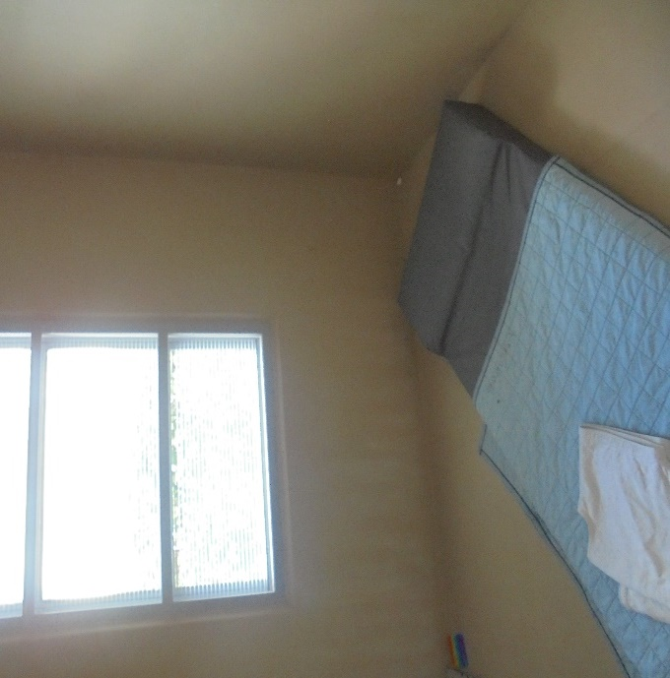 |  | 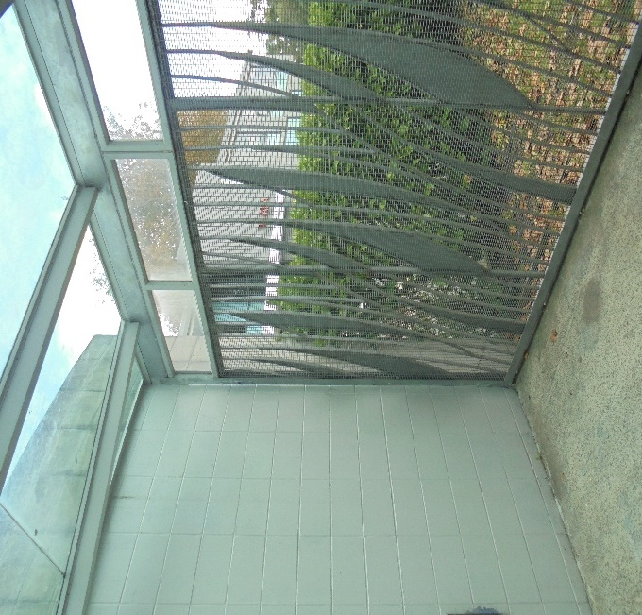
Figure 1: Seclusion room |  | Figure 2: Seclusion courtyard
Staff advised my Inspectors that all admissions were received through the HCA for assessment and care recipients would only spend as much time in the HCA as was deemed clinically necessary, otherwise they could transition directly onto the Unit.
Both seclusion rooms were clean, had sufficient natural light and a small clock was displayed for care recipients in the seclusion rooms to maintain orientation to time and date. The courtyard, while stark, was also clean and had adequate shelter.
I was pleased to see that the HCA had a range of sensory items available for care recipients. This included weighted beanbags and blankets, soft toys, and other items and activities.
Information was displayed in the HCA on the complaints process and how to contact the District Inspector, in accessible format. The use of visual ‘mood thermometers’ in the HCA was a positive initiative and effective tool used to support emotional regulation, which was well-received by care recipients my Inspectors spoke with.
Care recipients, based on risk assessment, were also able to keep taonga or sensory items with them in seclusion if deemed appropriate. Any removal of cultural or spiritual items of significance had to be confirmed via the Cultural/ Spiritual Advocacy services. Cultural Advisors visited care recipients in seclusion.
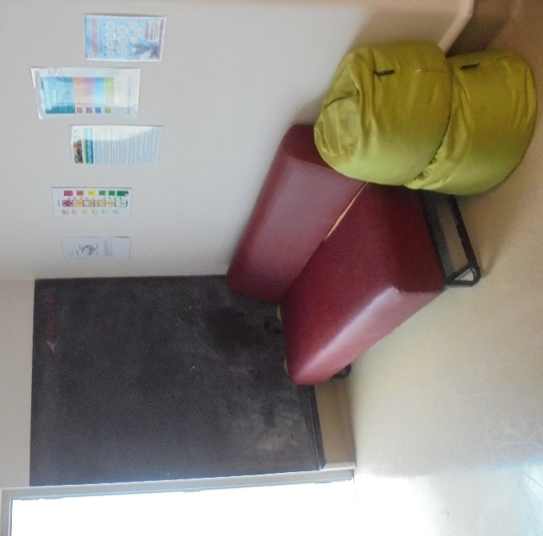 |  | 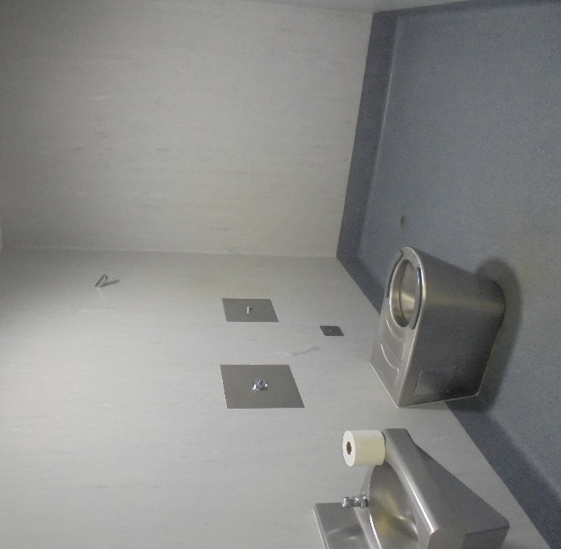
Figure 3: High Care Area – de-escalation lounge |  | Figure 4: High Care Area – bathroom

Seclusion policies and events
The DHB provided Inspectors with the Seclusion Procedures & Guidelines – Specialty Mental Health and Addictions (the Seclusion Procedure) (dated September 2020). The Seclusion Procedure had a review period of 36 months.
Data provided by the Service indicated that from 1 October 2020 to 31 March 2021 there were 22 seclusion events. In my previous report, data provided between March 2016 and February 2017 showed there were 20 seclusion events.
While this is a slight increase from my last inspection, I note there had been an overall decrease in the 12 months prior to the inspection. Data provided showed that seclusion hours per month had reduced by 50 percent from 73.65 hours to 36.83 hours by December 2021. Staff noted that there had been a number of spikes in the use of seclusion following the admission of one care recipient and impacts of COVID-19 lockdowns.
However, as I discuss below on page 22 of this report, the Unit was not recording the use of Night Safety Procedures (NSPs) as seclusion. I therefore cannot rely on the seclusion data provided, because NSPs are still not being reported as seclusion events.
Staff attributed the overall reduction in the use of seclusion to the implementation of the PBS model of care. My Inspectors saw staff regularly utilised therapeutic items and practices to support care recipients in seclusion. Inspectors also saw evidence of staff debriefing with care recipients post-seclusion and the use of behavioural support tools such as the ‘chain analysis’.
Table 1: Seclusion events 1 October 2020 to 31 March 2021
Month | Events | Care recipient numbers | Hours | Average hours
October | 3 | 2 | 420 | 140
November | 2 | 1 | 645 | 322.5
December | 2 | 2 | 100 | 50
January | 4 | 3 | 1775 | 443.75
February | 5 | 4 | 523 | 104.6
March | 6 | 5 | 3875 | 645.83
Total: | 22 | 17 | 7338 | 284.44

Self-seclusion of Care recipient A
At the time of inspection, Care recipient A was residing in a separate cluster on the Unit. Care recipient A had been on the Unit for 1,581 days.
Care recipient A required significant levels of support and resource in their daily living. They had 3:1 staffing and were reluctant to leave their cluster, as the physical environment, including noise, light and other stimuli, as well as their sensitivity to other people, including staff, would cause them significant distress.
Staff told my Inspectors that Care recipient A would decline to leave their cluster, and regularly self-secluded by requesting staff leave the space, where they locked the door to the cluster themselves. Once locked, the door had to be reopened by staff. Inspectors’ review of clinical notes, their Care and Rehabilitation Plan (CARP), management plan, and conversations with staff clearly indicated that this was the individuals’ preferred intervention if they became anxious or dysregulated. Staff remained at the door and offered support and encouraged Care recipient A to engage in autonomous decision-making by unlocking the door or joining staff in the lounge area. Inspectors found that staff were actively working to desensitise and introduce Care recipient A to the wider unit environment and support them to work with other staff.
A separate care plan was provided to Inspectors, which outlined that Care recipient A, on occasion, would request to sleep in a seclusion room in the HCA. Staff would leave the door open for them, however Care recipient A would always close the door themselves in order to feel safe. Again, the care recipient required staff to unlock the door to exit.
Care recipient A’s CARP stipulated [during their stays in the HCA] that ‘whenever the door is shut for any reasons, a new seclusion event is triggered and the appropriate documentation, reviews and notifications must be followed as per policy.’
Senior management acknowledged that while they recorded Care recipient A’s stays in the HCA seclusion room, they were not recording when they chose to self-seclude in their cluster, which was also a designated seclusion area. Staff told my Inspectors that this was because both staff and the care recipient viewed the cluster as the care recipient’s ‘home’.
I accept that Care recipient A’s decision to self-seclude in their cluster may not strictly meet the Ministry of Health’s definition of seclusion. However, as they are still alone and unable to freely exit from the area when the door is closed, there needs to be robust documentation and recording of these events.
Therefore, in order to monitor progress and support their progression to an open environment, I suggest the Unit record when Care recipient A self-secludes or spends periods alone in their cluster.
In response to my provisional report, the Service stated that ‘we fully accept we need a robust way of monitoring these differing forms of seclusion and hope we might be able to differentially record ‘full seclusion’ self-isolation and night safety plans all as forms of seclusion but all with varying levels of restriction’.
I look forward to seeing this in the future.

Night Safety Procedures
The Unit’s Night Safety Procedure (NSP) was captured within the Seclusion Procedure.
In my 2017 report, I raised concerns regarding the use of Night Safety Orders on the Unit and recommended that it should be recorded as a use of force event on the restraint register in accordance with the December 2016 draft Ministry of Health guidelines, and the reasons comprehensively documented.
This had not been achieved. However, considering current Ministry of Health guidance, my view now is that the use of NSPs is a seclusion event and should be recorded as such.
Ministry of Health guidance and the Health and Disability Services (Restraint Minimisation and Safe Practice) Standards define seclusion as: ‘Where a person is placed alone in a room or area, at any time and for any duration, from which they cannot freely exit’. Perhaps the key element of this definition that may distinguish it from environmental restraint is the deprivation of company.
The practise of locking care recipients in their bedrooms overnight, alone, and without the ability to freely exit, meets this definition of seclusion. I consider that it should be recorded as such.
At the time of inspection, seven of the 10 care recipients on the Unit had a NSP. One of those individuals was on continuous observations due to health reasons and all others had clear clinical rationale that was documented on file.
Inspectors saw that the Unit did not utilise NSPs as a blanket approach and they were only implemented on an individual basis.
Inspectors’ review of documentation showed that all orders were up-to-date, signed, and the use of NSPs was also regularly reviewed at weekly clinical meetings. However, the use of NSPs was not being recorded as seclusion.
The Service, in response to my provisional report, stated that all use of NSPs was reported to the Ministry of Health on a quarterly basis, separately from seclusion data and in accordance with Ministry of Health guidelines. I acknowledge the Service was reporting on use of NSPs as stated. However, this does not alter my view that NSPs amount to seclusion and should be recorded accordingly.

Restraint
Inspectors were provided with the DHB’s Restraint Minimisation – Adult and Auckland Regional Forensic Mental Health Services (the Restraint Policy), dated May 2018. The Restraint Policy had a review date of 36 months.
Data provided by the Service showed that between 1 October 2020 and 31 March 2021 there were 47 restraint events, involving seven care recipients. This is a marked increase from my previous inspection, which reported nine events between March 2016 and February 2017.
Inspectors’ review of documentation showed that two care recipients attributed to 68 percent of all restraint events. Less than half of all restraint events resulted in seclusion.
However, I note the use of wrist locks and prone (floor) restraints was still applied on the Unit. This will be discussed further on page 26 of this report. I encourage the Service to take further steps towards the reduction of restraint on the Unit, in particular, through de-escalation training for staff.
Table 2: Restraint data (exclusive of seclusion data) 1 October 2020 to 31 March 2021
 | October | November | December | January | February | March
Total restraint events | 5 | 7 | 6 | 9 | 11 | 9
Total service users restrained | 2 | 2 | 4 | 3 | 3 | 5
Personal restraint | 5 | 7 | 6 | 9 | 11 | 9
Number of males restrained (Māori) | 0 | 0 | 1 | 0 | 0 | 0
Number of males restrained (Non Māori) | 2 | 2 | 3 | 3 | 3 | 3
Youngest person restrained (years) | 21 | 21 | 21 | 21 | 21 | 21
Oldest person restrained (years) | 36 | 36 | 47 | 37 | 37 | 40
Shortest restraint episode (minutes) | 5 | 3 | 2 | 5 | 1 | 1
Longest restraint episode (minutes) | 10 | 10 | 10 | 20 | 20 | 30
Average restraint episode (minutes) | 7.4 | 6.1 | 5.3 | 11.1 | 10 | 7.4

Environmental restraint

Environmental restraint of a care recipient in a separate cluster
At the time of inspection, Care recipient B was residing in a separate cluster on the Unit. The cluster had been specifically modified and retrofitted for the care recipient to provide a safer environment and prevent property damage and self-harm. Care recipient B had been on the Unit for 467 days.
Staff advised that due to their acuity and significant safety risk to both staff and other care recipients, Care recipient B was prevented from leaving their cluster. They had 3:1 staffing (of the same gender) at all times and had limited access to other parts of the Unit, except to use a small enclosed courtyard, lounge area, or whānau room when other care recipients were not on the Unit. Inspectors’ review of clinical notes found that Care recipient B was offered daily access to the courtyard.
Care recipient B had no approved leave at the time of inspection and most activities and meals were provided in their cluster. Due to their significant assault risk, they were also unable to interact with other care recipients on the Unit.
Inspectors were provided copies of their CARP, reviewed clinical notes and documentation and spoke to the care recipient, their whānau and staff. Inspectors observed that they had good access to whānau and also received regular visits from a Cultural Advisor. Inspectors also saw evidence of whānau input in transition planning and strategies in place to move Care recipient B to a less restrictive environment.
My Inspectors observed that staff were proactively working to manage risk and ensure both staff and care recipient safety, while providing the least restrictive environment for the care recipient.
I acknowledge the efforts of staff and also the view that Care recipient B’s situation was not environmental restraint because the arrangements constituted ‘normal access to their environment’.
However, given Care recipient B was living in a more restrictive environment than ‘normal’ within the broader context of the Unit, I consider that there needs to be robust documentation and recording of these events.
Therefore, in order to monitor progress and encourage increased social interaction with others, I suggest the Unit record when Care recipient B is permitted to leave their cluster, including documenting whether it was at their request or the request of staff and what interactions or activities Care Recipient B was involved in at the time of the request.
The Service, in response to my provisional report, agreed that this should be monitored and further noted that ‘there are periods where Care Recipient B is alone in their cluster area often at their own request. Their area has been designated as a seclusion area. In keeping with Care Recipient A, we feel time spent alone in his cluster should therefore also be recorded as a form of seclusion’. I agree with this approach.

Restraint training for staff
The Service is one of the only mental health services across New Zealand to still use Control and Restraint (C&R) training as opposed to Safe Practice Effective Communication training. All Unit staff were up-to-date with C&R training, with the exception of two staff, one of whom was the Unit Manager.
The Restraint Policy dated May 2018 stated:
‘Training in the use of prone (floor) and wrist lock restraint types will be phased out eliminated over the next two years. This will result in the elimination of prone and wrist locks by 2020.’
The use of wrist locks and prone (floor) restraints was still applied on the Unit at the time of inspection, contrary to the Restraint Policy. I consider the Service needs to implement its own policy to ensure that restraint training aligns with human rights standards that does not inflict pain on care recipients.
In response to my provisional report, the Service recognised that C&R was ‘out of step’ with the national shift towards approved standardised training (or SPEC). The Service raised a number of reasons for not having adopted SPEC, including that the initial review completed by Te Pou which led to adoption of SPEC was provided across adult mental health services only. The Service also raised that the physical environment did not allow for the safe implementation of SPEC techniques or secure holds and referenced the size of the seclusion room exits and corridors.
The Service also stated that ‘in February 2021 this service approached the SPEC National Governance Group seeking a process for the development of a site wide variance to SPEC practice. In May 2021 the chair of the SPEC National Governance Group recommended that a Master Trainer attend one of the Mason Clinic restraint trainings to ascertain the specific issues and to work with the current trainers to find workable solutions. We have accepted this recommendation’. I look forward to seeing this implemented as a matter of priority, and will be monitoring progress.

Electro-convulsive therapy
There were no care recipients undergoing Electro-convulsive therapy (ECT) at the time of the inspection.

Sensory modulation
The Unit had an impressive Sensory Modulation Room, based on the international ‘Snoezelen Room’, a controlled multisensory environment that provides a non-directive therapy for people with autism and other developmental disabilities, dementia or brain injury.
The Room was large and well-equipped with multiple sensory items such as different materials on both the walls and floor to stimulate tactile senses, as well as lighting, colours, sounds and scents.
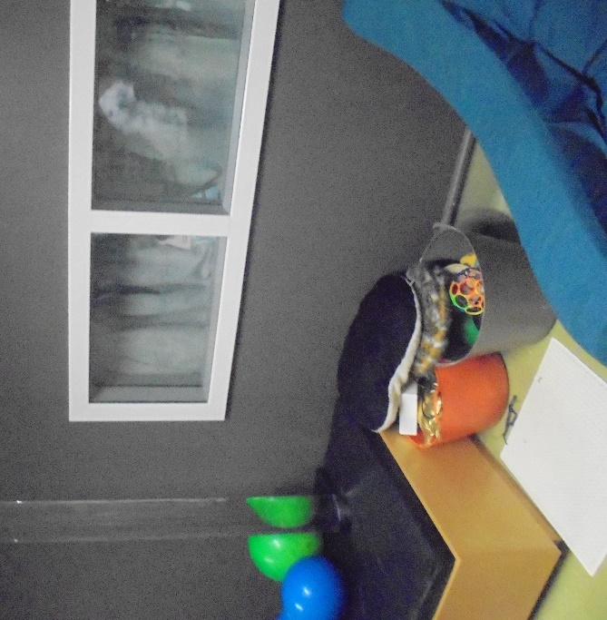 |  | 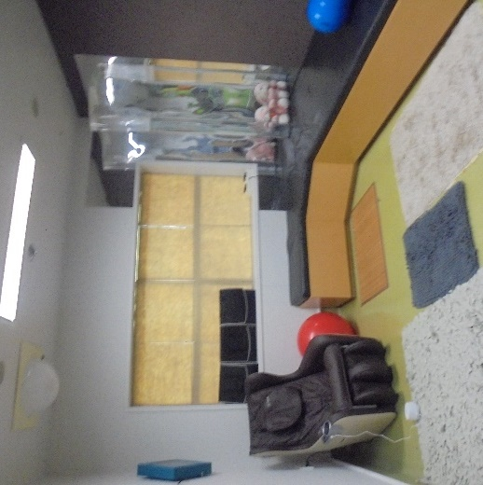
Figure 5: Sensory Modulation Room – activities |  | Figure 6: Sensory Modulation Room
Access to the Sensory Modulation Room was under staff supervision and I was pleased to see this room was well utilised, based on my review of clinical notes and conversations with staff and care recipients.
It would be beneficial for the Unit to keep a record or register, separate to clinical notes, which tracks the use of the Sensory Modulation Room, which may provide insight into its effectiveness in supporting rehabilitation and reducing seclusion and restraint on the Unit.

Care recipients’ and whānau views on treatment
Care recipients spoken with reported they felt safe on the Unit and that staff treated them with respect. Care recipients also reported they felt they could approach staff if they had any concerns. Inspectors observed positive and respectful interactions between care recipients and staff throughout the inspection.
The Unit ran weekly community meetings, which were facilitated by the care recipients and minuted. Care recipients appeared to be actively involved and previous meeting minutes indicate a broad range of topics discussed, including van ride outings, purchasing gardening equipment, reminders to wear sunscreen, suggested outings and meals, hairdresser visits, and complaints. Some complaints included maintenance issues, such as blinds or blocked toilets, using personal laundry baskets and reminders to be respectful to others. These meetings also provided an opportunity to promote and encourage positive behaviour and offer compliments.
Inspectors were also provided copies of ‘Care Recipient Weekly Feedback Forms’, which asked care recipients’ views on their physical and mental health, self-care, family and friendships and both challenges and positive things that had happened during the week. This Form was provided in Easy Read format with visual cues, kept on the care recipients’ files and was also discussed in clinical reviews.
Whānau spoken with were complimentary about the staff and standard of care and treatment of their family members. Whānau also told Inspectors they felt included and involved in care planning and discussions relating to their family member.
At the time of inspection, there was no independent Consumer Advocate on the Unit. However, staff told my Inspectors that they had recently engaged with an external provider and were reviewing options to provide independent advocacy for care recipients on the Unit. I encourage the Unit to make this a priority.

Recommendations – treatment
I recommend that:
- The use of service-wide restrictive practices on the Unit cease.
- The use of Night Safety Orders be recorded and reported as seclusion events. This is a repeat amended recommendation.
- The Unit record when Care Recipient A is alone in their cluster with the door locked.
- The Unit record when Care Recipient B is able to leave their cluster.
- The Service eliminates the use of wrist lock and prone (floor) restraints, in line with the Restraint Policy.
- The Unit record the use of the Sensory Modulation Room.
- Consumer Advocate support is made available to care recipients.

Good practice
The implementation of the Positive Behavioural Support training was having a positive impact on seclusion reduction.
A range of sensory items and activities were available in the HCA, and care recipients were able to keep taonga and receive visits from the Cultural Advisor while in seclusion.
The Sensory Modulation Room (or ‘Snoezelen Room’) was therapeutic and well-equipped.

Protective measures

Complaints process
A copy of the DHB’s Complaints Management Policy (the Complaints Policy) (dated November 2019) was provided to Inspectors. The Complaints Policy had a review period of 36 months.
In my 2017 report, I recommended that the DHB’s internal complaint process be displayed in all areas of the Unit. I was pleased to see this had been achieved.
District Inspector (DI) contact details and posters for the Health and Disability Commissioner’s ‘Code of Health and Disability Service Consumers’ Rights’ were clearly displayed on the Unit, including the HCA. Information was displayed in accessible and Easy Read format.
Information on the role and functions of the DI was also available on the Unit.
Staff and care recipients my Inspectors spoke with had a good understanding of the complaints process and were aware of the DI, their role, and how to contact them. Inspectors observed that the DIs were active on the Unit.
The Unit received one complaint between 1 October 2020 and 31 March 2021. The complaint concerned a serious incident and was referred to the Ministry of Health and Police for investigation. Inspectors reviewed the documentation and found the Unit’s response was prompt and all appropriate agencies were notified on the date of the incident, including the DI. The Unit’s response was courteous, individualised and addressed the complaint in detail. Documentation from the external investigation provided to Inspectors indicated there was no evidence to support the allegation.

Records
Of the 10 care recipients residing on the Unit on the first day of the inspection, two were detained under the MHA and eight care recipients were under the IDCCR Act. All files contained the necessary paperwork to detain and treat the care recipients. Paperwork on care recipients’ Welfare Guardians were also on file and up-to-date.
Inspectors reviewed care recipients’ CARPs, leave paperwork, clinical notes and clinical review meeting minutes. Overall, Inspectors found that records were comprehensive, detailed and plans were individualised.
Leave plans were comprehensive and all care recipients had some form of leave, accompanied by comprehensive and up-to-date risk management plans. Inspectors attended one of the Unit’s weekly clinical meetings, where staff were actively seeking opportunities to facilitate leave for care recipients to support their transition plans.
The Unit had an impressive care recipient admission and orientation checklist that was presented in an Easy Read format and provided visual cues. I welcome this initiative, which supports care recipient involvement and is tailored to the needs of the individuals.
However, Inspectors found that physical paper files were messy and it was difficult to locate some information. Staff told my Inspectors that the Unit was in the process of recording all information online.
My Inspectors also reviewed care recipients’ files for evidence of completed treatment consent forms. While care recipients on the Unit are not there voluntarily, it is standard to seek consent to treatment wherever possible. Where a care recipient does not consent to treatment, this should be recorded on their file and in clinical notes.
While care recipients had completed consent to share information, there was no evidence of consent to treatment on file.

Recommendations – protective measures
I recommend that:
- Care recipient Consent to Treatment forms be completed.

Good practice
The Unit’s admission checklists in Easy Read and visual format were a positive initiative.

Material conditions

Accommodation and sanitary conditions
The Unit, which opened in 2006, was clean and tidy throughout.
The Unit comprised four separate clusters, which staff advised followed a step-down and transitional model:
- Cluster 1: Assessment cluster comprising two bedrooms, shared bathroom and a lounge area;
- Cluster 2: Four bedrooms, shared bathrooms and a lounge area;
- Cluster 3: Two bedrooms, shared bathrooms and a lounge area; and
- Cluster 4: Four bedrooms with en-suite bathrooms, an occupational therapy kitchen and a lounge area.
Bedrooms were personalised, tidy and spacious and had adequate natural light and ventilation. Staff advised that care recipients could not independently lock or unlock the doors to their bedrooms, which had to be facilitated through staff via a call bell.
Access to linen and clean bedding was good. Both the cluster lounge areas and the main communal lounge area provided suitable furnishings, natural light, and a television. Toiletries, however, were locked and had to be accessed via staff. Only individuals residing in bedrooms with en-suites were able to keep personal toiletries.
Some maintenance issues were identified on the Unit, such as issues with the laundry machine and toilet locks. Action was taken at the time of inspection to address both of these issues.
While the Unit was well-maintained and had adequate facilities, the environment was not ideal for the particular cohort at the time of inspection, which included autistic individuals.
Staff advised that the impacts of noise, such as echoes and loud water pipes, as well as excess of natural and artificial light and other overstimulation, were negatively impacting care recipients on the Unit with autism. As discussed on page 21 of this report, one care recipient required high levels of care in a separate cluster, due to the negative impact of the physical environment on their wellbeing.
One care recipient told Inspectors they enjoyed using the bathtub on the Unit but were no longer able to do so. Staff advised this was as a result of the noise and distress it would cause another care recipient who was residing adjacent to the bathtub.
Staff were aware of these constraints and were actively working to address them to ensure care recipients were not negatively impacted by their environment. This included installing additional blinds and coverings on windows or encouraging care recipients to use other bathrooms that would not negatively impact on others.
I would encourage the Unit to continue seeking alternative arrangements to allow care recipients access to the bathtub, perhaps at times where the other care recipient is not in earshot or is in another part of the Unit.
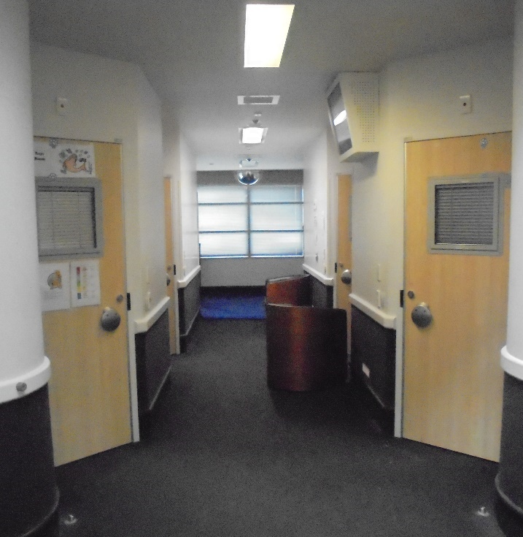 |  | 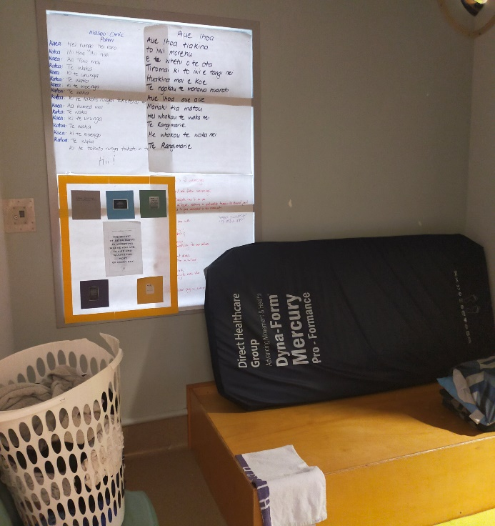
Figure 7: Cluster hallway |  | Figure 8: Bedroom

Food
Care recipients’ meals were prepared at North Shore Hospital and delivered to the Unit in heated trolleys. Breakfast was delivered from around 8.30am, lunch at 12.30pm, and dinner around 5.30pm. During the day, care recipients were also provided with a range of snacks, fruits and yoghurts.
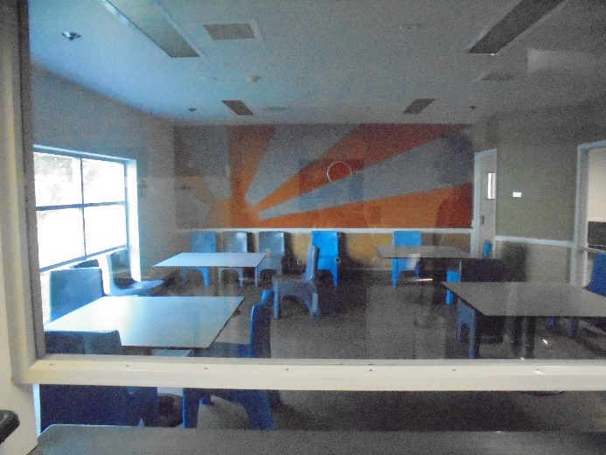 |  | 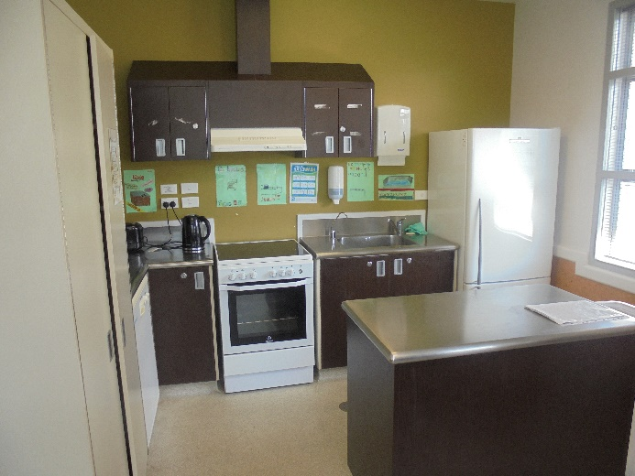
Figure 9: Dining room |  | Figure 10: Occupational Therapy Kitchen
All care recipients had regular access to personal snacks, which were securely kept in the Unit kitchen. Care recipients were also able to purchase takeaway meals on community leave or during whānau visits. One care recipient, who had no approved leave at the time of inspection, was able to order takeaway in their cluster on a weekly basis. The care recipient told Inspectors they enjoyed getting takeaway and sharing weekly meals with staff, which they felt was a way of ‘celebrating their culture’.
The Unit also had a separate occupational therapy kitchen, which allowed care recipients to make meals on a set roster. This was facilitated through the Occupational Therapist (OT).
Aside from one care recipient, all meals were provided in the dining area, which was locked outside of meal times. Water coolers were available on the Unit so care recipients had independent access to cold water. However, care recipients were unable to access the dining area to make their own hot drinks during the day. Staff said that hot drinks were only available at specified times during the day.
While I acknowledge the view that the restriction exists for safety reasons, I consider the blanket restriction on access to the kitchen unreasonably restricted care recipients’ ability to access hot water for drinks. I consider that access to hot drinks should be based on individual risk and subject to regular review.

Recommendations – material conditions
I have no recommendations to make.

Activities and programmes

Outdoor exercise and leisure activities
A number of outdoor exercise and leisure activities were available to care recipients.
The Unit comprised an occupational therapy kitchen, an Arts and Activity Room, gymnasium, and two courtyards. The main courtyard was spacious, with adequate seating and shade, had a basketball court and a vegetable garden. The small secure courtyard had adequate seating and shade.
Care recipients also had access to a range of puzzles, books, television and personal activities such as PlayStation in their separate clusters.
At the time of inspection, all recreational areas were locked and access could only be facilitated under staff supervision. Staff told my Inspectors that two staff were required for care recipients to access these rooms due to previous assaults and complaints made against staff. However, Inspectors saw that care recipients had good access to the courtyard, activity rooms and gym throughout the inspection.
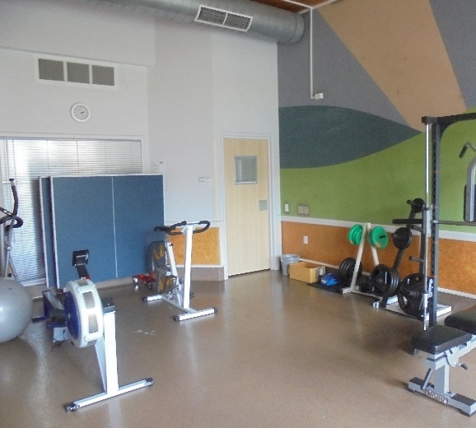 |  | 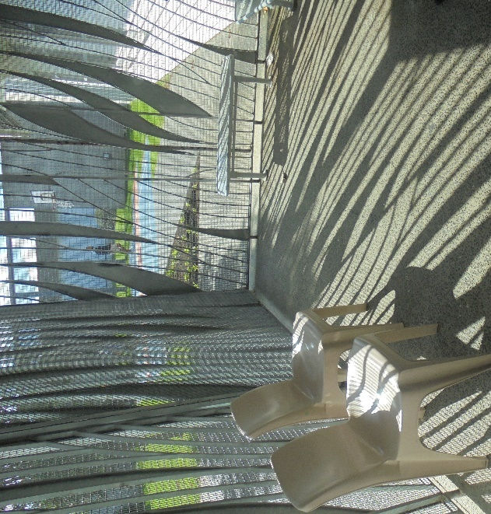
Figure 11: Unit Gym |  | Figure 12: Small secure courtyard
Each care recipient had their own tailored weekly programme, which was individualised and included both group and 1:1 activities. Individual activities included kapa haka, volleyball, basketball, gardening, and van rides or community outings and were displayed on care recipients’ doors.
A weekly schedule of the Unit’s activities programme was well advertised to care recipients on the Unit and included baking, arts and craft, music therapy, and other sensory activities. Activities generally took place in the Arts and Activity room.
The Unit employed three full-time equivalent (FTE) OTs and I was pleased to hear they covered both evenings and weekends. The OTs facilitated Unit activities and programmes and were also counted as ‘on rostered numbers’. This meant that, on occasion, the OTs may be required to support the staff with observations and other tasks, which could impact on programmes.
Nearly all care recipients had some form of leave and staff were proactive in facilitating leave as part of their transition plans. A number of care recipients had recently gone on a communal fishing trip with staff, with photos displayed on the Unit. Both staff and care recipients told Inspectors they enjoyed this community outing and looked forward to more outings in the future.
However, staff told my Inspectors that the Unit required a dedicated fit-for-purpose secure van to facilitate community leave for some care recipients. This included requirements for a secure barrier between care recipient and driver, additional locks and mirrored windows. At the time of inspection, one care recipient was unable to take leave due to the lack of secure fit-for-purpose transport. I encourage the Unit to provide access to fit-for-purpose transport.

Programmes
Core skills programmes available included independent living skills (cooking, shopping, budgeting), creative programmes, mindfulness, biofeedback games, sensory processing activities, sports and leisure off-site activities. A number of care recipients were attending the SAFE programme on-site with an external provider.
At the time of inspection, the DHB had vacancy for an FTE Clinical Psychologist. As a result, there were fewer therapeutic programmes occurring on the Unit at the time of inspection. The current vacancy was felt across the Unit, by both staff and care recipients, and was impacting on programmes and care recipients that required individual sessions.
I encourage the DHB to continue its efforts to engage an FTE Clinical Psychologist to provide support for care recipients.
In response to my provisional report, the Service stated that ‘The funding is in place and multiple adverts have been placed. The national crisis over clinical psychology and the competition for arguably more attractive posts supporting people with less complex needs and the lack of training in New Zealand specifically working with people with ID and pervasive developmental disabilities adds to our difficulty recruiting and retaining psychologists’.
I acknowledge the national difficulties in recruiting clinical psychologists and encourage the Service to continue its recruitment drive.

Cultural and spiritual support
The Service had a Memorandum of Understanding (MoU) with both Te Whanau o Waipareira Trust and Te Runanga o Ngati Whatua. The MoU stated that ‘both parties acknowledge that the basis of this Treaty relationship is the commitment to achieving improvements in Maori health status within the WDHB region and giving due priority to any existing inequities’.
Staff told my Inspectors that the Unit previously had a Cultural Advisor, however they recently left the role. In the interim, the Unit had secured the support of a Taurawhiri from the Service’s Cultural team to provide one-on-one support for one of the care recipients.
Inspectors observed that the Taurawhiri was frequently on the Unit and engaging with the care recipient in one-on-one activities, community outings, whānau visits and attending relevant clinical meetings and MDTs to provide cultural input.
The Service also employed the support of a Pasifika Cultural Advisor for three care recipients on the Unit. However, due to the Taurawhiri and Pasifika Cultural Advisor’s commitments across the wider service, they were only available to support a small number of care recipients.
While I am pleased to see active engagement and support being provided to these individuals, I would like to see additional resource made available to provide cultural support to all care recipients.
Spiritual and pastoral support was also available to care recipients. The Service employed two Chaplains, who provided pastoral support across the wider forensic inpatient service. Staff told my Inspectors that the Chaplains visited the Unit twice per week and facilitated church services and one-on-one engagement with care recipients. Chaplains had also been invited to meet with care recipients in seclusion or the HCA in the past.

Recommendations – activities and programmes
I recommend that:
- A secure fit-for-purpose van is provided to facilitate care recipients’ leave.
- Cultural support is made available to all care recipients on the Unit.

Communications

Access to visitors
Unit visiting hours were only permitted on weekends and for up to 30 minutes. However, staff told my Inspectors that visiting hours were flexible for whānau visiting from out of region or on a case-by-case basis. While I acknowledge staff were flexible with visits, I consider these visiting hours overly restrictive, as mentioned on page 18 of this report.
Visits were facilitated off the Unit in the whānau room, which provided tea, coffee and snacks for visitors. Whānau were also able to bring food to visits. There was no whānau flat for out of region visitors on the Mason Clinic campus.
Staff told Inspectors that visits were supervised but that whānau were afforded privacy.
Staff advised that a number of care recipients were also regularly given leave to visit whānau off-site, accompanied by staff. A number of care recipients visited whānau living out of region once per month. My Inspectors observed, through review of clinical notes, the Unit diary and conversations with care recipients, whānau and staff, that these visits were regularly facilitated and encouraged.

Access to external communication
Staff advised that all care recipients had an individualised phone plan and approved phone list. The Unit had a phone booth, which was located in the main communal area. The booth had privacy and care recipients were able to make calls after 4pm on weekdays and anytime from 9am on weekends. Phone calls were restricted to 10 minutes and access was not independent of staff. In response to my provisional report, the Service stated that time restrictions were in place to ‘enable fairness for all service users and their whanau to communicate. The timing of phone calls is encouraged to be between the ‘non-working’ hours so as not to unnecessarily interrupt programmes and rehabilitation but again is not rigidly adhered to’.
Mobile phones and computers were not permitted on the Unit, however, staff and care recipients noted that access to Skype and Zoom was good. Video calls were used for meetings with whānau, court hearings and meetings with the DI throughout the COVID-19 Alert Levels 4, 3, and 2.
Care recipients did not raise any concerns with Inspectors about their ability to send and receive mail.

Recommendations – communications
I have no recommendations to make.

Health care

Primary health care services
Care recipients received a physical assessment on admission with the House Officer. Assessments included obtaining a medical history, taking routine blood tests, and addressing any physical concerns. The Unit also had a GP that was available three days per week, however the House Officer was available at all other times.
A treatment room was available on the Unit for physical examination and storage of medications, including controlled drugs. Inspectors observed that the room was secure, tidy and well organised.
Care recipients were aware of their medications and education sessions were provided by the Unit staff, with input from the Pharmacist. Care recipients also had ‘health passports’ and Easy Read pamphlets that explained their medications.
There was one documented medication error between 1 October 2020 and 31 March 2021.
Care recipients did not raise any concerns with Inspectors regarding access to primary health care services.

Recommendations – health care
I have no recommendations to make.

Staff

Staffing levels and staff retention
Inspectors observed a supportive and cohesive team environment and culture. Staff my Inspectors spoke with felt supported by and were complimentary towards leadership, who appeared to be actively involved on the Unit.
Data provided by the Service showed a multi-disciplinary staff complement (excluding doctors) of 28 Registered Nurses (RNs) and 16 Mental Health Support Workers (MHSWs). There were no nursing staff vacancies at the time of inspection.
Nursing staff worked a four-shift roster, with a designated staffing level on each shift. Occupational Therapists (OTs) were counted as ‘on rostered numbers’ during the am and pm shift as part of the team working with care recipients for care and therapy. The designated staffing levels were:
- Morning shift from 7am to 4pm with eight RNs, seven MHSWs and one OT;
- Early afternoon shift from 12pm to 9pm with 1 RN and 1 MHSW;
- Afternoon shift from 3pm to 11.30pm with eight RNs, five MHSWs and one OT; and
- Night shift from 11.30pm to 8am with two RNs and two MHSWs.
Data provided by the Service indicated that between 2017/18 and 2018/19, staff sickness rates decreased from 3.7 percent to 3.3 percent for RNs and from 5.3 percent to 3.8 percent for MHSWs.
Data also showed that between 2017/18 and 2018/19, nursing staff turnover rates increased from 0 percent to 4.8 percent. However, between 2018/19 and 2019/20 this decreased to 4.3 percent.

Workforce training
Staff and senior management told my Inspectors that there was a lack of intellectual disability (ID) specific training available.
Senior management raised concerns that this was a national issue and a lack of psychopaedic or ID trained nurses meant that services had to source expertise and recruitment internationally.
The Service employed one Nurse Educator, who specialised in mental health and provided in-house training across the wider inpatient forensic service.
Inspectors observed that the Nurse Educator was responsible for a significant level of training, education and resource across the Service for over 200 nursing staff. As a result, there was only sufficient resource to focus on mandatory training and supervision. Additional training, such as PBS, required external funding or delivery through external agencies.
Staff raised that they wanted more training to cover a range of cognitive impairment and intellectual disabilities including autism spectrum disorder, acquired brain injury and traumatic brain injury, among others.
Due to the lack of resources and funding for ID specific training, Care Managers and the Lead Clinician provided in-house training to nursing staff. This training covered the IDCCR Act, communication and behavioural analysis techniques, and models of care. The in-house training was also made available to staff across the wider service who worked with care recipients with an ID.
I consider there is a need for additional Nurse Educator resource, which includes disability specific interventions.
After the Inspection I wrote to the Ministry of Health and the Nursing Council Aotearoa to enquire as to what specific ID training is currently provided to nursing staff, and how the Ministry of Health engages with the Nursing Council and DHBs to deliver training specific to ID. The Ministry’s response acknowledged that there were significant workforce pressures within the sector, including the ongoing attrition of suitably qualified ID nurses.
I will continue to engage with the Ministry of Health, the Nursing Council Aotearoa, the DHB and others, as relevant, on this matter.
Inspectors also observed a lack of sufficient resource for Care Managers (CM). The CM was responsible for all aspects of a care recipient’s rehabilitation and care planning, as set out in section 141 of the IDCCR Act. At the time of inspection, there was only one FTE CM. Copies of the Clinical Governance Reports to the FIDSS highlighted that the CM FTE was not funded in the budget, lacked support and was over allocated. Concerns were also raised around the lack of structured national training available for CMs.
In regards to lack of training for CMs, the Ministry of Health stated that, as part of ongoing strategic planning, a workforce strategy and action plan would be developed, which would cover ongoing needs of training for CMs.

Recommendations – staff
I recommend that:
- The DHB provide additional:
  - Nurse Educator resource, with focus on disability specific interventions; and
  - Care Manager resource.

Acknowledgements
I appreciate the full co-operation extended by the care recipients, Unit Manager and staff to the Inspectors during their inspection of the Unit. I also acknowledge the work involved in collating the information requested.

Peter Boshier
Chief Ombudsman
National Preventive Mechanism
- List of people who spoke with Inspectors
Table 3: List of people who spoke with Inspectors
Managers | Unit staff | Others
Unit Manager  Operations Manager  Director of Area Mental Health Services | Consultant Psychiatrist  Registered Nurses  Occupational Therapists  Social Worker  Mental Health Support Workers  House Officer | Care recipients  Whānau  District Inspector  Taurawhiri  Chaplain

- Legislative framework
In 2007 the New Zealand Government ratified the United Nations Optional Protocol to the Convention against Torture and Other Cruel, Inhuman or Degrading Treatment or Punishment (OPCAT).
The objective of OPCAT is to establish a system of regular visits undertaken by an independent national body to places where people are deprived of their liberty, in order to prevent torture and other cruel, inhuman or degrading treatment or punishment.
The Crimes of Torture Act 1989 (COTA) was amended by the Crimes of Torture Amendment Act 2006 to enable New Zealand to meet its international obligations under OPCAT.

Places of detention – health and disability facilities
Section 16 of COTA defines a “place of detention” as:
“…any place in New Zealand where persons are or may be deprived of liberty, including, for example, detention or custody in…
(d) a hospital
(e) a secure facility as defined in section 9(2) of the Intellectual Disability (Compulsory Care and Rehabilitation) Act 2003…”
Ombudsmen are designated by the Minister of Justice as a National Preventive Mechanism (NPM) to inspect certain places of detention under OPCAT, including hospitals and the secure facilities identified above.
Under section 27 of COTA, an NPM’s functions include:
- to examine the conditions of detention applying to detainees and the treatment of detainees; and
- to make any recommendations it considers appropriate to the person in charge of a place of detention:
  - for improving the conditions of detention applying to detainees;
  - for improving the treatment of detainees; and
  - for preventing torture and other cruel, inhuman or degrading treatment or punishment in places of detention.

Carrying out the OPCAT function
Under COTA, Ombudsmen are entitled to:
- access all information regarding the number of detainees, the treatment of detainees and the conditions of detention;
- unrestricted access to any place of detention for which they are designated, and unrestricted access to any person in that place;
- interview any person, without witnesses, either personally or through an interpreter; and
- choose the places they want to visit and the people they want to interview.
Section 34 of COTA provides that when carrying out their OPCAT function, Ombudsmen can use their Ombudsmen Act (OA) powers to require the production of any information, documents, papers or things (even where there may be a statutory obligation of secrecy or non-disclosure) (sections 19(1), 19(3) and 19(4) OA). To facilitate his OPCAT role, the Chief Ombudsman has authorised inspectors to exercise these powers on his behalf.

More information
Find out more about the Chief Ombudsman’s OPCAT role, and read his reports online: ombudsman.parliament.nz/opcat.

The Unit referred to people under the IDCCR Act as ‘care recipients’ and those under the Mental Health (Compulsory Assessment and Treatment) Act 1992 as ‘service users’. For the purpose of anonymity in this report, the term care recipients is used to refer to all people being held on the Unit under a detaining order.
RIDSS provide hospital level secure residential services and assessment beds. Both Auckland and Wellington RIDSS services provide some beds for clients transferring from other regions. RIDSS are contracted through the DHBs.
When the term Inspectors is used, this refers to the inspection team comprising of three Inspectors.
Section 7.
Delivered by Explore, the PBS framework ‘focuses on understanding a person’s needs and supporting them and the people around them to experience a better quality of life’ while reducing challenging behaviour. See www.healthcarenz.co.nz/explore-specialist-advice for more information.
See https://www.goodlivesmodel.com/ for more information.
Office of the Ombudsman report on an unannounced inspection to Pohutukawa Unit – Mason Clinic under the Crimes of Torture Act 1989, March 2017.
The Ministry of Health defines night safety procedures as: ‘the practice of locking a patient in their bedroom overnight for the purposes of safety. The practice has no therapeutic function and constitutes (at the very least) a form of environmental restraint.’ Ministry of Health. 2018. Night Safety Procedures: Transitional Guideline.
The role of Care Manager is to fulfil the functions and duties as set out in section 141 of the IDCCR Act, including work with the care recipient to develop a ‘Care and Rehabilitation Plan’ that reflects the support needs of the care recipient.
Female care recipients were accommodated in other mental health units within the wider service due to safety concerns. This will be discussed further on page 16 of this report.
For more information on the Service and contracting model, see https://www.mhaids.health.nz/our-services/intellectual-disability-services/
No assessment beds were available at the time of inspection due to a cluster being occupied by one care recipient. This will be discussed on page 15 of this report.
Two female care recipients were residing in other units across the wider forensic inpatient service at the time of inspection. The care and treatment of these care recipients was not assessed on this inspection.
See https://covid19.govt.nz/alert-system/covid-19-alert-system/ for more about New Zealand’s COVID-19 alert system.
The Service is one of the only mental health services across New Zealand to still use Calming and Restraint training. Most mental health services use Safe Practice Effective Communication training.
My inspection methodology is informed by the Association for the Prevention of Torture’s Practical Guide to Monitoring Places of Detention (2004) Geneva, available at www.apt.ch.
For a list of people spoken with by the Inspectors, see Appendix 1.
See page 30 of this report.
‘People with “high and complex needs” are a small and unique group of people with disabilities at the high end of the support needs spectrum. This group of disabled people includes those with multiple disabilities such as sensory disabilities, physical disabilities, severe intellectual disability, and serious and ongoing medical conditions. These individuals require support with self-care and basic activities of daily living. They tend to also have behaviours that require a very high level of support.’ Te Pou o Te Whakaaro Nui (2013). Valuing and supported disabled people and their family/whānau. Te Pou o Te Whakaaro Nui.
These care recipients had been residing on the Unit for 467 days and 1,581 days on the first day of inspection.
On 12 April 2021 five supernumerary beds had come on-stream across the wider inpatient forensic service to provide additional capacity for the Unit.
At the time of inspection, one female care recipient was residing in Te Aka Kaupapa Māori Rehabilitation Unit, while another was in Totara Forensic Sub-Acute Inpatient Unit.
Staff told my Inspectors that care recipients remained under the care of the Unit and the Care Manager regularly visited care recipients. However, staff on these units were not ID trained or had specific expertise to support these care recipients.
Final opinion of the Chief Ombudsman – Oversight: An investigation into the Ministry of Health’s stewardship of hospital-level secure services for people with an intellectual disability (June 2021).
See page 21 of the report.
Seclusion is defined as: ‘Where a person is placed alone in a room or area, at any time and for any duration, from which they cannot freely exit’. New Zealand Standards. Health and Disability Services (Restraint Minimisation and Safe Practice) Standards. Ministry of Health. 2008.
This was achieved for five consecutive months from October 2020 to February 2021.
Also known as functional analysis, this technique is designed to help a person to understand the function of a particular behaviour, uncover the factors that led to that behaviour, providing the person a better ability to intervene and prevent that behaviour in future.
Data provided by the Service.
As at 12 April 2021.
‘Care and Rehabilitation Plans’ are a requirement for care recipients under s25 (1) of the IDCCR Act.
Management plans were updated on a monthly basis.
Now referred to as Night Safety Procedures.
Ministry of Health. 2018. Night Safety Procedures: Transitional Guideline. Wellington: Ministry of Health. https://www.health.govt.nz/system/files/documents/publications/night-safety-procedures-transitional-guideline-feb18.pdf
New Zealand Standards. Health and Disability Services (Restraint Minimisation and Safe Practice) Standards. Ministry of Health. 2008.
Mental Health (Compulsory Assessment and Treatment) Act 1992, section 71.
Data as provided by the Service.
Personal restraint is when a service provider(s) uses their own body to limit a care recipient’s normal freedom of movement. New Zealand Standards. Health and Disability Services (Restraint Minimisation and Safe Practice) Standards. Ministry of Health. 2008.
As at 12 April 2021.
This is distinct to Care recipient A’s circumstances (as described on page 20 of this report) as they were not prevented from leaving the cluster, rather they independently chose not to.
SPEC training was designed to support staff working within inpatient mental health units to reduce the incidence of restraints. SPEC training has a strong emphasis on prevention and therapeutic communication skills and strategies, alongside the provision of training in safe, and pain-free personal restraint techniques. https://www.tepou.co.nz/initiatives/towards-restraint-free-mental-health-practice/149. Accessed online 29 September 2020.
Electroconvulsive therapy is used mainly in the treatment of severe depressive episodes. It involves the passage of an electric current across the head of a person to produce a convulsion.
Sensory modulation uses a range of tools to help individuals get the right amount of sensory input. In mental health settings, sensory modulation can be used to assist distressed clients to regain a sense of calm’. Te Pou o te Whakaaro Nui. Sensory modulation in inpatient mental health: A summary of the evidence. (2011), Te Pou o Te Whakaaro Nui, Auckland, at page 3.
The Snoezelen Room was developed in the Netherlands and provides a multisensory environment for users to reduce agitation and anxiety, stimulate reactions and encourage communication. For more information see https://www.snoezelen.info/
At the time of inspection, Cluster 1 was occupied by Care recipient A (see page 20 of this report).
At the time of inspection, Cluster 3 was occupied by Care recipient B (see page 24 of this report).
This was due to the physical layout of the Unit.
https://www.safenetwork.org.nz/
https://www.healthpoint.co.nz/mental-health-addictions/mental-health-addictions/te-whanau-o-waipareira-mental-health-addiction/
https://www.ngatiwhatua.iwi.nz/

