OPCAT Report
Report on an announced inspection of Māngere Refugee Resettlement Centre under the Crimes of Torture Act 1989
April 2021
Peter Boshier
Chief Ombudsman
National Preventive Mechanism

OPCAT Report: Report of an announced inspection of Māngere Refugee Resettlement Centre under the Crimes of Torture Act 1989
ISBN: 978-0-9951496-2-5 (PDF)
Published May 2021

Office of the Ombudsman | Wellington, New Zealand | www.ombudsman.parliament.nz
Contents
Foreword 1
Good practice 2
Areas for improvement 2
Facility facts 4
Operating capacity 4
Facility Manager 4
Previous inspections 4
The Inspection 5
Methodology 5
Evaluation techniques 6
Treatment 8
Torture or other cruel, inhuman or degrading treatment or punishment 8
Use of force 8
Safety and security 8
Policies and procedures 8
Reception into the Facility 9
Decency, dignity and respect 9
Accommodation 9
Clothing and bedding 10
Food and meal times 10
Weekly living allowance 11
Interactions between residents and staff 11
Cultural provision, equality, and diversity 11
Accessible accommodation 12
Health and wellbeing 13
Governance arrangements 13
Primary health care services 13
Mental health services 13
Protective measures 15
Complaints 15
Mail and telephones 15
Purposeful activity and transition to the community 16
Outdoor activity and exercise 16
Library services 16
Legal representation 16
Leave 17
Visits 18
Activities 18
Training, education and employment 19
Case management 19
Detention or monitoring status 19
Processing of claims 19
Resident notes and records 20
Appendix 1. Immigration New Zealand’s comments on recommendations 21
Appendix 2. Legislative framework 24
Places of detention 24
Carrying out the OPCAT function 24
More information 25

Figures
Figure 1: Accommodation blocks at the Centre 9
Figure 2: An empty bedroom at the Centre 9
Figure 3: Playground 16
Figure 4: Gymnasium 16

Foreword
The following report has been prepared in my capacity as a National Preventive Mechanism (NPM) under the Crimes of Torture Act 1989 (COTA). The COTA gives effect to the United Nations Optional Protocol to the Convention against Torture and Other Cruel, Inhuman or Degrading Treatment or Punishment (OPCAT), ratified by Aotearoa New Zealand in 2007. My function under the COTA is to examine, and make any recommendations that I consider appropriate to improve, the treatment and conditions of detained persons in places of detention, including approved premises under the Immigration Act 2009. This report examines the treatment and conditions of people detained in the Māngere Refugee Resettlement Centre (the Centre).
The Centre was rebuilt as part of the New Zealand Refugee Resettlement Strategy and became operational in June 2016. The Centre has 264 beds in eight accommodation blocks.
The Centre principally provides accommodation to individuals and families who have arrived in Aotearoa New Zealand under the Refugee Quota programme (quota refugees). At the time of the inspection, Aotearoa New Zealand was in COVID-19 Alert Level 2 and the numbers of quota refugees living in the Centre was lower than usual due to significant COVID-19 related border restrictions.
The Centre also accommodated people detained under Part 9 of the Immigration Act 2009 (by ‘warrants of commitment’), or required to reside there under Residence and Reporting Requirements Agreements (RRR Agreements).
At the time of the inspection there were no people detained under warrants of commitment. There were four people (referred to as ‘residents’ in this report) under RRR Agreements who were required to reside at the Centre. These residents were within the purview of my inspection, as there were substantial barriers to their ability to leave the facility at will.
I authorised my Inspectors to conduct a two-day inspection of the facility in June 2020, using defined criteria to assess the treatment residents were experiencing, and their living conditions.

Good practice
Overall, the Centre was well run and my Inspectors found a number of positive practices which were to be commended.
- Residents and staff reported that the Centre was a safe and secure place to be in.
- My Inspectors observed positive and respectful interactions between staff and residents.
- Interpreters were provided for residents who did not speak, read, or write in English. Key informational posters and messages were displayed in several different languages.
- There were no instances of use of force in the Centre.
- Residents’ accommodation was of an adequate standard and reasonable accommodation was provided for people with disabilities.

Areas for improvement
However, there were some matters that needed attention.
- The amount of the weekly allowance provided to residents should be reviewed to ensure it is fair and reasonable in relation to residents’ food and other essential living costs.
- Over-the-counter pain relief medication was not provided at the Centre. Residents had to purchase medication from a pharmacy or supermarket, or go to a GP or hospital which could delay access. Staff noted that this process could be impractical and resource-intensive, especially after-hours.
- There were no curtains in the communal kitchen and lounge areas, which could compromise the privacy of residents.
- Residents had a varied understanding of the formal complaints process.
- Residents under a RRR Agreement did not have clear and consistent information about the leave procedures that applied to them, including the consequences of breaching the conditions of their RRR Agreements.
- Residents had limited access to activities, training and employment. To promote residents’ mental, emotional, spiritual and physical wellbeing, I consider it necessary for the Centre to offer tailored activities and training.
In conclusion, I wish to express my appreciation to the managers and staff at the Centre and Immigration New Zealand for the full co-operation they extended to my Inspectors. I also welcome the positive response to my report and wish to highlight that Immigration New Zealand reported that they had already made good progress implementing my recommendations and observations in this report.

Peter Boshier
Chief Ombudsman
National Preventive Mechanism

Facility facts
The Māngere Refugee Resettlement Centre (the Centre) is approved as a place of detention for the purposes of the Immigration Act 2009 (the Act).
The Centre provided accommodation for quota refugees and residents. Residents may be detained in the Centre under a warrant of commitment (warrant) issued by a District Court Judge. A warrant may last for a period of up to 28 days and must be renewed by the District Court if it is to continue. Residents may also be required to reside in the Centre under a Residence and Reporting Requirements Agreement (RRR Agreement).
The Centre is located in Māngere, Auckland.
The Centre was rebuilt following approval of the New Zealand Refugee Resettlement Strategy and Government financial commitments in Budgets 2013 and 2014. The Centre became operational in June 2016.

Operating capacity
The Centre had 264 beds. The beds were primarily designated for quota refugees preparing to move into the community, but 28 beds were designated for residents.

Facility Manager
The facility was managed by Qemajl Murati.

Previous inspections
Unannounced visits of the Centre were undertaken in 2009 and 2016.
This inspection was the first full inspection.

The Inspection
From 23 June 2020 to 24 June 2020, a team of three Inspectors, whom I have authorised to carry out visits to places of detention under COTA on my behalf, made an announced two-day inspection to the Centre.
On 23 June 2020 there were four residents in the Centre. At the time of the inspection, all four residents were under an RRR Agreement.
While the residents were not subject to a warrant of commitment under the Immigration Act 2009, there were substantial barriers to their ability to leave the facility at will which amounted to them being ‘deprived of their liberty’ for the purposes of my OPCAT role.
At the time of the inspection, my Inspectors were told by staff and residents that residents on RRR Agreements required permission to leave the Centre. There was also a lack of clarity around what the consequences would be if a resident were to leave the Centre without permission. Information provided by the Centre indicated that the consequences could include prosecution or review of residents’ ‘detention status’. The expectation was that residents’ agreement to reside in the Centre under conditions formed the basis for their placement there. However, their agreement did not change the fact that there were considerable restrictions which meant they were not free to leave the Centre at will.
By contrast, quota refugees are granted Permanent Residence status as soon as they arrive in Aotearoa New Zealand. Quota refugees stayed at the Centre as part of a reception period and were not subject to the same restrictions as residents. For these reasons, quota refugees were not the focus of my inspection.

Methodology
The following matters were examined to determine whether there had been torture or other cruel, inhuman or degrading treatment or punishment, or whether other issues were adversely affecting residents.

Treatment
- Torture or other cruel, inhuman or degrading treatment or punishment
- Use of force
- Safety and security

Reception into the facility

Decency, dignity and respect
- Accommodation
- Clothing and bedding
- Food and meal times
- Weekly living allowance
- Interactions between residents and staff
- Cultural provision, equality and diversity
- Accessibility

Health and wellbeing
- Health care governance
- Primary health care services
- Mental health services

Protective measures
- Complaints process
- Mail and telephones

Purposeful activity and transition to the community
- Outdoor activity and exercise
- Library services
- Legal services
- Leave and visits
- Activities
- Training, education and employment
- Case management

Evaluation techniques
My Inspectors gathered and assessed a range of information, resulting in the evidence-based findings presented in this report, using a variety of techniques including:
- obtaining information and documents from Immigration New Zealand and the Centre;
- shadowing and observing staff as they performed their duties within the Centre;
- interviewing residents, visitors and staff;
- conducting focus groups with residents;
- conducting focus groups with staff;
- observing the delivery of a range of services within the Centre;
- inspecting facilities used by residents and staff;
- reviewing policies, procedures and performance reports produced by the Centre and by Immigration New Zealand.
Follow-up inspections will be made to monitor the implementation of my recommendations.

Treatment

Torture or other cruel, inhuman or degrading treatment or punishment
There was no evidence that any resident had been subject to torture or cruel, inhuman or degrading treatment or punishment.

Use of force
According to the information available to me, there had been no instances of use of force in the 12 months prior to the inspection. I have no concerns about the use of force in the Centre.

Safety and security
There is an expectation that residents feel, and are, safe from bullying and victimisation, including verbal or racial abuse, threats of violence, and assaults.
Residents and staff said they felt the Centre was a safe and secure place.
Staff told Inspectors the Centre had increased security levels since the Christchurch shootings of 15 March 2019. The focus of these changes was to protect the safety of residents rather than control residents’ movements or actions. Staff also told Inspectors about plans for further security enhancements.

Policies and procedures
Residents at the Centre were a particularly vulnerable group. The uncertainty of their immigration situation and often long stays in the Centre until their status received final determination, as well as the restrictions on their movement, meant their experience was significantly different to that of the quota refugees accommodated at the Centre. Their special circumstances and particular needs must be taken into account in their conditions and treatment.
I was pleased that the ‘Māngere Refugee Resettlement Facility, Policies and Procedures Manual in relation to Immigration Detention’ (the Manual) recognised and reflected such circumstances and needs. The Manual was dated June 2020, and was under revision at the time of my inspection.
The Manual expressly applied only to residents detained under a warrant, not residents under an RRR Agreement. However, my Inspectors observed that in practice the policies and procedures in the Manual appeared to be applied to both. Following the inspection, Immigration New Zealand acknowledged this and informed my Inspectors that the Manual would be updated to recognise the different legal status. I was pleased to see these changes made in response to my observations.
Recommendations – Treatment
I have no recommendations to make.

Reception into the Facility
The Centre had a clear induction procedure. On arrival, residents were given a detailed tour of the Centre and told about Centre schedules, rules, and emergency procedures. They were given an explanation of their rights and obligations, and the complaints process. No concerns were raised about the induction procedure during the inspection.
Residents were also provided with a welcome package that included basic hygiene and sanitary items, including a toothbrush, and menstrual products if required.
Recommendations – reception into the Centre
I have no recommendations to make.

Decency, dignity and respect

Accommodation
Residents were housed separately from quota refugees, in one of eight housing blocks in the Centre. Each housing block was divided into four flats which each had its own communal kitchen and lounge. Bedrooms and bathroom facilities were located off a hallway extending from the communal kitchen and lounge area.
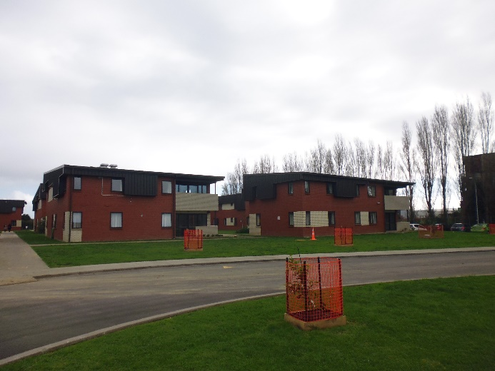 |  | 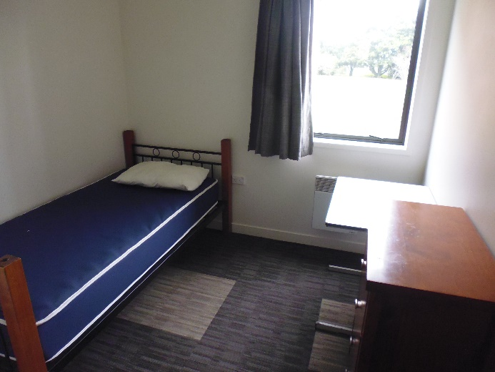
Figure 1: Accommodation blocks at the Centre |  | Figure 2: An empty bedroom at the Centre
The communal areas were clean and home-like with plenty of natural light. The kitchens were well equipped, and lounge areas contained dining tables, sofas, and a TV.
Residents had their own individual bedrooms furnished with a bed, desk, and storage space. The bedrooms were lockable and all residents had swipe cards to access the block and their room. Bedrooms were in a good state of repair. A window in each room could be opened to access fresh air, with curtains for privacy. Residents said that the rooms were a comfortable temperature.
There were no curtains in the communal kitchen and lounge areas, which could compromise the privacy of residents. Staff acknowledged this was an issue and said they were not aware of any reason why curtains were not provided in communal living areas. I consider that there should be curtains in the communal living areas of each flat to promote residents’ privacy.
Bathroom facilities were clean and could be locked from the inside.
Housing blocks and other facilities were cleaned twice a week by cleaners.
My Inspectors observed that all areas of the Centre were clean, tidy, and well-maintained.

Clothing and bedding
Residents dressed in their own clothes and could access washing machines to do their own laundry. The Centre provided laundry detergent. Bedding and linen were laundered once a week.
The Manual stated that the ‘Person in Charge’ (the Manager – Refugee Quota Programme and their delegates) was responsible for ensuring that residents had adequate clothing for safety, comfort and warmth. Staff told my Inspectors that residents were provided with sufficient clothing if they arrived at the Centre without it. Residents could also purchase additional clothing in the community using their weekly allowance.

Food and meal times
Residents generally catered for themselves, using a portion of their weekly allowance to buy groceries. The flat kitchens had sufficient cooking and food storage facilities for residents to prepare their daily meals.
During COVID-19 Alert Levels 4 and 3, access to and from the site was restricted to essential services only. Residents were required to remain at the Centre and therefore were not able to purchase groceries and cook for themselves. Instead, meals were prepared for residents in the Centre’s kitchen and delivered to residents’ accommodation. The meals were paid for using a portion of residents’ weekly allowance, and a partial subsidy from Immigration New Zealand.
Residents told my Inspectors that snacks were not available outside of meal times during this period, and if a resident missed a meal time they would not have anything to eat until the next meal. Following the inspection, Immigration New Zealand told my Inspectors they were not aware of any incidences of residents missing meals, and that they would have responded promptly if this had been raised.
On return to Alert Level 2, residents were offered the choice to return to their full weekly allowance and prepare their own food, or to continue to have meals prepared for them. All residents chose to return to preparing their own meals.

Weekly living allowance
Residents were granted $85 a week to meet their basic living costs, including food, clothing, personal hygiene items and medical needs. Residents said they found this amount to be low given the range of other expenses they were expected to cover. Residents said that the weekly allowance was insufficient to cover hygiene and menstrual products as well as food and other costs, and staff acknowledged this.
During COVID-19 Alert Levels 4 and 3, the Centre deducted $50 a week for the prepared meals (described above). Residents said the remaining $35 was not enough to cover their other weekly expenses.
My Inspectors asked staff whether the weekly allowance had been reviewed, in light of residents’ concerns. Staff said there had not been a review, but were supportive of the idea. I consider that the weekly allowance provided to residents should be reviewed to ensure it is fair and sufficient to meet residents’ food and other essential living costs.

Interactions between residents and staff
My Inspectors saw residents and staff interact in a positive and respectful way. This was supported by staff and resident comments. Residents were complimentary of staff at the Centre.

Cultural provision, equality, and diversity
The Manual provided that residents have the right to practise their religion and to enjoy their culture, including the use of their language.
The Facility had a designated ‘Quiet Room’ which was reserved for prayers and/or quiet reflection, and copies of the Qur’an and Bible were available for residents.
Interpreters were provided for residents who did not speak, read, or write in English. Interpreters were independently contracted through Ezispeak translation and interpreter services, and underwent police vetting to ensure their suitability to work with potentially vulnerable individuals. My Inspectors found interpreters present during the inspection to be attentive, responsive and professional.
Key informational posters and messages were presented in several different languages throughout the Centre.
As discussed under ‘Weekly living allowance’ above, those residents who needed menstrual products faced a significant expense in proportion to the total living allowance, which could be seen to disadvantage residents who menstruate. Staff suggested that menstrual products could be included in a monthly pack of hygiene items given to residents. I encourage such a move.
I consider that a choice of menstrual products should be provided to those who need them, as required.

Accessible accommodation
Inspectors were told that all accommodation blocks were accessible, and where individual flats were not accessible (for example, flats on the first floor of an accommodation block), residents with mobility issues could be assigned a flat with accessible bedrooms and bathrooms accordingly.
Recommendations – decency, dignity and respect
I recommend that:
- Curtains are installed in communal areas of each accommodation block.
- The weekly allowance provided to residents is reviewed to ensure it is sufficient.
- A choice of menstrual products is provided to those who need them, as required.

Immigration New Zealand accepted recommendation 1, 2 and 3.
Ombudsman response:
I wish to highlight that Immigration New Zealand reported good progress implementing my recommendations. In particular, I was pleased to hear that blinds had been installed in communal areas and that residents were now afforded an ongoing supply of menstrual products and a wider range of options to meet individuals’ needs. Immigration New Zealand also accepted that the weekly allowance should be reviewed. I look forward to the outcome of this.

Health and wellbeing

Governance arrangements
Everyone has the right to the enjoyment of the highest attainable standard of physical and mental health. This includes people in places of detention. The Manual reflected this, stating that the standard of health care available to residents must be ‘reasonably equivalent to the standard of health care available to the public’.
Governance arrangements for the provision of health care to residents were in a state of transition at the time of inspection due the COVID-19 pandemic. The Centre had a health team to provide health assessments on site, and this was usually made up of health professionals provided by the Auckland District Health Board (ADHB). However, ADHB staff had been reassigned due to the COVID-19 pandemic, and some on-site health services had been provided by Counties Manukau District Health Board (Counties Manukau DHB) staff in the interim. Counties Manukau DHB also funded Refugees As Survivors New Zealand (RASNZ) to provide mental health and counselling services for residents.
Inspectors heard differing accounts from different staff members concerning health care governance arrangements, which suggests these were not clearly understood across staff. There was no evidence to suggest, however, that this had an adverse effect on services provided to residents.

Primary health care services
Staff told my Inspectors they did not give over-the-counter pain relief medication to residents, because residents’ medical histories may be unknown (including potential drug dependency or abuse). Residents had to purchase medication from a pharmacy or supermarket when allowed out of the Centre on leave, or go to a GP or hospital. Staff said this process could be impractical and resource intensive for minor pain, especially after-hours. I recommend that over-the-counter pain relief medication (such as paracetamol) be available to residents as required in a safe and controlled manner.

Mental health services
My Inspectors were pleased to note the emphasis placed on residents’ mental health by staff. Immigration New Zealand advised that all residents undergo assessments by mental health professionals and a support plan is put in place.
Counties Manukau DHB also funded Refugees as Survivors New Zealand (RASNZ) to provide mental health and counselling services for residents. Inspectors were informed that RASNZ provided counsellors, psychiatrists, psychologists, and body therapists for residents. Staff noted that it was the individual choice of a resident whether they used a service or not, however most residents engaged with some form of support. Staff told my Inspectors that residents had good access to mental health practitioners.
Some residents arrived at the Centre following initial detention in a prison. Staff, providers and residents all told my Inspectors that most, if not all, residents who arrived at the Centre from prison had experienced violence and abuse while incarcerated. Consequently, residents who had been imprisoned arrived at the Centre with additional trauma and care needs. Staff and providers told my Inspectors that they worked with residents to try to address these needs.
Despite the high standard of care provided at the Centre, staff noted that they witnessed a significant decline in the wellbeing of residents the longer they remained at the Centre. Three of the four residents had been detained at the Centre for between 12 and 18 months, and residents told my Inspectors that it was very difficult waiting for their claims with Immigration New Zealand to be decided. Residents also told my Inspectors that they did not receive regular information about their claims.
My Inspectors were pleased to hear that staff would reach out to residents who appeared to be struggling or not engaging with mental health services, and I encourage this practice to continue.
Recommendations – health and wellbeing
I recommend that:
- Over-the-counter pain relief medication be available to residents as required in a safe and controlled manner.

Immigration New Zealand rejected recommendation 4. In response to recommendation 4, Immigration New Zealand commented as follows:
INZ acknowledges the need for residents to have access to pain relief medication, as required, for minor pain. However, over-the-counter pain relief medication may not be safe for all residents, depending on their medical histories. INZ will continue to facilitate access to pain relief medication through medical professionals. This position is consistent with medical advice.
Ombudsman response:
I acknowledge that there may be circumstances where, based on an individual medical assessment, it would be unsafe for residents to use over-the-counter pain relief medication. That is why I recommended that pain relief be available in a “safe and controlled manner”. I remain of the view that the current process appears to be unnecessarily burdensome, particularly to the extent it limits after hours’ access to pain relief. I therefore encourage Immigration New Zealand and the Centre to implement my recommendation, with a particular focus on ensuring that over-the-counter pain relief is available after hours where use of the medication is safe for the resident.

Protective measures

Complaints
The Manual stated that residents could raise complaints with the Person in Charge or any responsible authorised staff/contractor either orally or in writing. The Manual detailed the process for recording, referring and investigating complaints. It also noted that if the complaint could not be resolved to the resident’s satisfaction, the Person in Charge was required to inform the resident of their right to raise their complaint with an Ombudsman, and to facilitate that process if the resident desired.
The Facility reported that there were no complaints for the period 1 December 2019 to 31 May 2020. Staff told Inspectors that residents generally raised matters with them that were not complaints, but practical issues that were usually easily resolved. Staff indicated that they encouraged residents to make a complaint if they wished to, but that residents rarely did so.
The residents told Inspectors that, generally, they did not have any complaints about the Centre. However, residents’ awareness and understanding of the complaints process varied. Residents told Inspectors they were generally confident raising issues with staff, but were unsure how any complaints were formally processed. Only one of the four residents said they were aware of the Ombudsman.

Mail and telephones
Access to telephones at the Centre was good. Every resident had a cell phone and had been provided with a $20 New Zealand SIM card on their arrival. After that, residents were expected to pay for their own cell phone use out of their $85 per week allowance.
No concerns about mail or other forms of external contact were raised with my Inspectors.
Recommendations - protective measures
I recommend that:
- The Centre provide residents with comprehensive and understandable information about the complaints process, including on the role of the Ombudsman.

Immigration New Zealand accepted recommendation 5.

Purposeful activity and transition to the community

Outdoor activity and exercise
Access to fresh air was unlimited for residents. There was adequate outdoor space within the Centre for residents to go for walks and enjoy fresh air. The Centre had a well-equipped playground for children and also had a small park which staff told my Inspectors was being developed into a football pitch.
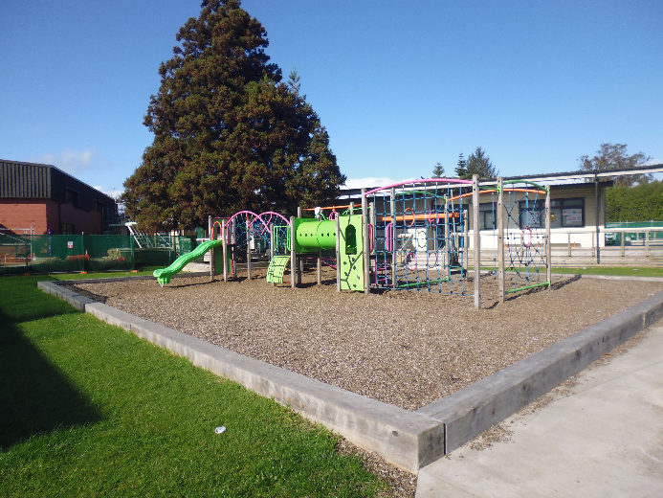 |  | 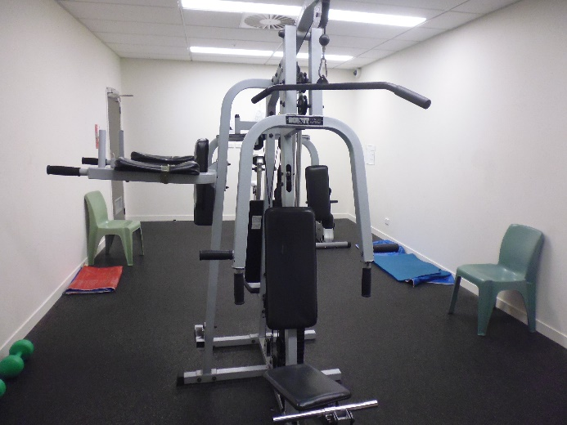
Figure 3: Playground |  | Figure 4: Gymnasium
The Centre had a small gymnasium in the main office building, which was available for residents to use. The gymnasium had basic equipment, much of which was old and needed replacing. Staff explained that the equipment had largely been provided through charitable donations, but that they were working on a plan to purchase new equipment and relocate the gymnasium to be closer to residents’ accommodation.
The Centre had implemented a policy of reserving the gymnasium for two hours a day for women. Staff reported an increase in women’s use of the gymnasium as a result.

Library services
The Centre did not have a dedicated library, but had an adequate range of books available for residents to borrow from the recreation room. Residents could also visit the library in the community. Residents also had access to the internet. I have no concerns about residents’ access to books and information services.

Legal representation
All residents had legal representation. Legal visits could take place at any time. No concerns were raised about the ability of legal representatives to visit the Centre.
The Centre had a phone in a secure, soundproofed room to contact legal representatives. The Centre also had a computer suite. Staff told Inspectors that this phone and computer suite were rarely used, though staff told my Inspectors that a resident had recently scheduled a Zoom meeting in the computer suite with their lawyer.
Residents and providers did, however, note that residents were heavily reliant on the availability of interpreters to access legal counsel. The Centre had a strong network of interpreters contracted from outside the Centre to provide this service. However, the need for both counsel and interpreters to be available meant that it could be difficult for residents to raise issues in real time.

Leave
I found that there was a lack of clarity regarding residents’ leave status and entitlement, in particular how these applied to residents on RRR Agreements.
The Manual allowed the Person in Charge the discretion to grant leave to residents for up to four hours per day between 9am and 9pm. Additional leave may also be approved by the Person in Charge or the Immigration Manager – Support Services, where evidence of the reason for leave is provided.
During the inspection, staff told my Inspectors that all residents in the Centre had been approved to take up to four hours’ leave per day. Residents told Inspectors that the four-hour limit on leave was restrictive, given the distances and time involved in travelling in Auckland. Residents also said that they were unaware of the processes to extend leave. Staff acknowledged that travel was time-consuming, but also noted that in practice they applied discretion to ensure reasonable flexibility for residents.
Following the inspection, staff told my Inspectors that residents under an RRR Agreement were not required to apply to leave the Centre, but that there was an expectation that they comply with house rules. Staff said that between 9am and 9pm residents were free to move in and out of the Centre. Residents were required to inform the reception of their movements from their health and safety perspective.
However, the Centre had provided my Inspectors with copies of residents’ leave application forms. The leave forms included applications for leave between 9am and 9pm. The Centre had also provided reports from the security team which tracked residents’ entry and exit from the Centre for the fortnight prior to the inspection.
As previously noted, the Manual rules only expressly applied to residents detained under a warrant, not under an RRR Agreement. The evidence available suggests that, while the residents were under RRR Agreements, they were effectively treated as being detained under a warrant at the time of the inspection.
The leave application forms stated that failure to return to the Centre at the required time could result in a resident being “found by the police, held in prison and charged with a serious offence.” The specific offence and penalty for non-compliance were not clearly stated. Further, residents’ RRR Agreements did not clearly state any offences or penalties associated with non-compliance. Residents’ induction material simply stated that a breach of the rules, particularly leaving the centre without permission, could result in charges for criminal offending and/or being detained in prison.
I consider it is important that residents under an RRR have clear and consistent information about the leave procedures that apply to them, including the consequences of breaching the conditions of their detention.

Visits
The Manual provides that residents’ visits must be in private, though could not take place in the resident’s accommodation. Visits could take place between the hours of 9am and 9pm each day.
No concerns around access to visits were raised with Inspectors. My Inspectors observed that, in practice, residents received few visitors in the Centre as they generally had limited contacts in the community and, where they did have community contacts, it was preferable to visit them outside of the Centre during leave hours.

Activities
Staff, providers and residents told my Inspectors that there were no tailored activities available for residents. The activities onsite were designed specifically for quota refugees. Staff told Inspectors that residents would sometimes join in on these activities, but my Inspectors did not find evidence of this occurring regularly.
I consider that the Centre needs to actively provide more opportunities for residents to participate in activities that are suitable for them.
I acknowledge that residents have leave and that some may not wish to regularly participate in structured activities. However, residents in the Centre are often highly vulnerable, and are disconnected from their country of origin and from the community in Aotearoa New Zealand. Residents can also spend a long time in the Centre, sometimes up to several years, while they await final determination of their status.
Some staff and providers suggested that residents were treated as ‘second-class citizens’ compared to quota refugees due to their differing legal status. The difference in treatment was primarily in relation to access to activities, training and education. Staff and providers also reported that residents and quota refugees were discouraged from mixing with one another.
Following the inspection, staff from the Centre and Immigration New Zealand emphasised that residents were not denied access to activities. Regardless, I consider it is necessary for the Centre to proactively design and offer tailored activities for residents to promote their mental, emotional, spiritual and physical wellbeing.

Training, education and employment
No residents were in formal training or employment at the time of the inspection. My Inspectors were told that a work visa would be granted only in exceptional circumstances. Being granted a visa may result in a claimant no longer being liable for deportation and therefore not be liable for detention under the Immigration Act 2009.
The Manual contained specific requirements for education in respect of residents under the age of 18 years. Specifically, the Manual required the Person in Charge, in conjunction with the relevant child or young person and their responsible adult, to endeavour to prepare a plan relating to the education, recreation and welfare of the child or young person. No residents were under 18 years of age at the time of the inspection.

Case management

Detention or monitoring status
Staff at the Centre, providers and residents were generally unsure of the criteria that determined whether or where an asylum seeker would be detained. Staff from Immigration New Zealand were able to clarify this with Inspectors after the inspection. However, I consider that residents would benefit from staff at the Centre having an understanding of this framework. This is important for ensuring that any restrictions are applied appropriately, such as restrictions to freedom of movement and leave from the Centre.
Residents’ detention status was continually reviewed by Immigration New Zealand staff. Immigration New Zealand told my Inspectors that they had frequent contact with residents, often through residents’ lawyers, to help inform these reviews and determinations.

Processing of claims
Refugee and Protection officers (RPOs) in the Refugee Status Unit of Immigration New Zealand decide all residents’ claims for refugee or protection status in the first instance. It is a shared inquiry, where the resident is responsible for establishing their claim, and the RPO may also determine the relevant facts, including assessing credibility. RPOs were not present at the Centre and residents did not report having frequent contact with RPOs.
As previously stated in this report, the length of time residents were waiting for updates or decisions on their claims, impacted their mental health and general wellbeing.
Following the inspection, Immigration New Zealand told my Inspectors that RPOs seek to expedite claims for those in detention, including residents. Immigration New Zealand also acknowledged that RPOs are expected to remain in contact with claimants and their representatives, particularly if standard timeframes are not going to be met, and that they have clarified this expectation in guidance to staff. I note that in Budget 2020 additional funding was provided to respond to increased claims for refugee and protected person’s status, and will be available from July 2021. I look forward to seeing the results of the additional guidance and funding.

Resident notes and records
Inspectors were told that, while notes were kept on the movements of residents by the security team, staff did not routinely keep notes on residents’ overall wellbeing or safety.
I consider that the Centre should keep up-to-date records of residents’ wellbeing in order to identify their needs and, when necessary, to facilitate independent oversight of their treatment.

Recommendations – purposeful activity and transition to the community
I recommend that:
- The Centre ensure there are clear leave procedures in place for residents under a Residence and Reporting Requirements Agreement.
- Residents have access to a greater range of organised activities in the Centre.
- The Centre keeps up-to-date records regarding the welfare and wellbeing of residents.

Immigration New Zealand accepted recommendations 6, 7 and 8.

- Immigration New Zealand’s comments on recommendations
Recommendations – decency, dignity and respect
I recommend that:
- Curtains are installed in communal areas of each accommodation block.
- The weekly allowance provided to residents is reviewed to ensure it is sufficient.
- A choice of menstrual products is provided to those who need them, as required.

Immigration New Zealand accepted recommendation 1 and commented as follows:
Blinds were installed in the communal areas of each accommodation block in late 2020.
Immigration New Zealand accepted recommendation 2 and commented as follows:
INZ accepts that the weekly allowance should be reviewed.
Immigration New Zealand accepted recommendation 3 and commented as follows:
Residents are provided with a welcome pack, which includes menstrual products where needed, as noted in the draft report. INZ is now providing residents with an ongoing supply of menstrual products and a wider range of options to meet individuals’ needs.
Recommendations – health and wellbeing
I recommend that:
- Over-the-counter pain relief medication be available to residents as required in a safe and controlled manner.

Immigration New Zealand rejected recommendation 4. In response to recommendation 4, Immigration New Zealand commented as follows:
INZ acknowledges the need for residents to have access to pain relief medication, as required, for minor pain. However, over-the-counter pain relief medication may not be safe for all residents, depending on their medical histories. INZ will continue to facilitate access to pain relief medication through medical professionals. This position is consistent with medical advice.

Recommendations - protective measures
I recommend that:
- The Centre provide residents with comprehensive and understandable information about the complaints process, including on the role of the Ombudsman.

Immigration New Zealand accepted recommendation 5 and commented as follows:
The draft report acknowledges the provision of information about the complaints process as part of the residents’ induction, and the lack of concerns raised about the induction process.
INZ will ensure that more information regarding the formal complaints process, including the role of the Ombudsman, is made available to residents in an accessible way, including in different languages, to meet the needs of residents. This information will be developed in consultation with the Office of the Ombudsman.
Recommendations – purposeful activity and transition to the community
I recommend that:
- The Centre ensure there are clear leave procedures in place for residents under a Residence and Reporting Requirements Agreement.
- Residents have access to a greater range of organised activities in the Centre.
- The Centre keeps up-to-date records regarding the welfare and wellbeing of residents.

Immigration New Zealand accepted recommendation 6 and commented as follows:
INZ acknowledges the need for clearer leave procedures for residents on Residence and Reporting Requirements Agreements.
Residents can leave the Centre between 9am and 9pm, and are not required to seek permission. It is however expected that residents remain at the Centre between the hours of 9pm and 9am, unless they have received permission from Centre management to be absent between these hours.
Where a resident has breached the requirement for them to reside at the Centre, INZ would review the breach. A serious breach or history of non-compliance may result in INZ cancelling the resident’s Residence and Reporting Requirements Agreement in favour of stringer detention requirements.
INZ has communicated the leave provisions to residents, and has updated the Manual. INZ has also communicated the leave provisions to staff at the Centre, and will communicate broader information regarding the detention framework.
Immigration New Zealand accepted recommendation 7 and commented as follows:
INZ agrees that there are benefits for residents from participating in a broader range of activities while at the Centre.
Under current arrangements, residents can participate in various activities onsite, as noted in the draft report. These activities also include access to gardening, and onsite teaching from volunteers. Residents can also attend various programmes in the community
The Senior Civil Detention and Welfare Advisor in INZ supports refugee and protection claimants who are in detention. The advisor provides regular engagement sessions with those detained at the Centre and will expand these sessions to work with individual residents to understand their areas of interest, and explore options for activities that meet their needs.
Immigration New Zealand accepted recommendation 8 and commented as follows:
INZ will introduce new processes to maintain up-to-date records regarding residents’ welfare and wellbeing to support early identification of residents’ needs and to inform any actions that may be required.
- Legislative framework
In 2007 the New Zealand Government ratified the United Nations Optional Protocol to the Convention against Torture and Other Cruel, Inhuman or Degrading Treatment or Punishment (OPCAT).
The objective of OPCAT is to establish a system of regular visits undertaken by an independent national body to places where people are deprived of their liberty, in order to prevent torture and other cruel, inhuman or degrading treatment or punishment.
The Crimes of Torture Act 1989 (COTA) was amended by the Crimes of Torture Amendment Act 2006 to enable New Zealand to meet its international obligations under OPCAT.

Places of detention
Section 16 of COTA defines a “place of detention” as:
…any place in New Zealand where persons are or may be deprived of liberty, including, for example, detention or custody in…
g) premises approved under the Immigration Act 2009
Ombudsmen are designated by the Minister of Justice as a National Preventive Mechanism (NPM) to inspect certain places of detention under OPCAT, including premises approved or agreed under the Immigration Act.
Under section 27 of COTA, an NPM’s functions include:
- to examine the conditions of detention applying to detainees and the treatment of detainees; and
- to make any recommendations it considers appropriate to the person in charge of a place of detention:
  - for improving the conditions of detention applying to detainees;
  - for improving the treatment of detainees; and
  - for preventing torture and other cruel, inhuman or degrading treatment or punishment in places of detention.

Carrying out the OPCAT function
Under COTA, Ombudsmen are entitled to:
- access all information regarding the number of detainees, the treatment of detainees and the conditions of detention;
- unrestricted access to any place of detention for which they are designated, and unrestricted access to any person in that place;
- interview any person, without witnesses, either personally or through an interpreter; and
- choose the places they want to visit and the people they want to interview.
Section 34 of COTA provides that when carrying out their OPCAT function, Ombudsmen can use their Ombudsmen Act (OA) powers to require the production of any information, documents, papers or things (even where there may be a statutory obligation of secrecy or non-disclosure) (sections 19(1), 19(3) and 19(4) OA). To facilitate his OPCAT role, the Chief Ombudsman has authorised inspectors to exercise these powers on his behalf.

More information
Find out more about the Chief Ombudsman’s OPCAT role, and read his reports online: ombudsman.parliament.nz/opcat

For more information about New Zealand’s Refugee Resettlement Strategy see https://www.immigration.govt.nz/about-us/what-we-do/our-strategies-and-projects/refugee-resettlement-strategy (accessed 4 September 2020).
See https://www.immigration.govt.nz/about-us/what-we-do/our-strategies-and-projects/supporting-refugees-and-asylum-seekers/refugee-and-protection-unit/new-zealand-refugee-quota-programme (accessed 18 September 2020).
Section 315 of the Immigration Act 2009 provides for the detention of ‘liable persons’ under a ‘warrant of commitment’. See http://www.legislation.govt.nz/act/public/2009/0051/latest/DLM1440303.html (accessed 18 September 2020).
Section 316 of the Immigration Act 2009, Part 9.
Residents were given an $85 weekly allowance which was expected to cover a large range of costs, including groceries, phone bills, and menstrual products.
Immigration Act 2009, s 330.
Immigration Act 2009, s 317. Alternatively, a Judge may order a person to be released on conditions.
Immigration Act 2009, s 315. Instead of arresting a person under the Act, or applying for a warrant of commitment, the person and an immigration officer may agree to entry conditions requiring the person to reside at a specified place, in this case, the Māngere Refugee Resettlement Centre. If the person fails to comply with their conditions they may be detained by an immigration officer or arrested and detained by Police.
Information provided by Immigration New Zealand indicated that the number of residents in the Centre
See https://www.immigration.govt.nz/about-us/what-we-do/our-strategies-and-projects/supporting-refugees-and-asylum-seekers/refugee-and-protection-unit/new-zealand-refugee-quota-programme
Our inspection methodology is informed by, but not limited to, the Standard Minimum Rules for the Treatment of Prisoners (the Nelson Mandela Rules), the Association for the Prevention of Torture’s publication ‘Monitoring Places of Detention’, the New Zealand Bill of Rights Act 1990 (NZBORA), and the Immigration Act 2009.
Guideline 9, the United Nations High Commissioner for Refugees, Detention Guidelines, 2012.
See https://covid19.govt.nz/alert-system/covid-19-alert-system/ for details on the New Zealand Government’s COVID-19 alert level system.
Immigration New Zealand’s comments on recommendations 1, 2 and 3 can be seen in Appendix 1.
Article 12, International Covenant of Economic, Social and Cultural Rights.
Immigration New Zealand provided a subset of data for the period 1 January 2016 and 31 December 2020, which indicated that the average length of time a subset claimants were held at the Centre was 235 days.
Immigration New Zealand’s response to recommendation 5 can be seen in Appendix 1.
Immigration New Zealand, ‘Immigration Factsheets: Refugees and asylum seekers’ (May 2020).
Immigration New Zealand’s response to recommendations 6, 7 and 8 can be seen in Appendix 1.

