OPCAT Report
Report on an unannounced inspection of Rangipapa Forensic Acute Mental Health Unit, Rātonga-Rua-O-Porirua Campus, under the Crimes of Torture Act 1989
October 2021
Peter Boshier
Chief Ombudsman
National Preventive Mechanism

A3.a

OPCAT Report: Report on an unannounced inspection of Rangipapa Forensic Acute Mental Health Unit, Rātonga-Rua-O-Porirua Campus, under the Crimes of Torture Act 1989
ISBN: 978-1-99-115510-8 (PDF)
Published October 2021

This work is licensed under the Creative Commons Attribution 4.0 International License. To view a copy of this license, visit https://creativecommons.org

Office of the Ombudsman | Wellington, New Zealand | www.ombudsman.parliament.nz
Contents
Executive summary 1
Background 1
Summary of findings 1
Recommendations 4
Feedback meeting 5
District Health Board response 5
Facility facts 7
Rangipapa Forensic Acute Mental Health Unit 7
Region 7
District Health Board 7
Operating capacity 7
Last inspection 8
The inspection 9
Inspection methodology 9
Inspection focus 10
Treatment 10
Protective measures 10
Material conditions 10
Activities and programmes 10
Communications 11
Health care 11
Staff 11
Evidence 11
Recommendations from previous report 11
Treatment 13
Torture or other cruel, inhuman or degrading treatment or punishment 13
Over-occupancy 13
Seclusion 13
Seclusion facilities 13
The use of seclusion rooms as bedrooms 15
Length of stay in seclusion rooms 15
Inequitable admission process for female clients 16
General issues with seclusion rooms 17
Seclusion policies and events 17
Night Safety Orders 17
Restraint 18
Restraint training for staff 19
Electro-convulsive therapy 19
Sensory modulation 19
Clients’ and whānau views on treatment 19
Recommendations – treatment 20
Rangipapa comments 20
Protective measures 23
Complaints process 23
Records 23
Recommendations – protective measures 24
Rangipapa comments 24
Material conditions 25
Accommodation and sanitary conditions 25
Food 26
Recommendations – material conditions 27
Rangipapa comments 27
Activities and programmes 30
Outdoor exercise and leisure activities 30
Programmes 31
Cultural and spiritual support 31
Recommendations – activities and programmes 32
Communications 32
Access to visitors 32
Access to external communication 32
Recommendations – communications 33
Health care 33
Primary health care services 33
Recommendations – health care 33
Staff 34
Staffing levels and staff retention 34
Recommendations – staff 35
Rangipapa comments 35
Acknowledgements 36
Appendix 1. List of people who spoke with Inspectors 37
Appendix 2. Legislative framework 38

Tables
Table 1: List of people who spoke with Inspectors 37

Figures
Figure 1: Decommissioned seclusion room (now being used as a high care bedroom) 14
Figure 2: Bathroom – Rangimārie de-escalation area 14
Figure 3: Communal area - Aniwaniwa 25
Figure 4: Dining area 25
Figure 5: Courtyard – male wing 26
Figure 6: Courtyard – female wing 26
Figure 7: OT Art Room 30
Figure 8: Exercise room 30

Executive summary

Background
Ombudsmen are designated as one of the National Preventive Mechanisms (NPMs) under the Crimes of Torture Act 1989 (COTA), with responsibility for examining and monitoring the conditions and treatment of clients detained in secure units within New Zealand hospitals.
Between 14 and 16 July 2020, two Inspectors — whom I have authorised to carry out visits to places of detention under COTA on my behalf — made an unannounced inspection of Rangipapa Mental Health Inpatient Unit (the Unit), which is located in the grounds of Rātonga-Rua-O-Porirua Mental Health Campus, Porirua.

Summary of findings
My findings are:
- There was no evidence that clients had been subject to torture or other cruel or inhuman treatment or punishment.
- Clients spoken with felt safe and that they were treated with dignity and respect.
- There were no instances of seclusion or restraint in the six months prior to the inspection.
- Files contained the necessary paperwork to detain and treat clients on the Unit, with the exception of one client.
- Consent to treatment forms were on file for all clients.
- The complaints process appeared to be well understood by staff and clients. Clients had a good understanding of the District Inspectors’ role.
- Access to leave was encouraged and well utilised.
- Clients were invited to attend their Huihui multi-disciplinary team meetings and provided with feedback of the outcomes of these meetings.
- Worn and damaged carpets had been replaced.
- There were no concerns about the quality or quantity of the meal service.
- There was a wide range of activities available to clients, including group and 1:1 settings.
- Cultural and spiritual support was evident and well received by clients.
- Access to visits and communication was good, including during COVID-19 Alert Levels 4, 3 and 2. Clients had individualised phone plans and could make calls in private.
- Clients had access to primary health care services.
- Staff were identifiable on the Unit.
The issues that needed addressing are:
- Seclusion rooms were being used as bedrooms. This may amount to degrading treatment and a breach of Article 16 of the United Nations Convention against Torture and Other Cruel, Inhuman or Degrading Treatment or Punishment (‘Convention against Torture’).
- Female clients were spending prolonged periods of time in seclusion rooms, due to lack of available bedrooms on the Unit.
- Female clients were being admitted directly into seclusion rooms.
- Female clients were treated inequitably, particularly by admission into, and long term stays in seclusion rooms.
- One of the seclusion room windows had graffiti of a sexually violent nature.
- The outside area in Rangimārie did not have any seating or shade.
- Night Safety Orders (NSOs) were not being recorded as seclusion events and NSO paperwork did not clearly specify the reasoning or rationale for their use.
- Record keeping surrounding the use of NSOs was inconsistent and incomplete. It was difficult to assess when an NSO had been implemented and subsequently terminated. There was also evidence of NSOs being used outside of the period for which they were in force.
- Clients could not access complaint forms independent of staff.
- Client files were generally disorganised and forms were inconsistently completed.
- The Unit had a number of ongoing maintenance issues, including faulty air conditioning and leaks.
- Clients did not have independent access to secure courtyards.
- The courtyard in Aniwaniwa was small, had minimal seating, and did not provide adequate shade.
- Clients were unable to access hot drinks independent of staff.
- The Unit had a high and increasing rate of staff turnover.

Recommendations
I recommend that:
- Seclusion rooms, and other non-designated bedrooms, are never used as bedrooms.
- Clients are not kept in seclusion rooms for prolonged periods of time, unless clinically necessary.
- Female clients are not admitted into seclusion rooms, unless clinically necessary.
- The use of seclusion rooms without clinical rationale be reviewed, with a particular focus on the equitable treatment of female clients.
- The seclusion room window covered in graffiti be replaced. This is an amended repeat recommendation.
- Seating and shade is provided in the Rangimārie exercise yard. This is an amended repeat recommendation.
- The use of Night Safety Orders be recorded and reported as seclusion events. This is a repeat recommendation.
- The Service take all necessary steps to ensure comprehensive and accurate collection and reporting on the use of Night Safety Orders.
- Complaint forms are available to clients, independent of staff.
- Complete and correct documentation is kept in respect of all client records.
- Ongoing maintenance issues are addressed (with particular attention to the variation in temperatures across the Unit).
- All clients have unrestricted access to courtyards during the day, unless deemed inappropriate for individual clients on a clinical or safety basis.
- Shade is provided in the Aniwaniwa exercise yard. This is an amended repeat recommendation.
- Clients are able to freely access hot drinks, unless deemed unsafe based on individual risk assessment.
- The Unit take urgent action to address the high staff turnover.

I intend to monitor the implementation of my recommendations, including conducting follow-up inspections at future dates.

Feedback meeting
On completion of the inspection, my Inspectors met with representatives of the Unit’s leadership team, to outline their initial observations.
The Service’s Operations Manager and the Acting Director of Area Mental Health Services Forensic and Rehabilitation Service provided Inspectors with additional information about this and two other Te Korowai Whāriki Units inspected at the same time.
They told my Inspectors they faced challenges with COVID-19, recruitment, and service demand. They were aware of a growing waitlist of acutely unwell people in prisons and the community, compounded by patients being directed to the Service by Courts. They said this resulted in:
- patients being admitted to the Service with high needs, requiring more staff attention than those admitted in a timely manner;
- a shortfall of beds, leaving patients accommodated in spaces other than bedrooms, affecting their dignity and privacy;
- increased risks to patients and staff, and
- diminishing staff morale.

District Health Board response
The Capital and Coast District Health Board (the DHB) received a copy of my provisional report and were invited to comment. The DHB responded and I have had regard to that feedback when preparing my final report.
The DHB’s letter and comments responded to a number of common themes from my inspections of the Unit and two other units in the DHB which were conducted at the same time, in particular around the use of seclusion rooms as bedrooms and ongoing reliance on night safety procedures (NSPs).
The DHB emphasised that they considered the reports provided evidence of unmet need within the forensic mental health services. The DHB noted the legal requirement to admit from court and the high acuity of the prison waitlist are such that the bed capacity in the forensic mental health service is continually exceeded.
While I acknowledge the comments, my role as an NPM is to report on the conditions and treatment for people who are being detained, as they are at the time of the inspection. I have, however, highlighted my concerns with the Ministry of Health. I also intend to conduct follow up inspections of all the Units.

Facility facts

Rangipapa Forensic Acute Mental Health Unit
Rangipapa Forensic Acute Mental Health Unit (the Unit) is a 17-bed medium secure mixed gender facility.
Clients receive mental health services provided by Capital and Coast District Health Board’s (DHB) Te Korowai Whāriki – Central Regional Forensic Adult Mental Health Service (The Service).
The Unit provides assessment and treatment in a secure setting for people who have committed an offence as a result of, or in association with, a psychiatric disorder. Clients are admitted under the Mental Health (Compulsory Assessment and Treatment) Act 1992 (MHA) or the Criminal Procedure (Mentally Impaired Persons) Act 2003 (CPMIP Act).
Clients are also admitted for assessment under the Intellectual Disability (Compulsory Care and Rehabilitation) Act 2003.
The Unit consisted of two wings: the men’s wing, with nine beds, and the women’s wing (Aniwaniwa), with four beds. The Safe Care Area (Rangimārie) had two seclusion rooms. At the time of inspection, both seclusion rooms were being used as bedrooms for female clients, due to lack of other available accommodation.
The Unit also comprised a self-contained cottage (Pūkeko House) with four beds, which functioned as a rehabilitative step-down facility.
The Unit is located in the grounds of Rātonga-Rua-O-Porirua Mental Health Campus, Porirua.

Region
Wairarapa, Hutt Valley, Capital & Coast, Hawke’s Bay, Midcentral, Whanganui, and Tairāwhiti

District Health Board
Capital and Coast District Health Board

Operating capacity
17 (plus one seclusion room and one high care bedroom).

Last inspection
Unannounced inspection – February 2016
Unannounced follow up inspection – June 2012
Unannounced inspection – August 2011

The inspection
Two Inspectors conducted the inspection of the Unit between 14 and 16 July 2020. On the first day of the inspection, there were 19 clients on the Unit, comprising six females and 13 males. The average length of stay for the preceding six months was 1004 days.
At the time of inspection, New Zealand was at COVID-19 Alert Level 1.

Inspection methodology
At the beginning of the inspection, Inspectors met with the Clinical Nurse Specialist (CNS), before being shown around the Unit.
Inspectors requested the following information during and after the inspection:
- a list of clients and the legal authority for their detention (at the time of the inspection);
- the seclusion and restraint data from 1 January to 30 June 2020, and the seclusion and restraint policies;
- any meetings/reports relating to restraint, seclusion minimisation, and adverse events from 1 January to 30 June 2020;
- records of staff mandatory training, including Safe Practice Effective Communication training (SPEC);
- client absent without leave (AWOL) events from 1 January to 30 June 2020;
- details of all sentinel events from 1 January to 30 June 2020;
- complaints received from 1 January to 30 June 2020, a sample of responses and associated timeframes, and a copy of the complaints policy;
- copies of minutes of client group meetings from 1 January to 30 June 2020;
- activities programme;
- information provided to clients and their whānau on admission;
- incident reports relating to medication errors from 1 January to 30 June 2020;
- staff sickness and retention data for the previous three years;
- staff vacancies at time of inspection (role and number); and
- data on staff, categorised by profession.

Inspection focus
The following areas were examined to determine whether there had been torture or other cruel, inhuman or degrading treatment or punishment, or any other issues impacting adversely on clients.

Treatment
- Torture or other cruel, inhuman or degrading treatment or punishment
- Seclusion
- Seclusion policies and events
- Night Safety Orders
- Restraint
- Environmental restraint
- Restraint training for staff
- Electro-convulsive therapy (ECT)
- Sensory modulation
- Clients’ and whānau views on treatment

Protective measures
- Complaints process
- Records

Material conditions
- Accommodation and sanitary conditions
- Food

Activities and programmes
- Outdoor exercise and leisure activities
- Programmes
- Cultural and spiritual support

Communications
- Access to visitors
- Access to external communications

Health care
- Primary health care services

Staff
- Staffing levels and staff retention

Evidence
In addition to the documentary evidence provided, Inspectors spoke with a number of managers, staff, clients, and whānau.
Inspectors also reviewed client records and additional documents provided by staff, and observed the facilities and conditions.

Recommendations from previous report
Inspectors also followed up on 11 recommendations following an inspection to the Unit in 2016, which were:
  - If night safety orders are to continue in the Unit, they should be captured as seclusion events and reported as such.
  - The windows that are covered in graffiti in the seclusion room should be replaced.
  - The exercise yard in the IPC area should offer seating and shade.
  - Information on the DHB’s complaints policy/process, including the contact details for the District Inspectors, should be easily available to all clients. The contact details of District Inspectors should be updated on a regular basis.
  - Clients should be provided with a copy of their MDT review.
  - Worn and damaged carpet should be replaced.
  - Clients should be offered access to daily fresh air. This should be documented.
  - Seating and shade should be made available in the female exercise yard.
  - Clients should be afforded privacy when using the telephones.
  - All staff should be up-to-date with mandatory training requirements.
  - Staff should be easily identifiable to clients and visitors.
The Unit’s adoption, or not, of these prior recommendations is referred to in the relevant sections of this report.

Treatment

Torture or other cruel, inhuman or degrading treatment or punishment
There was no evidence that any client had been subject to torture. However, I found evidence of degrading treatment.

Over-occupancy
Over-occupancy and a lack of resources were creating significant pressure for staff and clients on the Unit and across the wider inpatient forensic service. Inspectors were told by senior management that the Service was experiencing ‘unsustainable pressures’ around demand for beds.
One concerning effect of over-occupancy on the Unit was that female clients were accommodated in seclusion rooms, despite there being no safety or therapeutic reasons for seclusion. As detailed below, I consider this may amount to degrading treatment and a breach of Article 16 of the Convention against Torture.
At the time of inspection, the Unit was running at 112 percent capacity. Between 1 January and 30 June 2020, the Unit had an average capacity of 108 percent. Senior management told Inspectors this was due to a number of factors, including lack of available beds and growing waitlists, and pressure and backlog from the court system and prisons, which were compounded by high levels of acuity within the Service. Senior management said that these pressures resulted in ‘downstream effects’ across all inpatient forensic services within the region.
I acknowledge the difficulties faced across the Service, however this does not justify the use of seclusion rooms as bedrooms.

Seclusion

Seclusion facilities
At the time of the inspection, Inspectors’ observations were that the Unit had two dedicated seclusion rooms, located in Rangimārie. Rangimārie also contained a small de-escalation lounge area and two separate bathroom facilities.
Access to Rangimārie was via a sally port, which is a secure garage-style entrance, used to admit female clients to the Unit. There was also a separate entrance via Aniwaniwa.
Both rooms, while clean, were basic and stark. Each room consisted of a concrete plinth with a mattress on the floor. At the time of inspection, the Unit had two mattresses, one on top of the other, so that clients weren’t sleeping directly on the floor.
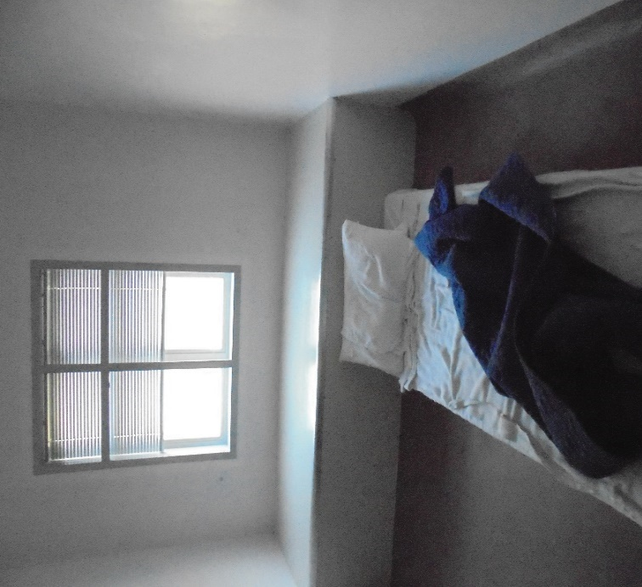 |  | 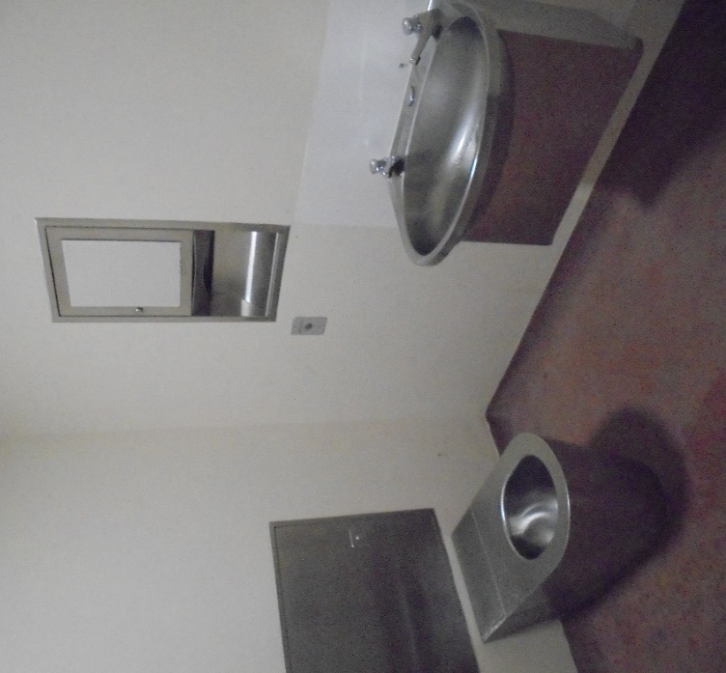
Figure 1: Decommissioned seclusion room (now being used as a high care bedroom) |  | Figure 2: Bathroom – Rangimārie  de-escalation area
The rooms did not have an en-suite, so clients were required to use the bathroom and showering facilities in the de-escalation area. Staff advised that bedrooms remained unlocked at night so that clients could access the toilet. A small clock was displayed from the nurses’ station for clients in the seclusion rooms to maintain orientation to time and date. However, this could only be viewed from one of the seclusion rooms.
Seclusion rooms are meant to be used to nurse clients in isolation for a short period if they are a risk to themselves or others. Section 71(2)(a) of the MHA states:
Seclusion shall be used only where, and for as long as, it is necessary for the care or treatment of the patient, or the protection of other patients.
The Ministry of Health seclusion guidelines also provide that ‘seclusion should not occur as part of a routine admission or therapeutic procedure, or be administered as discipline, or as a replacement for adequate levels of staff or resources’.
The Service’s Seclusion Policy (dated September 2015) also states that ‘seclusion should only be considered as a last resort after a range of other possible options for clinical intervention have been considered’.

The use of seclusion rooms as bedrooms
Staff advised that female clients would be accommodated in the seclusion rooms until a bedroom became available in Aniwaniwa. Staff told my Inspectors that the seclusion room doors were unlocked at night, and during the day female clients could ‘day trip’ to Aniwaniwa to take part in activities and programmes.
On the first day of inspection, there was one female client who had been admitted to Rangimārie. Another female client, who had also been admitted to Rangimārie and spent an extended period of time sleeping in a seclusion room, had been discharged to another region that day.
My Inspectors were told by staff that female clients were moved to seclusion rooms due to lack of accommodation or other appropriate areas for de-escalation and nursing support. Again, these female clients were not subject to a period of seclusion. Senior management commented that ‘… many factors are considered when someone is residing in Rangimārie including bed pressures, mental states and safety (of the person, and others within the Unit)’.
The practice of accommodating clients in seclusion rooms, despite them not being subject to seclusion, has the potential to cause significant physical and psychological harm, and compromise the dignity and wellbeing of those using the Service.
I consider the use of seclusion rooms and other non-designated rooms as bedrooms may amount to degrading treatment and a breach of Article 16 of the Convention against Torture.
I will continue to raise my concerns with the Ministry of Health on this matter.

Length of stay in seclusion rooms
Inspectors’ review of documentation and clinical records, as well as interviews with staff and clients, showed that a number of female clients had spent months at a time in Rangimārie.
One female client (Client Z) spent a period of 133 consecutive days in Rangimārie. Client Z had previously been staying in Aniwaniwa, however, as a result of a conflict with another client, she was placed in Rangimārie. Staff cited behavioural issues and risk of harm to others as reasons for Client Z’s extended period in Rangimārie. However, on review of Client Z’s clinical notes, there was no clear evidence to justify why she needed to remain there, beyond initial placement to defuse and de-escalate tension with the other client. It was evident to my Inspectors, through review of clinical notes and interviews with staff, that Client Z’s wellbeing was negatively affected by her living in Rangimārie for an extended period of time.
One female client expressed a feeling of being ‘punished’ during her extended placement in Rangimārie.
I have serious concerns that the practice of accommodating female clients into seclusion rooms for prolonged periods of time, due to lack of other appropriate accommodation, places female clients at a heightened risk of vulnerability and has potential to re-traumatise women.

Inequitable admission process for female clients
I saw a number of practices imposed on female clients which I consider negatively impacted on their mana and dignity. Similar practices were not imposed on male clients.
One of these practices was the difference in treatment around admission onto the Unit and initial allocation of a bed. Staff advised my Inspectors that while male clients were admitted through the main entrance, female clients were admitted via the high-security sally port, with no alternative entry other than through the male wing. Also, male clients were allocated a bed on the Unit straight away, while female clients were routinely admitted directly into seclusion rooms.
Admission through the sally port is appropriate in some cases, where clients present with high levels of distress and risk. However, it is not appropriate as a routine admission process. I also note that an average 56 percent of all female clients on the Unit identified as Māori. I consider that routinely admitting wāhine Māori through the sally port is not a necessary or culturally safe way to bring wāhine onto the Unit.
Similarly, and as set out above, wāhine were routinely admitted into seclusion rooms, despite there being no safety or therapeutic rationale for doing so. This treatment, along with extended length of stay in seclusion rooms, was not seen in the treatment of male clients on the Unit.
Services which promote and protect women’s rights to equitable treatment are reflected in international human rights law and guidance. Operational or environmental constraints are not sufficient justification to deny women treatment that is appropriate and equitable with other clients. As such, I have significant concerns regarding the disparity in treatment of female clients, who are not only being admitted directly into seclusion rooms, but are also spending extended periods of time in such restrictive environments. I will discuss further concerns regarding the equitable treatment of female clients on pages 25 to 26 of this report.

General issues with seclusion rooms
While the rooms had some natural light, Inspectors saw that one of the window blinds was broken. This same issue had been raised in my 2016 report. Both rooms had adequate ventilation, however, the rooms were noticeably colder than the rest of the Unit.
My Inspectors also saw graffiti of a sexually violent nature covering one of the seclusion room windows. I raised this issue in my 2016 report and was disappointed this had not been addressed.
Clients in Rangimārie were able to access fresh air, but only in the Unit’s sally port entrance. This was a small, unkempt and austere outside area. As a main entrance to the Unit, the sally port did not offer adequate privacy for clients wishing to access fresh air.
In my 2016 report, I recommended the Unit provide seating and shade for clients using the outside area. I was disappointed to see that this also had not been achieved.
Inspectors’ review of clinical notes found that a number of female clients raised concerns with staff during their stay in Rangimārie. These concerns included cold rooms, poor ventilation, and lack of access to fresh air.

Seclusion policies and events
The DHB provided Inspectors with the Seclusion policy, issued in September 2015 with a review period of five years.
Data provided by the Service indicated that from 1 January to 30 June 2020, there were no seclusion events. However, my Inspectors identified that a number of clients were subject to Night Safety Orders (NSOs) during this period.
In 2016, I recommended that any use of NSOs be recorded and reported as seclusion events. I therefore cannot rely on the seclusion data provided, because NSOs are still not being reported as seclusion events.
I reiterate my view that NSOs are a form of seclusion. Accordingly, I repeat my recommendation that NSOs should be recorded and reported as seclusion events.

Night Safety Orders
The DHB provided Inspectors a copy of the Te Korowai Night Safety Procedure (NSO Policy) (dated October 2018). The policy had a review period of three years.
In my 2016 report, I raised concerns regarding the blanket use of NSOs on the Unit. I was pleased to hear that the Unit no longer utilised NSOs as a blanket approach and they are now only implemented on an individual basis.
However, I do have concerns that documentation and record keeping surrounding the use of NSOs was inadequate.
The NSO Policy stated that a Night Safety Plan (NSP) must be generated, and authorised by the Forensic Director Area Mental Health Services (DAMHS) and the Responsible Clinician. The NSP must be documented in the client’s management plan, including the required hourly observations and when doors are locked and unlocked. Each use of NSO must be signed by two members of the nursing staff. NSOs are valid for a maximum period of three months, but can be renewed if necessary.
The NSO Policy also stated:
Consent will be obtained from the person each night prior to the initiation of the NSP, unless doing so is likely to cause the person distress. If the person is not asked for consent every night, the rationale for this must be clearly documented in the Night Safety Plan.
NSO documentation contained a number of discrepancies, including NSPs with no end date, NSPs that had not been authorised by the DAMHS, incomplete environmental restraint paperwork, and variable documentation regarding observations. There was no consistent documentation on file to record clients’ consent to NSPs, nor could Inspectors find the rationale for not seeking consent in NSPs.
Inspectors’ review of clinical notes revealed that the following information was missing:
- clear rationale for using NSPs,
- information as to when the NSP was implemented and subsequently terminated, and
- whether a particular NSP was used at all.
The clinical notes also indicated that there was at least one incident where an NSO was implemented when no current NSP was in force for the client, meaning no authority to use the NSO. It was unclear to Inspectors what risks to the person, peers, and/or staff made the NSO necessary.
The Unit’s reporting on NSOs did not follow the Unit’s own policy, and was unreliable. This poor quality record-keeping meant I could not determine why NSOs were put in place, how they were implemented, or when they were used, with any confidence. NSO documentation should be up-to-date, accurate and comprehensive.

Restraint
Inspectors were provided with the DHB’s Restraint Minimisation and Safe Practice Policy (the Restraint Policy), dated May 2020. The policy had a review date of November 2023.
Data provided by the Service showed that no clients were subject to restraint events between 1 January and 30 June 2020.
However, Inspectors found that some NSOs were being recorded as environmental restraint, albeit inconsistently. Again, I reiterate my view that NSOs are a form of seclusion and should be reported as such.

Restraint training for staff
All Unit staff were up-to-date with Safe Practice Effective Communication (SPEC) training, with the exception of two staff, who were scheduled to attend training in August 2020.

Electro-convulsive therapy
There were no clients undergoing Electro-convulsive therapy (ECT) on the Unit at the time of inspection.

Sensory modulation
At the time of inspection, the Unit did not have a dedicated Sensory Modulation Room. However, my Inspectors were advised that work was underway to introduce a Sensory Modulation Group and activities programme, which would be facilitated by the Occupational Therapists.
I encourage the Service to make this a priority as another means of therapeutic intervention for clients.

Clients’ and whānau views on treatment
Clients my Inspectors spoke with said they felt safe on the Unit and that staff treated them with dignity and respect. Clients also said they felt they could approach staff if they had any concerns. Inspectors observed positive interactions between clients and staff throughout the inspection.
The Unit ran weekly community meetings, facilitated by clients with minutes taken.
Clients appeared to be actively involved and previous meeting minutes indicated a broad range of topics discussed, including general complaints or concerns, weekly highlights, health and safety, jokes and ‘quotes of the day’, requests for hāngī or baking, and any praise.
The Unit also ran a women’s only meeting, which was run on a monthly basis, facilitated by female clients with minutes taken. These meetings covered similar topics, providing the opportunity for female clients to raise concerns and feedback in more detail.
Common concerns were mostly centred around maintenance issues and, in some instances, staff communication with clients.
Whānau my Inspectors spoke with said that they did not have any significant concerns about the Unit, and were complimentary about staff and the standard of care.
Inspectors were also told by staff that clients and whānau could provide feedback via ‘Mārama Real Time Feedback’, a digital feedback survey that asks questions about clients’ and whānau experience using the Service.

Recommendations – treatment
I recommend that:
- Seclusion rooms, and other non-designated bedrooms, are never used as bedrooms.
- Clients are not kept in seclusion rooms for prolonged periods of time, unless clinically necessary.
- Female clients are not admitted into seclusion rooms, unless clinically necessary.
- The use of seclusion rooms without clinical rationale be reviewed, with a particular focus on the equitable treatment of female clients.
- The seclusion room window covered in graffiti be replaced. This is an amended repeat recommendation.
- Seating and shade are provided in the Rangimārie exercise yard. This is an amended repeat recommendation.
- The use of Night Safety Orders be recorded and reported as seclusion events. This is a repeat recommendation.
- The Service take all necessary steps to ensure comprehensive and accurate collection and reporting of Night Safety Orders.

Rangipapa comments
The DHB accepted recommendations 1 to 3, 5, 6 and 8.
The DHB partially accepted recommendation 4.
The DHB rejected recommendation 7.
The DHB’s response included the following comment regarding recommendation 2:
Female clients are able to transition from Rangimārie (Intensive/Safe Care Area) to Aniwaniwa during the daytime, as the acuity of their symptoms reduces. However, the shortage of female beds means that they may still need to sleep in a seclusion room until a bedroom becomes available in Aniwaniwa. Sometimes individual female clients can present special difficulties when transitioning back to Aniwaniwa and this is progressed cautiously. Rangipapa staff strive to make clients as comfortable as possible by providing additional mattresses, blankets and personal belongings. While not condoning the practice, it is important to note that sleeping in a seclusion room is not the same as being subject to seclusion.
Ombudsman response:
While I acknowledge the shortage of beds within the Service, I reiterate my concerns that the practice of accommodating female clients in seclusion rooms for prolonged periods of time, due to lack of other appropriate accommodation, places female clients at a heightened risk of vulnerability and has potential to re-traumatise women.
I am pleased to hear that staff strive to make the room as comfortable as possible, however, as raised in my report, I do not agree that sleeping in a seclusion room is fundamentally different to being subject to seclusion.
The DHB’s response included the following comment regarding recommendation 4:
The use of seclusion is never implemented without a clear clinical rationale. Rangipapa strives to work towards the zero-seclusion initiative.
Rangimārie is a safe care area exclusively for female clients. It is the equivalent of the intensive care area (Tanerore) for males on the male acute admission unit (Purehurehu).
As previously stated (see points 1, 2 and 3 above), when the seclusion room in Rangimārie is used as a bedroom, Rangipapa staff strive to make the client as comfortable as possible by providing additional mattresses, blankets and personal belongings. The door is never closed unless the client closes it herself and she is able to freely access Aniwaniwa.
We reject that there is an inequitable admission process to Aniwaniwa for female clients.
We note that a gendered analysis reveals an inequity of access to the provision of medium secure treatment facilities for acutely unwell female clients. This is a national as well as regional issue. Aniwaniwa has 4 acute medium secure female beds to serve 7 DHBs in the Central Region of North Island. The provision is inadequate and Aniwaniwa is continually over-capacity. The increased rate of incarceration of women in prison in New Zealand well exceeds that of men and is continuing to rise. Arohata women’s prison is expanding. The high rate of mental disorder in the female (and male) prison population is well-documented. We agree that while Aniwaniwa allows for privacy and additional safety, it is too small. The need for expanded Regional (possibly National), therapeutically-safe, medium secure treatment facilities, dedicated to the gendered and cultural needs of acutely unwell female clients, has been brought to the attention of the DHB and MOH. Addressing gender and cultural inequity for this vulnerable, highly disadvantaged population will require significant financial investment.
Ombudsman response:
I acknowledge the DHB’s view that there is ‘an inequity of access to the provision of medium secure treatment facilities for acutely unwell female clients’, which the DHB highlights is both a national and regional issue.
However I remain of the view that operational or environmental constraints are not sufficient justification to deny women treatment that is appropriate and equitable with other clients.
The DHB’s response included the following comment regarding recommendation 7:
When used, Night Safety Orders are recorded as an environmental restraint in accordance with the Te Korowai Night Safety Procedure. Night Safety Plans are reported through Night Safety Observations and are reviewed regularly. Rangipapa continues to work towards the cessation of Night Safety Orders.
Ombudsman response:
I acknowledge that Ministry of Health Night Safety Procedures: Transitional Guideline suggest that NSOs constitute, at the very least, environmental restraint and should be recorded as such. However, Ministry of Health guidance and the Health and Disability Services (Restraint Minimisation and Safe Practice) Standards define seclusion as: ‘Where a person is placed alone in a room or area, at any time and for any duration, from which they cannot freely exit’. Perhaps the key element of this definition that distinguishes it from environmental restraint is the deprivation of company.
The practise of locking clients in their bedrooms overnight, alone, and without the ability to freely exit, by definition constitutes seclusion. I consider that it should be recorded as such.
I also note that our review of documentation showed that the Unit was not consistently recording NSOs as environmental restraint, contrary to the DHB response.

Protective measures

Complaints process
A copy of the DHB’s Consumer Complaints, Advocacy and Code of Rights Policy (the Complaints Policy) (dated November 2016) was provided to Inspectors. The policy had a review period of three years.
District Inspector (DI) contact details and posters for the Health and Disability Commissioner’s ‘Code of Health and Disability Service Consumers’ Rights’ were displayed on the Unit. Information on the role and functions of the DI was also available on the Unit.
Information about the complaints process was displayed across the Unit, however, there were no complaint forms available for clients. I encourage the Unit to ensure that complaint forms are available to clients at all times, independent of staff.
Staff and clients my Inspectors spoke with had a good understanding of the complaints process and were aware of the DI, their role, and how to contact them.
Both staff and clients said that all complaints were mailed to the Quality and Risk Team, then logged and reviewed by the Team Leader.
The Unit received 15 complaints between 1 January and 30 June 2020. Inspectors reviewed all complaints and responses and found of the 15 complaints, five were about staff conduct. Some clients complained that they were unable to identify staff. A number of complaints were not responded to within required timeframes.
Overall, the responses were courteous, individualised, and addressed the issues raised in detail.

Records
Of the 19 clients on the Unit on the first day of the inspection, seven were detained under the MHA and 12 clients were under the CPMIP Act. All files contained the necessary paperwork to detain and treat the clients, with the exception of one client. This client’s file did not contain a copy of their original detention order and their legal status was overdue for review at the time of inspection.
Inspectors reviewed clients’ recovery plans, leave paperwork, clinical notes and clinical review meeting minutes. Overall, Inspectors found that records were disorganised. Forms were completed inconsistently, misplaced, and the type of information and documentation available was varied. This was particularly the case in regards to NSOs and admission checklists.
My Inspectors also reviewed clients’ files for evidence of completed treatment consent forms. While clients on the Unit are not there voluntarily, it is standard to seek consent to treatment wherever possible. Where a client does not consent to treatment, this should be recorded on their file and in clinical notes. My Inspectors found that all files contained consent records. However, a number of forms were not completed within required timeframes.
I encourage the Unit to improve its documentation and record keeping processes as a priority.
The Unit ran multi-disciplinary team meetings (referred to as ‘Huihui’) on a three-monthly basis, as well as fortnightly ‘Special Patient Review’ meetings. Clients attended their Huihui and were routinely provided with feedback of the outcomes. Staff advised that whānau were also invited to attend these meetings. Inspectors were provided with copies of clients’ Huihui plans, which were comprehensive, detailed and demonstrated clear care pathways for clients.
Inspectors’ review of Huihui plans also showed that clients had good access to leave. Taking leave was encouraged and supported by Unit staff. Throughout the inspection, Inspectors observed clients taking both escorted and unescorted leave from the Unit, which was clearly documented in their Huihui plans. Clients told my Inspectors they enjoyed being able to take leave, including attending programmes on the wider hospital campus, meetings with whānau and visiting the local gym or art galleries.

Recommendations – protective measures
I recommend that:
- Complaint forms are available to clients, independent of staff.
- Complete and correct documentation is kept in respect of all client records.

Rangipapa comments
The DHB accepted recommendations 9 and 10.

Material conditions

Accommodation and sanitary conditions
The Unit, which opened in 2000, was generally clean, tidy and well maintained. The Unit comprised two separate wings; the male wing with nine beds, and Aniwaniwa with four beds.
Bedrooms were spacious, with adequate storage, natural light and means of raising an alarm. All bedrooms had en-suite facilities and clients had independent access to their bedrooms throughout the day. Access to linen and clean bedding was good.
The communal lounge in both wings provided suitable furnishings, natural light, and a television.
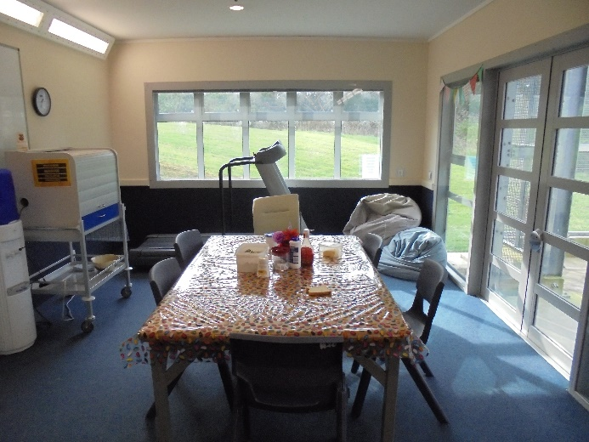 |  | 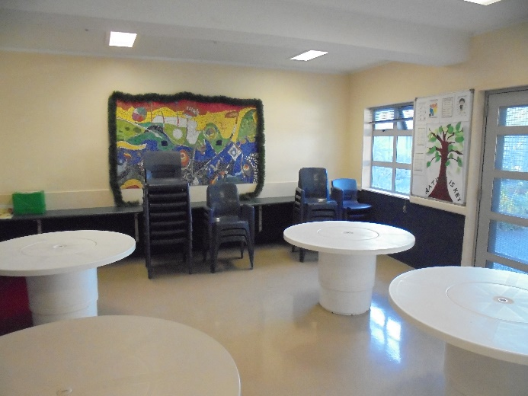
Figure 3: Communal area - Aniwaniwa |  | Figure 4: Dining area
I was pleased to note that worn, damaged carpets had been replaced since my previous inspection. However, overall the Unit was tired, with a number of ongoing maintenance issues, including faulty air conditioning and leaks.
Aniwaniwa, in particular, was not fit for purpose. While I am pleased that separate accommodation was provided for female clients, allowing for privacy and additional safety, the wing was small and restrictive and there were insufficient communal areas for female clients.
Inspectors also noted a variation in temperatures across the Unit. This was particularly noticeable in Rangimārie, which was often colder than the rest of the Unit.
The Unit contained three courtyards, which were locked throughout the day and only accessible under staff supervision. Only one client had unescorted access to the courtyard in their wing at the time of inspection. While I acknowledge the importance of mitigating risk and ensuring clients’ safety, the blanket approach to locking the courtyard appears counterintuitive, particularly given the majority of clients can take leave off the Unit.
Inspectors reviewed clinical notes and found that clients did receive regular access to courtyards. As such, I would question why access to the courtyard must remain locked.
In my 2016 report, I recommended that the Unit add seating and shade to both courtyards in Rangimārie and Aniwaniwa. While Inspectors observed some seating and plants in Aniwaniwa (refer Figure 6), I consider that there was still insufficient shade.
Both courtyards were stark and austere. In contrast, the courtyard on the male wing was large and open, with a tennis court, grassy areas, seating and a small garden. Staff advised that female clients could access this courtyard on request.
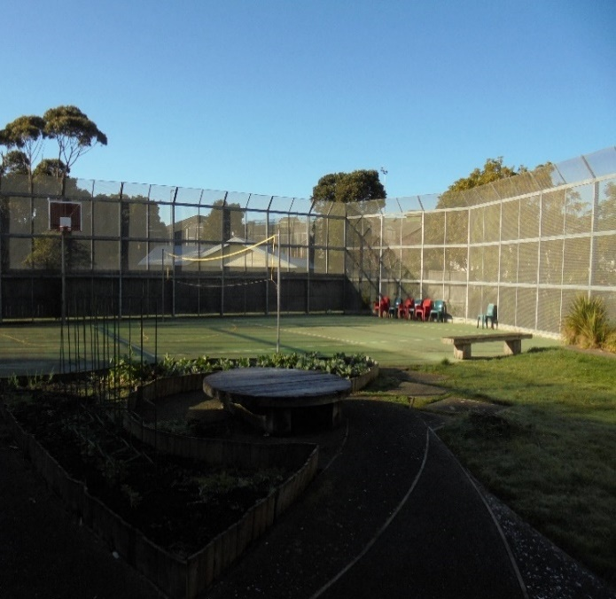 |  | 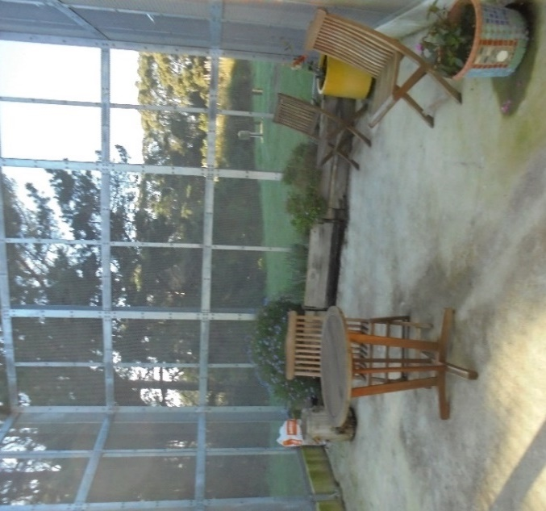
Figure 5: Courtyard – male wing |  | Figure 6: Courtyard – female wing
As noted on page 16 of this report, I have concerns regarding the disparity of treatment between male and female clients on the Unit. The small, poorly equipped outdoor spaces dedicated for women highlighted this problem.
Inspectors also visited Pūkeko Cottage, which comprised four bedrooms and two bathrooms. The house was adequately ventilated, with a large open kitchen. There were heat pumps, but these were broken. The house was self-managed and overall was clean and tidy throughout.

Food
Clients’ meals were prepared in the main hospital kitchen and delivered to the Unit in heated trolleys. Breakfast was delivered from around 8am, lunch at 1pm, and dinner around 5pm. During the day, clients were also provided with a range of snacks, fruits and yoghurts.
The Unit also had a separate Occupational Therapist (OT) kitchen, which allowed clients to make meals on a set roster. Clients told my Inspectors they enjoyed the opportunity to make meals for the Unit, which included curries, pikelets, and cakes, among other things.
All meals were provided in the dining area, which was locked outside of meal times. Clients were unable to access the dining area to make their own hot drinks during the day. Staff said that hot drinks were only available at specified times during the day.
I consider the blanket restriction on access to the kitchen unreasonably restricted clients’ ability to access hot water for drinks. I acknowledge the view that the restriction exists for safety reasons. However, the current process applies to everyone irrespective of safety risk. I consider that access to hot drinks should be based on individual risk and subject to regular review.

Recommendations – material conditions
I recommend that:
- Ongoing maintenance issues are addressed (with particular attention to the variation in temperatures across the Unit).
- All clients have unrestricted access to the courtyards during the day, unless deemed inappropriate for individual clients on a clinical or safety basis.
- Shade is provided in the Aniwaniwa exercise yard. This is an amended repeat recommendation.
- Clients are able to freely access hot drinks, unless deemed unsafe based on individual risk assessment.

Rangipapa comments
The DHB accepted recommendation 11.
The DHB rejected recommendations 12 and 13.
The DHB partially accepted recommendation 14.
The DHB’s response included the following comment regarding recommendation 12:
Rangipapa is a mixed-gender medium secure forensic unit, which provides care for clients who are acutely unwell through to those who are on a rehabilitation pathway. All areas in use require safe staffing, including the courtyard. Given the range of acuity and gender mix, the normative expectation in Rangipapa is of access to the courtyards being available upon request. Access is granted when it is appropriate to the care of an individual client and does not compromise the overall safety of the unit. We consider this to be a necessary and proportionate response to maintain a safe environment.
Ombudsman response:
I acknowledge that unrestricted access to the courtyard may not be safe for all clients and in all circumstances. However, my concern is with the blanket approach taken to accessing the courtyards that disadvantages all clients regardless of their individual circumstances.
My expectation is that that restrictions are only put in place where strictly necessary on the basis of specific, individual risk, rather than by way of a general rule which must be disproved on a case-by-case basis. I consider that this approach is especially important when it concerns access to basic needs such as fresh air.
The DHB’s response included the following comment regarding recommendation 13:
The female clients themselves rejected the idea of shade in the Aniwaniwa courtyard. The area is too small for exercise, which occurs in the main Rangipapa courtyard where there is good shade, or in the hospital grounds for those who have ground access. The clients' preference is for this courtyard to be an area where they can sit and enjoy fresh air and sunshine.
Ombudsman response:
I welcome the Unit’s efforts to engage with clients about their preferences. However, while this may be the current preference for clients in the Unit, this preference may change over time and for different clients. I encourage the Unit to continue to engage with clients on this matter. I also remain of the view that it would be beneficial for the Unit to explore options for shade that do not involve permanent fixtures, for example retractable awnings, which would enable clients to choose the level of shade from day-to-day.
The DHB’s response included the following comment regarding recommendation 14:
The safety risks associated with free access to hot drinks are well-recognised in secure environments. Rangipapa is a medium secure forensic unit, which provides care for clients who are acutely unwell through to those who are on a rehabilitation pathway. Given the range of acuity, the normative expectation in Rangipapa is of hot water for drinks being available upon request. We consider this to be a necessary and proportionate response to maintain a safe environment. Staff are able to relax this (and do) when it is inappropriate to the care of an individual client and does not compromise the overall safety of the unit. Additional consideration is required of the risks to physical and mental health of unlimited access to hot drinks (caffeine/sugar).
Ombudsman response:
I acknowledge the DHB’s safety concerns and the practical realities of what is needed to keep service users and staff safe. However, the current policy on the Unit disadvantaged all clients as it applied to everyone irrespective of safety risk.
My Inspectors’ observations are that there is not a consistent approach to this issue across all facilities in the country. Providing clients the opportunity to make their own hot drinks also promotes independence and autonomy.
I therefore remain of the view that free access to hot drinks should be available for all clients unless deemed unsafe based on an individual risk assessment.

Activities and programmes

Outdoor exercise and leisure activities
A number of leisure and exercise activities were available to clients. Inspectors were pleased to observe a wide range of activities were available to clients both on and off the Unit.
Each client had their own tailored weekly programme, which was individualised and included both group and 1:1 activities. Individual activities included computer courses, sewing, attending the gym, and driving lessons.
The Unit also had an impressive shared activities programme, which was clearly displayed throughout the Unit. Activities included bingo, music therapy, circuit training, boxing, art classes, meditation groups and communal walks. Visits were also regularly facilitated offsite to a local gym and swimming pool for those with approved leave.
The Unit had a dedicated OT kitchen and art room for activities as well as a small library and exercise room, which some clients were able to access without supervision. Board games, puzzles, books, ping pong and other activities were freely available on the Unit.
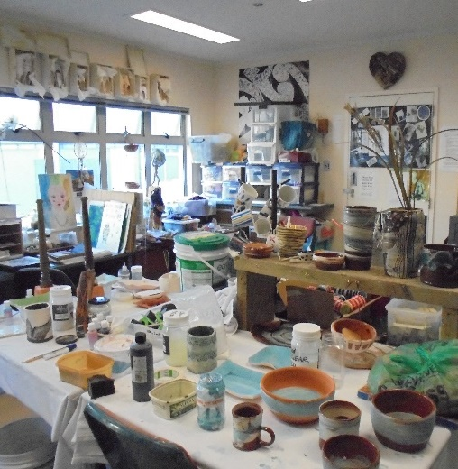 |  | 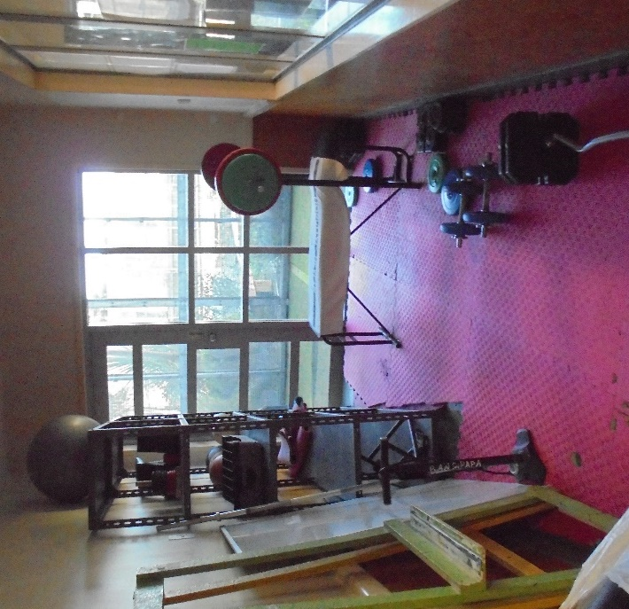
Figure 7: OT Art Room |  | Figure 8: Exercise room
Inspectors observed clients participating in activities both on and off the Unit. Clients told my Inspectors they enjoyed the activities they were attending.
The Unit had one full-time equivalent (FTE) OT and an OT Support Worker. These roles were integral in facilitating programmes and Inspectors also saw nursing staff involved in activities. Inspectors were informed that the OTs worked from Monday to Friday, as clients generally preferred to have quiet weekends.
The Unit had also recently employed a Dietitian, who provided health promotion support to clients across the Service. Given that a number of clients were prescribed high doses of psychotropic medication, such as Clozapine, I was pleased to see that the Unit had placed an emphasis on addressing the physical health needs of clients. The Dietitian attended Huihui and other clinical governance groups, provided guidance on clients’ dietary needs, and promoted physical activity programmes.

Programmes
At the time of inspection, the DHB had vacancies for an FTE Clinical Psychologist and an Alcohol and Drug Clinician. As a result, there were no therapeutic programmes occurring on the Unit at the time of inspection.
However, a number of clients were attending community-based groups and the Unit was facilitating a Violence Prevention Programme at the time of inspection.
One client and a number of staff told my Inspectors there was a lack of gender-specific programmes available on the Unit, particularly for women.

Cultural and spiritual support
Cultural and spiritual support was evident and available to clients on the Unit. The Unit employed two Spiritual Pastoral Therapists, who worked across the Service. The Hospital Chaplaincy Team was also available to clients. Access to the team could be requested through staff.
Sunday services and pastoral care were available to clients across the Service.
The Unit also had a broad range of relationships with cultural services such as Ruaumoko Kaupapa Māori Service and Vaka o le Pasifika Service.
Ruaumoko, a Māori cultural centre, provided assessment, treatment, programmes and support to tāngata whai ora and Vaka o le Pasifika, a Pasifika facility, similarly provided cultural support to tagata pasifika.
The Unit employed a Kuia and Kaumātua, who had regular contact with both tāngata whai ora (clients) and staff to provide spiritual and cultural guidance and support. Inspectors were advised that there was positive communication and support for the cultural team by senior management.
The Unit also employed a Kai Manaaki, who was clinically trained and provided direct input and support to tāngata whai ora. The Kai Manaaki was involved in a number of working groups and clinical meetings, such as the Huihui, ensuring a te ao Māori perspective was applied.
One of the Unit’s Social Workers (SWs) also worked specifically with tāngata whai ora, to guide clients in identifying their whakapapa and support establishing or re-establishing connections with whānau, hapū, and iwi. At the time of inspection, one client was being supported by the SW and Kai Manaaki in returning to their marae and urupā.
Tāngata whai ora my Inspectors spoke with enjoyed participating in cultural programmes, as a space to explore their cultural identity.
I was pleased to hear that the Unit has good cultural provision and encourage the Service to continue utilising the knowledge of the cultural team to support tāngata whai ora and their whānau, reflecting the Unit’s ‘Te Whare Tapa Wha’ model of care.

Recommendations – activities and programmes
I have no recommendations to make.

Communications

Access to visitors
Unit visiting hours were between 3pm and 5pm during week days and from 10am to 5pm on weekends. All visits had to be pre-booked at least one day prior and approved by Unit staff. Any visits with children had to be pre-approved by the Team Leader.
Visits were permitted for up to 30 minutes, however, those visiting from out of region were permitted an hour.
Visits were facilitated off the Unit either in the whānau room, meeting rooms or in the Whānau Flat, which was attached to the Unit. Staff said that visitors would stay overnight at the flat occasionally if they had travelled from out of region. Tea, coffee, milo, milk and linen were provided. The Unit diary contained evidence of visits taking place regularly.
At the time of inspection, the Unit was in the process of drafting a whānau information pack, which provided information on key Unit contacts and support services, as well as information on client pathways, the MHA process, advocacy services and information on visits. Free parking was available to visitors on the Unit.
Staff advised that clients were also regularly given leave to visit whānau offsite. A number of clients, who were from out of region, were able to arrange visits approximately twice per month. My Inspectors observed, through review of clinical notes and conservations with clients and staff, that visits with whānau were regularly facilitated and encouraged.
Whānau told my Inspectors that visits were easy to arrange and well facilitated.

Access to external communication
The Unit had two phone booths on the male wing, as well as two cordless phones in the nurses’ station. Staff advised that all clients had an individualised phone plan and approved phone list. Inspectors reviewed a sample of these plans and found they were individualised and clearly outlined risk assessments. These plans were also reviewed on a regular basis. Throughout the inspection, Inspectors observed clients accessing the telephone.
Phone booths in the male wing allowed for privacy when making calls, and given female clients could access cordless phones, calls could be made in private.
Mobile phones and computers were not permitted on the Unit, however, staff and clients noted that access to Skype and Zoom was good. Staff and clients also said video calls were used for meetings with whānau, court hearings and meetings with the DI throughout the COVID-19 Alert Levels 4, 3, and 2.
Clients told my Inspectors that they were able to send and receive mail.

Recommendations – communications
I have no recommendations to make.

Health care

Primary health care services
Clients received a physical assessment on admission and a House Officer visited the Unit. Assessments included obtaining a medical history, taking routine blood tests, and addressing any physical concerns. The Unit also employed a Pharmacist, who regularly attended Huihui and other clinical governance groups.
A treatment room was available on the Unit for physical examination and storage of medications, including controlled drugs. Inspectors observed that the room was tidy and well organised.
There were no documented medication errors between 1 January and 30 June 2020.
Clients did not raise any concerns with Inspectors regarding access to primary health care services.

Recommendations – health care
I have no recommendations to make.

Staff

Staffing levels and staff retention
In my 2016 report, I raised concerns that staff were not easily identifiable and recommended that staff wear clear identification at all times. My Inspectors observed that all Unit staff wore badges with both their name and role. However, Inspectors’ review of complaints from 1 January to 31 June 2020 showed that a number of clients raised that they were unable to identify staff. I encourage the Unit to remind staff that identification should be visible at all times.
Data provided by the Service showed a multi-disciplinary staff complement (excluding doctors) of 12.6 Registered Nurses (RNs), a Clinical Nurse Specialist, Team Leader, and 15 Mental Health Support Workers (MHSWs).
Information provided to Inspectors indicated that the Unit had vacancies for 3.6 RNs.
Nursing staff worked a three-shift roster, with a designated staffing level on each shift. The morning shift ran from 7am to 4pm with three RNs and five MHSWs, afternoon shift from 3pm to 11.30pm with three RNs and five MHSWs, and the night shift from 11pm to 7.30am with one RN and three MHSWs.
Data provided by the Service indicated that between 2017/18 and 2018/19, staff sickness rates decreased from 5.4 percent to 3.4 percent, however, this increased in 2019/20 to 3.9 percent.
Data also showed that between 2017/18 and 2018/19, nursing staff turnover rates increased significantly from 5.3 percent to 15 percent. Between 2018/19 and 2019/20 this increased again to 20 percent. This is a marked increase over a three-year period.
Senior management advised that the high turnover was due to a number of circumstances, such as staff transfers across the wider service and other DHBs, retirement, family reasons, career changes and promotions. While I acknowledge that retention of nursing staff is a national workforce issue and that the Service was making efforts to recruit new staff, I find this high turnover concerning.
Inspectors’ review of data provided by the Service showed that the majority of staff had worked on the Unit for over five years, while there was only one RN that had joined the Service within the last year. While I acknowledge the importance of having senior staff on the Unit and the difficulty in recruiting staff, it is imperative that the Service has a balance in skill mix and workforce demographic.
Senior management advised that the Service had recently increased the number of placements for new graduates in forensic mental health services. Senior management also stated that there was a focus on recruiting more staff with diverse cultural backgrounds into undergraduate and postgraduate scholarships. I support this initiative and look forward to seeing its progress on future inspections.
Having a diverse workforce, with a range of professional and cultural backgrounds, expertise and experience is essential for optimal quality of care and improved client outcomes.
I consider that more urgent work needs to be done to address the high and increasing staff turnover rate on the Unit.

Recommendations – staff
I recommend that:
- The Unit regularly monitor and analyse the reasons for staff turnover and take action to address any concerning trends.

Rangipapa comments
The DHB partially accepted recommendation 15.

Acknowledgements
I appreciate the full co-operation extended by the Clinical Nurse Specialist and staff to the Inspectors during their inspection of the Unit. I also acknowledge the work involved in collating the information requested.

Peter Boshier
Chief Ombudsman
National Preventive Mechanism
- List of people who spoke with Inspectors
Table 1: List of people who spoke with Inspectors
Managers | Unit staff | Others
Team Leader  Forensic Director Area Mental Health Services  Clinical Director  Operations Manager | Clinical Nurse Specialist  Registered Nurses  Consultant Psychiatrist  Occupational Therapists  Occupational Therapist Support Workers  Social Workers  Mental Health Support Workers | Clients  Whānau  Family Advisor  Spiritual Pastoral Therapist  Kaumātua  Kuia  Pasifika Advisor  District Inspector

- Legislative framework
In 2007 the New Zealand Government ratified the United Nations Optional Protocol to the Convention against Torture and Other Cruel, Inhuman or Degrading Treatment or Punishment (OPCAT).
The objective of OPCAT is to establish a system of regular visits undertaken by an independent national body to places where people are deprived of their liberty, in order to prevent torture and other cruel, inhuman or degrading treatment or punishment.
The Crimes of Torture Act 1989 (COTA) was amended by the Crimes of Torture Amendment Act 2006 to enable New Zealand to meet its international obligations under OPCAT.

Places of detention – health and disability facilities
Section 16 of COTA defines a “place of detention” as:
“…any place in New Zealand where persons are or may be deprived of liberty, including, for example, detention or custody in…
(d) a hospital
(e) a secure facility as defined in section 9(2) of the Intellectual Disability (Compulsory Care and Rehabilitation) Act 2003…”
Ombudsmen are designated by the Minister of Justice as a National Preventive Mechanism (NPM) to inspect certain places of detention under OPCAT, including hospitals and the secure facilities identified above.
Under section 27 of COTA, an NPM’s functions include:
- to examine the conditions of detention applying to detainees and the treatment of detainees; and
- to make any recommendations it considers appropriate to the person in charge of a place of detention:
  - for improving the conditions of detention applying to detainees;
  - for improving the treatment of detainees; and
  - for preventing torture and other cruel, inhuman or degrading treatment or punishment in places of detention.

Carrying out the OPCAT function
Under COTA, Ombudsmen are entitled to:
- access all information regarding the number of detainees, the treatment of detainees and the conditions of detention;
- unrestricted access to any place of detention for which they are designated, and unrestricted access to any person in that place;
- interview any person, without witnesses, either personally or through an interpreter; and
- choose the places they want to visit and the people they want to interview.
Section 34 of COTA provides that when carrying out their OPCAT function, Ombudsmen can use their Ombudsmen Act (OA) powers to require the production of any information, documents, papers or things (even where there may be a statutory obligation of secrecy or non-disclosure) (sections 19(1), 19(3) and 19(4) OA. To facilitate his OPCAT role, the Chief Ombudsman has authorised inspectors to exercise these powers on his behalf.

More information
Find out more about the Chief Ombudsman’s OPCAT role, and read his reports online: ombudsman.parliament.nz/opcat.

A person who uses mental health and addiction services. This term is often used interchangeably with consumer, patient, or tāngata whai ora.
When the term Inspectors is used, this refers to the inspection team comprising of two Inspectors.
See https://covid19.govt.nz/alert-system/covid-19-alert-system/ for more about New Zealand’s COVID-19 alert system.
UN Convention against Torture, Article 16(1): ‘Each State Party shall undertake to prevent in any territory under its jurisdiction other acts of cruel, inhuman or degrading treatment or punishment which do not amount to torture as defined in article I, when such acts are committed by or at the instigation of or with the consent or acquiescence of a public official or other person acting in an official capacity. In particular, the obligations contained in articles 10, 11, 12 and 13 shall apply with the substitution for references to torture of references to other forms of cruel, inhuman or degrading treatment or punishment.’
The Ministry of Health defines night safety procedures as: ‘the practice of locking a patient in their bedroom overnight for the purposes of safety. The practice has no therapeutic function and constitutes (at the very least) a form of environmental restraint.’ Ministry of Health. 2018. Night Safety Procedures: Transitional Guideline.
Recommendations from my 2016 report are on page 11.
Addressed in my Report on an unannounced inspection of Tāwhirimātea Forensic Rehabilitation Unit, Rātonga-Rua-O-Porirua Campus, under the Crimes of Torture Act 1989, (2021) Wellington, and Report on an unannounced inspection of Pūrehurehu Unit, Rātonga-Rua-O-Porirua Campus, under the Crimes of Torture Act 1989, (2021) Wellington.
Data provided by the DAMHS shows occupancy across the Service has averaged over 103 percent in the six months from January to June 2020.
When a court orders a person be referred to the Service, that person must be accommodated regardless of capacity and waiting lists.
The units inspected at the same time were Tāwhirimātea and Pūrehurehu.
For example, I have provided the Ministry of Health with my Report on an unannounced inspection of Haumietiketike Unit, Rātonga-Rua-O-Porirua Campus, under the Crimes of Torture Act 1989 (2021) and Final opinion of the Chief Ombudsman – Oversight: An investigation into the Ministry of Health’s stewardship of hospital-level secure services for people with an intellectual disability (2021).
http://www.mhaids.health.nz/our-services/regional-forensic-and-rehabilitation-services/central-regional-forensic-adult-inpatient-service/
My Inspectors had observed two seclusion rooms at the time of the inspection. However, following the inspection, I was advised that the second seclusion room had been decommissioned and was being used as a high care bedroom for female clients.
SPEC training was designed to support staff working within inpatient mental health units to reduce the incidence of restraints. SPEC training has a strong emphasis on prevention and therapeutic communication skills and strategies, alongside the provision of training in safe, and pain-free personal restraint techniques. https://www.tepou.co.nz/initiatives/towards-restraint-free-mental-health-practice/149. Accessed online 29 September 2020.
Sentinel events are unanticipated events in the healthcare setting which have resulted in serious harm to clients.
My inspection methodology is informed by the Association for the Prevention of Torture’s Practical Guide to Monitoring Places of Detention (2004) Geneva, available at www.apt.ch.
For a list of people spoken with by the Inspectors, see Appendix 1.
Report on an unannounced inspection to Rangipapa Forensic Acute Mental Health Unit under the Crimes of Torture Act 1989, February 2016.
Seclusion is defined as: ‘Where a person is placed alone in a room or area, at any time and for any duration, from which they cannot freely exit’. New Zealand Standards. Health and Disability Services (Restraint Minimisation and Safe Practice) Standards. Ministry of Health. 2008.
Ministry of Health. 2010. Seclusion under the Mental Health (Compulsory Assessment and Treatment) Act 1992.
Dr Sharon Shalev and New Zealand Human Rights Commission. 2017. Thinking outside the box: A review of seclusion and restraint practices in New Zealand. At page 18.
Male clients were generally admitted from the male-only Purehurehu Adult Acute Forensic Mental Health Unit, located on the Kenepuru Hospital campus.
Rangipapa is one of two facilities within the Service that provide beds for female clients. Tāwhirimātea is a Forensic Rehabilitation Unit that provides step-down rehabilitative services and has a dedicated female wing with six beds. I have reported separately on Tāwhirimātea’s clients’ treatment and conditions.
The rights and needs of women are specifically referred to in the International Covenant on Civil and Political Rights, the Convention on the Elimination of All Forms of Discrimination against Women, and the Beijing Declaration and Platform for Action.
Electroconvulsive therapy is used mainly in the treatment of severe depressive episodes. It involves the passage of an electric current across the head of a person to produce a convulsion. https://www.health.govt.nz/publication/electroconvulsive-therapy-ect
‘Sensory modulation uses a range of tools to help individuals get the right amount of sensory input. In mental health settings, sensory modulation can be used to assist distressed clients to regain a sense of calm’. Te Pou o Te Whakaaro Nui. Sensory modulation in inpatient mental health: A summary of the evidence. (2011), Te Pou o Te Whakaaro Nui, Auckland, at page 3.
New Zealand Standards. Health and Disability Services (Restraint Minimisation and Safe Practice) Standards. Ministry of Health. 2008.
Mental Health (Compulsory Assessment and Treatment) Act 1992, section 71.
Despite a compulsory treatment order, section 59 of MHA requires clinicians to make efforts to obtain clients’ consent to treatment wherever practicable. See Guidelines to the Mental Health (Compulsory Assessment and Treatment) Act 1992. Ministry of Health. 2008.
The outside sally port area in Rangimārie was described to Inspectors as a courtyard where clients could access fresh air.
https://www.health.govt.nz/our-work/populations/maori-health/maori-health-models/maori-health-models-te-whare-tapa-wha
Nine RNs and 11 MHSWs had worked on the Unit for over 5 years, 6 RNs and 4 MHSWs had 1 to 5 years’ experience.

