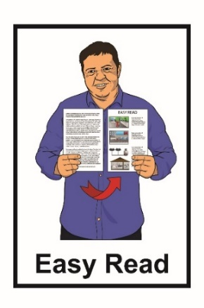
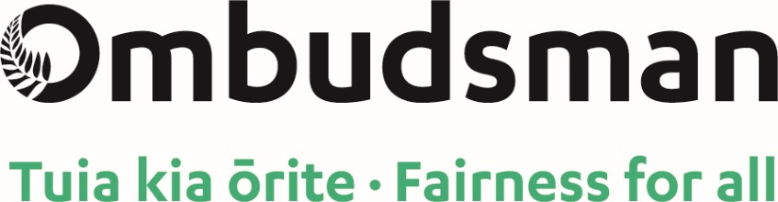

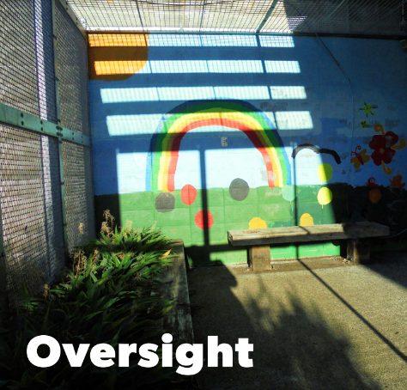

Report: Oversight

An investigation into the

High and Complex Framework

Published: July 2021

What you will find in this document

Page number:

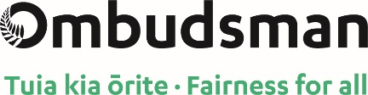

What is the Office of the Ombudsman? …..3
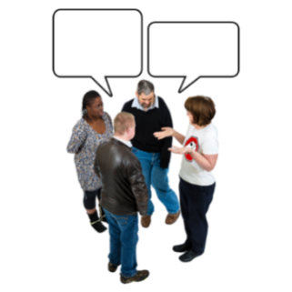

About the words used in
this report 6

About the High and Complex Framework 8

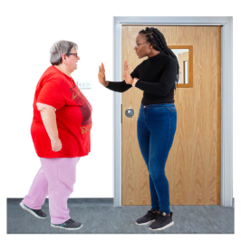
Why the Chief Ombudsman
started the investigation 14

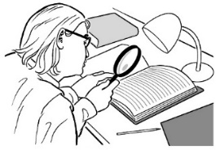
The investigation 17

Page number:

What the investigation found 22

What will happen next? 33

Where to find more
information………………….…….....36

What is the Office of the Ombudsman?

The Office of the Ombudsman looks into problems with government services.
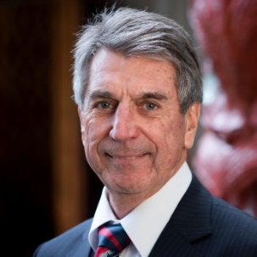

The Chief Ombudsman is Peter Boshier.

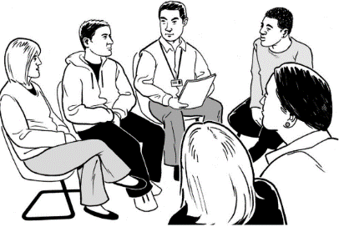
There are a lot of people who work with him at the Office of the Ombudsman.

The Chief Ombudsman can:
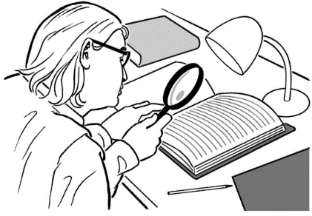
- do investigations

- write reports about what he has found out
- say what needs to be done to make things better.

An investigation means looking closely at something to find out what has been happening.

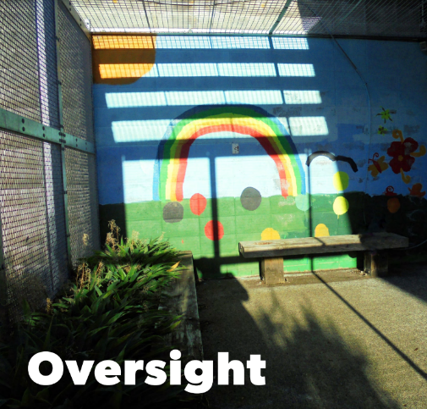
The Chief Ombudsman has written a report called:

Oversight: An investigation of the High and Complex Framework.

The High and Complex Framework
is a group of services for people with an intellectual disability who have needs that regular services cannot meet.

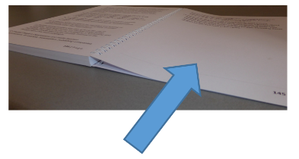
There is more information about the High and Complex Framework on pages 8 to 13.

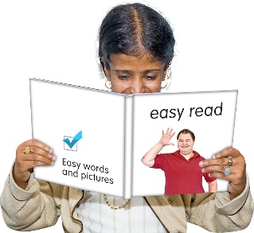
This document is an Easy Read translation of main things found in the full report.

You can find the full report on the Office of the Ombudsman website:

www.ombudsman.parliament.nz

About the words used in this report

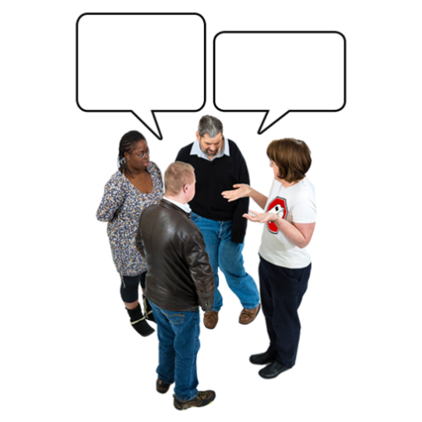
The words used to talk about disability are important.

Different people use different words.

In this report the Chief Ombudsman uses intellectual disability.

Some people prefer learning disability or other words.

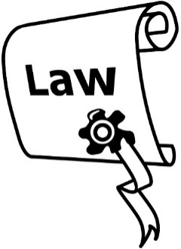
The reason the Chief Ombudsman uses intellectual disability is because it matches a law that is important to this report.

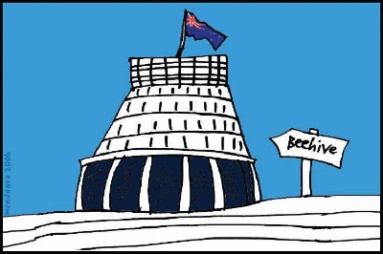
Laws are rules made by the government that everyone has to follow.

The law that is important for this investigation is called:

Intellectual Disability (Compulsory Care and Rehabilitation) Act 2003.

It is also sometimes called the
IDCCR Act.

About the High and Complex Framework

The High and Complex Framework is a group of services for people with an intellectual disability who have needs that regular services cannot meet.

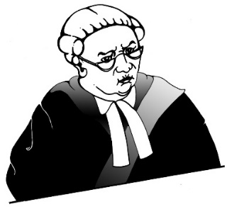
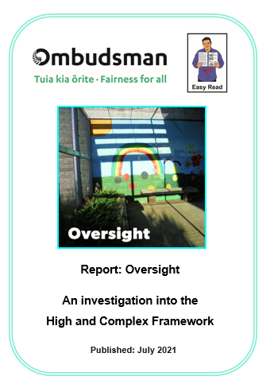
Some of these people have to get services under the High and Complex Framework because the court says they have to.

In this document the High and Complex Framework is called the Framework.

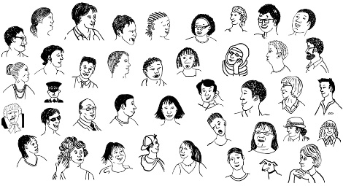
There are between 2 hundred and 2 hundred and 50 people supported by the Framework at any time.
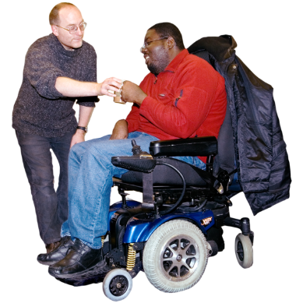
In this report service user mostly means people who are supported by the Framework.

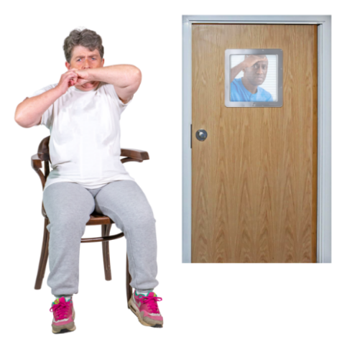
Service users:
- have an intellectual disability

- have very high support needs
- can find it hard to advocate for themselves.
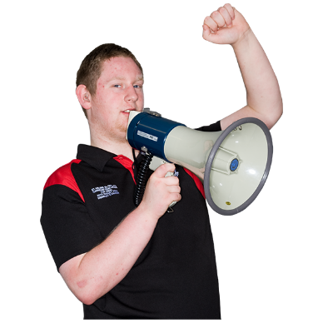

When you advocate for yourself it means you speak up to get what you need.

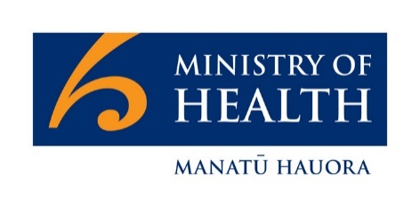
The Ministry of Health – Manatū Hauora is the steward / kaitiaki of the health and disability system.

Steward / kaitiaki means to look after something.

In this document the Ministry of Health – Manatū Hauora is called the Ministry.

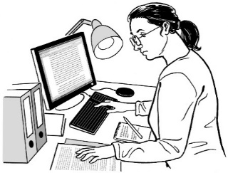
The Ministry is responsible for:
- planning Framework services
- buying Framework services.

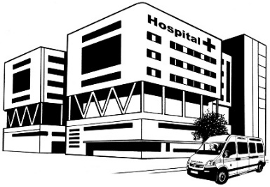
Services that are part of the Framework are provided by:
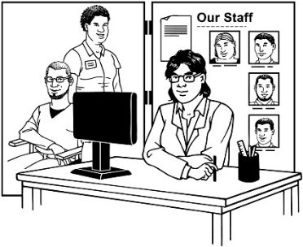
- District Health Boards
- Non Government Organisations.

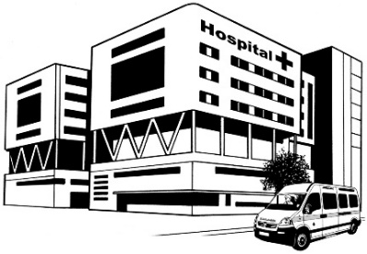
District Health Boards are also called DHBs.

DHBs look after health services like hospitals in different parts of New Zealand.

Non Government Organisations can also be called NGOs.

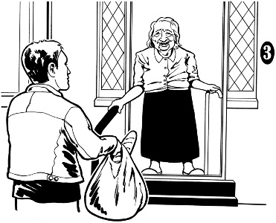
NGOs do things like provide disability services.

They are not part of the government.
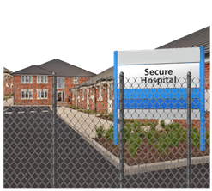
Service users may live in secure facilities like:
- hospitals which are run by the DHBs
- community homes where there are staff working all the time.

Secure facilities are places where people cannot leave when they want.
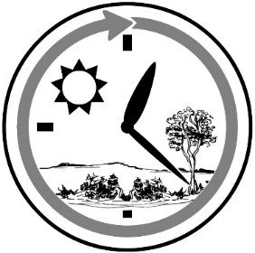
People who live in secure facilities have support:

- all day
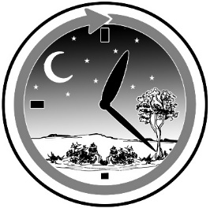
and

- all night.
Sometimes we talk about how many beds there are in secure facilities.
When we say beds we mean:
- space for a person to live
and
- enough services to support them.

Why the Chief Ombudsman

started the investigation

In late 2018 the Chief Ombudsman became concerned that there were not enough services for people who:
- had an intellectual disability
- needed care in a secure place.

He was also worried about what it was like for people in some of these secure places.

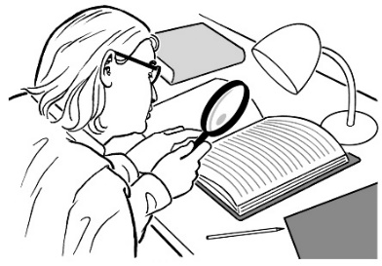
On 22 January 2019 the Chief Ombudsman told the Ministry he was going to start an investigation.

The investigation was into how the Ministry:

- planned their Framework services

- monitored their Framework services.

Monitoring is how the Ministry checks how things are going.

The investigation looked mostly at what was happening in secure hospital services.

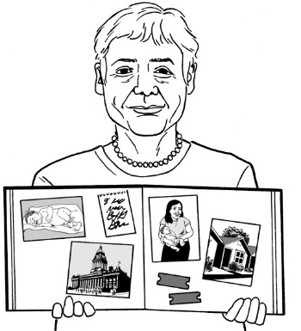
The investigation looked at case studies to find out about what it was like for some people while they were in secure facilities.

Case studies are real life stories.

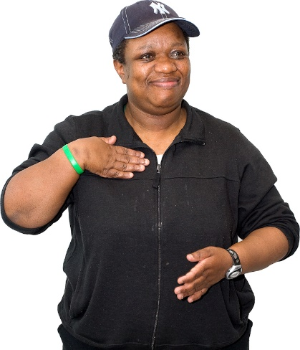
They help us understand:

- what is was like for people who were being supported under the Framework

- how decisions changed the lives of real people.

The investigation

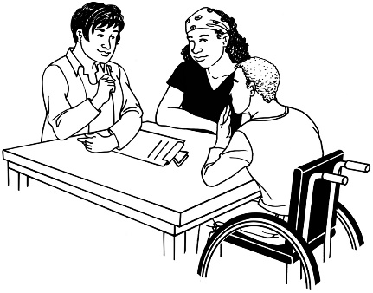
As part of the investigation people who work for the Chief Ombudsman:
- talked to people who work for the Ministry
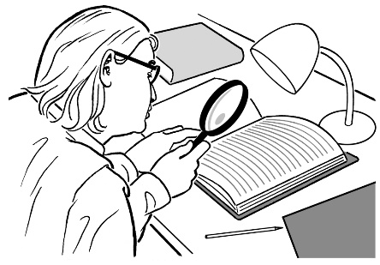
- looked at written information from:
  - the Ministry
  - DHBs
  - some of the community services
  - others who were important parts of the Framework.

People who work for the Chief Ombudsman also visited 5 DHBs that have secure care services for people with an intellectual disability.

These visits were to:
- see what the places service users lived in were like
- meet with:
  - staff
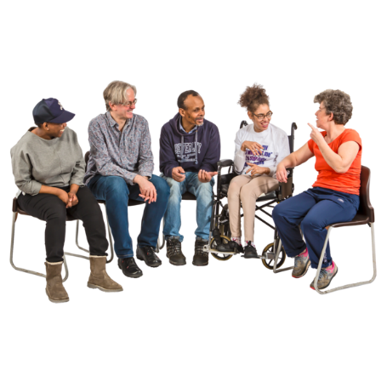
  - service users
  - the family / whānau of service users.

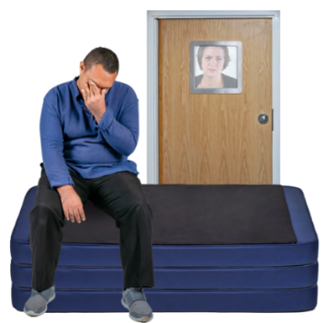
This was important so the Chief Ombudsman could see the things that were making it hard for people to get good support.

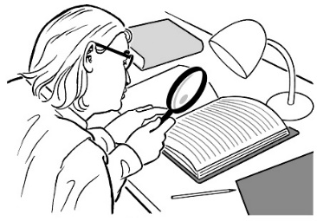
The investigation was mostly about:

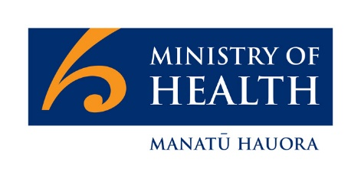
- how the Ministry works as a steward / kaitiaki

- how well the Ministry did the things it needed to from:
- January 2015
to
- December 2020.

Some of the things the Ministry needs to do as a steward / kaitiaki are:
- make sure the system is running well
- find out when there is going to be a need for things like more beds for people in the secure facilities
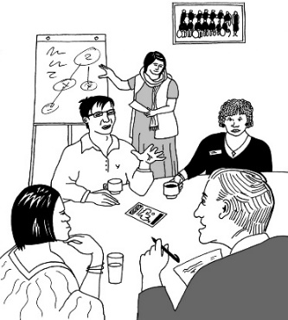
- make sure the system can keep running well for the years ahead
- give advice to the Minister that they can use to make decisions.

The Ministry also needs to look at the whole system when deciding how best to provide:
- facilities
- services.

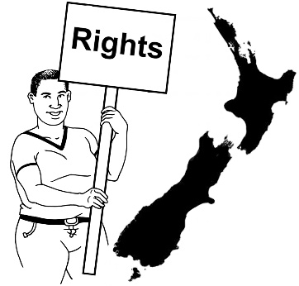
As part of being the steward / kaitiaki the Ministry must also take steps to make sure the Framework supports:
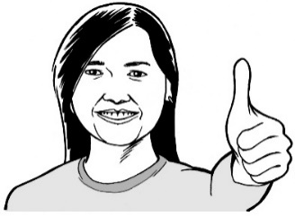
- the rights of service users
- service users having good lives.

What the investigation found

The investigation found problems with:
- the Framework
- there not being enough services for the people who need them.

Things have got worse since the Chief Ombudsman started his investigation in January 2019.

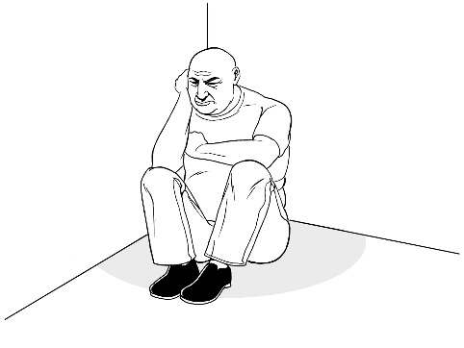
These problems have had a big impact on the lives of people in the Framework.

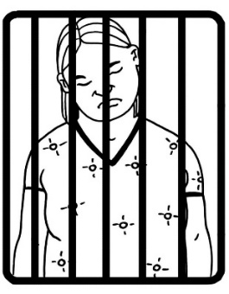
People had to spend extra time in prison because there were not any beds free in secure hospitals.

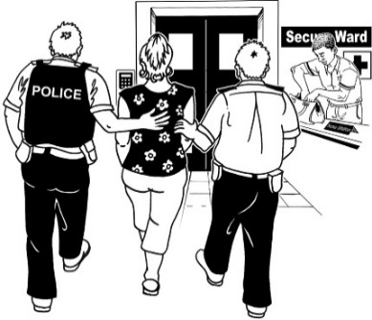
People were put in mental health units even though their needs were mostly to do with intellectual disability.

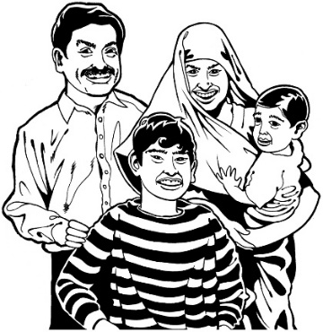
People were also put in places a long way from their:
- home
- family / whānau.

In secure hospitals:

- seclusion rooms

- de-escalation areas

were used as bedrooms.

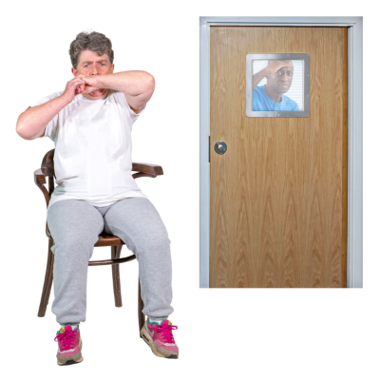
Seclusion rooms and de-escalation areas are rooms people are put into so that they:

- calm down
- do not hurt themselves

- do not hurt other people.

These rooms were not set up as bedrooms for people to stay in for a long time.
The Ministry tried to make things better by:
- looking for more money for Framework services in 2015 to 2016
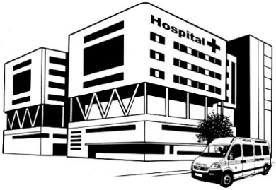
- making more service units at
Capital and Coast DHB
- agreeing to find the money for more beds at Waitematā DHB.

The Chief Ombudsman found that the Ministry:
- understood the problems
- was not doing enough to solve these problems.

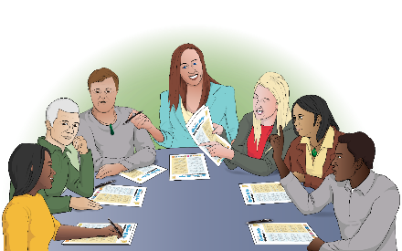
The Ministry should have worked with the DHBs to make a clear plan to sort out the problem of there not being enough beds.

The Ministry did not have a plan to guide:
- the decisions they made
- how services could be made better
- what services were needed.
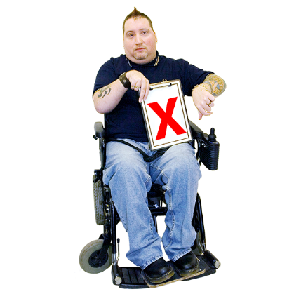

The Chief Ombudsman thought the Ministry did not do enough to sort out the problems.

The Chief Ombudsman thought the Ministry should have been looking at:
- why the Framework was not doing well
- how the Framework could do better.

In late 2020 the Ministry started doing more about there not being enough beds in the Framework.

The Chief Ombudsman said it looks like the Ministry is now doing more to make things better.

The Chief Ombudsman’s final thoughts were that the Ministry:

- did not do enough to look after the Framework

- did not do enough to make sure service users had good support services to enable them to live good lives
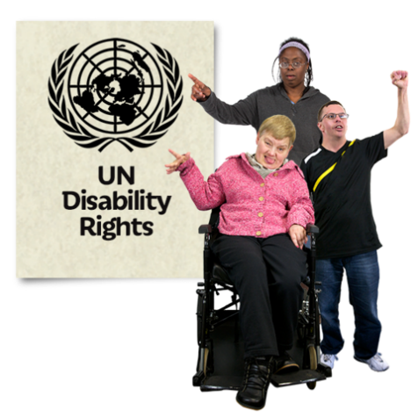
- did not do what the United Nations Convention on the Rights of Persons with Disabilities says New Zealand needs to do.

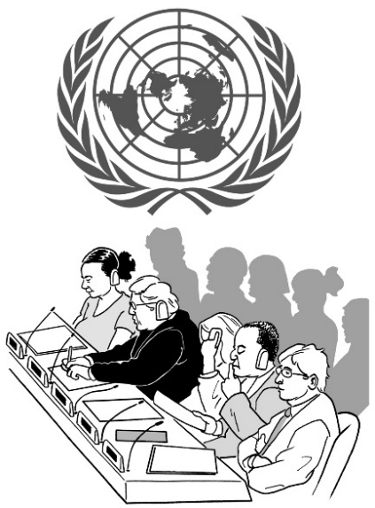
The United Nations Convention on the Rights of Persons with Disabilities is a law lots of countries have agreed to.

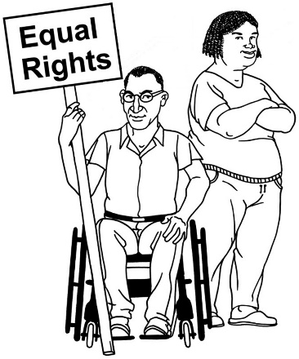
The United Nations Convention on the Rights of Persons with Disabilities is also called the UNCRPD.

It says what governments must do to make sure disabled people get the same rights as everybody else.

The Chief Ombudsman’s final thoughts were also that the Ministry did not do the planning it needed to so that:
- Framework services were done well
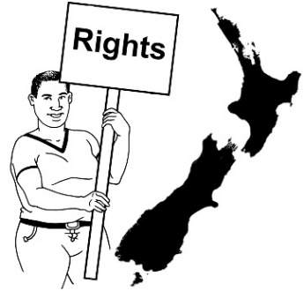
- all the Framework service users got their rights
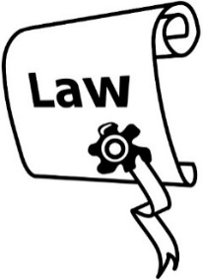
- there was space for all the Framework service users who needed it
- the law was being followed.

Laws are rules made by the government that everyone has to follow.

The Chief Ombudsman also thought that the Ministry did not:

- do planning work with the DHBs
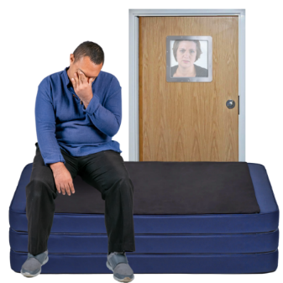
- do the things it needed to sort out the problem of there not being enough beds for people in the right secure place
- collect enough information on how different parts of the Framework were going

- have a good way of checking the information it collected.

This meant it was hard for them to see what some of the problems were.

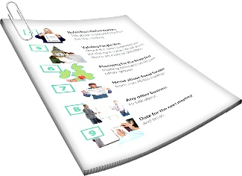
The Director General of Health was not given the information needed about the problems with the Framework.

The job of the Director General of Health is to make sure the Ministry of Health is working well.
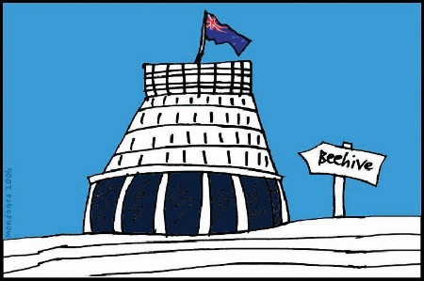

The Director General of Health tells the Minister of Health about the work they are doing.

The Minister of Health was also not given the information needed about the problems with the Framework.

What will happen next?

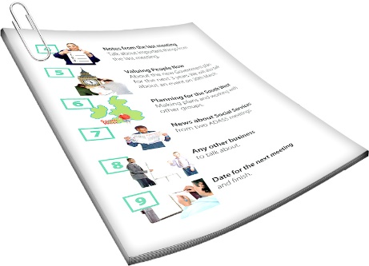
The Chief Ombudsman has made some recommendations to make things better.

Recommendations are things the Ministry needs to do.

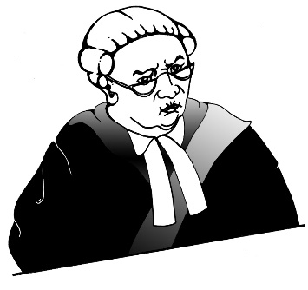
The Ministry needs to make sure that service users sent by the courts can stay in secure places that are right for them.

The Ministry needs to put together a good plan for all parts of the Framework.

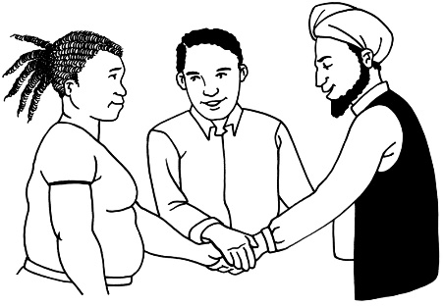
When the Ministry makes this plan they need to work together with:
- DHBs
- NGOs.

The Ministry also needs to check on how the new plan is going.

The Ministry needs to make sure it gets true information about seclusion.

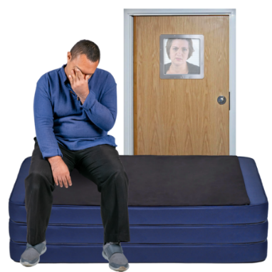
Seclusion is when:

- someone is put in a place on their own

- they cannot leave when they want to.

The Ministry also needs to make sure:

- community services are following the rules about secure facilities
- there is good reporting on:
  - the Framework
  - how service users are doing.

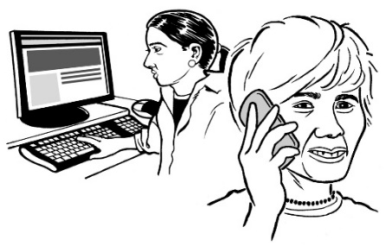
The Ministry needs to:
- keep the Minister of Health up to date on what is happening
- tell the Minister of Health how they are going with working better on the Framework
- keep the Chief Ombudsman up to date on how they are going with these recommendations.

Where to find more information

If you want to find out more about what happens next you can talk to the Office of the Ombudsman:

Phone: 0800 802 602

Email:

info@ombudsman.parliament.nz

You can also find more information on our website:

www.ombudsman.parliament.nz

This information has been written by the Office of the Ombudsman.
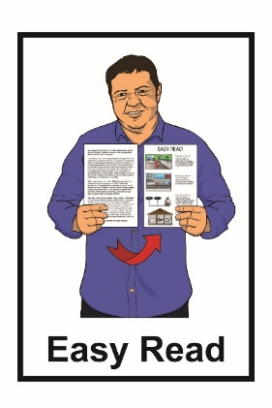
It has been translated into Easy Read by the Make It Easy service of People First New Zealand Inc. Ngā Tāngata Tuatahi.

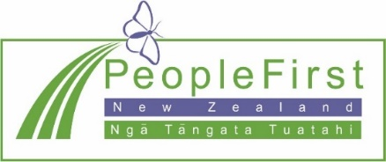
The ideas in this document are not the ideas of People First New Zealand Inc. Ngā Tāngata Tuatahi.
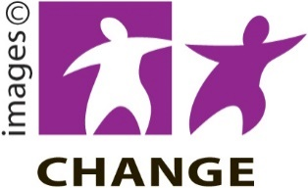
Make It Easy uses images from:
- Changepeople.org

- Photosymbols.com

- Sam Corliss

All images used in this Easy Read document are subject to copyright rules and cannot be used without permission.

