OPCAT Report
Report on an unannounced inspection of Tiaho Mai Mental Health Inpatient Unit, Middlemore Hospital, under the Crimes of Torture Act 1989
June 2021
Peter Boshier
Chief Ombudsman
National Preventive Mechanism

OPCAT Report: Report of an unannounced inspection of Tiaho Mai Mental Health Inpatient Unit, Middlemore Hospital under the Crimes of Torture Act 1989
ISBN: 978-0-9951496-0-1
Published June 2021

This work is licensed under the Creative Commons Attribution 4.0 International Licence. To view a copy of this licence, visit https://creativecommons.org

Office of the Ombudsman | Wellington, New Zealand | www.ombudsman.parliament.nz
Contents
Executive Summary 1
Background 1
Summary of findings 1
Recommendations 4
Feedback meeting 5
Facility Facts 6
Tiaho Mai Mental Health Inpatient Unit 6
Region 6
District Health Board 7
Operating capacity 7
Last inspection 7
The Inspection 8
Inspection methodology 8
Inspection focus 9
Treatment 9
Protective measures 9
Material conditions 9
Activities and programmes 10
Communications 10
Health care 10
Staff 10
Evidence 10
Recommendations from previous report 10
Treatment 12
Torture or other cruel, inhuman or degrading treatment or punishment 12
Seclusion 12
Seclusion policies and events 14
Restraint 14
Restraint training for staff 15
Environmental restraint 15
Electro-convulsive therapy 18
Sensory modulation 18
Service users’ views on treatment 19
Reduction in over-occupancy 19
Recommendations – treatment 20
Good practice 20
Tiaho Mai comments 20
Protective measures 21
Complaints Process 21
Records 21
Recommendations – protective measures 23
Good practice 23
Tiaho Mai comments 23
Material conditions 25
Accommodation and sanitary conditions 25
New build 25
Unit layout 26
Food 27
Recommendations – material conditions 27
Good practice 28
Activities and programmes 28
Outdoor exercise and leisure activities 28
Programmes 29
Cultural and spiritual support 29
Recommendations – activities and programmes 31
Tiaho Mai comments 31
Communications 31
Access to visitors 31
Access to external communication 32
Recommendations – communications 32
Tiaho Mai comments 32
Health care 32
Primary health care services 32
Recommendations – health care 33
Staff 33
Staffing levels and staff retention 33
Staff safety 33
Recommendations – staff 34
Tiaho Mai comments 34
Acknowledgements 35
Appendix 1. List of people who spoke with Inspectors 36
Appendix 2. Legislative framework 37

Tables
Table 1: List of people who spoke with Inspectors 36

Figures
Figure 1: Seclusion room 12
Figure 2: Seclusion en-suite 12
Figure 3: Retreat area courtyard 13
Figure 4: Retreat area 13
Figure 5: Sensory Modulation Room 18
Figure 6: Sensory items 18
Figure 7: Reception area 25
Figure 8: Admission suite 25
Figure 9: Bedroom – Ki Te Whai Ao 26
Figure 10: En-suite bathroom – Ki Te Whai Ao 26
Figure 11: Courtyard – Ki Te Whai Ao 28
Figure 12: Communal area – Ki Te Whai Ao 28
Figure 13: Nga Whetu Marama 30

Executive Summary

Background
Ombudsmen are designated as one of the National Preventive Mechanisms (NPMs) under the Crimes of Torture Act 1989 (COTA), with responsibility for examining and monitoring the conditions and treatment of service users detained in secure units within New Zealand hospitals.
Between 23 and 25 June 2020, four Inspectors — whom I have authorised to carry out visits to places of detention under COTA on my behalf — made an unannounced inspection of Tiaho Mai Mental Health Inpatient Unit (the Unit), which is located in the grounds of Middlemore Hospital Campus, Otahuhu, Auckland.
Service users receive acute mental health services provided by Counties Manukau District Health Board’s (DHB’s) Adult Mental Health Services (The Service).

Summary of findings
My findings are:
- There was no evidence that service users had been subject to torture or other cruel, inhuman or degrading treatment or punishment.
- Seclusion facilities were modern and clean, with natural light and access to fresh air.
- The care of service users in seclusion was good, with cultural support from the Kai Manaaki, and the retreat area was well utilised.
- Service users’ views of the Unit were positive and service users felt staff treated them with dignity and respect.
- The Unit did not go over occupancy, an achievement from my previous inspection in 2015.
- Up-to-date contact details for District Inspectors (DIs) were visible in each of the wards and the DIs had an active presence on the Unit.
- Files contained all the necessary paperwork to detain and treat service users on the Unit, except for one voluntary service user who did not have consent documentation on file.
- Information on the Mental Health (Compulsory Assessment and Treatment) Act 1992 (MHA) process and the Unit’s privacy policy was clearly displayed throughout the Unit, in an accessible format.
- The recently built Unit was light, modern, therapeutic, and considered in its design. All bedrooms had en-suite bathrooms and internal courtyards were accessible to service users throughout the day.
- The thoughtful design of Nga Whetu Marama and the admission suite was commendable. Service users were welcomed to the Unit in an environment that was open and friendly.
- The Unit was clean, tidy and well maintained throughout.
- Service users had independent access to hot and cold drinks throughout the Unit.
- Therapeutic programmes were being rolled out and feedback from service users on these was positive.
- Service users had good access to telephones and were able to keep their personal cell phones on the Unit. Any decision to remove cell phones was based on an individual risk assessment.
- Cultural and spiritual support was evident on the Unit and te ao Maaori perspectives were integrated in the facility’s design, care of service users in seclusion, and the established roles of the Kai Manaaki, Kaumatua and Kuia on the Unit.
- Service users’ physical health care needs appeared to be well met.
- Staff were regularly observed on the Unit and engaged with service users.
The issues that needed addressing are:
- The collation and reporting of seclusion data was incomplete.
- The collation and reporting of restraint data was incomplete.
- Data on the number of staff who were up-to-date with mandatory training at the time of the inspection was not available.
- Consent paperwork for a voluntary service user was incomplete.
- There was a lack of information detailing the process for voluntary service users to enter and exit the Unit.
- Leave restrictions were in place for voluntary service users and at the time of inspection they were not free to leave at will.
- Sensory modulation facilities were not well advertised on the Unit or accessible to service users.
- There was no information about the complaints process on display throughout the Unit and the process was not clearly understood by service users.
- Consent to treatment forms were not always on file.
- Completion of admission forms and orientation checklists was variable.
- Service users were not invited to their Multi-Disciplinary Team (MDT) meetings and did not regularly receive feedback on the outcomes of these meetings.
- While there were activities available on the Unit, they were not individualised or tailored to the service user group.
- Data on staffing levels, sickness, and turnover was not available.
- Staffing levels and staff safety continued to be an issue on the Unit.

Recommendations
I recommend that:
- The Service take all necessary steps to enable comprehensive and accurate collection and reporting of seclusion data.
- The Service take all necessary steps to enable comprehensive and accurate collection and reporting of restraint data.
- The Service take all necessary steps to enable comprehensive and accurate collection and reporting of staff mandatory training data.
- The Open Door Policy is adhered to. This includes the Unit only being locked when clinical need dictates and for no longer than is necessary, as well as clear rationale being provided for any variance from the Open Door Policy, which should be recorded and reported as an incident.
- Voluntary service users’ informed consent is routinely sought and recorded.
- Voluntary service users are fully informed of their right to leave the Unit at will, including through information displayed on the Unit and provided in induction material.
- Leave restrictions are not placed on voluntary service users.
- Information on sensory modulation and how to access it be made available for service users. This is a repeat recommendation.
- The complaints process, including complaint forms, is well advertised and accessible to service users on the Unit and their whaanau. This is an amended repeat recommendation.
- Service user consent to treatment forms are completed and recorded in service users’ files.
- Admission and orientation checklists are completed.
- Service users and their whaanau, are invited to attend their MDT meetings where appropriate, and feedback of the outcome is provided and documented. This is an amended repeat recommendation.
- The Unit expand the activities programme, incorporating the views of service users.
- Any visiting restrictions are justified, necessary and proportionate.
- The Service take all necessary steps to enable comprehensive and accurate recording of staffing data.

Follow-up inspections will be made at future dates to monitor implementation of my recommendations.

Feedback meeting
On completion of the inspection, my Inspectors met with Unit staff and representatives of the leadership team to outline their initial observations.

Facility Facts

Tiaho Mai Mental Health Inpatient Unit
Tiaho Mai Mental Health Inpatient Unit (the Unit) is a 52-bed acute adult inpatient unit. Its purpose is to provide assessment, treatment and stabilisation of service users experiencing acute mental health issues, who are unable to be cared for safely in a community environment.
Admission to the Unit is by referral from the Emergency Care Centre or a Community Mental Health Team. Service users can be admitted to the Unit either as voluntary service users or under the Mental Health Act.
In 2016, following extensive collaboration and co-design, the Unit commenced a full reconstruction on the existing site. The first half of the building was completed in November 2018, and the final design was due to be completed by September 2020.
The Unit consists of three wards; Ward 42 Ki Te Whai Ao with 18 beds, Ward 22 Tui with 20 beds, and Ward 43 Kimi Whanaungatanga with 14 high-dependency beds. The Unit is located in the grounds of Middlemore Hospital Campus, Auckland.
The Unit is located within the boundary of Waikato-Tainui Iwi and, as such, this report has adopted the language and spelling of te reo Maaori of this Iwi area.
Some voluntary service users were placed in the Unit, which was a secure locked facility with a controlled single point of entry. Voluntary service users could not unlock external doors, required staff assistance and accompaniment to leave and, in some cases, were not permitted to leave without permission. The expectation was that voluntary service users’ informed consent formed the basis for their placement in the Unit. However, informed consent did not change the fact that there were considerable restrictions which meant they were not free to leave the Unit at will. I discuss these issues further on pages 16 – 17.

Region
Auckland South

District Health Board
Counties Manukau District Health Board

Operating capacity
52 (plus two seclusion beds)

Last inspection
Unannounced inspection – October 2015
Unannounced inspection – December 2011

The Inspection
Four Inspectors conducted the inspection of the Unit between 23 and 25 June 2020. On the first day of the inspection, there were 50 service users on the Unit, comprising 27 females and 23 males. The average length of stay for the preceding six months was 24 days.
At the time of inspection, New Zealand was at COVID-19 Alert Level 1.
The Unit, an open facility, was locked at the time of inspection, reportedly as a response to COVID-19.

Inspection methodology
At the beginning of the inspection, Inspectors met with the Nurse Unit Manager (NUM), before being shown around the Unit.
Inspectors requested the following information during and after the inspection:
- a list of service users and the legislative reference under which they were being detained (at the time of the inspection);
- the seclusion and restraint data from 1 December 2019 to 31 May 2020, and the Service’s seclusion and restraint policies;
- any meetings/reports relating to restraint, seclusion minimisation, and adverse events from 1 December 2019 to 31 May 2020;
- records of staff mandatory training, including Safe Practice Effective Communication training (SPEC);
- service user absent without leave (AWOL) events from 1 December 2019 to 31 May 2020;
- details of all sentinel events from 1 December 2019 to 31 May 2020;
- complaints received from 1 December 2019 to 31 May 2020, a sample of responses and associated timeframes, and a copy of the complaints policy;
- copies of minutes of service user group meetings from 1 December 2019 to 31 May 2020;
- activities programme;
- information provided to service users and their whaanau on admission;
- incident reports relating to medication errors from 1 December 2019 to 31 May 2020;
- staff sickness and retention data for the previous three years;
- staff vacancies at time of inspection (role and number); and
- data on staff, categorised by profession.

Inspection focus
The following areas were examined to determine whether there had been torture or other cruel, inhuman or degrading treatment or punishment, or any other issues impacting adversely on service users.

Treatment
- Torture or other cruel, inhuman or degrading treatment or punishment
- Seclusion
- Seclusion policies and events
- Restraint
- Restraint training for staff
- Environmental restraint
- Electro-convulsive therapy (ECT)
- Sensory modulation
- Service users’ views on treatment

Protective measures
- Complaints process
- Records

Material conditions
- Accommodation and sanitary conditions
- Food

Activities and programmes
- Outdoor exercise and leisure activities
- Programmes
- Cultural and spiritual support

Communications
- Access to visitors
- Access to external communications

Health care
- Primary health care services

Staff
- Staffing levels and staff retention

Evidence
In addition to the documentary evidence provided at the time of the inspection, Inspectors spoke with a number of managers, staff, and service users.
Inspectors also reviewed service user records, were provided additional documents upon request by the staff, and observed the facilities and conditions of the Unit.

Recommendations from previous report
Inspectors also followed up on 14 recommendations, following an inspection to the Unit in 2015, which were:
  - Privacy blinds in seclusion rooms should be repaired or replaced.
  - The seclusion policy needs to be updated and a quality assurance framework applied to the completion of seclusion paperwork.
  - All staff should be up to date with their SPEC training.
  - The Unit needs to develop a locked door policy.
  - The DHB’s complaint policy should be readily available in the Unit and in the service users’ admission pack.
  - A regular audit of MHA paperwork should be undertaken.
  - Service users should be invited to or receive a copy of the outcome of the MDT review.
  - Lounges/ day rooms should not be used as bedrooms.
  - Replace worn and damaged soft furnishings, curtains and privacy blinds.
  - Service users should have greater access to programmes/activities both on and off the unit.
  - The telephone in Kuaka ward should be relocated.
  - Management should address the safety concerns relating to staffing levels.
  - There should be set, advertised meal times for the Unit.
  - Information on sensory modulation and how to access it should be made available for service users.
The Unit’s adoption, or not, of these prior recommendations is referred to in the relevant sections of this report.

Treatment

Torture or other cruel, inhuman or degrading treatment or punishment
There was no evidence that service users had been subject to torture or other cruel, inhuman or degrading treatment or punishment.

Seclusion

Seclusion facilities
The Unit had two seclusion rooms, which were both located on Ward 43 Kimi Whanaungatanga, also referred to as the High Dependency Unit (HDU). Both seclusion rooms, while somewhat stark, were clean, light and spacious, and had en-suite and showering facilities. The rooms included modern design features where access to water could be remotely controlled by staff, based on any assessed risk to its use, and staff advised that en-suite bathrooms were therefore able to be kept unlocked.
Service users were able to maintain orientation to time and date with a clock in the retreat area. Windows had frosting for privacy and external blinds could be controlled by service users.
Access to both seclusion rooms was via two separate ‘retreat areas’, which were secure lounge areas, with seating and a chalkboard. Both retreat areas had access to a separate internal courtyard.
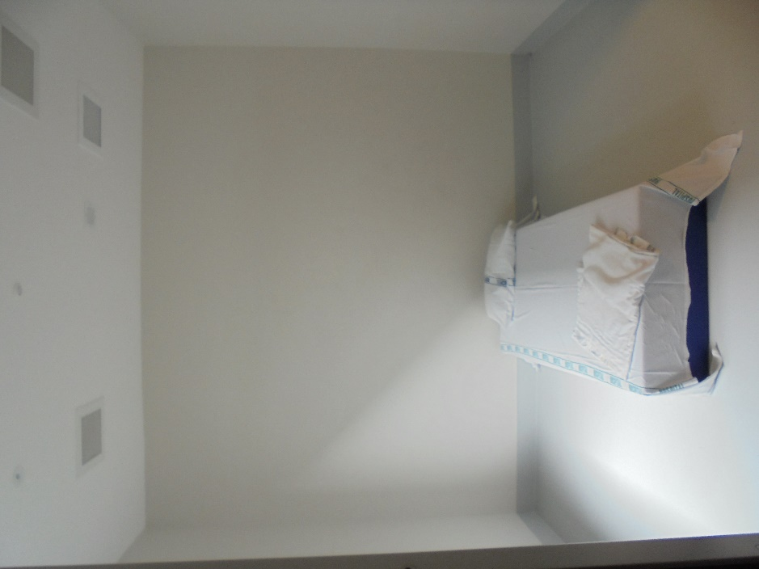 |  | 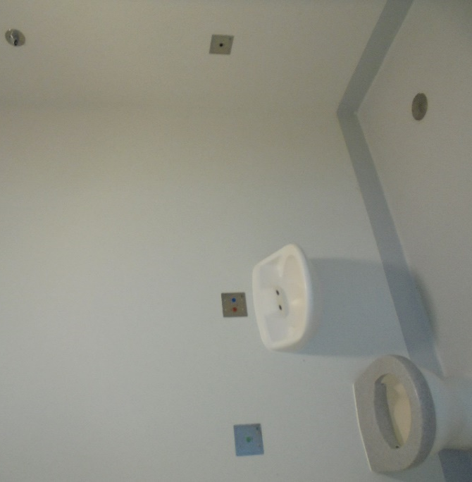
Figure 1: Seclusion room |  | Figure 2: Seclusion en-suite
The courtyard was fitted with artificial grass and a small garden. Senior management told my Inspectors that a business case had been submitted to the DHB to install cedar wood wall panels in order to promote a more therapeutic environment for service users.
I am pleased to hear that the Service intends to soften the courtyard environment, and I encourage the Unit to consider options to reflect this in the retreat area and seclusion rooms.
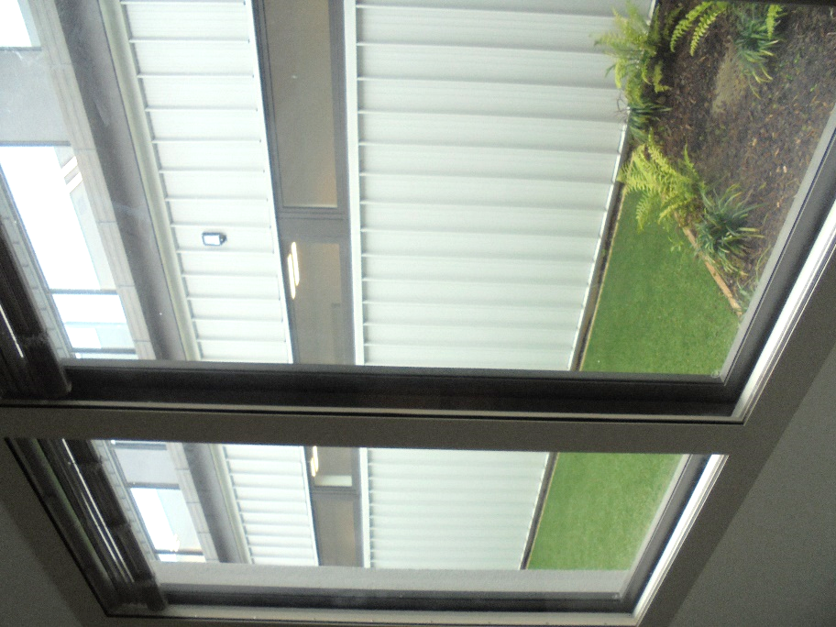 |  | 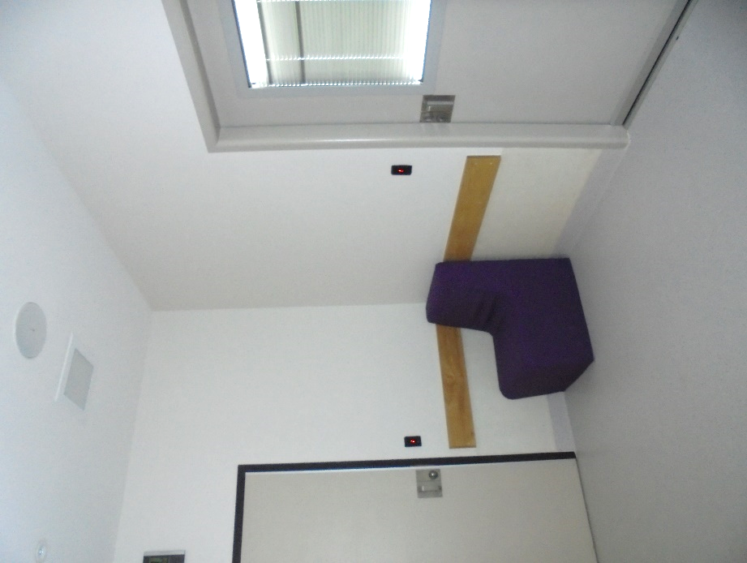
Figure 3: Retreat area courtyard |  | Figure 4: Retreat area

Care of service users in seclusion
My Inspectors observed that there were service users in seclusion throughout the inspection. Service users in seclusion were nursed on 1:1 continuous observations and Inspectors were pleased to observe that retreat areas were well utilised when caring for service users in seclusion. During the inspection, and on review of clinical notes, Inspectors observed that staff regularly provided service users with meals in the retreat area rather than on the floor of the seclusion room.
The role of the Kai Manaaki was integral in providing cultural support to service users in seclusion and was another positive initiative. Inspectors received feedback from service users and staff, which was highly positive and supportive of the role of the Kai Manaaki, particularly in seclusion as well as on admission to the Unit. One service user commented, ‘they [Kai Manaaki] showed me awhi-awhi, I felt secure, respected’.
However, some staff and service user feedback indicated that there was a lack of support for service users coming out of seclusion. My Inspectors requested copies of the minutes for the Service’s ‘Safe for All’ working group, which had been established to focus on reducing seclusion, particularly for Maaori service users. My Inspectors also requested evidence of reviews, ‘lessons learnt’ and debriefs with service users and staff following seclusion. However, this information was unavailable despite a number of requests.
I expect to see the Service actively engaging and collaborating with staff and service users towards reducing seclusion, in the form of debriefs with service users, reviews, ‘lessons learnt’, ongoing staff training in de-escalation, and considering the causes behind the service user being secluded.
While I am pleased to see examples of positive treatment and care of service users in seclusion, I consider more work is needed towards reducing seclusion on the Unit.

Seclusion policies and events
The DHB provided Inspectors with the Seclusion Policy (dated May 2019). The policy had a review period of three years.
As part of the inspection process, my Inspectors requested specific data on seclusion events, including the number of events per month, the total and average hours of seclusion, the number of service users secluded, as well as their gender, age, and ethnicity.
Despite multiple requests for this specific data, the Service was unable to provide this. I am very concerned that the Service is unable to provide specific data on seclusion events.
However, Inspectors received a number of graphs, which indicated that between 1 December 2019 and 31 May 2020 there was a total of 76 seclusion events. Of these, 58 were with restraint and 18 were without restraint. Inspectors also received a graph with average duration for seclusion events, which was approximately 1,900 total hours (average 366 hours per month and 25 hours per seclusion event).
The graphs provided did not indicate the number of service users secluded, nor any information about their gender, age, or ethnicity nor the total time per event.
I am pleased that the number of seclusion events is a reduction from my previous inspection. However, the level of detail provided did not allow for any effective or meaningful analysis on the use of seclusion.
I am therefore unable to determine how the Service is working towards the reduction and minimisation of seclusion on the Unit or how the Service is ensuring equitable treatment of service users, including in the use of seclusion of Maaori service users.

Restraint
Inspectors were provided with the DHB’s Restraint Minimisation and Safe Practice Policy document (dated December 2018). The policy had a review period of three years.
My Inspectors requested specific data on restraint events, including the number of events per month, the total and average hours, the number of service users restrained, as well as their gender, age, and ethnicity.
Despite multiple requests for this specific data, the Service was unable to provide this.
However, Inspectors received a number of graphs, which indicated that between 1 January and 31 May 2020 there were 58 restraint events that resulted in seclusion.
There was no information provided as to what form of restraint was applied, the length of time, number of service users nor any analysis on those restrained.
The level of detail provided in this data did not allow for any effective or meaningful analysis on the use of restraint.
I am therefore unable to determine how the Service is operating in relation to restraint on the Unit or how regularly the Service is monitoring and reviewing its use.

Restraint training for staff
Inspectors requested data on the number of Unit staff who were up-to-date with Safe Practice Effective Communication (SPEC) training. While the Service provided data on those up-to-date across the wider Service over a two-year period, Inspectors were unable to determine how many of those staff were either up-to-date or out-of-date at the time of inspection.
Despite multiple requests, this data was not available. Staff advised that training information could not be provided for the COVID-19 period due to ‘server capability issues’. However, Inspectors were advised that two full SPEC training and two refresher training courses were facilitated during this period.
Information provided by the Service indicated that between 2018 and 2020, on average 24 percent of Unit staff were compliant in SPEC training. Data also indicated that 45 percent of staff across the wider inpatient services were current in their SPEC training.
While I acknowledge the limitations regarding COVID-19, I reiterate that it is imperative all staff are up-to-date with mandatory training requirements and that there is a clear reporting system which indicates any staff who may not be up-to-date with training requirements.

Environmental restraint
Inspectors were provided with a copy of the DHB’s ‘Open Doors in Acute Adult Inpatient MHS’ Policy (the Open Doors Policy) (dated April 2019). The policy had a review period of five years.
The Unit was classed as an ‘open unit’ and the Open Doors Policy stated that ‘ward doors, with the exception of Kimi Whanaungatanga/ Ward 43, are kept unlocked daily between 9am and 5pm’. Under this Policy all service users should have been able to enter and exit the Unit between those hours.

Hospital-wide restrictions due to COVID-19
For the duration of the inspection, all doors leading into and out of the Unit were locked and no service users were permitted to leave the Unit. This included voluntary service users, despite them not being detained under the MHA.
Senior management advised that this was part of a hospital-wide DHB response to the COVID-19 pandemic. They were not able to confirm when this restriction might be lifted. Senior management told my Inspectors that the current restrictions were ‘working well’ for staff and attributed a reported reduction in assaults on the Unit to service users being prevented from leaving the Unit.
While the Open Doors Policy provided the caveat that there may be a variance from the Policy ‘where it has been considered and agreed that access and egress to and from wards is controlled by the temporary use of a locked door when clinical need dictates’ it also stated that ‘doors are only locked when a situation is risky enough to warrant this action and that the duration of the period that the door is locked is no longer than is necessary’.
At the time of inspection, New Zealand was at COVID-19 Alert Level 1 and other DHBs across New Zealand had ceased restrictions in response to the lower Alert Level.
Inspectors noted entry and exit processes were in place for patients in the main hospital. The blanket restriction for service users in the Unit therefore appeared to be inconsistent with the wider practice and therefore risked being discriminatory against service users, receiving treatment for their mental health, in comparison to patients receiving physical health care.
The reason for the Unit being locked was not clearly communicated. The Open Door Policy included that when doors are locked, clear signage should be in place with a rationale for this. No such signage was observed by Inspectors.
The Policy also stated that locking the door is considered an incident and should be recorded and reported as such. Inspectors’ review of documentation indicated that door-locking was not being recorded or reported in monthly incident reports at the time of inspection.
While I acknowledge that COVID-19 has presented unprecedented circumstances for mental health services throughout New Zealand, this should not preclude the Service from adhering to its own policy. Any ongoing restrictions should be justified, necessary and proportionate to the risk.

Environmental restraint of voluntary service users
At the time of inspection, there was one voluntary service user on the Unit.
Voluntary service users are under no legal compulsion to remain on the Unit. Informed consent provides the lawful authority for a voluntary service user to remain in the Unit and receive treatment. Consent may be revoked at any time by voluntary service users and they should be able to enter and exit the Unit at will. Appropriate procedures must be in place to allow for this to occur. Such procedures are particularly important as voluntary service users are not protected by the other legal safeguards for service users under the MHA, such as oversight of the District Inspectors (DIs).
Consent paperwork for the voluntary service user was incomplete. I also found no evidence that there were appropriate procedures to allow voluntary service users to revoke their consent to remain in the Unit. I therefore consider that there was a risk that voluntary service users were being arbitrarily detained.
Inspectors saw that information detailing the entry and exit process was available to visitors at the Unit’s main entrance. However, Inspectors did not observe information displayed on the wards detailing the process to enter or exit the Unit nor any information explicitly stating that voluntary service users had the right to leave when they wished to.
Inspectors were also informed that service users were not provided induction packs with information on the leave process, and that admission and orientation checklists were not regularly completed. Therefore, it was unclear whether or how service users were informed of the process of entering and exiting the Unit, or their right to do so.
According to the Open Doors Policy, service users who are not detained under an order should be safe to leave and are aware of how to do so. However, as noted above, there was a blanket policy in place at the time of the inspection that service users were not permitted leave from the Unit. My Inspectors’ conversations with staff and their review of clinical notes found no evidence that there was an exception for voluntary service users, despite the Open Doors Policy.
Voluntary service users were therefore subjected to the same restrictions as people subject to an order under the MHA. In all the circumstances I consider that, at the time of inspection, the voluntary service user was not free to leave at will.
I acknowledge that the Unit requires a process to identify and manage absences from the Unit, for example by requesting that voluntary service users notify staff before they leave the Unit. However, in my view, voluntary service users have a fundamentally different legal status to people detained under an order and should not be treated the same. Leave restrictions, in particular, are fundamentally incompatible with voluntary status.

Electro-convulsive therapy
There were two service users undergoing Electro-convulsive therapy (ECT) on the Unit at the time of inspection. Both service users had the relevant consent paperwork and records of discussion with whaanau were well-documented.

Sensory modulation
The Unit had three Sensory Modulation Rooms. Two were located in the HDU and one in Ward 42 Ki Te Whai Ao, also referred to as the Low Dependency Unit (LDU). All rooms were locked and were available only under staff supervision.
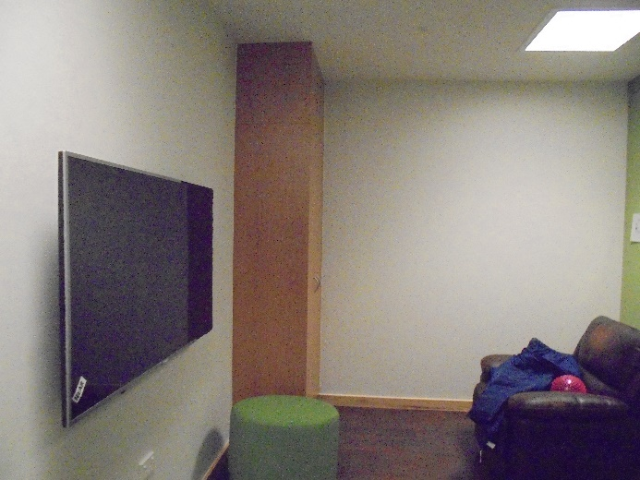 |  | 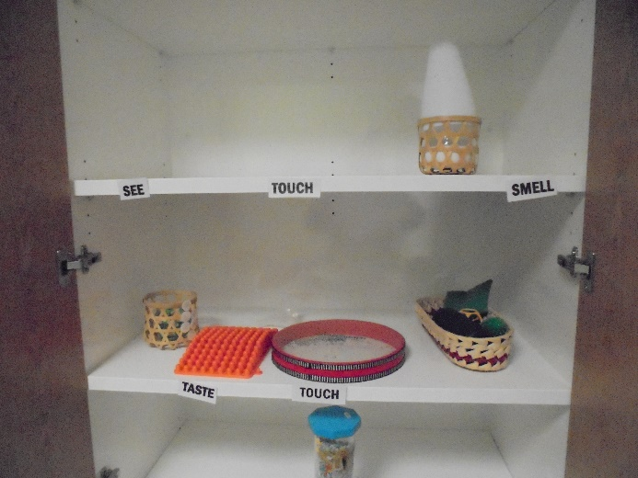
Figure 5: Sensory Modulation Room |  | Figure 6: Sensory items
Inspectors observed that the rooms were small, not well equipped and lacked a therapeutic feel. Staff and service users advised Inspectors that the rooms were not regularly used, and that staff were not recording when service users accessed these rooms. Inspectors were also told that the rooms lacked options, and did not incorporate perspectives, that reflected a range of cultures.
As highlighted in my 2015 report, there was no information available on the Unit about the Sensory Modulation Rooms or how to access them. It was not immediately clear to Inspectors where these rooms were located, except for one room which had a sign labelled ‘out of order’ on the door at the time of inspection.
It was disappointing to see that these spaces were not being effectively used as another means of therapeutic intervention for service users.

Service users’ views on treatment
Service users who spoke to my Inspectors reported they felt staff treated them with respect and that they could approach staff if they had any concerns. Inspector observations reflected this. Throughout the inspection, Inspectors noted positive and friendly interactions between service users and staff.
Service users’ concerns were generally focused on the lack of meaningful activities available and a sense of ‘boredom’. Activities were generally limited to making smoothies and colouring-in. On a number of occasions, service users had requested more individualised activities as well as access to exercise equipment.
The smoking policy was another area of concern for service users, who were unable to take leave to smoke at the time of the inspection due to the ‘lockdown’.
The Unit did not run weekly forums or service user group meetings, as service users had previously raised that they preferred to discuss issues and concerns in private. The Consumer Engagement Advisor regularly visited the Unit, and feedback from service users was documented and provided to senior management.
At the time of inspection, service users did not receive an induction pack. However, Inspectors were advised that the Unit was in the process of drafting an induction pack.
I encourage the Unit to make this a priority. Access to information and proactive, clear communication is key to treating service users with dignity and respect.

Reduction in over-occupancy
In my 2015 report, I raised concerns that the Unit frequently ran over occupancy, resulting in service users being accommodated in non-designated bedrooms.
Therefore, I was pleased to see that the Unit no longer operated over-occupancy. Staff advised that robust processes had been implemented to manage occupancy levels, including monthly reporting, improved admission processes, restructuring the leadership team to support after- hours staff and reduce unwarranted admissions, and enhancing discharge processes.
The Unit worked closely with community mental health teams and non-governmental organisations (NGOs) and regularly facilitated community interface and length of stay meetings to improve discharge processes.
I commend the Unit on this effort, and encourage the Service to continue working to maintain safe and optimum ward occupancy levels.

Recommendations – treatment
I recommend that:
- The Service take all necessary steps to enable comprehensive and accurate collection and reporting of seclusion data.
- The Service take all necessary steps to enable comprehensive and accurate collection and reporting of restraint data.
- The Service take all necessary steps to enable comprehensive and accurate collection and reporting of staff mandatory training data.
- The Open Door Policy is adhered to. This includes the Unit only being locked when clinical need dictates and for no longer than is necessary, as well as clear rationale being provided for any variance from the Open Door Policy, which should be recorded and reported as an incident.
- Voluntary service users’ informed consent is routinely sought and recorded.
- The Unit ensure that voluntary service users are fully informed of their right to leave the Unit at will, including through information displayed on the Unit and provided in induction material.
- Leave restrictions are not placed on voluntary service users.
- Information on sensory modulation and how to access it be made available for service users. This is a repeat recommendation.

Good practice
The role of the Kai Manaaki, and the care they provide to service users in seclusion and on admission, is a positive initiative.
The Unit had addressed the issue of over-occupancy, which was identified in my 2015 report and, in line with my recommendation, was successfully managing occupancy levels.

Tiaho Mai comments
The DHB accepted recommendations 1 to 8.

Protective measures

Complaints Process
A copy of the DHB’s ‘Consumer Related Feedback and Complaints Policy’ (the Complaints Policy) (dated 3 January 2019) was provided to Inspectors. The Complaints Policy had a review period of three years.
However, there was no information displayed about the complaints process on the Unit. While complaints forms were available in the reception area, there was no information available across the wards.
While staff were familiar with the complaints process and were able to describe how to support service users and whaanau to make a complaint, most service users interviewed did not have a clear understanding of the complaints process.
The Unit had received six complaints between 1 December 2019 and 31 May 2020. Inspectors reviewed all complaints and responses and found of the six complaints, only one complaint was lodged by a service user during their stay. Three complaints were filed by relatives on behalf of service users and two were from service users following their discharge from the Unit. Overall, the responses were courteous in tone, individualised, and addressed the issues raised in detail.
District Inspector (DI) contact details and posters for the Code of Rights were well-displayed on the Unit. Information on the role and functions of the DI was also available on the Unit as well as information on the MHA process and the Unit’s privacy policy, which were both available in accessible format.
Inspectors observed that the DIs maintained a strong presence on the Unit, and service users knew who the DIs were and how to contact them.
Inspectors were provided copies of the monthly DI reports from 1 December 2019 to 31 May 2020. These reports were detailed and raised service users’ complaints and concerns to senior management. DIs, in conjunction with the Director of Area Mental Health Services (DAMHS), also held a monthly meeting with senior management to discuss areas of concern for service users. Inspectors attended one of these meetings and found that they were well-led and addressed a number of key issues such as workforce capacity, seclusion reduction, doctors’ meetings with service users and activities available to service users.
I consider these meetings to be an area of good practice and an important oversight mechanism for service users.

Records
Of the 50 service users on the Unit on the first day of the inspection, 49 were detained under the MHA and one service user had voluntary status. All files contained the necessary paperwork to detain and treat the service users on the Unit. As noted above, consent documentation for the voluntary service user was incomplete.
Staff advised that service users were given a copy of their detaining paperwork. However, recording of this was variable. During the inspection, Inspectors were pleased to observe a staff member sitting with a service user explaining their legal status and relevant paperwork.
Consent to treatment forms were not located for the majority of service users who were subject to a compulsory treatment order. Admission and orientation checklists were also incomplete.
Inspectors reviewed service users’ recovery plans, leave paperwork, clinical notes and clinical review meeting minutes. All documentation was thorough and up-to-date. However, a number of service users had not signed their recovery plans.
Inspectors attended the Unit’s weekly Multi-Disciplinary Team (MDT) meeting. The MDT was well-attended by representatives of staff and a variety of DHB mental health community services. Discussion was professional and constructive.
However, Inspectors did not see any evidence that service users or their whaanau were invited to attend their weekly MDT meetings. Inspectors also did not see any evidence that service users, or their whaanau, were routinely or proactively provided with feedback about the outcome of the MDT.
Effective multi disciplinary-based care in mental health services should enable service users to determine their level of involvement in decision-making and ensure they have a clear understanding of their recovery plan.
It is my view that service users and their whaanau should be invited to their MDT wherever possible and kept informed of the outcome of their meetings.

Recommendations – protective measures
I recommend that:
- The complaints process, including complaint forms, is well-advertised and accessible to service users on the Unit and their whaanau. This is an amended repeat recommendation.
- Service user consent to treatment forms be completed and recorded in service users’ files.
- Admission and orientation checklists are completed.
- Service users and their whaanau are invited to attend their MDT meetings, where appropriate, and feedback of the outcome is provided and documented. This is an amended repeat recommendation.

Good practice
The monthly meetings held between senior management and the DIs to raise concerns and complaints was a positive initiative and an additional protective measure for service users.

Tiaho Mai comments
The DHB accepted recommendations 9, 10 and 11.
The DHB rejected recommendation 12.
Recommendation 9 response:
We accept that this is a vital aspect of upholding human rights, however we want to confirm that at the time of the OPCAT visit there was information and forms clearly displayed in the wards.
Ombudsman response:
Recommendations relate to the conditions and evidence my Inspectors found during the time of inspection.
My Inspectors observed complaint forms were available at the entrance to the Unit, however, there were no forms displayed or available on the wards.
Recommendation 12 response:
The focus of the MDT meeting is the coordination of the service user’s care including medical, psychosocial, environmental, functional, safety management, and cultural and spiritual concerns. The MDT meeting is highly structured in order to be a concise and rapid review of each service user’s care so that team members are aware of progress in each disciplinary area. The MDT meets weekly for 90 minutes; during this time 14 – 20 service users are discussed. Each member of the MDT is expected to predicate the interventions in his/her area of expertise upon the goals and preferences of the service user and family/whaanau to the greatest extent possible, with the goal of providing all services in the least restrictive and most consumer-guided manner.
In our planning regarding the structure of the MDT, inclusion of the service user and family or whaanau was considered. However, it was felt that having a substantive discussion with each service user and their support system would require 30-60 minutes per service user, making the MDT process 7 to 20 hours in duration. Other practical considerations included our experience that many families or whaanau are very limited in terms of the times they are available to meet, one cannot accurately predict how much time an individual or their family/whaanau may need for discussion of their care so scheduling becomes chaotic, and many service users find it intimidating to meet with the entire MDT (which can be 10-12 people including various students and trainees) especially early in the course of their recovery. In the past, when MDTs were conducted with the service user present, we also found that individuals often contributed little and were understandably uncomfortable discussing sensitive issues such as trauma or addiction. Further, the MDT meeting was intended to be a place where various team members could express differences in their clinical opinions about the person’s care and this was felt to be something that would best be resolved within the team prior to discussion with the individual or their family/whaanau.
Ombudsman response:
I consider service users, and their whaanau, should be invited to attend their MDT meetings, where appropriate, and that feedback of the outcome is provided and documented.
My Inspectors’ observations are that, where service users are invited to their MDT, this further facilitates the development of ongoing, individualised care and support for the service user. While not all service users may wish to attend, taking a case by case approach in inviting service users to attend their MDT supports service users to decide their level of involvement in their own care.

Material conditions

Accommodation and sanitary conditions

New build
Following ongoing issues with the existing building and growing safety concerns, the Unit commenced a major reconstruction on the existing hospital site in 2016. Construction will be completed in two phases – the first phase of the build was completed in November 2018, with the second phase due to be finalised in September 2020.
The new Unit was light, modern and spacious, with a recovery and patient-centred design approach. Inspectors were advised that the Unit design was developed in consultation with a number of stakeholder groups including service users, family and whaanau, staff, police, administration, Maaori advisors, and other community groups.
The reception area had an open floor plan, with high ceilings, modern design, and general information displayed for visitors to the Unit.
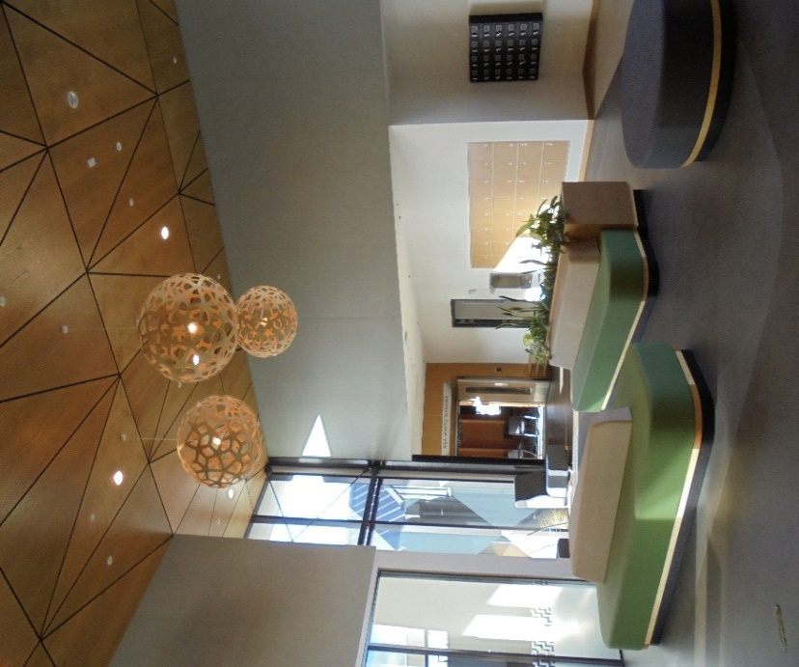 |  | 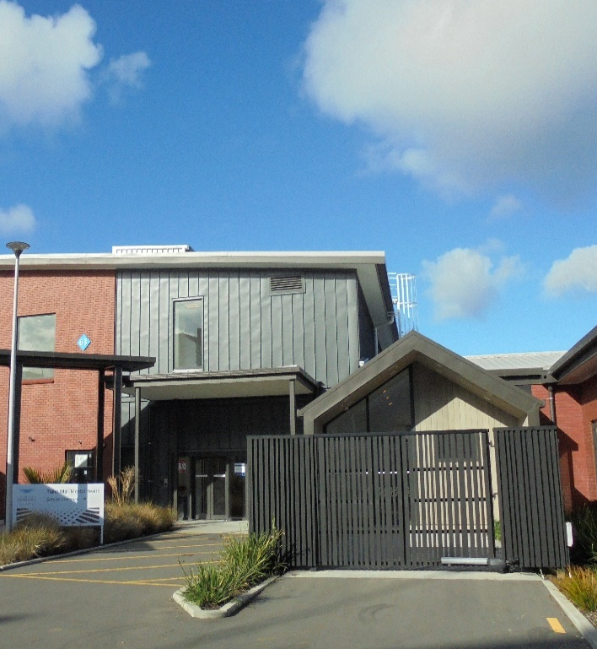
Figure 7: Reception area |  | Figure 8: Admission suite
One of the two main entries to the Unit was via Nga Whetu Marama (see page 29), which was used for new admissions, whaanau hui, activities and other functions. The whare was located adjacent to the wharekai and the Unit had integrated Maaori and Pasifika patterns in communal spaces and furnishings.
Aside from the whare, service users could also be admitted via the admission suite, which was modelled on the whare design. The admission suite had a light and spacious lounge area, with bathroom and showering facilities, as well as a small kitchen with free access to tea, coffee, and snacks.
I commend the Unit for creating a culturally safe and therapeutic space for service users to be admitted to the Unit, which allowed plenty of space and privacy for service users and their whaanau.

Unit layout

Wards 42 and 43
The Unit was separated into three wards at the time of inspection, and was clean, tidy and well maintained throughout.
Both Ward 42 Ki Te Whai Ao (referred to as the ‘LDU’) and Ward 43 Kimi Whanaungatanga (referred to as the ‘HDU’) were part of the new build. The LDU comprised 18 beds and the HDU had 14 beds, with two seclusion rooms.
Both wards were spacious and were built in a circular design, with centrally located courtyards, and open communal areas with plenty of natural light. All rooms were equipped with en-suite facilities, magnetic blinds, door-top pressure sensors, soft break-away privacy screens in the en-suite, and ligature-free fixtures.
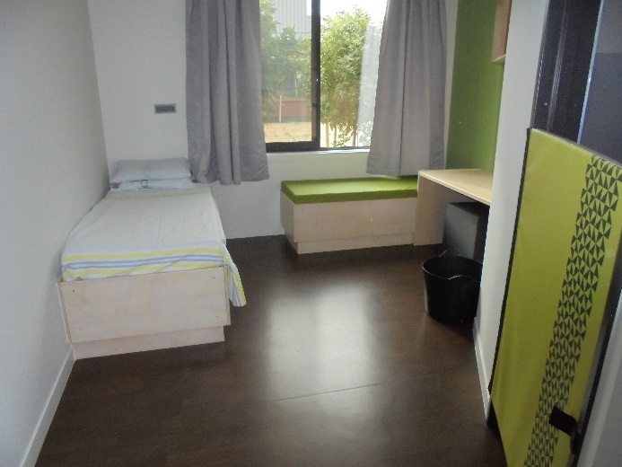 |  | 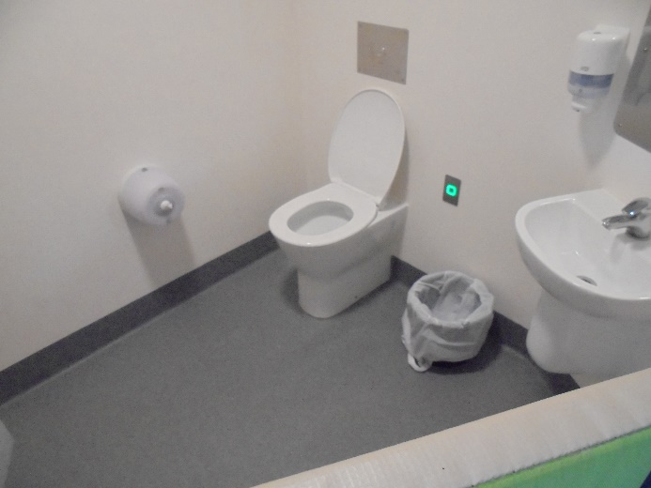
Figure 9: Bedroom – Ki Te Whai Ao |  | Figure 10: En-suite bathroom – Ki Te Whai Ao
All bedrooms contained a small desk and chair, sofa bed, which could be used for whaanau, and large external facing windows.
The nurses’ station was located in a central hub between the LDU and HDU, with large windows and private areas for discussions with service users.
The Unit had a dedicated ‘Flexi wing’, which was located between the LDU and HDU. This wing allowed for more rooms to be added as and where required. Staff advised that the ‘Flexi rooms’ could be used to provide additional care to more vulnerable service users or to provide gender separation. The ‘Flexi wing’ also had a separate lounge area, with amenities to make hot and cold drinks.

Ward 22
Ward 22 (referred to as Tui), which was part of the original hospital design, was located separate to the new Unit. The ward, while generally clean throughout, was not fit for purpose.
Inspectors were advised that all service users would be moved from Tui to the new ward, which was due to be completed by September 2020.
Tui comprised 20 beds, with six communal bathrooms and a small communal lounge area. There were no private spaces or gender separation on the ward. There was a small courtyard, connected to the lounge area, which was locked and could be accessed only with security staff supervision.
Tui also had a dedicated ‘Flexi area’, which comprised four bedrooms, a small yard, and separate lounge. Staff advised that this area was used to provide additional care for more vulnerable service users.
My Inspectors also observed three shared bedrooms, two with three beds, and one with two beds. These beds were separated by curtains only and did not provide adequate privacy for service users.
I have significant concerns regarding the use of shared bedrooms, which places service users at risk of harm and contravenes service users’ right to privacy. I was pleased to hear that this ward will be decommissioned on completion of the final build.

Food
Service users’ meals were transported from the main hospital kitchen and delivered to the Unit in heated trolleys. Breakfast was delivered from around 8am, lunch at 1pm, and dinner around 5pm. During the day, service users were also provided with a range of snacks, fruit and yoghurt.
Service users were positive about the food and were happy with being able to choose their own meals. My Inspectors were pleased to observe that service users could make hot and cold drinks throughout the day, independent of staff.

Recommendations – material conditions
I have no recommendations to make.

Good practice
I consider the new Unit design to be a model for recovery and patient-centred care and the thoughtful design of the admission suite, in particular, is commendable.

Activities and programmes

Outdoor exercise and leisure activities
A number of leisure activities were available to service users. All wards had a communal lounge area where service users could access books, board games, colouring sheets, television and other activities. Both the LDU and HDU had an interactive space for crafts, group activities and wellbeing groups.
The Unit did not have any specialised activity rooms at the time of inspection. However, staff advised that on completion of the final build, the Unit would have a dedicated Occupational Therapist (OT) kitchen, an art room, and an activity room.
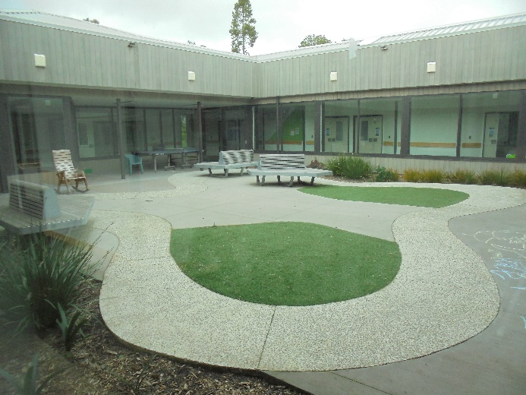 |  | 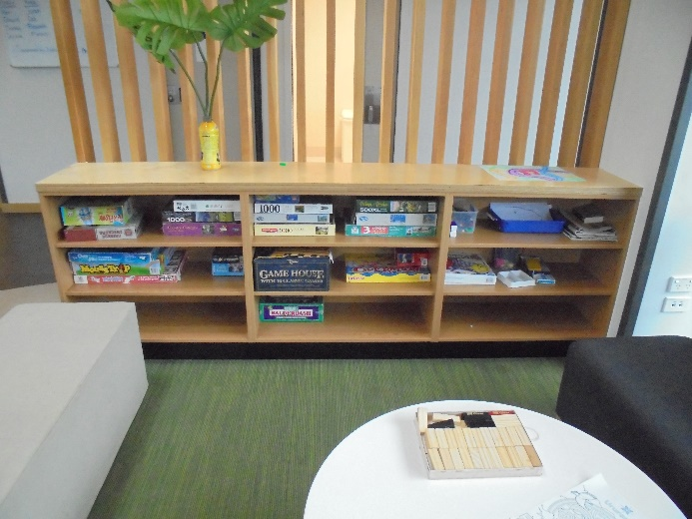
Figure 11: Courtyard – Ki Te Whai Ao |  | Figure 12: Communal area – Ki Te Whai Ao
The Unit employed three full-time equivalent (FTE) OTs and one OT Assistant (OTA). A fourth OT had recently been recruited. The OTs worked Monday through to Friday.
Inspectors were pleased to observe the OTs regularly engaged on the Unit, playing badminton and spending time in the courtyard with service users. Throughout the day service users could freely access the outside courtyard in the LDU and HDU, which was spacious and included chairs and grassy areas. The courtyard for Tui was more austere and service users could access the courtyard only with security staff supervision.
Staff advised that the courtyard for Tui remained locked throughout the day and service users were unable to access the courtyard if security staff were unavailable. While I acknowledge the importance of mitigating risk and ensuring service users’ safety, the blanket approach to locking the courtyard appeared restrictive.
The Unit’s activities programme included crafts, exercise and making smoothies. On occasion, a therapy dog visited the Unit, which was well-received by staff and service users. However, this was not occurring at the time of inspection due to the restricted visiting schedule in place due to COVID-19.
Staff and service users raised, on a number of occasions, that a lack of variation in activities had created a sense of ‘boredom’ on the Unit. Activities did not appear to be tailored to the service user group and there was a lack of individualised options available. Some service users commented that the activities were ‘repetitive’ and did not reflect their needs or preferences.
With the recruitment of a fourth OT and the opening of the final build, I encourage the Service to seek service users’ views on establishing a more tailored and varied activities programme.

Programmes
The Unit employed one FTE Psychologist and planned to recruit a second Psychologist to commence on completion of the final build.
The Psychologist conducted weekly therapeutic programmes in each ward, along with one-on-one work with service users. These programmes included Anger Management, Communication Skills, Self-care, and Emotions Management among others. Both service users and staff spoke positively of the programmes and Inspectors observed that these programmes were well attended by service users.
However, staff raised with my Inspectors that there was a lack of resource for Alcohol and Drug support for both service users and their whaanau on the Unit.

Cultural and spiritual support
Cultural and spiritual support was evident and available to service users on the Unit. The Unit had a broad range of relationships with services such as Te Kaahui Maaori Health Whaanau Ora Service and the Pacific Health Services’ Fanau Ola team. The Hospital Chaplaincy Service was also available to service users, and could be requested through staff.
The Unit had a dedicated whare, Nga Whetu Marama, which was used for cultural and therapeutic engagement, new admissions to the Unit, whaanau hui, discharges and other activities.
While staff, Maaori service users, and their whaanau provided positive feedback on the whare, it was raised to Inspectors that the whare could be utilised more frequently. I encourage the Service, upon completion of the final build, to embrace and enhance the use of this space, reflecting the Unit’s ‘Te Whare Tapa Wha’ model of care.
The Unit employed a Kuia and Kaumatua, who had regular contact with Maaori service users to provide spiritual and cultural guidance and support. Both the Kuia and Kaumatua, who worked Monday to Friday, provided support to Maaori service users, as well as staff and whaanau, and were involved in a number of working groups to provide a te ao Maaori perspective on behalf of the Unit.
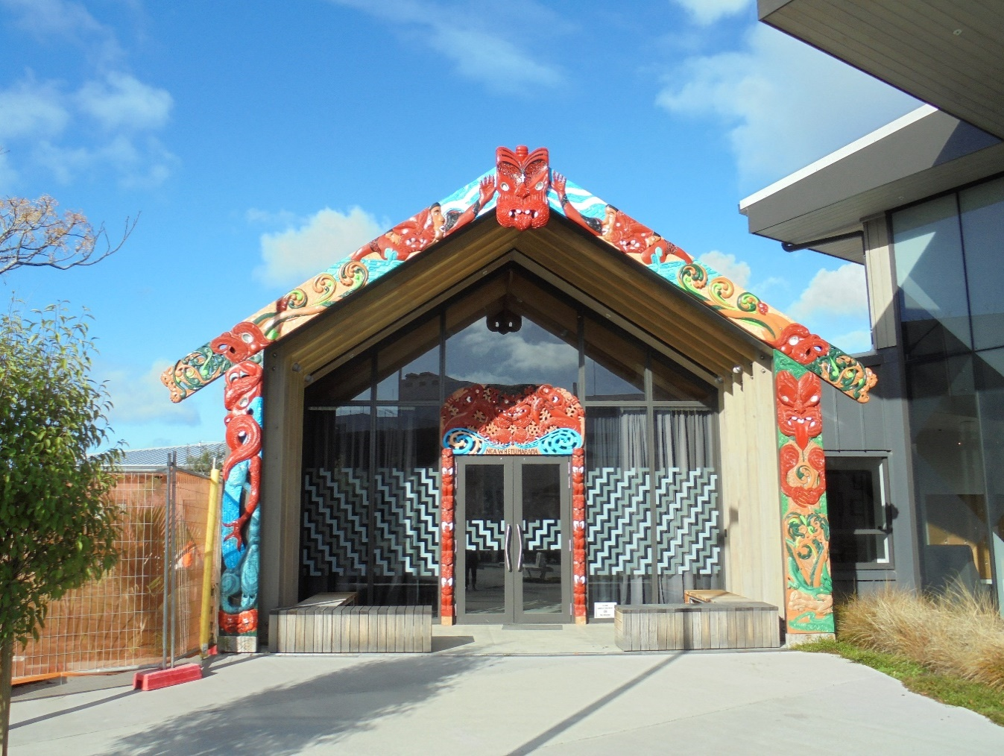
Figure 13: Nga Whetu Marama
Staff advised that members of the Maaori cultural team would usually visit Maaori service users within 48 hours of admission. The team also provided educational support to staff on cultural understanding, tikanga and applying te ao Maaori perspectives.
The Unit’s recently established Kai Manaaki role was tasked with improving staff cultural confidence and supporting the Unit to reduce restraint and seclusion on admission, particularly for Maaori service users. Maaori service users, staff, and senior management spoke highly of the Kai Manaaki’s influence on the Unit and how they had helped to improve Maaori service users’ experience of the Unit.
Inspectors were pleased to observe numerous positive interactions between the Kai Manaaki and Maaori service users, both on the Unit and in seclusion. On one occasion, during a lengthy admission process, Inspectors observed the Kai Manaaki providing a calming influence for both the service user and staff involved.
The Unit had also recently recruited a new Kai Manaaki Family Whaanau Support role, who would provide individualised support to service users’ family and whaanau throughout admission, care planning, treatment, and the discharge planning process. Staff my Inspectors spoke with welcomed the establishment of the role.
I support the implementation of these positions and encourage the Service to utilise the knowledge of the cultural team to support Maaori service users’ experience, particularly in regards to reducing seclusion and restraint on the Unit.

Recommendations – activities and programmes
I recommend that:
- The Unit expand the activities programme, incorporating the views of service users.

Tiaho Mai comments
The DHB accepted recommendation 13.

Communications

Access to visitors
At the time of inspection, access to visitors was restricted due to a hospital-wide DHB response to the COVID-19 pandemic.
Staff advised that, as per the DHB policy, visits had to be pre-approved and were allowed only for a maximum period of 30 minutes per visit. Visits could be scheduled only between 12.30pm to 2pm and 5pm to 7pm. The DHB policy also stated that service users could receive only one visitor per visit and more than one visitor at a time had to be approved by senior management.
While service users understood the reasons for restricting access to the Unit, a number of service users and staff noted that the visiting times were restrictive.
Visiting rooms and meeting areas were located in the reception area, allowing visitors and whaanau to meet with service users in private areas, with frosted windows for additional privacy. At the time of inspection, there was no specific child-friendly area. However, staff advised that a child-friendly visits area would be available on completion of the final build.
Staff advised that prior to COVID-19, visits were unrestricted and bookings were not required.
Inspectors were also informed by senior management that the ongoing restrictions were in place due to the vulnerable population and proximity to the airport.
I note that other DHBs across New Zealand had lifted visiting restrictions at Alert Level 1, including those in the Auckland region.
While I acknowledge that such restrictions may be appropriate when the risk of COVID-19 is high, I encourage the DHB to ensure that any ongoing restrictions are justified, necessary and proportionate to the risk.

Access to external communication
The Unit had cordless phones for private calls and service users had independent access to the telephones throughout the day.
Inspectors were advised by staff that service users were able to keep their cell phones in their possession and these were removed only if there was clinical need to do so.
Staff and service users also noted that they were happy with the use of Zoom and Skype during COVID-19 visitor restrictions for meetings with whaanau, court hearings and meetings with the DI.
Service users did not raise any concerns with Inspectors about their ability to send and receive mail.

Recommendations – communications
I recommend that:
- Any visiting restrictions are justified, necessary, and proportionate.

Tiaho Mai comments
The DHB accepted recommendation 14.
Recommendation 14 response:
We believe we continuously adhere to this principle, the various Covid lockdown restrictions have been challenging to implement. Feedback from the leadership of Tiaho Mai believe this principle is adhered to.
Ombudsman response:
I accept the various COVID-19 lockdown restrictions have been challenging to implement. However, I remain of the view that visits on the Unit were unnecessarily restrictive, particularly given New Zealand was at Alert Level 1 at the time of the inspection.

Health care

Primary health care services
Service users received a physical assessment on admission and a House Officer visited the Unit regularly, which included obtaining a medical history, taking routine blood tests, and addressing any physical concerns. The Unit also had access to the Patient At Risk (PAR) Team, who worked throughout the hospital to support any patient who was deteriorating physically, providing physical assessments and critical care.
A treatment room was available on the Unit for physical examinations. A separate medication room stored medications, including controlled drugs. These rooms were tidy and well-organised.
There were eight documented medication errors between 1 December 2019 and 31 May 2020. Medication errors were due to either incorrect time or schedule, missing or misplaced medication, incorrect medication/ fluid or route, or incorrect patient. Staff noted that the recently installed electronic prescribing system had resulted in a significant reduction in medication errors.
Service users did not raise any concerns with Inspectors regarding access to primary health care services.

Recommendations – health care
I have no recommendations to make.

Staff

Staffing levels and staff retention
As part of the inspection process, my Inspectors requested specific data on staffing levels, which included staffing breakdowns by role, gender, and ethnicity. My Inspectors also requested information on daily staffing levels, staff sickness, staff turnover and length of service.
As with the information requests mentioned earlier in the report (see page 14), Inspectors were not provided with this data.
While Inspectors did not receive any data, it was identified that agreed minimum staffing levels had been an issue on the Unit. Staff my Inspectors spoke with reported often working double shifts to cover gaps in staffing, and this was observed during the inspection.
Staff were generally complimentary of the leadership and management of the Unit. They reported feeling supported and that they were part of a cohesive team environment. Staff worked well together and good practice was evident around team support and care of service users.

Staff safety
In my 2015 report, I raised concerns regarding staff safety and morale on the Unit. Staff and managers had commented that this was due to loss of experienced staff, understaffing and Unit pressures, such as high acuity levels.
During the inspection, Inspectors found that while the new build had improved the feel of the Unit, staff again raised concerns regarding safety. Concerns were mostly around acuity levels and staff vacancies. A number of staff highlighted the lack of appropriate gender ratios on the Unit as a safety concern.
Inspectors’ review of the Charge Nurse Manager’s (CNMs) monthly reports showed that in May 2020, three staff were on long term ACC leave due to service user assaults in the HDU. Incident reports for May 2020 also demonstrated 22 reportable events under ‘staff vacancies’ and 17 were recorded as ‘acuity’.
Senior management advised that permanent external security staff had been employed to alleviate safety concerns. These security staff received training through the main hospital, as well as SPEC training and some mental health training prior to working on the Unit.
Staff advised that security staff were mostly located in Tui and the HDU and reported to the CNM. On occasion, security staff assisted with restraint of service users and were present during the admission process.
I acknowledge that the Service is actively working to recruit new staff. The development of ‘Tiaho Mai Healthy Service Task Force’, which aims to reduce staffing vacancies, overtime, sick leave, and improve retention, is a positive initiative. I look forward to seeing the progress of this working group in improving staffing levels and thus alleviating safety concerns on the Unit.

Recommendations – staff
I recommend that:
- The Service take all necessary steps to enable comprehensive and accurate recording of staffing data.

Tiaho Mai comments
The DHB accepted recommendation 15.

Acknowledgements
I appreciate the full co-operation extended by the Nurse Unit Manager and staff to the Inspectors during their inspection of the Unit.

Peter Boshier
Chief Ombudsman
National Preventive Mechanism
- List of people who spoke with Inspectors
Table 1: List of people who spoke with Inspectors
Managers | Unit staff | Others
General Manager  Director Area Mental Health Services  Clinical Director  Service Manager  Nurse Unit Manager  Clinical Nurse Specialist  Charge Nurse Managers  Associate Charge Nurse Manager | Registered Nurses  Consultant Psychiatrist  Medical Officer Specialist Scale  Clinical Psychologist  Care Quality Coordinator  Occupational Therapists  Social Worker  Psychiatric Assistants | Service users  Kai Manaaki  Family Advisor  Professional Leader Consumer and Family/ Whaanau Centred Care  Consumer Engagement Advisor  District Inspector

- Legislative framework
In 2007 the New Zealand Government ratified the United Nations Optional Protocol to the Convention against Torture and Other Cruel, Inhuman or Degrading Treatment or Punishment (OPCAT).
The objective of OPCAT is to establish a system of regular visits undertaken by an independent national body to places where people are deprived of their liberty, in order to prevent torture and other cruel, inhuman or degrading treatment or punishment.
The Crimes of Torture Act 1989 (COTA) was amended by the Crimes of Torture Amendment Act 2006 to enable New Zealand to meet its international obligations under OPCAT.

Places of detention – health and disability facilities
Section 16 of COTA defines a “place of detention” as:
“…any place in New Zealand where persons are or may be deprived of liberty, including, for example, detention or custody in…
(d) a hospital
(e) a secure facility as defined in section 9(2) of the Intellectual Disability (Compulsory Care and Rehabilitation) Act 2003…”
Ombudsmen are designated by the Minister of Justice as a National Preventive Mechanism (NPM) to inspect certain places of detention under OPCAT, including hospitals and the secure facilities identified above.
Under section 27 of COTA, an NPM’s functions include:
- to examine the conditions of detention applying to detainees and the treatment of detainees; and
- to make any recommendations it considers appropriate to the person in charge of a place of detention:
  - for improving the conditions of detention applying to detainees;
  - for improving the treatment of detainees; and
  - for preventing torture and other cruel, inhuman or degrading treatment or punishment in places of detention.

Carrying out the OPCAT function
Under COTA, Ombudsmen are entitled to:
- access all information regarding the number of detainees, the treatment of detainees and the conditions of detention;
- unrestricted access to any place of detention for which they are designated, and unrestricted access to any person in that place;
- interview any person, without witnesses, either personally or through an interpreter; and
- choose the places they want to visit and the people they want to interview.
Section 34 of COTA provides that when carrying out their OPCAT function, Ombudsmen can use their Ombudsmen Act (OA) powers to require the production of any information, documents, papers or things (even where there may be a statutory obligation of secrecy or non-disclosure) (sections 19(1), 19(3) and 19(4) OA. To facilitate his OPCAT role, the Chief Ombudsman has authorised inspectors to exercise these powers on his behalf.

More information
Find out more about the Chief Ombudsman’s OPCAT role, and read his reports online: ombudsman.parliament.nz/opcat.

A person who uses mental health and addiction services. This term is often used interchangeably with consumer and/or tāngata whai ora. See Mental Health Foundation.
When the term Inspectors is used, this refers to the inspection team comprising of a Senior Inspector, Inspector and two Assistant Inspectors.
Tiaho Mai translates as ‘the light that comes from the moon and the stars – shine here’. See https://www.countiesmanukau.health.nz/our-services/a-z/tiaho-mai-adult-mental-health-services
Office of the Ombudsman report on an unannounced inspection to Tiaho Mai Mental Health Inpatient Unit under the Crimes of Torture Act 1989, October 2015.
A voluntary service user (sometimes called an 'informal patient') is someone who has been admitted as an inpatient to a psychiatric ward but is not detained under the MHA. This means that the service user has agreed to have treatment and has the right to suspend or stop that treatment. The service user has the right to leave the facility at any time.
Nga Whetu Marama is the marae/ whare situated alongside the Unit. Nga Whetu Marama translates to ‘the bright stars’ and was named by the local Kaumatua and Kuia of Tainui.
At the time of inspection, the Unit was in its final design phase. Inspectors were advised that on completion, the Unit would have capacity for 76 service users, however, it would initially take up to 60 service users during the transition period.
For more information about Tiaho Mai Mental Health Inpatient Unit see the Healthpoint website at https://www.healthpoint.co.nz/mental-health-addictions/mental-health-addictions/counties-manukau-health-tiaho-mai-mental-1/
See https://countiesmanukau.health.nz/about-us/performance-and-planning/quality-accounts/tiaho-mai-rebuild/
See https://countiesmanukau.health.nz/about-us/use-of-the-double-vowel-in-te-reo-maaori-at-cm-health/
See https://covid19.govt.nz/alert-system/covid-19-alert-system/ for more about COVID-19 and New Zealand’s COVID-19 alert system.
I will discuss this further in the Environmental Restraint section of my report.
SPEC training was designed to support staff working within inpatient mental health units to reduce the incidence of restraints. SPEC training has a strong emphasis on prevention and therapeutic communication skills and strategies, alongside the provision of training in safe, and pain free personal restraint techniques. https://www.tepou.co.nz/initiatives/towards-restraint-free-mental-health-practice/149
Sentinel events are unanticipated events in the healthcare setting which have resulted in serious harm to service users.
My inspection methodology is informed by the Association for the Prevention of Torture’s Practical Guide to Monitoring Places of Detention (2004) Geneva, available at www.apt.ch.
For a list of people spoken with by the Inspectors, see Appendix 1.
Seclusion is defined as: ‘Where a person is placed alone in a room or area, at any time and for any duration, from which they cannot freely exit’. New Zealand Standards. Health and Disability Services (Restraint Minimisation and Safe Practice) Standards. Ministry of Health. 2008.
Which is most often where service users in seclusion will eat.
Between 1 January and 29 September 2015 there were 156 seclusion events.
Inspectors had requested data between 1 December 2019 and 31 May 2020.
Staff commented that assaults and incidents were often due to service users taking unaccompanied leave from the Unit and returning intoxicated due to drug or alcohol use.
District Inspectors are lawyers appointed by the Minister of Health to protect the rights of people receiving treatment under the Mental Health (Compulsory Assessment and Treatment) Act 1992 (the Mental Health Act) or the Intellectual Disability (Compulsory Care and Rehabilitation) Act 2003 (IDCCR Act).
Electroconvulsive therapy is used mainly in the treatment of severe depressive episodes. It involves the passage of an electric current across the head of a person to produce a convulsion. https://www.health.govt.nz/publication/electroconvulsive-therapy-ect
‘Sensory modulation uses a range of tools to help individuals get the right amount of sensory input. In mental health settings, sensory modulation can be used to assist distressed service users to regain a sense of calm’. Te Pou o te Whakaaro Nui (2011). Sensory modulation in inpatient mental health: A summary of the evidence. Auckland. Te Pou o Te Whakaaro Nui.
This was evidenced through Inspectors’ review of the weekly activity schedule, service user complaints, and conversations with service users.
Despite a compulsory treatment order, section 59 of the MHA requires clinicians to make efforts to obtain service users’ consent to treatment wherever possible. See Guidelines to the Mental Health (Compulsory Assessment and Treatment) Act 1992. Ministry of Health. 2008.
See https://countiesmanukau.health.nz/about-us/performance-and-planning/quality-accounts/tiaho-mai-rebuild/
See https://www.health.govt.nz/our-work/populations/maori-health/maori-health-models/maori-health-models-te-whare-tapa-wha

