A.3a

OPCAT Report
Report on an unannounced inspection of Puna Maatai Forensic Inpatient Ward, Waikato Hospital, under the Crimes of Torture Act 1989
March 2020
Peter Boshier
Chief Ombudsman
National Preventive Mechanism

Report on an unannounced inspection of Puna Maatai Forensic Inpatient Ward,
Waikato Hospital, under the Crimes of Torture Act 1989
ISBN: 978-0-473-51679-6 (PDF)
Published March 2020
Office of the Ombudsman | Wellington, New Zealand | www.ombudsman.parliament.nzv

Contents
Executive Summary 1
Background 1
Summary of findings 1
Recommendations 3
Feedback meeting 4
Consultation 4
District Health Board response 4
Facility Facts 5
Puna Maatai Forensic Inpatient Ward 5
Region 5
District Health Board 5
Operating capacity 5
Last inspection 5
The Inspection 6
Inspection methodology 6
Inspection focus 7
Treatment 7
Protective measures 7
Material conditions 7
Activities and programmes 7
Communications 8
Health care 8
Staff 8
Evidence 8
Recommendations from previous report 8
Treatment 9
Torture or other cruel, inhuman or degrading treatment or punishment 9
Seclusion/High care secure lounge 11
Seclusion policies and events 11
Restraint 13
Restraint training for staff 15
Electro-convulsive therapy 15
Sensory modulation 16
Service users’ and whānau views on treatment 16
Recommendations – treatment 17
Puna Maatai comments 17
Protective measures 20
Complaints process 20
Records 20
Recommendations – protective measures 21
Puna Maatai comments 21
Material conditions 22
Accommodation and sanitary conditions 22
Food 23
Recommendations – material conditions 24
Puna Maatai comments 24
Activities and programmes 25
Outdoor exercise and leisure activities 25
Programmes 26
Cultural and spiritual support 27
Recommendations – activities and programmes 28
Puna Maatai comments 28
Communications 29
Access to visitors 29
Access to external communications 29
Recommendations – communications 30
Puna Maatai comments 30
Health care 30
Primary health care services 30
Recommendations – health care 30
Staff 31
Staffing levels and staff retention 31
Recommendations – staff 31
Acknowledgements 32
Appendix 1. List of people who spoke with Inspectors 33
Appendix 2. Legislative framework 34

Tables
Table 1: Seclusion events 1 March – 31 August 2019 12
Table 2: Restraint data (exclusive of seclusion data) 1 March – 31 August 2019 13
Table 3: List of people who spoke with Inspectors 33

Figures
Figure 1: High care secure lounge – Puna Maatai Ward 9
Figure 2: Seclusion room – Puna Awhi-rua Ward 9
Figure 3: Seclusion room 11
Figure 4: Skylight in seclusion room 11
Figure 5: Bedroom in main wing 23
Figure 6: Bedroom in pod area 23
Figure 7: Courtyard area 26
Figure 8: Whare for Puna Maatai and Puna Awhi-rua 28

Executive Summary

Background
In 2007, the Ombudsmen were designated one of the National Preventive Mechanisms (NPMs) under the Crimes of Torture Act 1989 (COTA), with responsibility for examining and monitoring the conditions and treatment of service users detained in secure units within New Zealand hospitals.
Between 16 and 20 September 2019, Inspectors — whom I have authorised to carry out visits to places of detention under COTA on my behalf — made an unannounced five day inspection of the Puna Maatai Forensic Inpatient Ward (the Ward), which is located in the grounds of Waiora Waikato Hospital Campus, Hamilton.

Summary of findings
My findings are:
- There was no evidence that any service user had been subject to torture or other cruel or inhuman treatment or punishment. However, my Inspectors found evidence that service users were subject to degrading treatment.
- All service users had the necessary legal documentation to be detained in the Ward.
- The Ward was clean, tidy and well-maintained.
- There were adequate bathroom, shower and laundry facilities for the number of service users.
- Staff appeared to work together collegially and effectively and spoke positively about the support provided by the management team.
- Interactions between staff and service users were respectful, constructive and appropriate.
- Whānau spoken with by Inspectors did not report any issues about service users’ access to visitors.
- There was robust multi-disciplinary team work occurring regarding the ongoing care of service users, including the exploration of various treatment approaches.
- Cultural and spiritual support was provided on the Ward.

The issues that needed addressing are:
- The accommodation of service users in rooms other than designated bedrooms amounted to degrading treatment and a breach of Article 16 of the United Nations Convention against Torture and Other Cruel, Inhuman or Degrading Treatment or Punishment.
- Not all staff had the necessary knowledge and skills to deal with a diverse service user group.
- Insufficient natural light in the seclusion room and an inability for service users in seclusion to maintain orientation to date and time.
- The significant increase in the use of seclusion in recent years, and in particular the high levels of seclusion of Māori service users.
- Discrepancies in the collection and reporting of seclusion and restraint data.
- Relevant restraint policies were out of date at the time of the inspection.
- Training in the application of mechanical restraints on the Ward did not appear to comply with the policy on their use.
- Contact details for District Inspectors were not visible on the Ward.
- Consent to treatment forms were absent or out of date for most service users at the time of the inspection.
- Service users were unable to leave the dining area when they were ready to do so, or access hot drinks independent of staff.
- A lack of purposeful activities for service users in the afternoons and limited access to therapeutic programmes.
- Service users were unable to access the telephone independent of staff and generally only between 6pm and 9pm.

Recommendations
I recommend that:
- Staff receive training to enhance knowledge and skills for dealing with service users designated as having an intellectual disability or high and complex needs.
- Rooms such as the high care secure lounge, music room, day rooms or offices should never be used as bedrooms.
- Natural light in the seclusion room is increased and a mechanism is provided for service users in the room to orientate to date and time.
- The high and increasing use of seclusion is addressed with a particular focus on equitable treatment of Māori.
- The Service take all necessary steps to enable comprehensive and accurate collection and reporting of seclusion data.
- The Restraint Policy and the Wrist and/or Ankle procedure be reviewed, and updated.
- The Service take all necessary steps to enable comprehensive and accurate collection and reporting of restraint data, including by service users’ ethnicity.
- All staff involved in the application of mechanical restraints complete training in the use of such restraints.
- The Ward monitors and reviews the use of mechanical restraints to avoid normalisation of their use.
- District Inspectors’ contact details are displayed on the Ward.
- Service users’ consent to treatment forms are completed at the earliest opportunity and any refusal of consent is routinely recorded in their files.
- Service users are able to leave the dining area when they are ready to do so.
- Service users are able to freely access hot drinks, unless deemed unsafe based on individual risk assessment.
- Service users have increased access to activities and programmes.
- Service users have access to a telephone, independent of staff, at any time, unless deemed unsafe based on individual risk assessment.

Follow up inspections will be made at future dates to monitor implementation of my recommendations.

Feedback meeting
On completion of the inspection, my Inspectors met with representatives of the Ward’s leadership team, to outline their initial observations.

Consultation
A provisional report was forwarded to the DHB for comment as to fact, finding or omission prior to finalisation and distribution.

District Health Board response
The Waikato District Health Board (the DHB) provided a response to my provisional report on the Ward on 15 January 2020. I have carefully considered the comments made before finalising my report. Where the DHB has provided a specific response to my recommendations, this is recorded below each recommendation. Where necessary, I have responded with further comment.
The DHB’s report responded to a number of common themes from my inspections of this Ward and three other wards in the DHB which were conducted at the same time, including over occupancy, high and increasing use of seclusion and restraint, and the normalisation of restrictive practices.
The DHB emphasised planned changes or changes that had been made between the inspection in September 2019 and the DHB’s comments in January 2020. While I am pleased to hear that the DHB is taking steps to address a number of identified issues, my role as an NPM is to report on the conditions and treatment for people who are being detained, as they are at the time of the inspection. As such, while I acknowledge the further information provided by the DHB, my recommendations relate to the conditions and evidence my Inspectors found during the time of inspection.
I intend to conduct follow up inspections of all the wards, at which point I will be able to assess whether the actions highlighted by the DHB have been successful in addressing my concerns.

Facility Facts

Puna Maatai Forensic Inpatient Ward
Puna Maatai (the Ward) is a 12-bed acute forensic mental health ward in the Henry Rongomau Bennett Centre (HRBC), which is located in the grounds of Waiora Waikato Hospital campus, Hamilton.
The Ward primarily cares for service users from the courts and prisons. However, the Ward also receives transfers/referrals from other Forensic and Adult Mental Health wards. It provides these services for male and female service users. The Puawai Midland Regional Forensic Service (the Service) at the HRBC is also funded for four designated beds for service users with intellectual disabilities.

Region
Puawai Midland Regional Forensic Service – Waikato, Lakes, Taranaki and Bay of Plenty

District Health Board
Waikato District Health Board

Operating capacity
12 plus one seclusion room. Ten bedrooms were located in the main accommodation wing and two bedrooms in a separate pod area.

Last inspection
Unannounced inspection – August 2014
Announced inspection – December 2009

The Inspection
Three Inspectors conducted the inspection of the Ward between 16 and 20 September 2019.
On the first day of the inspection, there were 13 service users in the Ward, comprising one female and 12 males. The Ward was over capacity by one service user at the time of the inspection. There were three people on the waiting list for a forensic bed with individual wait times ranging from one week to four months. The average length of stay for the preceding six months was 51 days.

Inspection methodology
At the beginning of the inspection, Inspectors met with the Charge Nurse Manager (CNM), before being shown around the Ward.
Inspectors were provided with the following information during and after the inspection:
- a list of service users and the legislative reference under which they were detained (at the time of the inspection);
- the seclusion and restraint data for 1 March to 31 August 2019, and the seclusion and restraint policies;
- any meetings/reports relating to restraint, seclusion minimisation, and adverse events;
- records of staff mandatory training, including Safe Practice Effective Communication (SPEC);
- service user absent without leave (AWOL) events from 1 March to 31 August 2019;
- details of all sentinel events from 1 March to 31 August 2019;
- complaints received between 1 March to 31 August 2019, a sample of responses and associated timeframes, and a copy of the complaints policy;
- activities programme;
- information provided to service users and their whānau on admission;
- staff sickness and retention data for the previous three years;
- staff vacancies at time of inspection (role and number); and
- data on staff, categorised by profession.

Inspection focus
The following areas were examined to determine whether there had been torture or other cruel, inhuman or degrading treatment or punishment, or any other issues impacting adversely on service users.

Treatment
- Torture or other cruel, inhuman or degrading treatment or punishment
- Seclusion/High Care Secure Lounge
- Seclusion policies and events
- Restraint
- Restraint training for staff
- Electro-convulsive therapy (ECT)
- Sensory modulation
- Service users’ and whānau views on treatment

Protective measures
- Complaints process
- Records

Material conditions
- Accommodation and sanitary conditions
- Food

Activities and programmes
- Outdoor exercise and leisure activities
- Programmes
- Cultural and spiritual support

Communications
- Access to visitors
- Access to external communications

Health care
- Primary health care services

Staff
- Staffing levels and staff retention

Evidence
In addition to the documentary evidence provided at the time of the inspection, Inspectors spoke with a number of managers, staff and service users. Whānau were also spoken with.
Inspectors also reviewed service user records, were provided additional documents upon request by the staff, and observed the facilities and conditions.

Recommendations from previous report
The Inspectors also followed up on two recommendations made by my predecessor, following an inspection of the Ward in August 2014, which were:
  - The DHB should consider the installation of skylights or windows in the seclusion room.
  - All staff should be up to date with RESPECT training.
The extent to which the ward has implemented these prior recommendations is referred to in the relevant sections of this report.

Treatment

Torture or other cruel, inhuman or degrading treatment or punishment
There was no evidence that any service user had been subject to torture or other cruel or inhuman treatment or punishment. However, I found evidence of degrading treatment.
Over occupancy and a lack of resources were creating significant pressure for staff and service users in the Ward. Staff advised my Inspectors that ‘sleepovers’, the practice of service users being temporarily transferred into the Ward to spend the night to relieve pressure on other wards in the Henry Rongomau Bennett Centre, had become a regular occurrence.
At the time of inspection, sleepovers were occurring in the high care secure lounge (HCSL), a non-designated bedroom with nothing more than a mattress on the floor. While the HCSL had an en-suite bathroom and natural light, external windows had no coverings to prevent observation from the courtyard, compromising service users’ privacy. The HCSL was identical to the seclusion room in Puna Awhi-rua.
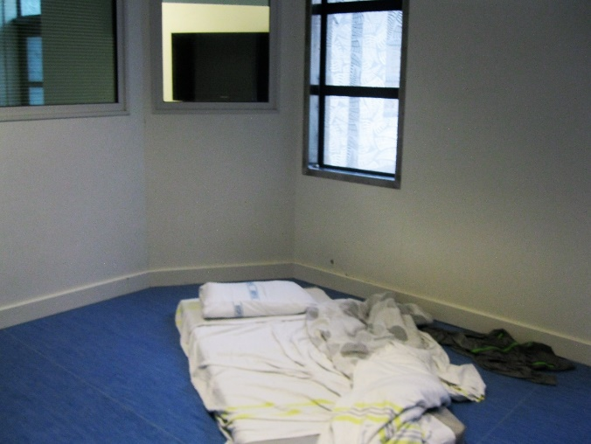 |  | 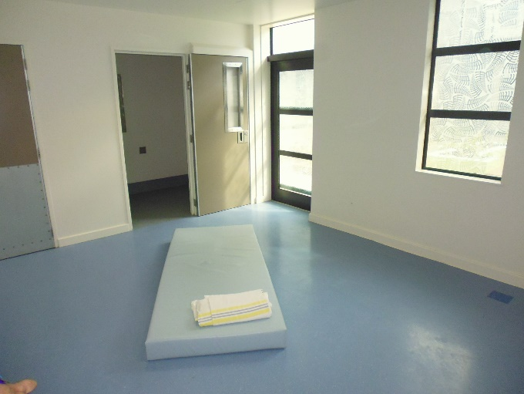
Figure 1: High care secure lounge – Puna Maatai Ward |  | Figure 2: Seclusion room – Puna Awhi-rua Ward

The placement of service users in the Ward with high and complex needs, and service users with intellectual disabilities that were not forensic service users compromised service users’ care and limited opportunities for recovery. My Inspectors heard that service users with intellectual disabilities were often the target of bullying, intimidation and assault. They were also told that service users with an intellectual disability could also sometimes display unpredictable and disruptive behaviour, which had an adverse impact on the wellbeing of others.
Staff made a significant effort to ensure that all service users in the Ward were cared for effectively and treated respectfully. However, my Inspectors were told that not all staff had the necessary knowledge and skills to deal with such a diverse service user group.
My Inspectors also observed one service user designated as having high and complex needs sleeping in the Ward music room, which was situated off the main communal lounge. The service user was being managed on a 2:1 basis due to a history of serious self-harm and assaultive behaviour. Their erratic behaviour was disruptive for other service users and contributed to the increased pressure in the Ward. On occasion, the service user’s level of self-harm resulted in their being restrained on a bed using ankle and wrist restraints. The music room door was the only door wide enough to accommodate the hospital style bed used to restrain service users. Staff tried to ensure the service user’s privacy so far as possible by closing the door and covering windows, however the room’s location was in the middle of a thoroughfare with high levels of foot traffic.
I consider the accommodation of service users in the rooms concerned that were not designated as bedrooms amounted to degrading treatment and a breach of Article 16 of the United Nations Convention against Torture and Other Cruel, Inhuman or Degrading Treatment or Punishment.

Seclusion/High care secure lounge

Seclusion facilities
The Ward had one dedicated seclusion room separate from the main Ward. The room had most basic features of a seclusion room, including an en-suite toilet and access to drinking water. However, there were no features in the seclusion area for service users to orientate to time and date. The bed was a mattress on the floor.
There were no facilities for service users in seclusion to access fresh air, and no low stimulus area or de-escalation lounge to transition service users from seclusion to the main Ward.
I note that the following recommendation made by my predecessor, resulting from the Ward’s 2014 inspection, had been partially implemented:
  - The DHB should consider the installation of skylights or windows in the seclusion room.
While a skylight had been installed in the seclusion room, my Inspectors observed that the natural light afforded by the skylight was minimal.
No service users were in seclusion at the time of the inspection.
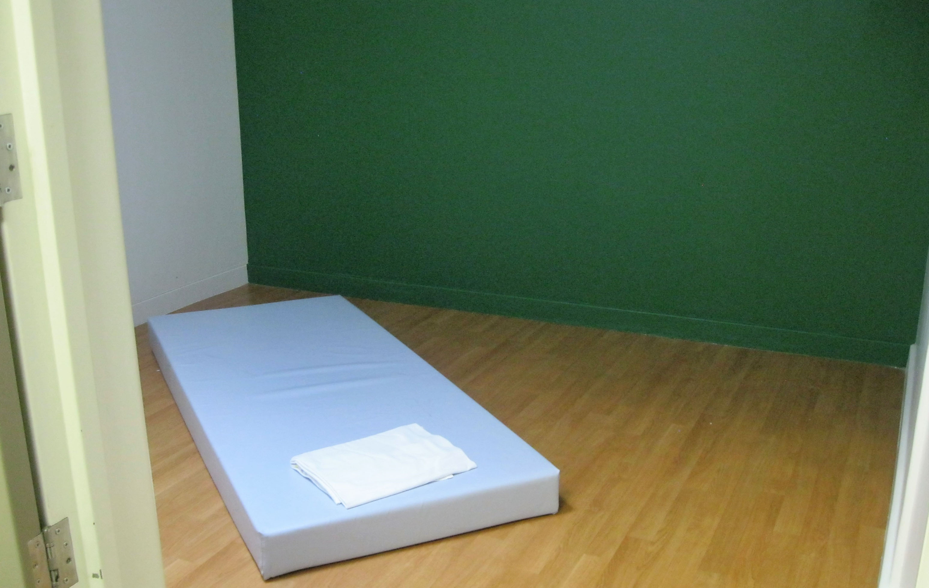 |  | 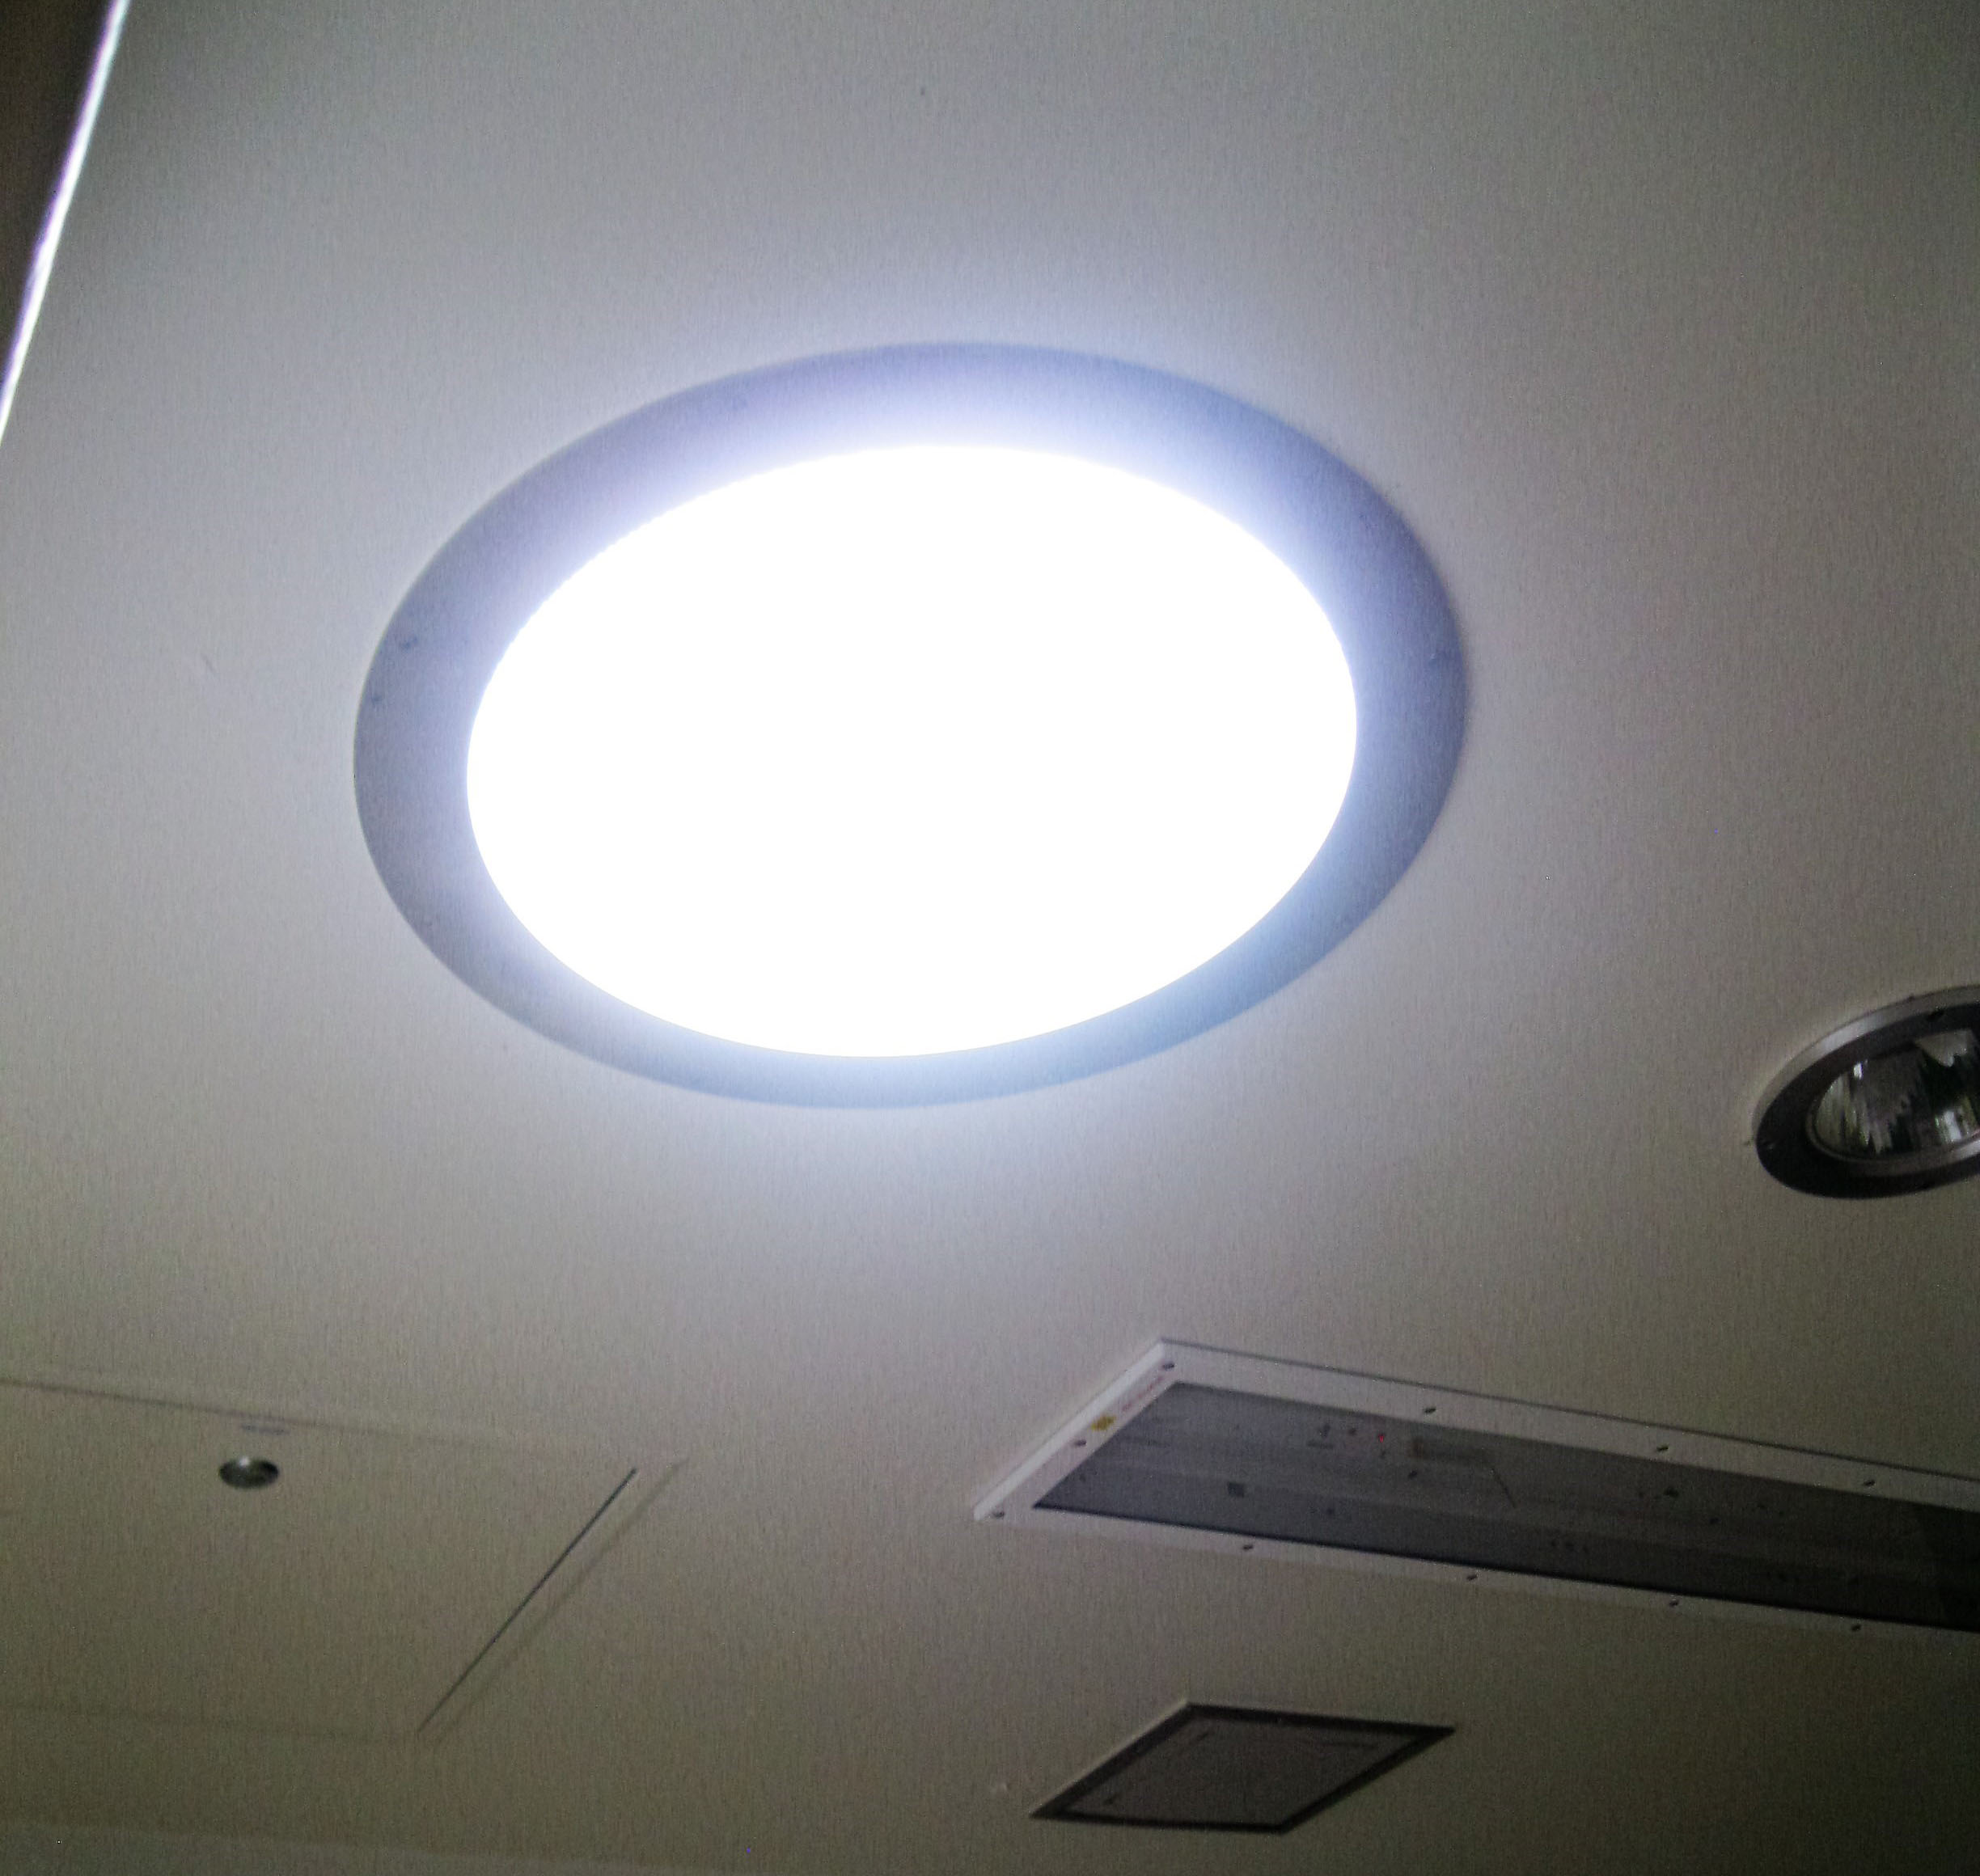
Figure 3: Seclusion room |  | Figure 4: Skylight in seclusion room

Seclusion policies and events
A copy of the DHB’s Seclusion Procedure 1860 (dated 28 August 2017) was provided to Inspectors. The procedure had a review date of 28 August 2020.
Data provided by the Service indicated that for the period 1 March to 31 August 2019 there were 64 seclusion events involving 17 service users. Approximately two-thirds of service users secluded were Māori, and Maori service users were secluded more frequently than non-Maori service users, and approximately two-thirds of total seclusion events and hours in the period involved a Māori service user. The total seclusion time for the six-month period was recorded as 1634.19 hours. This is broken down as follows:
Table 1: Seclusion events 1 March – 31 August 2019
Month | Events | Service users | Hours | Average hours
March | 12 | 5 | 320.23 | 26.69
April | 6 | 4 | 137.78 | 22.96
May | 19 | 8 | 231.67 | 13.07
June | 9 | 7 | 353.38 | 35.34
July | 10 | 4 | 101.5 | 10.14
August | 8 | 4 | 48.63 | 61.20
Total: | 64 | 17 | 1634.19 | 25.40

My Inspectors found a number of apparent discrepancies in the data. For example, within the aggregated data provided above, the average seclusion hours appear to be incorrectly calculated. Further, analysis of the underlying data provided by the Service suggests that the total seclusion hours may be under-reported. There was also a single seclusion event that commenced in May and crossed over into June, which appears to have been attributed mainly to May, when most of the seclusion took place in June.
I do not have full confidence in the accuracy of the data provided. However, the data available is sufficient to reach some conclusions around the use of seclusion in the Ward.
Forensic service users were the highest proportion (approximately 60 percent) of those secluded. Forensic service users were also secluded for longer in total (and on average) than persons with high and complex needs or an intellectual disability. However, people designated as having high and complex needs experienced the highest number of seclusion events over the six-month period.
I acknowledge that work is already underway to reduce the use of seclusion across the Service. Further information provided by the Service shows that a Seclusion Elimination Steering Group has been established and meets regularly. The information provided demonstrates a commitment to reducing seclusion, including for Māori. However, the progress of this work is slow and the data indicates that the work is yet to have an impact on the rate of seclusion in the Ward. Inspectors also reviewed a sample of the Ward’s seclusion checklists, the majority of which were incomplete.
I therefore consider that additional action is required to reduce the use of seclusion, with a particular focus on equitable treatment of Māori.

Restraint
The Service provided Inspectors with a copy of the DHB’s Restraint Policy 2162 (dated
10 March 2017). The policy was out of date and due for review on 1 July 2019.
Data supplied by the Service showed that for the period 1 March to 31 August 2019 there were 98 episodes of restraint involving 39 service users. This is broken down as follows:
Table 2: Restraint data (exclusive of seclusion data) 1 March – 31 August 2019
 | March | April | May | June | July | August
Total restraint episodes | 6 | 11 | 28 | 15 | 22 | 16
Total service users restrained | 3 | 4 | 8 | 7 | 10 | 7
Personal restraint | 2 | 7 | 13 | 9 | 12 | 6
Mechanical/physical restraint | 0 | 0 | 15 | 1 | 2 | 6
Environmental restraint (door locking) | 4 | 4 | 0 | 5 | 9 | 5
Police restraint | N/A | N/A | N/A | N/A | N/A | N/A
Number of males restrained | 6 | 6 | 19 | 10 | 21 | 15
Number of females restrained | 0 | 5 | 9 | 5 | 1 | 1
Youngest person restrained | 23 | 23 | 18 | 20 | 18 | 21
Oldest person restrained | 70 | 33 | 58 | 62 | 50 | 50

My Inspectors identified several discrepancies with the data provided. The Service reported ‘ongoing issues’ with the recording of restraint on the Restraint Event Notification form resulting in inaccurate data capture. Consequently, I do not have confidence in the data provided.
The Service also confirmed that it did not record information on the ethnicity of service users who have been restrained. Understanding how restraint is applied to different populations is important to understanding whether it is used equitably. The need to collect this information in relation to Māori arises from the principles of te Tiriti o Waitangi.
Restraint is a serious intervention that requires clinical rationale and oversight. It is not a treatment in itself but is one of a number of strategies used to limit or eliminate clinical risk.
During the inspection, a service user with high and complex needs, was mechanically restrained to their bed on two separate occasions. Staff reported that the service user had ‘a pre-authorisation’ to mechanically restrain in place due to their high level of risk of harm to self and others.
My Inspectors examined the circumstances around the pre-authorisation. They identified that the pre-authorisation was developed to mitigate the service user being held in personal restraint, causing them significant levels of distress, for extended periods before mechanical restraint was authorised. Seclusion was not clinically appropriate for the service user; they were also on constant 2:1 observations.
The pre-authorisation was reviewed on a weekly basis by the Responsible Clinician and had been developed in conjunction with the Clinical Nurse Specialist and the District Inspector. Clinical oversight of the mechanical restraint episodes was evident. Ongoing staff supervision and interaction with the service user during periods of mechanical restraint was observed. My Inspectors were encouraged to see multi-disciplinary team work occurring regarding the ongoing care of this service user, as well as the exploration of various treatment approaches.
Inspectors were provided with a copy of the DHB’s Restraint – Wrist and/or Ankle procedure 2158 which was due for review on 1 July 2019. Training in the application of mechanical restraints on the Ward did not appear to comply with the Service’s policy on their use. Inspectors attended a staff handover where staff who had attended training on the use of mechanical restraint were asked to train others on the Ward.
I consider that the Ward should guard against the normalisation of the practice of using mechanical restraints by regularly monitoring and reviewing their use. Accurate data collection, including duration of the restraint episode, is important in this regard.

Restraint training for staff
I was pleased to note that the following recommendation by my predecessor, resulting from the Ward’s 2014 inspection, had been implemented:
  - All staff should be up to date with RESPECT training.
Information provided by the Service showed that all Ward staff were up-to-date with Safe Practice Effective Communication (SPEC) training. Inspectors were informed that refresher SPEC training was provided every two years. The Service informed Inspectors that refresher training roll out was occurring, however no dates were provided to Inspectors.

Electro-convulsive therapy
There were no service users undergoing electro-convulsive therapy (ECT) in the Ward at the time of the inspection. Clinicians were exploring the option of ECT for one service user. My Inspectors were satisfied that due process was being followed. Issues relating to capacity and consent were being appropriately addressed with second opinions being sought as required by the Mental Health (Compulsory Assessment and Treatment) Act 1992.

Sensory modulation
The Ward had a designated Sensory Modulation Room. The room, although well equipped, was not welcoming due to its limited space, soft furnishings, and lighting. Further, the Sensory Modulation Room was locked and service users had to locate staff to facilitate and supervise their access to the room.
My Inspectors did not observe any service users using the Sensory Modulation Room during the inspection. My Inspectors were informed that no register for the use of the Sensory Modulation Room exists, and the Service does not track its use against seclusion and restraint events.
Staff reported that the Sensory Modulation Room was used infrequently. Use of the room was dependent on service users’ preferences which may be, for example, to spend time outside.

Service users’ and whānau views on treatment
Service users informed Inspectors that they generally felt safe in the Ward, and were satisfied with the standard of care in the Ward. Inspectors observed respectful and positive interactions between service users and staff.
Some service users expressed frustration at aspects of the routine on the Ward, specifically in relation to privacy of phone calls and the mealtime routine.
Inspectors attended the daily mihi whakamoemiti facilitated by the Ward’s Kaitakawaenga and a weekly service users’ community/whānau meeting facilitated by one of the Occupational Therapists (OTs). Service users were observed to be involved in the meetings and a broad range of topics were discussed, including plans for viewing the Rugby World Cup and activities for Mental Health Awareness Week.
Inspectors were unable to have detailed discussions with whānau about service users’ treatment in the Ward. However, whānau with whom Inspectors spoke, did not report any complaints.

Recommendations – treatment
I recommend that:
- Staff receive training to enhance knowledge and skills for dealing with service users designated as having an intellectual disability or high and complex needs.
- Rooms such as the high care secure lounge, music room, day rooms or offices should never be used as bedrooms.
- Natural light in the seclusion room is increased and a mechanism is provided for service users in the room to orientate to date and time.
- The high and increasing use of seclusion is addressed with a particular focus on equitable treatment of Māori.
- The Service take all necessary steps to enable comprehensive and accurate collection and reporting of seclusion data.
- The Restraint Policy and the Wrist and/or Ankle procedure be reviewed, and updated.
- The Service take all necessary steps to enable comprehensive and accurate collection and reporting of restraint data, including by service users’ ethnicity.
- All staff involved in the application of mechanical restraints complete training in the use of such restraints.
- The Ward monitors and reviews the use of mechanical restraint to avoid the normalisation of their use.

Puna Maatai comments
The DHB accepted recommendations 6, 7 and 8.
The DHB partially accepted recommendations 1, 2, 3 and 4.
The DHB rejected recommendations 5 and 9.
Recommendation 1 response:
The ability to provide care to service users with high and complex needs is a component of ongoing development of staff skills and knowledge in a mental health and addictions service. All staff are able and skilled to work with individuals with complex needs, owing to the nature of the complexities which are present in the forensic population.
There is currently a national process in place looking at MH workforce development on secure intellectual disability care.
The mental health and addictions service provided training by Altogether Autism in 2019. Additional training will be looked into during the first quarter of 2020.
Ombudsman response:
I am pleased to hear that some training is being provided to staff in caring for service users with intellectual disabilities and high and complex needs. However, my Inspectors were informed by some staff at the time of the inspection that not all staff had received this training and that further learning opportunities were needed. I encourage the Service to increase the training opportunities for staff in these areas.
Recommendation 2
The DHB did not provide a specific response to recommendation 2. However, the DHB’s overall response to this report and the inspections of a further three wards contained information concerning the theme of over occupancy highlighted in all reports. The DHB commented in its general response that the inspection team may not have been provided full detail of the work underway to address the issues of high occupancy. It stated that an Acute Sustainability Response Plan was implemented in June 2019 to address the significant pressures on inpatient services, and that associated risks had been noted as diminishing.
The DHB also commented in its general response that data relating to occupancy levels was showing a downward trend.
Ombudsman response:
I am pleased that work is currently underway to address the issue of over occupancy on the Wards and I note the Service’s development of the Acute Sustainability Response Plan. I reiterate that recommendations relate to the conditions and evidence my Inspectors found during the time of inspection. The inspection teams’ findings, based on Inspectors’ observations and information provided by the Service, were that high occupancy levels were an ongoing issue at the time of inspection.
I emphasise my expectation that rooms such as day rooms, offices or seclusion rooms should never be used as bedrooms.
Recommendation 3 response:
Work was completed on the provision of additional light to the seclusion room post a previous audit, and has provided light within the limitations of the facility.
Staff currently put a means of orientation to time in place when a service user is in the seclusion room. A permanent fixture providing orientation to date and time will be sourced.
Ombudsman response:
I acknowledge that work had been completed on the seclusion room to provide natural light to secluded service users. However, based on the observations of my Inspectors, I consider the levels of natural light remained insufficient at the time of the inspection. I therefore encourage the Ward to explore further options for increasing the levels of natural light in seclusion.
I am pleased to see a commitment to sourcing a permanent fixture providing orientation to date and time.
Recommendation 4 response:
All programmes of work within the organisation / service will have a particular focus on equitable treatment of Māori.
Ombudsman response:
I am pleased to hear of the Service’s commitment to the equitable treatment of Māori. I also acknowledge that work is already underway to reduce the use of seclusion across the Service. I remain concerned, however, that this work does not appear to have had a material impact on the levels of seclusion, particularly for Māori service users in the Ward. Further, no additional information about measures to reduce seclusion, particularly for Māori, has been provided. I encourage the Ward and Service to act on this issue.
Recommendation 5 response:
The DHB made the general comment that ‘The use of Seclusion is monitored and reported clearly to the highest levels of clinical and operational leadership in the service’.
Ombudsman response:
My concerns regarding the accuracy of data remain.
Recommendation 9 response:
The DHB made the general comment that the use of restraint across Waikato DHB has increased since 2017 across all settings, and that this is not unique to Waikato. It noted high acuity, and increase in aggression, occupancy issues and inpatient physical environment as contributing to this. The DHB indicated that it is ‘keen to ensure that the use of restraint is to the minimum required, safe and appropriate.’ It also advised that it is working closely with the Restraint Committee to look at ways to reduce the use of restraint within current operational limits.
Ombudsman response:
I am pleased to learn that the DHB is taking general action to reduce the use of restraint. Monitoring and reviewing the use of restraints would seem essential to achieve this. In this context it is not clear to me why the recommendation was rejected.

Protective measures

Complaints process
A copy of the Service’s Consumer Feedback and Complaints Policy 0101 (dated 28 January 2019) was provided to Inspectors. The procedure had a review date of 18 January 2022.
Posters for the Health and Disability Commissioner’s ‘Code of Rights’ were displayed in the Ward.
Complaint forms were not available on the Ward on the first day of the inspection; however, service users told Inspectors that they knew how to make a complaint. Service users and Inspectors brought the lack of complaint forms to the attention of staff and the forms were made available. Inspectors were informed by staff and service users that complaints had been made as a result.
Information provided by the Service showed that three complaints had been made in Puna Maatai for the period 1 March to 31 August 2019. One complaint was made by a service user and two by people outside the Ward. All complaints had been responded to within the required timeframe.
Contact details for District Inspectors, while on display in the staff office, were not displayed in the Ward. Service users instead had to request staff contact the District Inspectors on their behalf. Staff informed Inspectors they regularly facilitated these phone calls. Various explanations were provided for the restriction on access to District Inspectors’ contact details.
It is the statutory role of District Inspectors to hear service users’ complaints and of the facility to ensure that service users are informed of this.
I therefore consider that it is insufficient for District Inspectors’ details to be accessible only on request; these details should be clearly visible on the Ward.

Records
All service users had the necessary paperwork to be held and treated in the Ward. Service users had received a comprehensive assessment on admission. Recovery plans had also been developed for all service users. Progress and handover notes were thorough and up-to-date.
My Inspectors also reviewed service users’ files for evidence of completed consent to treatment forms. While service users in the Ward are not there voluntarily, it is standard to seek consent to treatment wherever possible. Staff confirmed this expectation with Inspectors.
Consent to treatment forms were unavailable for six of the 12 service users in the Ward. Two service users had consent to treatment forms on record, but they appeared to be out-of-date. The remaining four service users appeared to have the appropriate consent records.
I acknowledge that service users admitted to the Ward will often be too unwell to engage with the consent to treatment process. However, an approach with a consent to treatment form should be made when a service user is more settled. Service users’ inability to accept or reject treatment should be detailed in their files. My Inspectors were unable to locate such records during the inspection.

Recommendations – protective measures
I recommend that:
- District Inspectors’ contact details are displayed on the Ward.
- Service users’ consent to treatment forms are completed at the earliest opportunity and any refusal of consent is routinely recorded in their files.

Puna Maatai comments
The DHB rejected recommendations 10 and 11.
Recommendation 10 response:
Providing the contact details on the wards would result in the following:
- It would not be clear as to which District Inspector is on duty
- The District Inspectors would receive calls about matters that are unrelated to the role of the District Inspector
The District Inspectors are always accessible by staff and will speak to service users put through by a staff member at any time.
Ombudsman response:
I acknowledge the DHB’s response. However, I do not consider the reasons provided justify the restriction on access to District Inspectors’ contact information. Service users should be able to contact District Inspectors at any time, independent of staff.
My Inspectors’ observations are that there is not a consistent approach to this issue across all facilities in the country. There should be practical ways of mitigating the issues raised while also improving accessibility and visibility of the District Inspector’s contact information. My Inspectors have observed several facilities where this information is displayed prominently without this proving to be problematic.
Recommendation 11 response
The DHB commented as follows:
This is concerning and again is not an issue that has been highlighted previously by District Inspectors. Consent to treatment is required for all service users, even those subject to compulsory treatment. If a service user who is subject to any kind of treatment order does not consent, there is a well-documented requirement and process for a second option by a psychiatrist approved for those purposes. This routinely occurs in both inpatient and outpatient settings across the service. We will undertake an audit on compliance with the requirements of each legislation in those areas noted as not having current consent forms available at inspection date to confirm if this is an ongoing issue.
Ombudsman response:
My inspection did not evidence that consent form procedures are routinely adhered to. I acknowledge that the DHB will be auditing compliance with the consent form legislative requirements.

Material conditions

Accommodation and sanitary conditions
The Ward was clean, tidy, and well maintained. The communal lounge provided suitable furnishings, natural light, and a television.
Service users each had their own bedroom with an en-suite toilet and hand washing facility, privacy screening, and sufficient storage for personal possessions. The 10 bedrooms in the main accommodation wing were all spacious and had a good level of natural light.
The separate pod area, which was used as separate accommodation for female service users, had two bedrooms and a dedicated lounge area.
I was pleased that specific accommodation is provided for female service users. Separate accommodation allows for privacy and helps to mitigate risks to safety. However, my Inspectors considered that the pod area bedrooms lacked sufficient natural light.
The pod area was also located directly next to the seclusion area, separated by a locked door. The proximity of the pod to the seclusion room could conceivably cause problems of noise and anxiety if distressed service users are placed in seclusion.
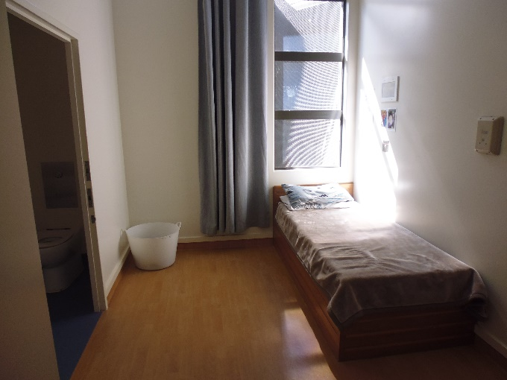 |  | 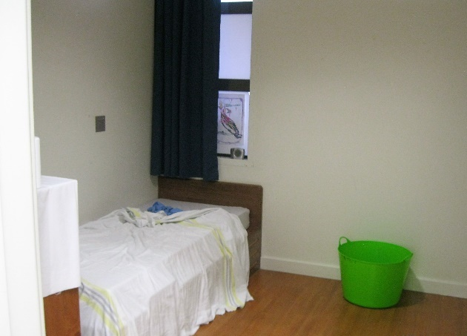
Figure 5: Bedroom in main wing |  | Figure 6: Bedroom in pod area
Service users’ bedrooms were locked from 8am and re-opened for ‘quiet time’ between lunch and 2pm, after which they were locked again until after dinner.
No service users were subject to a Night Safety Order at the time of the inspection. However, the Ward had a shared management plan with Puna Awhi-rua for one service user who was rotating between the wards on a three monthly basis and had been placed on a continuous Night Safety Order. The service user was in Puna Awhi-rua at the time of the inspection.
As noted above, the music room was used as a bedroom for a service user with high and complex needs.
There was a lack of ancillary spaces for service users, the quiet room being the only separate area generally available to service users. Inspectors noted the quiet room had a musty, stale smell.
There was a sufficient number of showers in the Ward for the number of service users, toiletries were provided, and a laundry facility was available for those wanting to launder their own clothes. Service users were encouraged to use these facilities to maintain personal hygiene and were also provided with clean bedding each week.

Food
All meals were taken in the dining area which appeared crowded for the capacity of the Ward. During the week, breakfast was served at 8am, lunch at 12.15pm, and dinner at 5pm. Meals were prepared in the hospital kitchen and transported to the Ward in a trolley.
Service users could choose their meals from a daily menu and dietary requirements were provided for. Inspectors observed a lunch meal and the quality and quantity of the food appeared satisfactory. Service users indicated they were largely happy with the meals.
Service users were unable to leave the dining area until all service users had finished their meal. Inspectors heard from some service users that they felt pressured to eat their meals quickly as a result, so as not to keep other service users waiting. Staff also reported heightened tensions during meal times due to keeping service users in a crowded dining space.
Outside of meal times, the dining area was locked. Service users were unable to access the kitchen area to make their own hot drinks during the day. Morning and afternoon tea, including a selection of cordials, were made available at 10am and 2pm respectively.
Access to personal snack foods was also inconsistent among service users. For example, service users transferred from prison could bring with them their snacks purchased from the prison shop. Alternatively, service users with leave from the Ward could purchase snacks from the local dairy. To avoid tensions building around access to such foods, snacks were not allowed to be consumed on the Ward itself. Service users reported frustration around the lack of access to their snacks. However, my Inspectors noted that the Ward provided daily snacks for all service users and staff were planning events around the Rugby World Cup where snacks would also be provided, courtesy of the Ward.
I am concerned that the blanket restriction on access to the kitchen adversely impacted on service users’ ability to access hot water for drinks. I acknowledge the DHB’s view that there is a safety rationale behind this restriction. However, the current policy disadvantaged all service users as it applied to everyone irrespective of safety risk. I consider that access to hot drinks should be facilitated based on individual risk and subject to regular review.

Recommendations – material conditions
I recommend that:
- Service users are able to leave the dining area when they are ready to do so.
- Service users are able to freely access hot drinks, unless deemed unsafe based on individual risk assessment.

Puna Maatai comments
The DHB rejected recommendations 12 and an earlier iteration of recommendation 13.
Recommendation 12 response:
This is a safety aspect of care and staff are required to follow the Puawai Internal Security procedure. This procedure is included in the associated appendices.
Ombudsman response:
I have reviewed the Puawai Internal Security Procedure 2687 (dated 8 April 2019). The Internal Security Procedure rightly includes controls for the safe distribution and storage of cutlery, including requiring that service users remain in the dining area until an accurate cutlery count is completed. I acknowledge the safety rationale behind this approach. As my Inspectors observed, however, blanket restrictions also create tension and may consequently compromise safety. I therefore encourage the Ward and the Service to consider options to allow more flexibility for service users while maintaining robust safety controls.
Recommend 13 response:
There is a safety aspect of care for both service users and staff. The potential for injury through hot drinks being thrown is a risk within the forensic area of practice. They are however regularly provided and can be made when requested.
Ombudsman response:
I acknowledge the safety concerns. However, it is not clear to me why a hot drink made by a staff member is less likely to cause injury than one made by the service user. My Inspectors’ observations are that there is not a consistent approach to this issue across all facilities. The current policy on the Ward disadvantaged all service users as it applied to everyone irrespective of safety risk. I consider that free access to hot drinks should be available for all service users unless deemed unsafe based on an individual risk assessment. I have adjusted my recommendation accordingly.

Activities and programmes

Outdoor exercise and leisure activities
The Service provided Inspectors with a copy of the Service’s Courtyards Procedure 0516 (dated 22 February 2019). The procedure had a review date of 22 February 2020.
The Ward had a courtyard area located off the communal lounge. My Inspectors observed that access to the courtyard and fresh air was well utilised and supported by staff. Recovery plans often contained a focus on ensuring opportunities for physical exercise are taken.
At the time of the inspection, three service users were allowed Ward leave and were able to take 30 minute escorted walks outside of the Ward.
Service users were able to access the gym twice a week. The gym, which was also used by service users from Puna Awhi-rua and Puna Poipoi, had recently been refurbished, was well-equipped and in good condition.
A pool table was available to service users in the main communal lounge. Staff and service users were observed playing pool together.
Two OTs and the Kaitakawaenga provided a structured programme of daily activities, including individual and group work. For example, art classes took place in the open communal area and all service users were able to participate. Inspectors also observed one service user in a tai chi session.
However, service users reported boredom in the afternoons, during which Inspectors observed that there tended to be fewer structured activities. Inspectors observed several service users sleeping on available couches and beanbags during the afternoon.
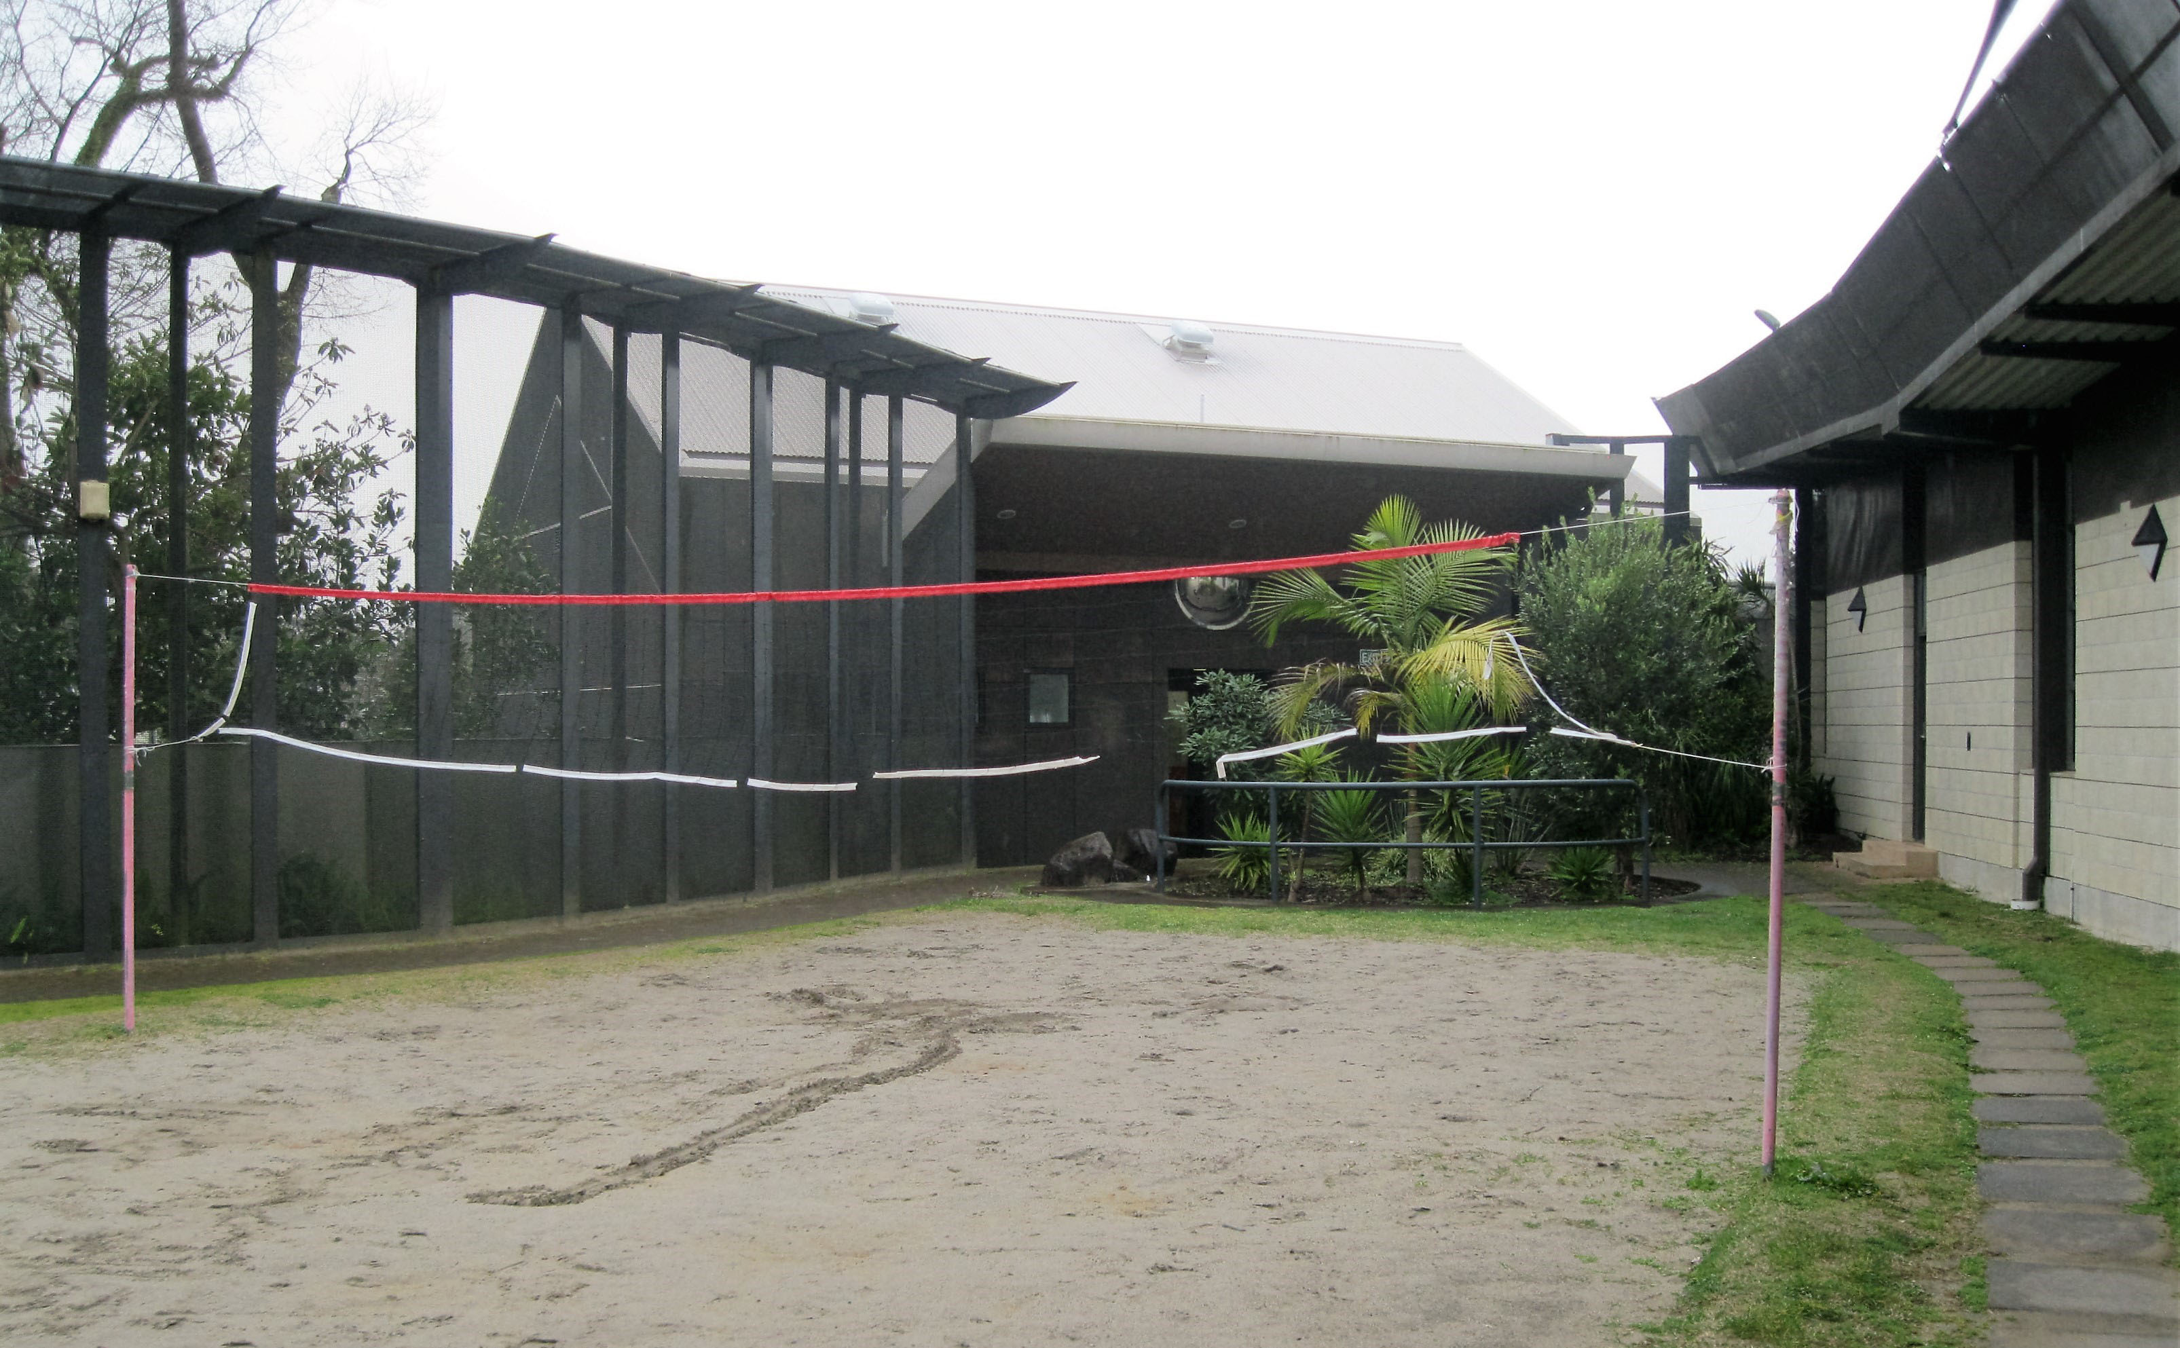
Figure 7: Courtyard area

Programmes
A therapeutic programme was in place, with a mix of open and closed groups divided into four terms per year of between eight and 10 weeks. Service users could not join closed groups part way through a term, but were able to join them in subsequent terms.
Two Clinical Psychologists worked across the Ward and Puna Poipoi, the Service’s forensic rehabilitation secure ward, conducting one-on-one work with service users and, where possible, contributing to therapeutic programmes.
There were six closed group therapeutic programmes operating during the period of the inspection. Inspectors heard that service users in the Ward have limited access to closed therapeutic programmes, mainly as a result of acuity and arriving in the Ward after a programme had started.
Clinical assessments informed participation in therapeutic programmes. Inspectors attended Short-Term Assessment of Risk and Treatability (START) and clinical meetings. These meetings were multi-disciplinary and staff showed a good understanding of service users’ health needs.
At the time of inspection, only one service user (designated with high and complex needs) was attending one of the six closed therapeutic groups. Information provided by the Service indicated that a total of five service users in the Ward had participated in closed groups across the current term. Staff reported that the Ward prioritised treatment through medication above longer term planning for return to the community. Although medical treatment is a core component of an acute forensic mental health ward, staff considered that more focus on reintegration and rehabilitation would be beneficial.
There were no programmes covering violence prevention and sexually appropriate behaviours at the time of the inspection. Inspectors also heard that there were no programmes specifically tailored for service users with intellectual disabilities. The forensic service therapeutic programme had recently been refreshed and several new treatment groups had been added or planned for future terms, including a violence prevention programme in 2020.
Given the benefit of therapeutic programmes, it would be desirable for a higher proportion of service users in the Ward to attend these programmes in future than was the case during the inspection.

Cultural and spiritual support
The Kaitakawaenga visited the Ward daily and was active in providing cultural support to service users, including input into the therapeutic programmes and multi-disciplinary meetings. As noted above, the Kaitakawaenga led the daily whakamoemiti involving karakia and waiata at the beginning and end of each session. Service users and staff participated actively in the whakamoemeti.
Inspectors also attended one of the open ‘Māorioke’ sessions in the whare, led by the Kaitakawaenga, where service users were able to sing karaoke along with staff. Engagement with staff during these sessions was positive.
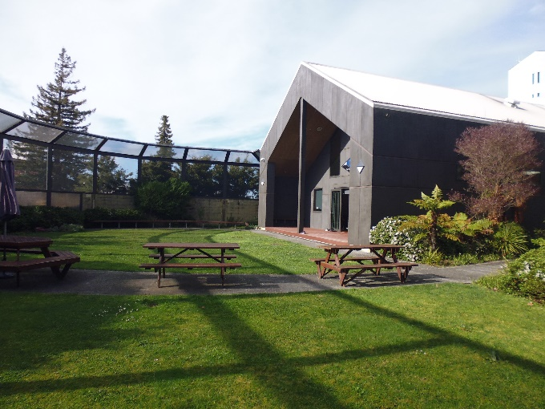
Figure 8: Whare for Puna Maatai and Puna Awhi-rua

Recommendations – activities and programmes
I recommend that:
- Service users have increased access to activities and programmes.

Puna Maatai comments
The DHB rejected recommendation 14.
Recommendation 14 response:
The Forensic service has a therapeutic programme in place which is developed by the therapeutic coordinator...
In addition there are activities provided on the wards for clients to participate in if they choose, and group activities / challenges are organised by staff periodically throughout the year.
Ombudsman response:
I acknowledge that a therapeutic programme is in place and that some activities are provided for. My Inspectors were provided with information on the therapeutic programme during the inspection and its contents had been taken into account in making my recommendation. I remain of the view that service users should have increased access to activities and programmes.

Communications

Access to visitors
The Service provided Inspectors with a copy of its guideline Visiting Patients at Waikato Facilities 0125 (dated 1 July 2017). The guideline had a review date of 1 July 2020.
Supervised visits were able to take place between 1.30pm to 3pm and 6pm to 8pm on weekdays. Inspectors were told that logistical difficulties precluded morning visits.
Visits took place off the Ward in a meeting room shared with Puna Awhi-rua. The use of a meeting room for visits in the absence of a dedicated visits area was understandable, but the environment was not ideal. Due to the limited physical space available, visits had to be prearranged 24 hours beforehand.
Visits were supervised and would last 30 minutes for local visitors and one hour for out-of-area visitors. The information pamphlet Visiting Puawai inpatient forensic services: a visitors’ guide did not clearly stipulate the duration of visits. While it was positive that additional visiting time is provided for out-of-area visitors, a 30 minute visit for local visitors seems insufficient.
Whānau spoken with by Inspectors did not report any issues about service users’ access to visitors.

Access to external communications
Service users were able to access a telephone on request between 6pm and 9pm. Calls for legal purposes and the DIs were able to be made at any time of day, again on request. Service users could make these calls in the quiet room, which offers some privacy during the call.
I consider the regime for telephone access to be unduly restrictive. It is necessary to have protocols in place to safeguard against prohibited or unsafe communication, such as where a protection or non-association order is in place. However, I am unaware of a compelling rationale for limiting personal calls to between 6pm and 9pm, particularly given the generally long periods of inactivity during the day.

Recommendations – communications
I recommend that:
- Service users have access to a telephone, independent of staff, at any time, unless deemed unsafe based on individual risk assessment.

Puna Maatai comments
The DHB rejected an earlier iteration of recommendation 15 as follows.
Recommendation 15 response:
Access to telephone use is a security issue and is based on conditions of protection orders, and short stay provision of hospital level care from prison.
As service users progress through the forensic rehabilitation pathway access to phones is implemented as part of their recovery pathway.
Ombudsman response:
I acknowledge your concerns regarding security. However, my Inspectors’ observations are that there is not a consistent approach to this issue across all facilities. The current policy on the Ward disadvantaged all service users as it applied to everyone irrespective of safety risk. I consider that independent access to a telephone should be available for all service users unless deemed unsafe based on an individual risk assessment.

Health care

Primary health care services
Service users received a physical assessment on admission and the House Doctor visited the Ward regularly. Staff were proactive about arranging specialist medical appointments for service users. Service users received health reviews, such as smear tests, and health promotion education.
I have no concerns with service users’ access to primary health care services.
An emergency trolley, containing oxygen and a defibrillator, was located on the Ward and shared with Puna Awhi-rua.

Recommendations – health care
I have no recommendations to make.

Staff

Staffing levels and staff retention
There was a good mix of age, gender, ethnicity and experience among staff.
Information provided to Inspectors indicated that the Ward had vacancies for a Clinical Nurse Specialist (CNS) and 1.5 Registered Nurse (RN) vacancies. Active recruitment was underway for a CNS.
Staff worked to a three-shift roster with a designated staffing level. The morning shift ran from 7am to 4pm with six RNs and three Psychiatric Assistants (PAs), afternoon shift from 3pm to 11.30pm with three RNs and three PAs, and the night shift from 11pm to 7.30am with one RN and three PAs.
Staff spent the majority of their time actively on the Ward with service users.
Staff were complimentary of the leadership and management of the Ward. They reported feeling well supported and that they were part of a cohesive team environment. Inspectors’ observations confirmed this. Staff worked well together and good practice was evident around team support and de-escalation of service users.
However, Inspectors also heard that there had been significant workload pressures over a long period of time. There was a consensus among staff that the risk of burnout was high given the pressure, not least of all because of the mix of service users in the Ward. Inspectors were also told that some staff did not feel safe in the Ward.
Data provided by the Service indicated that the reported pressures may be having an impact on staff turnover in the Ward. Specifically, the data indicated that turnover for the 2018/19 financial year was more than double the previous two financial years. Sick leave rates had declined somewhat over the same period.

Recommendations – staff
I have no recommendations to make.

Acknowledgements
I appreciate the full co-operation extended by the Charge Nurse Manager and staff to the Inspectors during their inspection of Puna Maatai. I also acknowledge the work involved in collating the information requested.

Peter Boshier
Chief Ombudsman
National Preventive Mechanism
- List of people who spoke with Inspectors
Table 3: List of people who spoke with Inspectors
Managers | Ward staff | Others
Operations Manager  Clinical Nurse Manager  Associate Clinical Nurse Manager | Clinical Nurse Specialist  Registered Nurses  Lead Clinical Psychologist  Occupational Therapists  Family/whānau Advisor  Psychiatric Assistants | Service users  Therapeutic Programmes Co-ordinator  Senior House Officer  District Inspector  Whānau  Kaitakawaenga  Chaplain  Consumer Advocate  Consumer Advisor  Social Worker

- Legislative framework
In 2007 the New Zealand Government ratified the United Nations Optional Protocol to the Convention against Torture and Other Cruel, Inhuman or Degrading Treatment or Punishment.
The objective of OPCAT is to establish a system of regular visits undertaken by an independent national body to places where people are deprived of their liberty, in order to prevent torture and other cruel, inhuman or degrading treatment or punishment.
The Crimes of Torture Act 1989 (COTA) was amended by the Crimes of Torture Amendment Act 2006 to enable New Zealand to meet its international obligations under OPCAT.

Places of detention – health and disability facilities
Section 16 of COTA defines a “place of detention” as:
“…any place in New Zealand where persons are or may be deprived of liberty, including, for example, detention or custody in…
(d) a hospital
(e) a secure facility as defined in section 9(2) of the Intellectual Disability (Compulsory Care and Rehabilitation) Act 2003…”
Pursuant to section 26 of COTA, an Ombudsman holding office under the Ombudsmen Act 1975 (Ombudsmen Act) was designated a National Preventive Mechanism (NPM) for certain places of detention, including hospitals and the secure facilities identified above.
The New Zealand Gazette of 6 June 2018 sets out in further detail the relevant places of detention:
“…in health and disability places of detention including within privately run aged care facilities; …”

Carrying out the NPM’s functions
Under section 27 of COTA, an NPM’s functions, in respect of places of detention, include:
- to examine the conditions of detention applying to detainees and the treatment of detainees; and
  - to make any recommendations it considers appropriate to the person in charge of a place of detention:
  - for improving the conditions of detention applying to detainees;
  - for improving the treatment of detainees; and
  - for preventing torture and other cruel, inhuman or degrading treatment or punishment in places of detention.
Under sections 28-30 of COTA, NPMs are entitled to:
- access all information regarding the number of detainees, the treatment of detainees and the conditions of detention;
- unrestricted access to any place of detention for which they are designated, and unrestricted access to any person in that place;
- interview any person, without witnesses, either personally or through an interpreter; and
- choose the designated places they want to visit and the people they want to interview.
Section 34 of the COTA, confers the same powers on NPMs that NPMs have under any other legislation when carrying out their function as an NPM. These powers include those given by the Ombudsmen Act to:
- require the production of any information, documents, papers or things that, in the Ombudsmen’s opinion, relates to the matter that is being investigated, even where there may be a statutory obligation of secrecy or non-disclosure (refer sections 19(1), 19(3) and 19(4) of the Ombudsmen Act); and
- at any time enter and inspect any premises occupied by any departments or organisation listed in Schedule 1 of the Ombudsmen Act (refer section 27(1) of the Ombudsmen Act).
To facilitate the exercise of the NPM function, the Chief Ombudsman has authorised inspectors to exercise the powers given to him as an NPM under COTA, which includes those powers in the Ombudsmen Act for the purpose of carrying out the NPM function.

More information
Find out more about the Chief Ombudsman’s NPM function, inspection powers, and read his reports online: ombudsman.parliament.nz/opcat.

When the term Inspectors is used, this refers to the inspection team comprising one Senior Inspector, an Inspector and a Specialist Advisor.
UN Convention against Torture, Article 16(1): “Each State Party shall undertake to prevent in any territory under its jurisdiction other acts of cruel, inhuman or degrading treatment or punishment which do not amount to torture as defined in article I, when such acts are committed by or at the instigation of or with the consent or acquiescence of a public official or other person acting in an official capacity. In particular, the obligations contained in articles 10, 11, 12 and 13 shall apply with the substitution for references to torture of references to other forms of cruel, inhuman or degrading treatment or punishment.”
The wards inspected at the same time were Wards 34, 35 and 36, Puna Awhi-rua and Puna Poipoi.
The forensic service includes Puna Maatai, Puna Awhi-rua and Puna Poipoi.
The separate pod area could be designated for specific service users groups such as those with an intellectual disability or female service users.
SPEC training was designed to support staff working within inpatient mental health wards to reduce the incidence of restraints. SPEC training has a strong emphasis on prevention and therapeutic communication skills and strategies, alongside the provision of training in safe, and pain free personal restraint techniques. https://www.tepou.co.nz/initiatives/towards-restraint-free-mental-health-practice/149
Sentinel events are unanticipated events in the healthcare setting which have resulted in serious harm to service users.
My inspection methodology is informed by the Association for the Prevention of Torture’s Practical Guide to Monitoring Places of Detention (2004) Geneva, available at www.apt.ch.
For a list of people spoken with by the Inspectors, see Appendix 1.
OPCAT report on an unannounced visit to Puna Maatai Forensic Inpatient Unit under the Crimes of Torture Act 1989, August 2014.
‘Sleepovers’ is the term used by staff at the HRBC. Sleepovers involve service users having to move to other wards to sleep. Inspectors observed service users on sleepovers in wards for days at a time as a result of chronic over capacity in the acute wards.
Information provided by the Service indicates that high and complex needs service users are people presenting with a number of bio-psycho-social-occupational and cultural complexities that cause barriers to their transition and reintegration from the ward back into the community. These barriers may include factors such as; no identified funding stream available, exited from residential providers due to their behaviour, having a number of medical comorbidities, exhibiting a high risk for residential providers, such as excessive illicit drug and alcohol use, and/or having personality traits and/or disorders that interfere with treatment. Waikato DHB Inpatient Coordination Team. Operating Manual.
Non-forensic service users were all under a compulsory detention order.
UN Convention against Torture, Article 16(1): “Each State Party shall undertake to prevent in any territory under its jurisdiction other acts of cruel, inhuman or degrading treatment or punishment which do not amount to torture as defined in article I, when such acts are committed by or at the instigation of or with the consent or acquiescence of a public official or other person acting in an official capacity. In particular, the obligations contained in articles 10, 11, 12 and 13 shall apply with the substitution for references to torture of references to other forms of cruel, inhuman or degrading treatment or punishment.”
Approximately 65 percent. The remaining 35 percent of services users secluded were non-Māori males (29 percent) and non-Māori females (6 percent).
The figures in the table are those provided by the Service. Additional analysis of raw data by Inspectors resulted in some differences for the total and average hours.
Data as reported by the Service.
Inspectors’ analysis of the data suggests a total of 1648.20 seclusion hours.
From 1 March to 31 August 2019, there were 28 seclusion events for persons designated as high and complex needs, compared to 23 for forensic service users and 13 for intellectual disability designated service users.
Data as reported by the Service.
Personal restraint is when a service provider(s) uses their own body to limit a service user’s normal freedom of movement. New Zealand Standards. Health and Disability Services (Restraint Minimisation and Safe Practice) Standards. Ministry of Health. 2008.
Physical restraint is when a service provider(s) uses equipment, devices or furniture that limits the service user’s normal freedom of movement. New Zealand Standards. Health and Disability Services (Restraint Minimisation and Safe Practice) Standards. Ministry of Health. 2008.
‘Where a service provider intentionally restricts a consumer’s normal access to their environment, for example where a consumer’s normal access to their environment is intentionally restricted by locking devices on doors or by having their normal means of independent mobility (such as wheelchair) denied’. Ministry of Health’s clarification of NZS 8134.2.2008 Health and Disability Services (Restraint minimisation and Safe Practice) Standards environmental restraint.
Specifically the principles of equity and active protection, which include a requirement to be fully informed of how Māori are treated. See, for example, Waitangi Tribunal, Hauora: Report on Stage One of the Health Services and Outcomes Kaupapa Inquiry (Wellington, Legislation Direct, 2019) p 138.
Waikato District Health Board Restraint Policy.
The person applying this restraint shall have completed specific training in its use. Completion of this training must be recorded on the staff member’s personal file held in payroll and/or in the department training record. Restraint – Wrist and/or Ankle policy.
At the time of the 2014 inspection report the terminology was RESPECT training, however at the time of the 2019 inspection the training within the service was SPEC training. This training places emphasis on de-escalation in an attempt to reduce the use of restraint. RESPECT training was superseded by SPEC training.
SPEC training was designed to support staff working within inpatient mental health wards to reduce the incidence of restraints. SPEC training has a strong emphasis on prevention and therapeutic communication skills and strategies, alongside the provision of training in safe, and pain free personal restraint techniques.
Electroconvulsive therapy is used mainly in the treatment of severe depressive episodes. It involves the passage of an electric current across the head of a person to produce a convulsion. https://www.health.govt.nz/publication/electroconvulsive-therapy-ect
See Mental Health (Compulsory Assessment and Treatment) Act 1992, section 60.
Waikato DHB’s Sensory Modulation Procedure 3248 (dated 28 Jan 2019): ‘A therapeutic environment specifically designed to promote self-organisation and positive change. Sensory modulation rooms can be used for de-escalation and for identifying new skills and preferences that can be transferred to other environments.’
‘Whakamoemiti’ is the Ward’s morning meeting. ‘Whakamoemiti’ means to give praise or express thanks. Definitions and applied examples are available on Māori Dictionary.
Kaitakawaenga provide cultural support to tangata whaiora (service users) and their whānau and work as part of multi-disciplinary teams to identify and address ways to improve service delivery to Māori. More information on the role of Kaitakawaenga is available on the Waikato DHB website.
Wards 34, 35 and 36, Puna Awhi-rua, and Puna Poipoi.
Mental Health (Compulsory Assessment and Treatment) Act 1992, sections 64(2)(g). The functions and powers of District Inspectors are located in sections 94 to 98 of the Act.
Puna Maatai Service user/tāngata whaiora – House Rules and guidelines.
Night Safety Orders is a term used to describe the practice of locking the entry to a service user’s bedroom overnight at the request of the service user.
See OPCAT report on unannounced inspection of Puna Awhi-rua Forensic Inpatient Ward, Waikato Hospital, under the Crimes of Torture Act 1989, March 2020.
Service users are able to freely access hot drinks.
Term Three, 22 July – 27 September 2019.
For weekends and public holidays, visiting hours were 10am to 12pm, 1.30pm to 4pm and 6pm to 8pm.
Service users have access to a telephone, independent of staff, at any time.
The turnover rate in the Ward was 5.7 percent for the 2016/17 year, 5.6 percent for the 2017/18 year and 13.2 percent for the 2018/19 year.

