Statement of Intent

for the period 1 July 2014
to 30 June 2018

PLEASE NOTE: Page numbers in this word version of the Statement of Intent will differ from the formal version in pdf.

Contents
Speaker’s Statement of Responsibility 2
Introduction from the Chief Ombudsman 3
Chief Ombudsman’s Statement of Responsibility 4
Nature and Scope of Functions 5
Who we are 5
Our purpose 5
Legislative functions 5
International responsibilities 6
Other functions 7
Constraints 7
Strategic Direction 9
Outcomes Framework 11
Operating Intentions 12
Impact 1: Improved administration and decision making in state sector agencies 12
Impact 2: Official information increasingly available and public assured access is not denied unnecessarily 18
Impact 3: Serious wrongdoing brought to light and investigated by appropriate authorities 23
Impact 4: People in detention treated humanely 25
All impacts 28
Managing in a Changeable Operating Environment 33
Expanding functions 33
Canterbury recovery 35
Changing demand for our services 35
Changing models of public service delivery 37
International environment 39
Assessing Organisational Health and Capability 40
People 40
Leadership and management systems 41
Technology 41
Capital and asset management intentions 42

Speaker’s Statement
of Responsibility
I am satisfied that the information on strategic intentions provided by the Office of the Ombudsman in this Statement of Intent is in accordance with the Public Finance Act 1989 and is consistent with the policies and performance expectations of the Officers of Parliament Committee acting on behalf of Parliament.

Rt Hon David Carter
Speaker of the House of Representatives
Responsible Minister for the Office of the Ombudsman
30 June 2014

Introduction from the
Chief Ombudsman
The Ombudsmen are appointed by Parliament to give effect to a number of key democratic measures aimed at safeguarding the rights of individuals and promoting government accountability and transparency. In essence, we investigate, review and inspect the administrative conduct of state sector agencies and provide advice and guidance, in order to ensure people are treated fairly in New Zealand.
The activities we carry out are balanced between:
- specific interventions in relation to individual complaints about administrative conduct and access to information that we receive from members of the public; and
- more general interventions to investigate and inspect significant and systemic issues and to provide advice and guidance, with the aim of contributing to wider administrative improvement in the state sector.
We operate in an environment where our stakeholders have high expectations, and there is an ever-changing demand for our services. Our functions and workload have been progressively increasing, and we need to remain relevant and able to respond in a rapidly evolving model of public service delivery.
To ensure that we can provide effective and efficient interventions that make the best use of available resources, we are operating under a revised business model in a process of continuous practice improvement. This model preserves our practices that have stood the test of time, but realigns them to meet current business needs and better reflect our overall purpose and strategic direction.

Dame Beverley Wakem DNZM, CBE
Chief Ombudsman

Chief Ombudsman’s
Statement of Responsibility
In signing this statement, I acknowledge that I am responsible for the information on strategic intentions for the Office of the Ombudsman. This information has been prepared in accordance with sections 38 and 40 of the Public Finance Act 1989.

Dame Beverley Wakem DNZM, CBE
Chief Ombudsman and Chief Executive

Nature and Scope
of Functions

Who we are
The Ombudsmen are Officers of Parliament. Each Ombudsman is appointed by the Governor-General on the recommendation of Parliament. We are responsible to Parliament and independent of the Government.

Our purpose
Our overall purpose is to investigate, review and inspect the administrative conduct of state sector agencies and provide advice and guidance, in order to ensure people are treated fairly in New Zealand.

Legislative functions
Our main functions under legislation are to:
- investigate state sector administration and decision making;
- investigate and review decisions made on requests to access official information;
- deal with requests for advice and guidance about alleged serious wrongdoing;
- monitor and inspect places of detention for cruel and inhumane treatment; and
- provide comment to the Ministry of Transport on applications for authorised access to personal information on the motor vehicle register.
In carrying out our functions, we provide Parliament and the New Zealand public with an independent and impartial check on the quality, fairness and integrity of state sector administrative conduct. By contributing to wider administrative improvement in the state sector, we can help to reduce overall downstream costs caused by poor decision making and ineffective administrative processes.
What is the state sector?
We have authority to investigate approximately 4000 entities in the state sector, including:
- government departments and ministries;
- local authorities;
- crown entities;
- state-owned enterprises;
- district health boards;
- tertiary education institutions;
- school boards of trustees; and
- Ministers of the Crown and the Police (in relation to decisions on requests for official information).

International responsibilities
Two of our functions have international responsibilities. We carry out our function to monitor and inspect places of detention under the Crimes of Torture Act 1989 as a National Preventive Mechanism. The Crimes of Torture Act fulfils New Zealand’s responsibilities under the United Nations Optional Protocol to the Convention Against Torture.
We are also an Independent Monitoring Mechanism protecting and monitoring the implementation of the United Nations Convention on the Rights of Persons with Disabilities (the Disabilities Convention). We carry out this role by investigating state sector administrative conduct.

Other functions
To complement and support our main functions under legislation, we are increasingly taking steps to:
- provide advice and guidance to state sector agencies in order to improve state sector capability in areas relevant to our role; and
- improve public awareness and accessibility of our services.

Constraints
We have a wide jurisdiction across the activities of the entire state sector, but finite resources with which to carry out our role. To some degree, therefore, we must carefully target our interventions.
We also face the following constraints in providing an independent and impartial check on state sector administrative conduct:
- we can only influence the state sector through:
  - investigation and review;
  - inspection;
  - advice and guidance;
  - recommendation; and
  - reporting;
- we can only comment on the matters that come to our attention;
- we are only one of a number of state sector accountability mechanisms;
- there are no statutory timeframes within which state sector agencies must respond to us in relation to our investigation of administrative and decision making practices, and our recommendations in that respect are not binding;
- people can only make complaints and seek guidance from us if they are aware of our various roles; and
- people can only make requests for official information if they are aware of the official information legislation.
Given the constraints on our role, most of our interventions to improve state sector administrative conduct are carried out through persuasion and reporting, rather than compulsion. To do this effectively, we need to be relevant, fair and accessible. We need to provide well-reasoned and independent opinions, and our interventions need to be proportionate, taking into account the impact on the agency and the costs and benefits of any proposed remedies.

Strategic Direction
Our strategic direction is:
- guided by the legislative functions assigned to us by Parliament; and
- informed by the current environment and the Government’s strategic direction.
In essence, our functions cover a range of key democratic measures aimed at safeguarding the rights of individuals and increasing government transparency and accountability. The overall outcome we contribute to is maintaining a high level of public trust in government.
Within this context, we can assist in achieving two of the Government’s four key priorities to:
- deliver better public services within tight fiscal constraints; and
- rebuild Christchurch and the Canterbury economy.
One of our primary strategic goals is to assist state sector agencies to improve their services to the public. Traditionally, the main mechanism we have used to do this is by investigating and reviewing state sector decisions in response to complaints we have received from the public. However, we are increasingly taking a more proactive approach, through more general interventions to investigate and inspect significant and systemic issues, and provide advice and guidance to state sector agencies. The aim of our interventions is to improve administrative systems and processes overall, and so support the delivery of better public services through:
- more effective and timely service delivery addressing what people need; and
- greater understanding of, and trust in, state sector processes and service delivery.
A significant number of requests for our assistance are continuing to arise from the Canterbury earthquakes. Approximately 6% of the complaints and other contacts received in the 2013/14 reporting year concerned the Earthquake Commission. We are also receiving complaints from Cantabrians about the delivery of other public services either involved in the rebuild process or adversely affected by the Canterbury earthquakes. Our assistance is increasingly being sought to ensure fair administrative processes and decision making in this context, as well as the provision of adequate information and consultation about the changes underway.

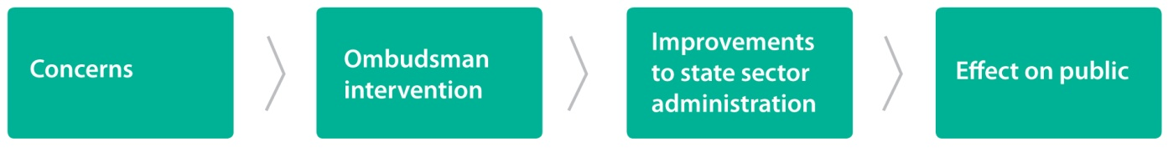
Figure 1: The overall impact of our work

Outcomes Framework
Our Outcomes Framework demonstrates the linkages between the services we deliver through our outputs, and the outcomes and impacts we are seeking to achieve.

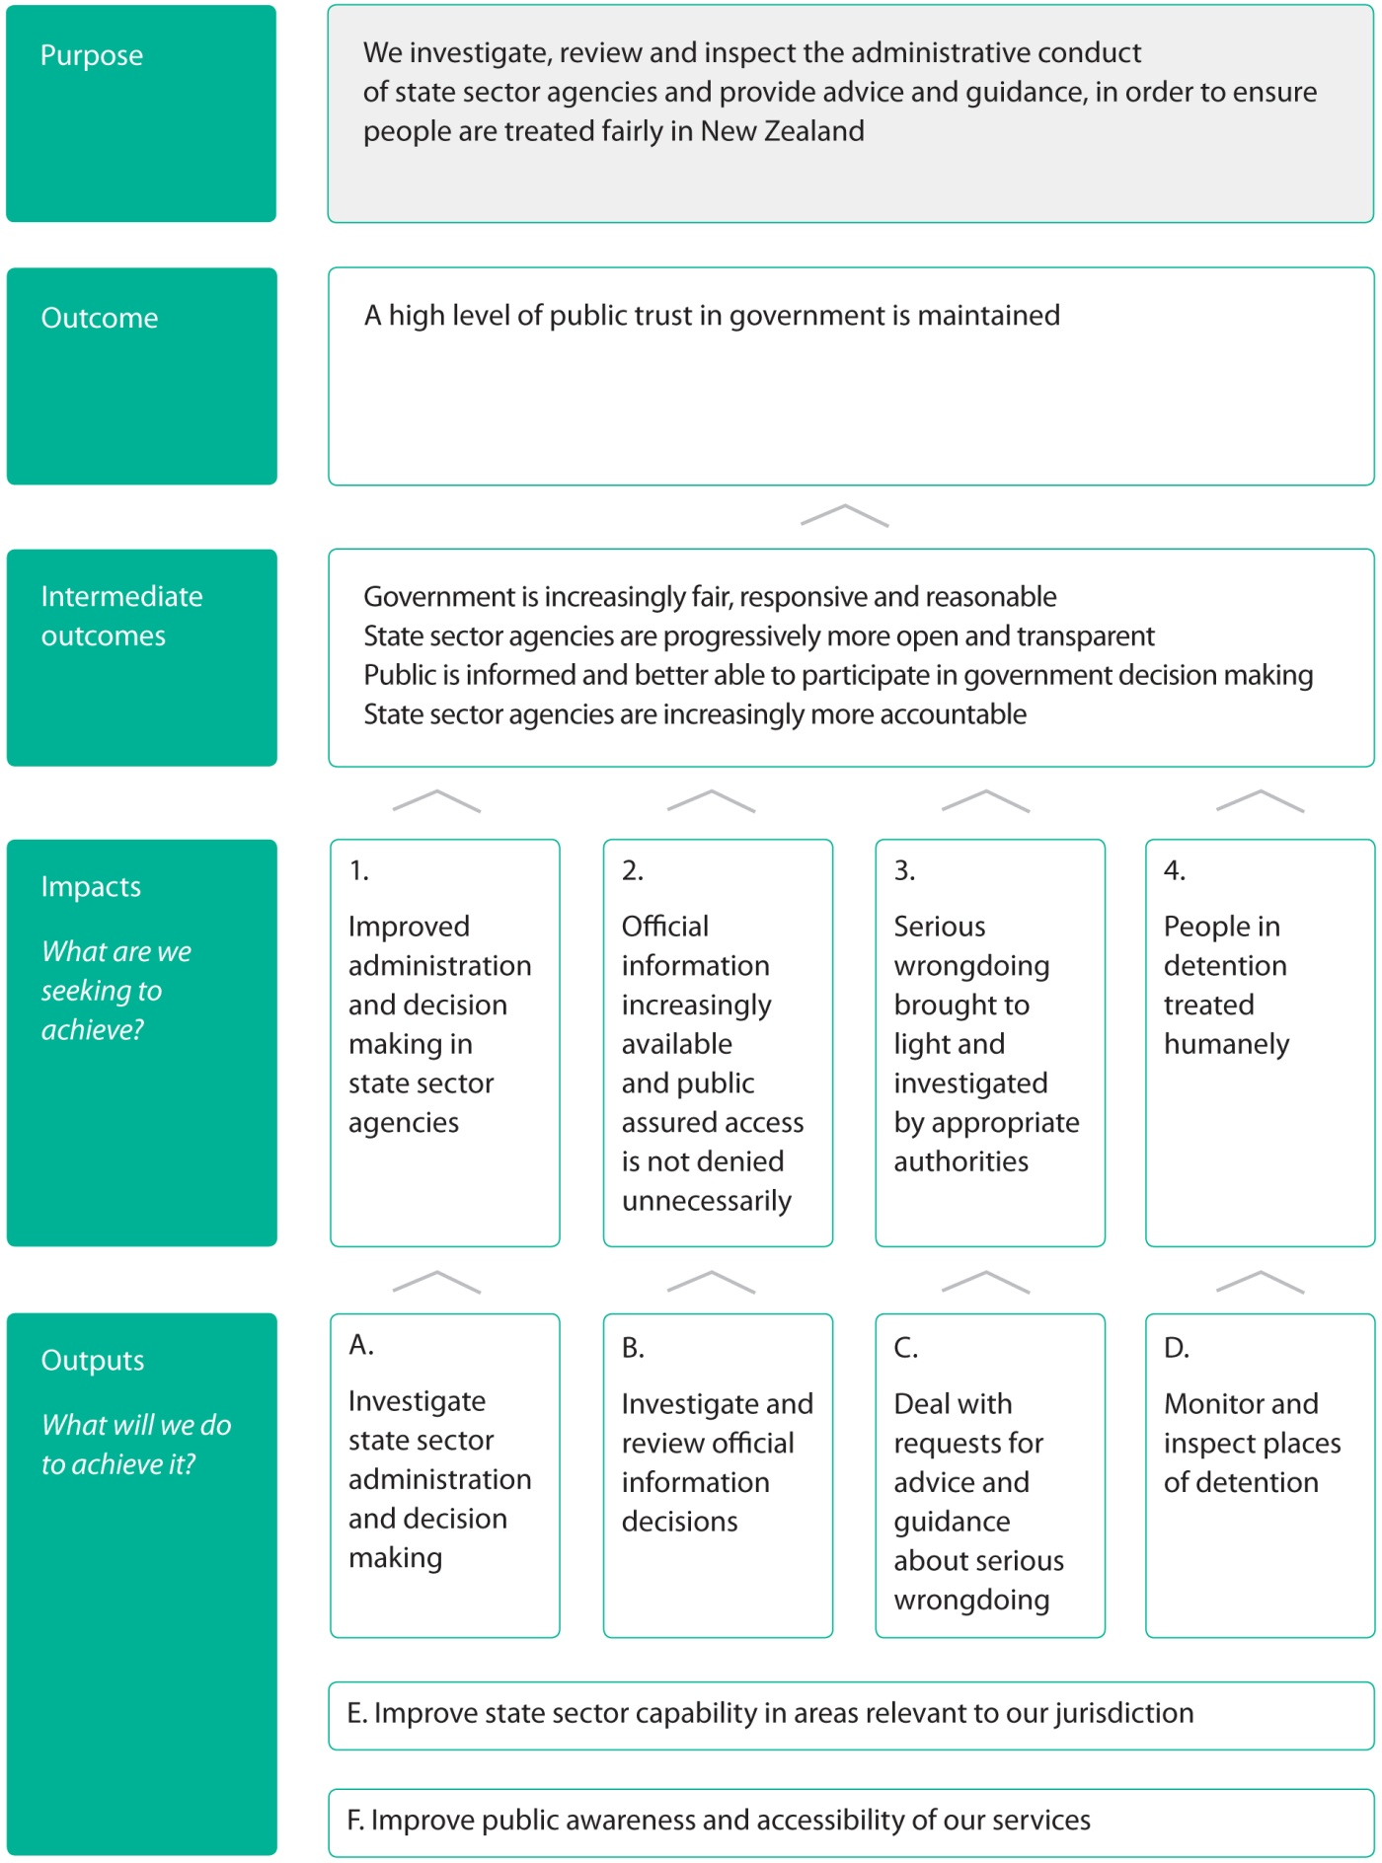

Operating Intentions
The following section discusses the impacts we are seeking to make in contributing to the outcomes we have identified in our Strategic Direction.

Impact 1: Improved administration and decision making in state sector agencies

What are we seeking to achieve?
Independent oversight by the Ombudsmen can assist state sector agencies to identify and correct administrative deficiencies. In doing so, we provide one means of improving administration and decision making over time.
Improved administration and decision making in state sector agencies will ultimately result in better services being provided to the public.

How will we demonstrate success in achieving this?
The main measure currently being used to track improvements in the public service is the Kiwis Count survey, which is independently administered by the State Services Commission. We will use the Kiwis Count survey to demonstrate improvements in administration and decision making in state sector agencies. Using the results of this survey, we will be able to track any overall improvements that are achieved through New Zealanders’ overall quality score for public services.
While this is a relatively high-level measure, our role encompasses oversight of over 4000 state sector agencies. The Kiwis Count survey provides an authoritative means to gauge perceived improvement in public services provided by state sector agencies overall.
The Kiwis Count survey was conducted in 2007 and 2009, and from 2012 it has been conducted on a quarterly basis. In 2007, New Zealand’s overall quality score for public services was 68, and in 2009 it improved to 69. For the December 2012 and December 2013 quarters, the overall quality score rose to 72. This compares favourably with the 2007 Canadian benchmark of 69.
How will we demonstrate our success?
Measure | Actual  2009 | Actual  December 2012 | Actual  December  2013 | Target  2014/15 | Target  2015/16 | Target  2016/17 | Target 2017/18
Overall quality of public services improves over time | 69 points | 72 points | 72 points | Higher than 70 points | Higher than 70 points | Higher than 70 points | Higher than 70 points

What will we do to achieve this?
The main activities we will carry out to improve administration and decision making in state sector agencies are grouped under outputs A, E and F.
We discuss output A below. Outputs E and F relate to all impacts we are seeking to achieve, and will be discussed at the end of the Operating Intentions section.

Output A: Investigate state sector administration and decision making
The Ombudsmen Act 1975 gives us authority to investigate the administrative conduct of state sector agencies. We may decide to investigate:
- after receiving a complaint from a member of the public about a particular matter of concern; or
- without receiving a complaint (on our “own motion”), particularly where we consider significant or systemic issues arise and our investigation may lead to wider administrative improvement in the state sector.
Following an investigation, we may make any recommendation considered appropriate to remedy identified deficiencies, both in relation to individual matters and broader issues. While our recommendations under the Ombudsmen Act are not legally binding, they are highly persuasive and almost always accepted. If recommendations are not accepted, we may report the matter to the Prime Minister and House of Representatives or, in the case of local authorities, compel a report to be published.

Under this output we will:
- investigate complaints from the public about administrative and decision making practices in state sector agencies;
- investigate significant or systemic issues arising in the state sector;
- monitor death in custody investigations conducted by the Department of Corrections;
- seek resolutions and remedies, form opinions and make recommendations to address identified administrative deficiencies;
- report on and monitor acceptance and implementation of our recommendations;
- publish our key opinions in relation to matters we have investigated;
- investigate and report on issues relating to implementation by state sector agencies of the Disabilities Convention; and
- provide advice and assistance where people raise matters that are outside our jurisdiction or can be resolved in a more appropriate way.
We treat matters as formal complaints once they have been put in writing. However, we also deal with a large number of enquiries from members of the public, mainly over the telephone, without a complaint being made to us in writing. While we term these matters “other contacts”, our staff spend a significant amount time providing advice and assistance, and resolving these matters.
Our performance measures for output A are set out below.

How will we demonstrate our success in providing output A?
Measure | 2011/12  Actual | 2012/13  Actual | 2013/14 |  |  | 2014/15  Budget  Standard | 2015/16  Target | 2016/17  Target | 2017/18  Target
 |  |  | Budget  Standard | Estimated  Actual
Demand driven measures
# of complaints completed | 8,784 | 11,161 | 2,500 | 2,400 |  | 2,500 | 2,500 | 2,500 | 2,500
# of other contacts completed |  |  | 7,000 | 5,500 |  | 5,500 | 5,500 | 5,500 | 5,500
# of cases where monitoring of death in custody investigation commenced | 27 | 18 | 12-15 | 11 |  | 12-15 | 12-15 | 12-15 | 12-15
Proactive measures
All complaints and other contacts considered | Met | 100% | 100% |  | 100% | 100% | 100% | 100% | 100%
# of wider administrative improvement investigations completed | - | 3 | 3-5 |  | 1 | 2-3 | 2-3 | 2-3 | 2-3
% of complaints outside jurisdiction completed within 1 month from date of receipt | 49% | 79% | 75% |  | 82% | 75% | 75% | 75% | 75%
% of complaints not investigated or resolved without investigation completed within 3 months from date of receipt | 86% | 85% | 72% |  | 79% | 75% | 75% | 75% | 75%
% of urgent investigations completed within 4 months from date of receipt | 93% | - | 90% |  | - | 90% | 90% | 90% | 90%
% of priority investigations completed within 6 months from date of receipt | 100% | 57% | 70% |  | 50% | 70% | 70% | 70% | 70%
% of all other investigations completed within 12 months from date of receipt | 64% | 56% | 60% |  | 48% | 60% | 60% | 60% | 60%
% of completed complaints and other contacts meeting internal quality standards, following random quality assurance check | - | - | Baseline  to be estab-lished |  | - | Baseline  to be estab-lished | Baseline  to be estab-lished | Baseline  to be estab-lished | Baseline  to be estab-lished
# of successful appeals for judicial review of Ombudsman | - | Nil | Nil |  | Nil | Nil | Nil | Nil | Nil

From 2013/14 onwards, we have had to reduce some of our performance targets for the completion of particular complaints and investigations within nominated timeframes. This is a result of the complaint handling pressures that we face, as discussed in the section headed Managing in a Changeable Operating Environment.
Since 2011/12, we have experienced a significant increase in both the number and complexity of complaints received. The Officers of Parliament Committee has acknowledged this, and an additional resource for 6 new Investigators has been provided for 2013/14 onwards, to address part of the increase in work we are experiencing. We have also implemented practice improvements and reorganised our teams and support structures. As a result, we have managed to lift our throughput, reduce the amount of work on hand and improve the age profile of work on hand. While we anticipate there will continue to be an impact on our achievement against performance targets over the next reporting period, we expect our performance to progressively improve over the next 1-3 years.
We have also developed additional measures of our performance for outputs A and B, which will be assessed biennially on the results of our stakeholder survey.
How will we demonstrate our success in providing outputs A and B?
Measure | 2008/09  Actual | 2011/12  Actual | 2013/14 |  | 2015/16  Target | 2017/18  Target
 |  |  | Target | Actual
% of complainants satisfied with overall quality of our service delivery | 66% | 55% | 55% | 49% | 55% | 55%
% of state sector agencies satisfied with our communication overall | 93% | 88% | 70% | 94% | 70% | 70%
% of state sector agencies satisfied the Ombudsmen’s opinions are fair | 76% | 73% | 70% | 72% | 70% | 70%

We conduct a stakeholder survey biennially, with the 2013/14 survey currently being completed. We survey both our complainants and the state sector agencies who have been the subject of an investigation. The objective of our survey is to assess the level of satisfaction with the service we provide, and to identity areas where we can improve. We currently conduct the surveys in-house, although we have obtained independent expert advice on the content of the survey questions. We have also agreed with the State Services Commission to include the questions and scales used in the Common Measurements Tool, which will enable us to benchmark our results against other agencies using this tool.
The declining satisfaction by complainants may be attributable to a reduction in the timeliness of some of our interventions as we prioritised dealing with the significant volume of complaints from Cantabrians following the Canterbury earthquakes. We anticipate that our performance in terms of complainant satisfaction with the overall quality of our service delivery will improve as our timeliness issues are addressed, following the reorganisation of our workflow processes and associated resources.

Impact 2: Official information increasingly available and public assured access is not denied unnecessarily

What are we seeking to achieve?
In reviewing decisions on requests for official information, we ensure that requests are being dealt with appropriately and access is not denied unnecessarily. In this way, we can enhance public trust and confidence in decision making processes, and also increase the availability of official information.
Making official information increasingly available, and assuring the public that access is not denied unnecessarily, will lead to greater transparency and accountability within the state sector, and facilitate public participation in the making and administration of laws and policies. Ultimately, this will help to improve public trust in government.

How will we demonstrate success in achieving this?
The main measure currently available to track perceptions of public trust in government is the Transparency International Corruption Perceptions Index (the Index). Launched in 1995, the Index is an aggregate indicator that annually ranks 177 countries by their perceived levels of corruption in the public and political sectors. New Zealand is currently ranked first equal on the Index, alongside Denmark.
We will demonstrate our success under this impact by tracking New Zealand’s ranking on the Index.
How will we demonstrate our success?
Measure | 2012/13  Actual | 2013/14  Actual | 2014/15  Target | 2015/16  Target | 2016/17 Target | 2017/18  Target
New Zealand is rated as one of the leading countries in public service probity as measured by the Transparency International Corruption Perceptions Index | New Zealand ranked first equal with Denmark and Finland | New Zealand ranked first equal with Denmark | On average over the next 5 years New Zealand is in the top three ranked countries | On average over the next 5 years New Zealand is in the top three ranked countries | On average over the next 5 years New Zealand is in the top three ranked countries | On average over the next 5 years New Zealand is in the top three ranked countries

What will we do to achieve this?
The main activities we will carry out to ensure official information is increasingly available, and to assure the public that access is not denied unnecessarily, are grouped under outputs B, E and F.
We discuss output B below. Outputs E and F relate to all impacts we are seeking to achieve, and will be discussed at the end of the Operating Intentions section.

Output B: Investigate and review official information decisions
The Official Information Act 1982 (OIA) and the Local Government Official Information and Meetings Act 1987 (LGOIMA) give the public the ability to request official information held by Ministers of the Crown and state sector agencies (including local authorities).
The Ombudsmen are the review mechanism under both pieces of legislation. On receipt of a complaint, we investigate and review whether a Minister or agency has complied with the legislation. The key obligations are to respond to requests for official information within the required time, and to grant such requests, unless in the circumstances of the particular case there are sound reasons for not doing so. Following our investigation and review, we may make any recommendation considered appropriate, including for the release of official information. With some exceptions, our recommendations must be observed unless vetoed by the Governor-General in Council or local authority resolution.
Under this output we will:
- investigate and review Ministerial and state sector agency decisions on requests for official information;
- seek resolutions and remedies, form opinions on whether Ministers and agencies have complied with their obligations under the official information legislation, and make necessary recommendations;
- report on and monitor the implementation of our recommendations; and
- publish our key opinions in relation to matters we have investigated.
Our performance measures for output B are set out below.
As discussed above, under Output A: Investigate state sector administration and decision making, current complaint handling pressures mean that we have had to reduce some of our performance targets from 2012/13 onwards to recognise the completion of particular complaints and investigations that are outside nominated timeframes. However, we expect our performance to progressively improve over the next 1-3 years.
We have also developed additional measures of our performance for outputs A and B, which will be assessed on the results of our stakeholder survey, as discussed above.

How will we demonstrate our success in providing output B?
Measure | 2011/12  Actual |  |  | 2012/13  Actual |  |  | 2013/14 |  |  | 2014/15  Budget  Standard | 2015/16  Target | 2016/17  Target | 2017/18  Target
 |  |  |  |  |  |  | Budget  Standard |  | Estimated  Actual
Demand driven measures
# of complaints completed | 1,076 OIA  217 LGOIMA |  |  |  | 1,913 OIA  245 LGOIMA | 800 OIA  250 LGOIMA |  | 1,600 OIA  220 LGOIMA |  | 800 OIA  250 LGOIMA | 800 OIA  250 LGOIMA | 800 OIA  250 LGOIMA | 800 OIA  250 LGOIMA
# of other contacts completed | - |  |  |  | - | Baseline to be estab-lished |  | 450 OIA  50 LGOIMA |  | 400 OIA  40 LGOIMA | 400 OIA  40 LGOIMA | 400 OIA  40 LGOIMA | 400 OIA  40 LGOIMA
Proactive measures
All complaints and other contacts considered |  | Met | Met |  |  |  | 100% |  | 100% | 100% | 100% | 100% | 100%
% of complaints outside jurisdiction completed within 1 month from date of receipt |  | 57% OIA  70% LGOIMA | 63% OIA  75% LGOIMA |  |  |  | 68% OIA  83% LGOIMA |  | 67% OIA  44% LGOIMA | 75% OIA  83% LGOIMA | 75% OIA  83% LGOIMA | 75% OIA  83% LGOIMA | 75% OIA  83% LGOIMA
% of complaints not investigated or resolved without investigation completed within 3 months from date of receipt |  | 82% OIA  88% LGOIMA | 30% OIA  68% LGOIMA |  |  |  | 75% OIA  70% LGOIMA |  | 38% OIA  73% LGOIMA | 75% OIA  70% LGOIMA | 75% OIA  70% LGOIMA | 75% OIA  70% LGOIMA | 75% OIA  70% LGOIMA
% of urgent investigations completed within 4 months from date of receipt |  | 92% OIA  100% LGOIMA | 81% OIA  93% LGOIMA |  |  |  | 90% OIA  90% LGOIMA |  | 85% OIA  91% LGOIMA | 90% OIA  90% LGOIMA | 90% OIA  90% LGOIMA | 90% OIA  90% LGOIMA | 90% OIA  90% LGOIMA
% of priority investigations completed within 6 months from date of receipt |  | 44% OIA  57% LGOIMA | 30% OIA  35% LGOIMA |  |  |  | 60% OIA  60% LGOIMA |  | 27% OIA  28% LGOIMA | 60% OIA  60% LGOIMA | 70% OIA  70% LGOIMA | 70% OIA  70% LGOIMA | 70% OIA  70% LGOIMA
% of all other investigations completed within 12 months from date of receipt |  | 84% OIA  89% LGOIMA | 50% OIA  69% LGOIMA |  |  |  | 60% OIA  60% LGOIMA |  | 43% OIA  61% LGOIMA | 60% OIA  60% LGOIMA | 60% OIA  60% LGOIMA | 60% OIA  60% LGOIMA | 60% OIA  60% LGOIMA
% of completed complaints and other contacts meeting internal quality standards, following random quality assurance check |  | - | - |  |  |  | Baseline  to be estab-lished |  | - | Baseline  to be estab-lished | Baseline  to be estab-lished | Baseline  to be estab-lished | Baseline  to be estab-lished
# of successful appeals for judicial review of Ombudsman |  | - | - |  |  |  | Nil |  | Nil | Nil | Nil | Nil | Nil

Impact 3: Serious wrongdoing brought to light and investigated by appropriate authorities

What are we seeking to achieve?
It is in the public interest for serious wrongdoing to be brought to light and investigated. Under the Protected Disclosures Act 2000, employees have various protections when they “blow the whistle” on serious wrongdoing by their organisation.
Insiders will often be the only ones with knowledge of serious wrongdoing. If they are unaware of the protections available to them, or do not feel confident raising their concerns through the appropriate channels, incidents of serious wrongdoing could go undetected.
In providing advice and guidance to potential whistleblowers, we can help to ensure:
- employees who are concerned about serious wrongdoing can seek advice;
- employees feel confident enough to raise their concerns through the appropriate channels; and
- legitimate concerns are investigated by appropriate authorities.
Ensuring that serious wrongdoing is brought to light and investigated by appropriate authorities will lead to greater transparency and accountability, and will ultimately help to ensure public trust in government.

How will we demonstrate success in achieving this?
As discussed previously under Impact 2, the main measure currently available to track perceptions of public trust in government is the Transparency International Corruption Perceptions Index. We propose to demonstrate our success under this impact by tracking New Zealand’s ranking on the Index.

What will we do to achieve this?
The main activities we will carry out to ensure serious wrongdoing is brought to light and investigated by appropriate authorities are grouped under outputs C, E and F.
We discuss output C below. Outputs E and F relate to all impacts we are seeking to achieve, and will be discussed at the end of the Operating Intentions section.

Output C: Deal with requests for advice and guidance about serious wrongdoing
The purpose of the Protected Disclosures Act 2000 is to facilitate the disclosure and investigation of serious wrongdoing in or by public and private sector organisations, and to protect employees who disclose information about serious wrongdoing.
Under the Protected Disclosures Act, the Ombudsmen provide information and guidance to employees wanting to make protected disclosures. We also act as an “appropriate authority” to receive protected disclosures and we can play a wider role to investigate or oversee investigations where serious wrongdoing by “public sector organisations” is alleged.
In addition, if we receive a disclosure which does not amount to “serious wrongdoing” under the Protected Disclosures Act, we can still address the matter where appropriate under our wider role to investigate the administrative conduct of state sector agencies under the Ombudsmen Act.
Under this output we will:
- provide advice and guidance to employees wanting to make protected disclosures;
- receive protected disclosures;
- investigate issues arising from protected disclosures or refer them to other appropriate authorities for investigation; and
- where required, review and guide investigations by public sector organisations.
Due to the significant nature of the issues arising under this output all matters we receive relating to protected disclosures are dealt with immediately by 4 senior and experienced staff members, who provide direct advice to the Ombudsmen in this respect.
How will we demonstrate our success in providing output C?
Measure | 2011/12  Actual | 2012/13  Actual |  | 2013/14 |  | 2014/15  Budget  Standard | 2015/16  Target | 2016/17  Target | 2017/18  Target
 |  |  |  | Budget  Standard | Estimated  Actual
Demand driven measure
# of requests for advice and guidance completed | - | 11 | 10 |  | 5 | 10 | 10 | 10 | 10
Proactive measures
All requests for advice and guidance considered | - | 100% |  | 100% | 100% | 100% | 100% | 100% | 100%
% of requests completed within 6 months from date of receipt | 100% | 82% |  | 95% | 100% | 95% | 95% | 95% | 95%

Impact 4: People in detention treated humanely

What are we seeking to achieve?
People deprived of their liberty are inherently vulnerable to abuse.
Our inspection of places of detention, and our reporting in this respect to Parliament and the United Nations, helps to ensure that people detained by the state are treated humanely. It also ensures New Zealand is seen nationally and internationally as a good global citizen, adhering to agreed international human rights instruments.
Ensuring that people in detention are treated humanely will lead to increased fairness and greater accountability within the state sector, and will ultimately help to ensure public trust in government.

How will we demonstrate success in achieving this?
As discussed previously under Impact 2, the main measure currently available to track perceptions of public trust in government is the Transparency International Corruption Perceptions Index. We propose to demonstrate our success under this impact by tracking New Zealand’s ranking on the Index.

What will we do to achieve this?
The main activities we will carry out to ensure people in detention are treated humanely are grouped under outputs D, E and F.
We discuss output D below. Outputs E and F relate to all impacts we are seeking to achieve, and will be discussed at the end of the Operating Intentions section.

Output D: Monitor and inspect places of detention
New Zealand is a signatory to the United Nations Optional Protocol to the Convention against Torture and other Cruel, Inhuman or Degrading Treatment or Punishment. The purpose of the protocol is to establish a system of independent monitoring of places of detention. The Crimes of Torture Act 1989 gives effect to New Zealand’s international obligations in this regard.
Ombudsmen are designated under the Crimes of Torture Act as a National Preventive Mechanism in respect of prisons, immigration detention facilities, health and disability places of detention, child care and protection residences and youth justice residences. Our role is to monitor and inspect detention facilities.
Under this output we will:
- identify and visit places of detention;
- make recommendations to improve the conditions of detention and treatment of detainees; and
- report on and monitor the implementation of our recommendations.
During the period 2014-2018 we aim to complete over 30 visits and inspections per year. We consider this number will provide sufficient coverage to monitor that people in detention are treated humanely in the 104 facilities we have currently identified for inspection.
There are also approximately an additional 130 aged care facilities with dementia units that may fall within our designation in respect of health and disability places of detention. If so, we would need to seek additional funding in order to conduct regular inspections of these facilities.
Our performance measures for output D are set out below.
How will we demonstrate our success in providing output D?
Measure | 2011/12  Actual |  | 2012/13  Actual | 2013/14 |  |  | 2014/15  Budget  Standard | 2015/16  Target | 2016/17  Target | 2017/18  Target
 |  |  |  | Budget  Standard |  | Estimated  Actual
Proactive measures
# of full inspections to places of detention | - | 22 |  | 22 | 22 |  | 22 | 22 | 22 | 22
# of other visits to places of detention | - | 23 |  | 10 | 17 |  | 10 | 10 | 10 | 10
% of unannounced full inspections and other visits | - |  | 77.7% | At least 33.3% |  | 44% | At least 33.3% | At least 33.3% | At least 33.3% | At least 33.3%
% of reports sent to places of detention within 3 months of visit | 100% |  | 91% | 95% |  | 100% | 95% | 95% | 95% | 95%
% of reports peer reviewed, to meet internal quality standards | - |  | 100% | 100% |  | 100% | 100% | 100% | 100% | 100%
% of formal recommendations accepted | 91% |  | 88% | 80% |  | 83% | 80% | 80% | 80% | 80%

All impacts
Outputs E and F relate to all impacts we are seeking to achieve. Alongside our legislative functions, we take more general action to:
- improve state sector capability in areas relevant to our jurisdiction; and
- improve public awareness and accessibility of our services.

Output E: Improve state sector capability in areas relevant to our jurisdiction
The general interventions we make to improve state sector capability are an important, and potentially more far reaching way in which we can contribute to wider administrative improvement within the state sector as a whole. We are seeking to be more proactive in assisting agencies to improve the quality of decision making and administrative processes before things go wrong and we are asked to investigate.
To improve state sector capability we:
- provide advice and comment on legislative and policy proposals to ensure they:
  - reflect good administrative practice;
  - promote good decision making; and
  - are consistent with the principles of open and transparent government;
- provide advice, guidance and training to state sector agencies to help them:
  - develop and implement good administrative and complaints handling practices; and
  - comply with their obligations under the official information legislation; and
- promote the proactive disclosure of official information where appropriate to reduce the administrative burden and transaction costs of reacting to individual requests for similar information.
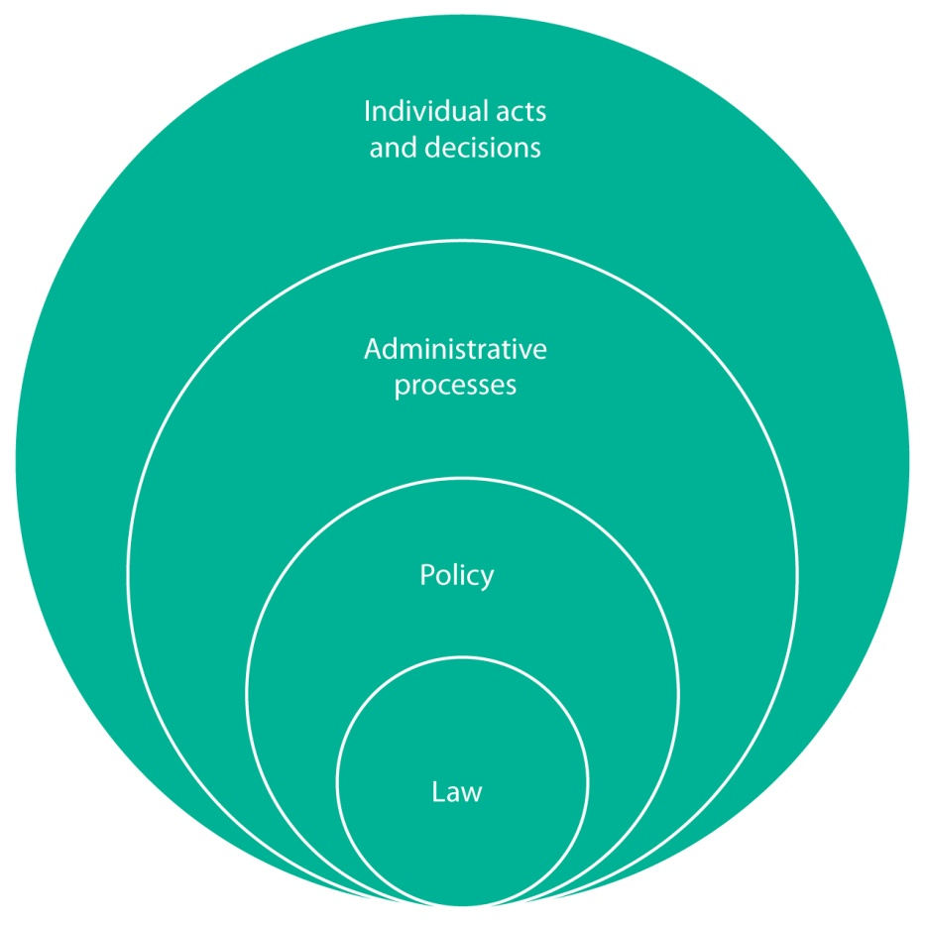
Figure 2: What can our interventions influence in the state sector?
We also carry out work in the international sphere. The long-established New Zealand Ombudsman model is held in high regard internationally. Our assistance is increasingly being sought to help set up and improve Ombudsman-type accountability mechanisms in both the Pacific region and further afield. We aim to provide effective international engagement, advice and guidance where we can, in a way that accords with New Zealand’s international priorities.
The Chief Ombudsman is currently the President of the International Ombudsman Institute and a board member of the Pacific Ombudsmen Alliance, which has a focus on the development of Ombudsman-type accountability mechanisms in the Pacific.
Under this output we will:
- provide advice and comment on legislative, policy and administrative proposals and practices;
- build constructive stakeholder relationships with state sector agencies;
- provide training and support to state sector agencies on how to comply with their obligations under the official information legislation;
- provide guidance and training on good administrative, decision making and complaints handling processes;
- regularly publish information and guidance on our current approach to relevant issues and principles; and
- monitor and assist in the development of international best practice and innovations.
Our performance measures for output E are set out below.
How will we demonstrate our success in providing output E?
Measure | 2011/12  Actual | 2012/13  Actual | 2013/14 |  |  | 2014/15  Budget  Standard | 2015/16  Target | 2016/17  Target | 2017/18  Target
 |  |  | Budget  Standard | Estimated  Actual
Demand driven measures
# of requests for advice or comment by state sector agencies responded to | 100 | 152 | 60-80 |  | 100 | 60-80 | 60-80 | 60-80 | 60-80
# of training sessions provided to stakeholders (amended measure) | 12 | 19 | 20 |  | 34 | 20 | 20 | 20 | 20
Proactive measures
# of guidance materials produced or updated | 10 | 45 | 10-15 | 15 |  | 25 | 25 | 25 | 25
% of participants in Ombudsman external training sessions who report that the training will assist them in their work | 100% | 100% | 95% | 100% |  | 95% | 95% | 95% | 95%
% of agencies which report that they use one or more of the Ombudsman’s information resources currently available | 95% | - | 80% | 100% |  | - | 80% | - | 80%
% of overseas participants receiving Ombudsman guidance and training who report this will assist them in their work (new measure) | - | - | - | - |  | 95% | 95% | 95% | 95%

Output F: Improve public awareness and accessibility of our services
The public needs to be aware of the Ombudsmen and what we can (and cannot) do, to maximise our ability to achieve the outcomes and impacts we have identified in our Strategic Direction.
We undertake a range of public awareness related activities, including making speeches and presentations, publishing information and resources, and maintaining a website so people can access information and resources electronically.
Under this output we will:
- use national surveys to measure the level of public awareness of the Ombudsmen;
- identify and address barriers to accessing our services;
- deliver a nationwide outreach programme aimed at educating the public on our role;
- make information available to reach diverse audiences; and
- maintain and update our website and progressively use social media to enable people to readily access information relating to our work.
Our performance measures for output F are set out below.

How will we demonstrate our success in providing output F?
Measure | 2011/12  Actual | 2012/13  Actual | 2013/14 |  | 2014/15  Budget  Standard | 2015/16  Target | 2016/17  Target | 2017/18  Target
 |  |  | Budget  Standard | Estimated  Actual
Demand driven measure
# of external speeches and presentations given | 23 | 27 | 25 | 24 | 25 | 25 | 25 | 25
Proactive measures
% of members of the public who have heard of the Ombudsman | 69% | 72% | 65% | 69% | 65% | 65% | 65% | 65%
% of complainants who looked at our website | 58% | - | 55% | 64% | - | 55% | - | 55%
% of complainants who found our website useful | 85% | - | 70% | 85% | - | 70% | - | 70%

Managing in a Changeable
Operating Environment
We operate in an environment where our stakeholders have high expectations, and there is an ever-changing demand for our services. Our functions have been progressively expanding over the past decade, and we are also responding to changing models of public service delivery. We discuss below the current operating environment, and our strategies to manage our key risks in this environment.
Our stakeholder expectations
Parliament expects us to:
- act robustly, independently and impartially; and
- provide timely and reliable reports on the administrative conduct of state sector agencies.
The public needs to know (or be able to easily find out) about us, what we do, and how and when to approach us.
Complainants expect a fast, fair, responsive and accessible service, which effectively resolves their concerns.
State sector agencies expect:
- a fair and impartial intervention, which does not impose an inappropriate burden and which provides a useful outcome in terms of improving good administrative practice; and
- effective advice and guidance on areas relevant to our role and the agency’s circumstances.

Expanding functions
Until 2000, our core role was to investigate state sector administration and decision making practices and investigate and review official information decisions. Since then, our role has progressively expanded, to include:
- dealing with requests for advice and guidance about serious wrongdoing;
- inspecting and monitoring places of detention;
- in-depth monitoring of death in custody investigations conducted by the Department of Corrections;
- commenting to the Ministry of Transport on applications for authorised access to personal information on the motor vehicle register; and
- protecting and monitoring implementation of the Disabilities Convention.
We are currently embedding new systems and ways of working to provide these functions. We have also requested additional resources to carry out these functions effectively.
One area in particular for which we have received no additional resource is the inspection and monitoring of aged care facilities with dementia units, to the extent that they may be places in which people are compulsorily detained.
To date we have identified 104 detention facilities to be inspected, not including aged care facilities with dementia units. We are currently able to carry out approximately 30 inspections per year. If we were required to also inspect the estimated 130 aged care facilities with dementia units, our resources would need to increase considerably.
Key risk: Damage to credibility or reputation | Our strategies to manage this risk
We must be seen to be fair, impartial and independent, and to form well reasoned and persuasive opinions. We must also be trusted to safely and securely manage sensitive and confidential information.  There is a risk that poor processes, flawed or inconsistent decisions, or insecure management of information will damage our credibility and reputation.  This would limit the effectiveness of our oversight of state sector administrative conduct and our ability to effect improvements in that respect. | All staff take an oath of secrecy and adhere to a code of conduct.
 | Formal induction and training for staff.
 | An ongoing programme of continuous practice improvement, to identify any professional practice issues that need to be addressed.
 | Mentoring and peer review by senior staff.
 | Guidance and resource material for staff.
 | Office quality standards and quality assurance.
 | Strategic direction by senior staff in identified areas of our work.

Canterbury recovery
We are continuing to see high levels of complaints arising from the Canterbury earthquakes, particularly as people raise their frustrations with delays and decision making in this area. We are receiving complaints against many different agencies involved in the Canterbury recovery, in particular the Earthquake Commission (EQC) and the Canterbury Earthquake Recovery Authority.
We are tracking towards 660 complaints and other contacts received against EQC for the 2013/14 year, making up approximately 6% of the total complaints and other contacts received concerning all agencies. Although trending down from a peak in 2012/13, the continuing high level of intake can be compared with the years before the Canterbury earthquakes, when we received approximately 10 complaints and other contacts concerning EQC per year.

Changing demand for our services
We are also receiving increasingly complex and challenging complaints overall. Changing pressures on different areas in the state sector result in changing levels and natures of complaint to us. In particular, we are receiving increasing numbers of complaints in the official information area. These complaints can raise more complex issues and tend to take longer and cost more to complete than complaints about the administrative conduct of state sector agencies.
Another area of growth is state sector agencies seeking more advice and guidance from us, in particular on the application of the official information legislation, good decision making and effective complaint handling. Such assistance is increasingly becoming a key area of our business, and needs to be appropriately resourced. We are also receiving an increasing number of requests from agencies for organisation wide training to be provided by our staff over multiple sessions and locations.
We are also increasing our focus on interventions relating to significant and systemic issues, both by formal investigation and reporting, and through more informal communication channels with agencies. This reflects Parliament’s request for us to undertake these more general interventions, in particular in the prisons and disability areas, together with our own increasing recognition of the need for such proactive interventions in order to achieve our desired outcomes and impacts. However, to be done effectively, investigating significant and systemic issues is a much more challenging and resource intensive process than individual complaints based investigations.
Key risk: Complaint handling pressures and finite resources | Our strategies to manage this risk
While we will not compromise the quality of our complaint handling process, there is a risk we will not be able to meet stakeholder expectations of the time taken to complete the complaints and other contacts we receive.  Timeliness is often critical to complainants and significant failures in this regard carry the risk that people will choose not to turn to us or, if they do, the outcomes we can achieve will not be relevant, useful or appropriate.  There is also a risk that a need to focus on individual complaints due to the sustained pressures we have in this area will limit our ability to address significant and systemic issues through more general interventions. | Progressive implementation of a revised operating model which realigns our practices to ensure they meet current business needs.
 | Up-front assessment on receipt of complaints, to determine priority, approach and resource allocation.
 | Managed allocation of work.
 | Increased focus on early resolution before investigation.
 | More flexible investigation methods.
 | Structured investigation planning, review and debriefing.

Key risk: Complaint handling pressures and finite resources | Our strategies to manage this risk
 | Formal reporting and oversight of complaints on hand.
 | Formal procedures for reporting and managing unreasonable complainant conduct, to minimise the impact that challenging interactions with certain complainants can have on our staff and resources.
 | An increasing focus on more general interventions to help state sector agencies improve their administrative, decision making and complaints handling processes before complaints arise.

Changing models of public service delivery
In 2012 the Government announced the Better Public Services Programme, with the goal of “a Public Service and State sector that provides better results and improved services with an ongoing focus on value-for-money and innovation”.
The Government has advised that the Better Public Services Programme is expected to deliver:
- agencies working more closely together, and in a fundamentally different way;
- more contestability in service provision and use of alternative providers;
- greater use of technology; and
- greater responsiveness to the needs and expectations of New Zealanders, and a willingness to do things differently.
Change and reorganisation in both central and local government will place new demands on us. People new to public service delivery standards and accountability frameworks may need our advice and assistance, and transitional difficulties or disruptions to service could result in increased complaints.
Key risk: Loss of relevance | Our strategies to manage this risk
To achieve systemic improvements in state sector administrative conduct, we must:  - respond to complaints in a relevant and appropriate way;  - conduct effective inspections and wider administrative improvement investigations; and  - provide useful advice and guidance.  There is a risk that we may be seen as too remote from every day realities, leading to inappropriate or irrelevant responses and guidance. We may also miss significant issues that arise, where more general interventions may be appropriate in addition to taking specific action to resolve a particular complaint. | Environmental scanning, to ensure that we remain connected to, and aware of, emerging trends and issues.
 | Strategic direction by senior staff in identified areas of our work.
 | The introduction of a formalised scoping process when significant and systemic issues arise, to ensure that we can identify and take appropriate action to address wider administrative improvement opportunities.

International environment
We also operate to some extent in the international environment, and must meet expectations in that regard.
Expectations in the international environment
The international community expects us to:
- act robustly, independently and impartially; and
- provide timely and reliable reports to the United Nations on the treatment of people in detention and the implementation of the Disabilities Convention.
New Zealand wants a stable region, with skilled and democratic accountability mechanisms.
The international Ombudsman community wants New Zealand input to international initiatives and access to New Zealand best practice, advice and guidance.
Operating in the international environment is becoming an increasing area of our work. This is especially so given our responsibilities under two international conventions, and the ongoing international interest in the New Zealand Ombudsman model.
Key risk: Loss of international credibility and reputation | Our strategies to manage this risk
There is a risk to New Zealand’s international credibility and reputation if we fail in any respect in our inspection and monitoring roles under international conventions.  In relation to our inspection role, the international community has identified a risk inherent in having “a single institution…to serve both as [National Preventive Mechanism] and as a forum for individual complaints”. | Maintain effective networks and work closely with the other New Zealand and international agencies involved.
 | Strong internal separation between our inspection and general complaint handling roles.

Assessing Organisational Health
and Capability
Our ability to deliver our outputs is essentially centred around the capability of our staff, supported by:
- the internal leadership, management systems and processes we have in place;
- our information and communication technologies; and
- our office accommodation.
The key capabilities we need to deliver our outputs and specific areas of focus during the period 2014-2018 are discussed below.

People
We aim to recruit and retain quality staff who adhere to high standards of professional conduct. We also aim to enhance the capability of our staff so that everyone can aspire to higher levels of performance. Measures to attract, develop and retain staff include:
- providing fair and consistent terms and conditions of employment;
- providing learning and professional development opportunities to enhance capability and performance; and
- providing opportunities for participation in health and wellness programmes that support the general wellbeing of staff.
The specific projects we are undertaking in this area include:
- progressive implementation of a revised performance review and professional development planning system, including the introduction of key performance indicators for staff linked to our outputs and output performance measures;
- progressive implementation of our training and development strategy, which provides for targeted core training and professional development for all staff;
- completing the roll out of consolidated human resource policies and procedures; and
- continuing regular internal surveys to gauge staff satisfaction and identify areas for improvement.

Leadership and management systems
The Office is led by the Chief Ombudsman, supported by the Ombudsman, Deputy Ombudsmen and Controller Finance and Business Services. The Office also has team managers, with responsibility for oversight and formal reporting on the work of their team members.
As part of our revised operating model, managers will be accountable for the performance of their team according to defined and independently assessed performance targets relating to workload, throughput, timeliness and quality.
In 2014/15 we intend to conduct a post-implementation review of our revised business model and workflow processes, to ensure they are meeting our business needs and reflect our overall purpose and strategic direction, and to identify any areas for ongoing improvement.

Technology
We aim to take full advantage of available technology to improve our performance.
We have redeveloped our website and incorporated social media tools such as facebook and Disqus to increase our engagement and the accessibility of information about our role. As part of this project, we have introduced a consistent look to all our resources and communication products, and we are considering how we can use social media to best effect.
During 2014 – 2018, we intend to harmonise and where necessary replace our current information management technologies to support our business needs in multiple jurisdictions. This includes:
- implementation of a new technology platform;
- integration and upgrade of our Office’s legacy systems; and
- an infrastructure upgrade.
We have convened an information management policy and strategy governance committee, charged with developing and maintaining a long term information management and technology strategy, and information management and technology governance and oversight.
The Office computer network is designed as a Wide Area Network hosted on servers in Wellington, with backup systems for disaster recovery.

Capital and asset management intentions
Our capital investment is primarily in the form of information technology equipment and computer software. Capital is otherwise committed to replacing office equipment and furnishings, and leasehold improvements when necessary.
During the period 2014-2018 capital investment projects will include:
- modernising information management support infrastructure, including implementation of a SharePoint technology platform and integration and upgrade of the Office’s legacy systems (funding approved in the 2013 Budget);
- moving to new Wellington office accommodation, to ensure it is sufficient to accommodate our current staff as well as anticipated staffing levels in future years;
- continued refinement of the Office case management system; and
- replacing computer hardware and peripherals on a 4 yearly cycle.

Under the Ombudsmen Act 1975.
Under the Official Information Act 1982 and the Local Government Official Information and Meetings Act 1987.
Under the Protected Disclosures Act 2000.
Under the Crimes of Torture Act 1989.
Under section 241 of the Land Transport Act 1998.
While there are timeframes that agencies must comply with in responding to us under the official information legislation, there are no timeframes in relation to our general investigation role under the Ombudsmen Act.
While there is a statutory duty to comply with our recommendations made under the official information legislation (unless vetoed), there is no duty to comply with our recommendations made under the Ombudsmen Act. Nor are our recommendations under the Crimes of Torture Act binding.
http://www.national.org.nz/Article.aspx?ArticleID=37832
http://www.ssc.govt.nz/better-public-services and http://www.dpmc.govt.nz/sites/all/files/bps/bps-faqs.pdf
As discussed in more detail below, under Managing in a Changeable Operating Environment, Canterbury recovery.
Refer http://www.ssc.govt.nz/kiwis-count
This is based on section 16(1A) of the Ombudsmen Act, which requires a complaint made orally to be put in writing as soon as practicable.
For the reporting years 2011/12 and 2012/13, complaints and other contacts were reported together.
No investigations completed in 2012/13 under the Ombudsmen Act were assessed as requiring urgency. Urgent matters were able to be addressed or resolved without formal investigation.
No investigations completed in 2013/14 under the Ombudsmen Act as at 3 June 2013 were assessed as requiring urgency. Urgent matters were able to be addressed or resolved without formal investigation.
The full introduction of random quality assurance checks has been deferred to the 2014/15 reporting year, largely due to the pressure of work on hand. However, we do have other measures in place to ensure quality, including review of all correspondence by senior staff with delegated authority from the Ombudsmen.
In the 2013/14 year we will complete approximately 300 more complaints and other contacts than we received. This compares to the 2012/13 year when we completed 334 fewer complaints and other contacts than we received, and the 2011/12 year when we completed 377 fewer complaints and other contacts than we received.
As at 30 June 2013, we had 2051 complaints and other contacts on hand. By 3 June 2014, we had reduced that number to 1751 complaints and other contacts on hand.
As at 30 June 2013, only 38% of our open complaints and other contacts were less than 6 months old. As at 4 June 2014, 50% of our open complaints and other contacts were less than 6 months old.
Output B is discussed under Impact 2.
The survey was first conducted in the 2008/09 reporting year. The second survey was due to be conducted in the 2010/11 reporting year, but was deferred to 2011/12 due to the Canterbury earthquakes. The third survey is being conducted in the 2013/14 reporting year.
The Common Measurements Tool is a set of survey questions and scales developed in Canada that allows state services agencies to measure client satisfaction and identify service delivery improvements for service users. By using a common set of questions, agencies are able to compare their performance with other state services agencies, with the Kiwis Count national survey and also measure how they are progressing over time. Refer http://www.ssc.govt.nz/common-measurements-tool.
Refer http://www.transparency.org/whatwedo
Refer discussion above, under Impact 1 - Output A.
The throughput of completed OIA complaints as at 4 June 2014 suggests year end performance will more than double the 2013/14 target. However, the increasing volume of OIA complaints is affecting the number of open files, and it is expected that this will impact on our timeliness.
We assess and prioritise all complaints received, to ensure they have the appropriate resource and oversight applied to complete the matter within acceptable timeframes.
The full introduction of random quality assurance checks has been deferred to the 2014/15 reporting year, largely due to the pressure of work on hand. However, we do have other measures in place to ensure quality, including review of all correspondence by senior staff with delegated authority from the Ombudsmen.
“Employee” includes a former employee, a secondee, a contractor and a volunteer (refer section 3 Protected Disclosures Act for full definition of employee).
“Serious wrongdoing” includes: - offences; - actions that would pose a serious risk to public health and safety or to the maintenance of the law; and - in the public sector context, unlawful, corrupt, or irregular use of funds or resources, and gross negligence or mismanagement by public officials.
Refer to section 2 of the Protected Disclosures Act for the definition of “public sector organisation”.
The Deputy Ombudsmen, General Counsel, and a Principal Advisor.
Given the limited number of matters arising under this output, and the direct involvement of the Ombudsmen and senior staff in dealing with them, we do not conduct internal quality assurance and so do not have a specific measure to demonstrate the quality of our work in this area.
We are not designated to inspect Police detention facilities (this role is carried out by the Independent Police Conduct Authority) or service penal establishments (this role is carried out by the Inspector of Service Penal Establishments).
The internationally accepted standard is for at least 1/3 of inspections and visits to be unannounced. Refer Guide to the Establishment and Designation of National Preventive Mechanisms.
We measure the use by state sector agencies of our information resources biennially through our stakeholder survey, as discussed previously under Impact 1.
Gauged through an annual, nationwide UMR survey, with the first survey conducted in May 2012.
We measure complainant use and satisfaction with our website biennially through our stakeholder survey, as discussed above under Impact 1.
http://www.dpmc.govt.nz/better-public-services/news-and-information and http://www.dpmc.govt.nz/sites/all/files/bps/bps-faqs.pdf
We conduct environmental scanning by: - liaising regularly with Ministers and state sector agencies; - presenting and participating in public forums and speaking engagements; - monitoring media and public opinion in online forums and publications; - obtaining information and feedback from those attending our outreach programmes, and from agency participants at our training sessions; and - carrying out biennial stakeholder surveys.
Guide to the Establishment and Designation of National Preventive Mechanisms, Association for the Prevention of Torture, pp 28-29.
Other assets are replaced on a 5 yearly cycle or when they have reached the end of their useful economic life, except for leasehold improvements which amortise over the term of the lease.

