OPCAT Report
Report on an unannounced inspection of Hawke’s Bay Regional Prison
Under the Crimes of Torture Act 1989
6 July 2017
Peter Boshier
Chief Ombudsman
National Preventive Mechanism

PLEASE NOTE: Page numbers in this accessible Word version differ from the PDF version.
Contents
Foreword 7
Facility Facts 9
Hawke's Bay Regional Prison 9
Region 9
Operating capacity 9
Prison Director 9
Regional Commissioner 9
Last inspection 9
The Visit 10
Visit methodology 10
Inspection criteria (the standards) 10
Evaluation 11
Standard 1: Lawful and transparent custody 12
Assessment 12
Standard 2: Decency, dignity and respect 14
Equality and diversity 14
Accommodation – High Medium (HM) units 14
Cleanliness and hygiene 16
Laundry and clothing 17
Mattresses 17
Accommodation—Hut units 18
Accommodation—Internal and External Self-Care Units 19
Accommodation—Te Whare Oranga Ake (TWOA) 19
Meal times 19
P119—canteen purchases 20
Prisoners’ views on treatment 21
Standard 3: Personal safety 25
Voluntary segregation 25
Deaths in custody 26
At-Risk Unit (ARU) 26
Violence 28
Gang management 29
Standard 4: Health and wellbeing 32
Governance arrangements 32
Physical health 33
Pharmacy 33
Dental provision 34
Mental health 35
Standard 5: Effective and humane exercise of authority 37
Misconducts 37
Security and searching 37
Segregation 38
Use of force 39
Standard 6: Autonomy and protection against mistreatment 41
Confidentiality assessment 41
Complaints process 41
Standard 7: Purposeful activity 43
Activities, work opportunities and programmes 43
Case management 44
Job Expo 45
Remand Prisoners 45
Time unlocked 46
Te Tirohanga 46
Visits and family contact—HM units 47
Visits and family contact—low security units 49
Communications – telephone and mail 49
Standard 8: Preparation for successful return to the community 51
Guided release process 51
Te Whare Oranga Ake 51
Youth Unit 53
Accommodation 53
Routine 54
Decency, dignity and respect 55
Personal safety 55
Effective and humane exercise of authority 55
Autonomy and protection against mistreatment 56
Purposeful activity 56
Visits and family contact 57
Acknowledgements 60
Consultation 60
Publication of report 60
Appendix 1. Summary of recommendations 61
Recommendations—lawful and transparent custody 61
Recommendations—decency, dignity and respect 61
Recommendations—personal safety 61
Recommendations—health and wellbeing 62
Recommendations—effective and humane exercise of authority 62
Recommendation—autonomy and protection against mistreatment 63
Recommendations—purposeful activity and family contact 63
Recommendations—Youth Unit 63
Appendix 2. Corrections’ comments on recommendations which were accepted 65
Appendix 3. Breakdown of prison population 74
Appendix 4. Inspection team (the Team) 77
Appendix 5. Prisoner questionnaire results 78
Section 1: About you 78
Section 2: Respect and dignity 78
Section 3: Complaint process 79
Section 4: Safety 80
Section 5: Health 81
Section 6: Purposeful activity 82
Appendix 5. Good practice 84
Appendix 6. Overview of OPCAT—Prisons 85

Foreword
Hawke’s Bay Regional Prison was opened in 1989. The Prison accommodates male prisoners with security classifications ranging from minimum to high, as well as a growing remand population. It has an operating capacity of 730 and there are plans for an additional 60 beds.
The Prison has increased in capacity over the years and now comprises six high-security units, which are mainly double-bunked, for adult male prisoners. There is a number of 60 and 80 bed low-security hut units, an internal self-care unit, an external self-care unit that was closed at the time of this inspection, two drug treatment units, a Te Tirohanga Unit and a Youth Unit for prisoners aged between 16 and 19 years. The Prison also has a residential reintegrative unit – Te Whare Oranga Ake, one of two such facilities in the country.
The Prison can be described as an institution of two halves, with pronounced differences between the conditions and atmosphere in the high-security units and the low-security areas. The high-security side of the prison presented a number of challenges and areas of serious concern, in particular the fundamental issues of safety and decency. I have made a number of recommendations relating to these matters.
There was a clear and urgent need for the Prison to address the levels of violence and intimidation that are features of too many prisoners’ experience, particularly in the high-security units. I saw no evidence of a gang management strategy, and anti-bullying efforts were ineffective in addressing predatory behaviour.
Limited staff interaction with high-security prisoners and insufficient provision of constructive activities has resulted in an atmosphere of boredom and frustration. The regime for remand accused prisoners remained unsatisfactory, despite the recommendations made by the United Nations Subcommittee for the Prevention of Torture following its visit in 2013.
A further key concern related to basic decency standards. There were shortfalls in the provision of clean bedding and clothing for prisoners and many mattress covers were stained and mouldy. Prisoners in the high-security units were washing clothing in buckets on the wings.
Prisoners reported a number of frustrating inconsistencies in the pricing of canteen goods and articles allowed in their possession. They expressed a lack of confidence in the complaints procedure.
There was a general lack of awareness around less familiar cultures and vulnerabilities. While this was disappointing, it was not altogether surprising given that the Prison does not have an Equality and Diversity Policy. The consequences for prisoners were that a range of differing needs such as religion, gender identity and physical and intellectual disability that were outside the established norms were not routinely met. Efforts were being made to reduce Māori offending, although it was difficult to determine how effective the initiatives were.
I found examples of good practice, particularly regarding the Prison’s efforts to establish itself as a working prison, engaging with potential employers in the community and providing prisoners with information on opportunities through a well-organised job exhibition. The current closure of the external self-care unit due to a shortage of suitable prisoners indicates that these positive efforts towards successful resettlement and reintegration need to be more closely matched with improved prisoner progression arrangements, in order to make best use of the available facilities, and to motivate prisoners to make positive use of their time in custody.
The Prison faces a number of challenges as it strives to contribute to Corrections’ key priorities that relate to reducing reoffending. International best practice indicates that the provision of a safe, decent and fair environment is the essential prerequisite for positive change. I have asked Corrections to implement the recommendations as soon as practicable and report back to me on their implementation within six months. It is my intention to prepare a progress report on the implementation of the recommendations to Parliament and the United Nations.
I will continue to monitor the Prison’s progress with follow-up visits.

Peter Boshier
Chief Ombudsman
National Preventive Mechanism

Back to contents.

Facility Facts

Hawke's Bay Regional Prison
The Prison accommodates male prisoners with security classifications ranging from minimum to high, as well as a growing remand population. It has an operating capacity of 730 and there are plans for an additional 60 beds.

Region
The Prison is part of the Department of Corrections’ Lower North Region.

Operating capacity
730

Prison Director
George Massingham

Regional Commissioner
Paul Tomlinson

Last inspection
Unannounced inspection (Youth Unit) – 2014
Prisoner questionnaire – June 2012
Unannounced inspection (High Medium, the Receiving Office and Separates) – January 2012
Announced informal visit – July 2008
Back to contents.

The Visit
In 2007, the Ombudsmen were designated as one of the National Preventive Mechanisms (NPMs) under the Crimes of Torture Act (COTA), with responsibility for examining and monitoring the general conditions and treatment of detainees in New Zealand prisons.
From 28 November to 4 December 2016, a team to whom I have delegated authority to carry out visits to places of detention under COTA visited Hawke's Bay Regional Prison (the Prison). The inspection team (the Team) consisted of eight inspectors and specialist contractors (see Appendix 4).

Visit methodology
At the commencement of the visit the Team met with the Prison Director before making their way around the site. On the first day of the inspection there were 676 prisoners in the Prison.
A voluntary, confidential and anonymous prisoners’ questionnaire was distributed. The Team spoke with prisoners individually and in groups to explain the purpose of the questionnaire.
Six hundred and forty-six questionnaires were given out and 442 were returned (68 percent). A copy of the questionnaire and responses is at Appendix 5.
The Prison has one of two Youth Units in New Zealand. All inspection criteria standards were applied to the Youth Unit inspection, and I report on the Youth Unit separately at page 52.

Inspection criteria (the standards)
I have developed eight core inspection standards, each of which describe the standards of treatment and conditions a prison is expected to achieve. These standards are underpinned by a series of indicators that describe the evidence inspectors look for to determine whether there is anything that could be considered to be torture, or cruel, inhuman or degrading treatment or punishment, or any other issues impacting adversely on detainees. The list of indicators underpinning the standards is not exhaustive, and does not exclude an establishment demonstrating that the expectation has been met in other ways.
This was the first full inspection undertaken using my new inspection standards. These standards will continue to be trialled and refined as necessary.
On completion of the trial I will publish the final standards on the Ombudsman’s website.
The following standards were examined during the seven-day inspection:
- Standard 1: Lawful and transparent custody
- Standard 2: Decency, dignity and respect
- Standard 3: Personal safety
- Standard 4: Health and wellbeing
- Standard 5: Effective and humane exercise of authority
- Standard 6: Autonomy and protection against mistreatment
- Standard 7: Purposeful activity and family contact
- Standard 8: Preparation for successful return to the community.

Evaluation
Inspectors assist me to assess information resulting in evidence-based findings, using a number of different techniques. These include:
- obtaining information and documents from the Department of Corrections and the Prison;
- conducting a questionnaire of prisoners;
- shadowing and observing Corrections Officers and other specialist staff as they perform their duties within the Prison;
- interviewing prisoners, visitors and staff on a one-to-one basis;
- conducting focus groups with prisoners and staff;
- observing the range of services delivered within the Prison at the point of delivery;
- inspecting a wide range of facilities impacting on both prisoners and staff;
- attending and observing relevant meetings impacting on both the management of the Prison and the future of the prisoners, such as case conferences;
- reviewing policies, procedures and performance reports produced both locally and by the Department of Corrections; and
- observing early morning, evening and weekend routines.
Follow-up visits will be made on future dates as necessary to monitor implementation of my recommendations.
Back to contents.

Standard 1: Lawful and transparent custody
Expected outcomes—lawful and transparent custody
- The Prison complies with administrative and procedural requirements of the law. The Prison takes appropriate action in response to the findings and recommendations of official bodies that exercise supervisory jurisdiction over it.

Assessment
Inspectors found that reception of prisoners took place in a well-designed, modern facility that enabled staff to carry out their role effectively. The Receiving Office (RO) was clean and bright and the provision of chalk boards and chalk in holding cells had proved highly effective in almost eliminating graffiti and tagging. The inspection team noted that the projected increase in muster will place additional pressures on processes to ensure safe, secure movement of prisoners, and storage and control of their property.
The systems and procedures for the admission and release of prisoners were implemented effectively. The range of information collected prior to a prisoner’s arrival was comprehensive and contributed to their safe reception and management. Inspectors witnessed the arrival procedure for a first offender, which was conducted with appropriate sensitivity and understanding. Co-ordination with nursing staff was good.
Inspectors also witnessed arrangements for audio-visual links (AVL) for a range of Court hearings and found them to be satisfactory. The benefits for prisoners and the Prison were obvious in reducing the number of movements to Courts for what have often proved to be very brief appearances with all the associated disadvantages for prisoners, escorting staff and the Courts.
Staff working in the RO were part of a wider group that were used to cover Courts, perform escorting duties and carry out AVL hearings. They reported that they enjoyed the diversity of the role.
Lengthy delays in access to personal property were a source of frustration for many prisoners. RO staff were aware of the issues and motivated to improve the service, while seeking to balance urgent demands on their time with important issues and other priorities.
The Prison used to have a ‘Gateway Unit’ where new arrivals were held overnight in designated accommodation, or longer if necessary, to ease their transition into custody and where they could be more closely supervised. Inspectors were told that this practice had lapsed due to the increase in the prison population. Consequently, arrangements for dealing with immediate and urgent first-night needs such as telephone calls, providing information on prison routines and issuing essential toiletries, took place in the accommodation units, which were typically busy environments. One prisoner who was admitted on the first day of the inspection did not get to make a phone call to his family for three days.
Given the expected increase in muster, the lack of assurance around meeting prisoners’ immediate needs and induction requirements, a dedicated first-night facility would be beneficial for prisoners.
Recommendations—lawful and transparent custody
- I recommend that:
  - Arrangements for prisoners to access personal property be improved.
  - First night in custody arrangements, as previously offered by the Gateway Unit, be reintroduced, and an assurance process developed to assess and improve the effectiveness of the induction process in meeting prisoners’ needs and entitlements.

Corrections has accepted recommendations 1a and 1b.
Back to contents.

Standard 2: Decency, dignity and respect
Expected outcomes—decency, dignity and respect
- The Prison employs fair processes whilst ensuring it meets the distinct needs of all prisoner groups irrespective of age, disability, gender and sexual orientation, marriage and civil partnership, pregnancy and maternity, race, religion and belief.
- The Prison supplies the basic requirements of decent life to the prisoners.
- A climate of mutual respect exists between staff and prisoners.

Equality and diversity
The Team found that the Prison did not have an Equality and Diversity Policy. Generally, staff did not demonstrate an awareness or understanding of how equality and diversity issues might be addressed. Consequently, a range of needs related to religion, gender identity and physical and intellectual disability that were outside the established norms were not routinely met.
Inspectors identified a number of occasions where prisoners’ physical disabilities were not being appropriately managed. For example, a prisoner with significant mobility issues had difficulty moving around his cell, including accessing the toilet which had no disability adaptations.
Forty percent of prisoners stated they could not access religious services and 57 percent of prisoners stated they could not access cultural activities. Prisoners with religious requirements relating to food had not been assured by the Prison that food was prepared appropriately, despite asking for assurance.
Staff did not appear to be aware of Corrections’ policy relating to transgender prisoners, although a prisoner who identified as transgender was at the Prison at the time of inspection.
Back to contents.

Accommodation – High Medium (HM) units
The HM units, which contain three wings, were generally dull, scruffy and grey, reflecting not only the concrete construction but also the environment and atmosphere. Widespread evidence of tagging and gang symbols added to the run-down appearance. Cells were quite small and extensive use of double-bunking added to cramped conditions and wear and tear on the fabric and facilities. With few exceptions, cell standards were poor and exuded a scruffy, unkempt appearance with unmade beds, improvised curtains, lightshades and floor coverings, and cardboard boxes for storage of personal effects.
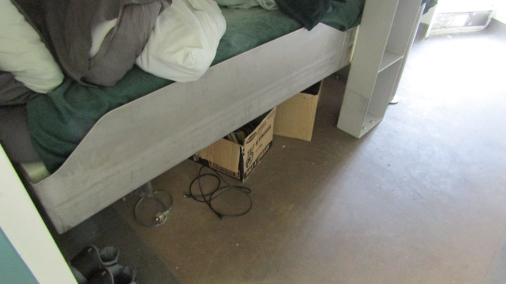 |  | 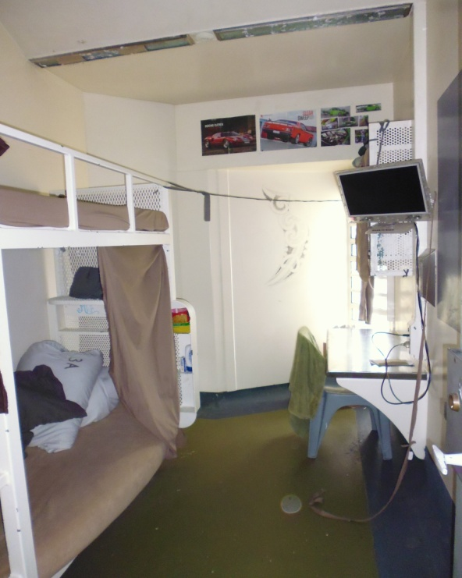
Figure 1: Double cell – storage area |  | Figure 2: High-security cell
Communal areas on each of the HM wings consisted of metal benches and tables, a telephone, an information kiosk, a notice board and a small adjoining internal yard. Prisoners were visibly cramped in the communal areas as wings originally designed to accommodate eight prisoners were double-bunked and housed up to 16 prisoners.
Limited facilities for interviews and meetings meant that confidentiality and privacy were regularly compromised.
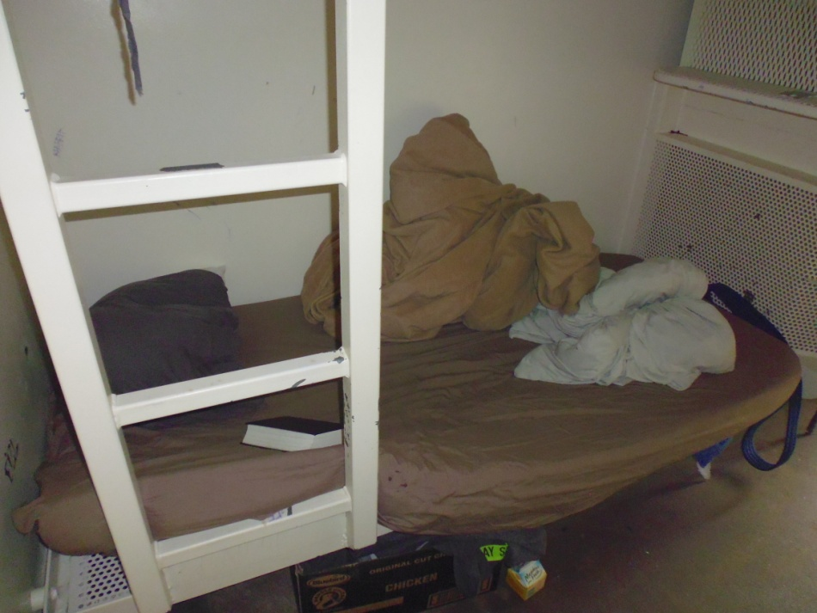 |  | 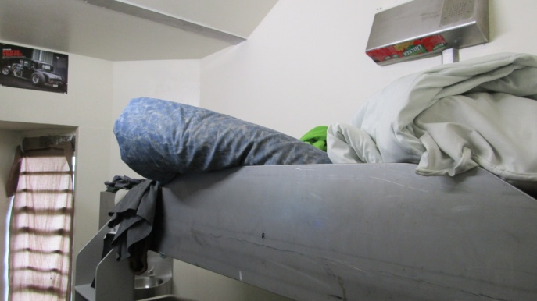
Figure 3: High-security cell - bottom bunk |  | Figure 4: High-security - top bunk
External exercise yards were reasonably large concrete yards with a wire-mesh roof covering and some seating and shelter. Not all drinking water fountains in external exercise yards worked.
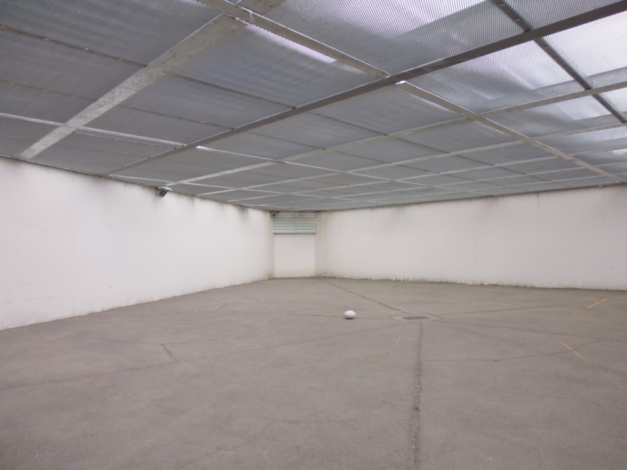 |  | 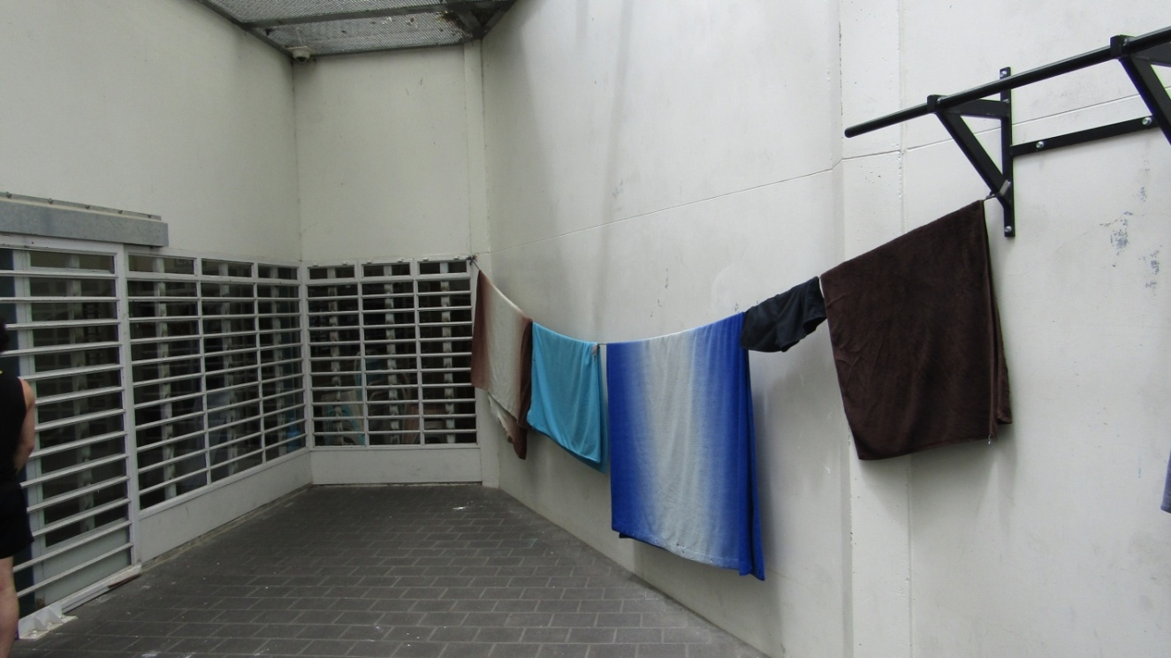
Figure 5: High-security external yards |  | Figure 6: High-security internal yards
Back to contents.

Cleanliness and hygiene
It is acknowledged that creating and maintaining a clean, ordered and hygienic environment is a shared responsibility between staff and prisoners, but prisoners do not have the primary responsibility or control of resources to achieve the necessary standards.
Staff seemed to be too busy on other tasks to spend much time in the wings engaging with prisoners and carrying out routine security and cleanliness checks. Consequently prisoners were left to their own devices for lengthy periods of their unlock time. While there were good lines of sight and CCTV monitoring of the wings from the staff base, dynamic security depends on frequent staff and prisoner interaction.
Access to showers and toileting facilities was good, although prisoners complained about the lack of disinfectant to prevent fungal infections such as athlete’s foot. Many prisoners stated that they were not provided with footwear on arrival.
Back to contents.

Laundry and clothing
Some prisoners did not have sheets or pillows and had been largely unsuccessful in their efforts to obtain them. Seventy-two percent of prisoners reported that they did not receive sufficient clean clothing and 44 percent reported not having clean sheets each week.
Laundry arrangements for prison issue clothing (kit) and bedding delivered a same-day service three times per week. However, clothing shortages, particularly for the most popular sizes, and inadequate stock control measures meant arrangements were not effective. A high number of prisoners told inspectors that they preferred to wash their prison issue clothing in a bucket rather than send it to the laundry as they said it would not be returned to them. They claimed that other prisoners substituted worn and torn clothing and kept the better kit for themselves.
Arrangements for washing prisoners’ own clothing such as underpants, socks and shorts were inadequate. Prisoners were highly critical of the situation and frustrated at the lack of progress. Inspectors were pleased to learn that a draft project plan had been drawn up to improve the situation and will watch developments with interest.
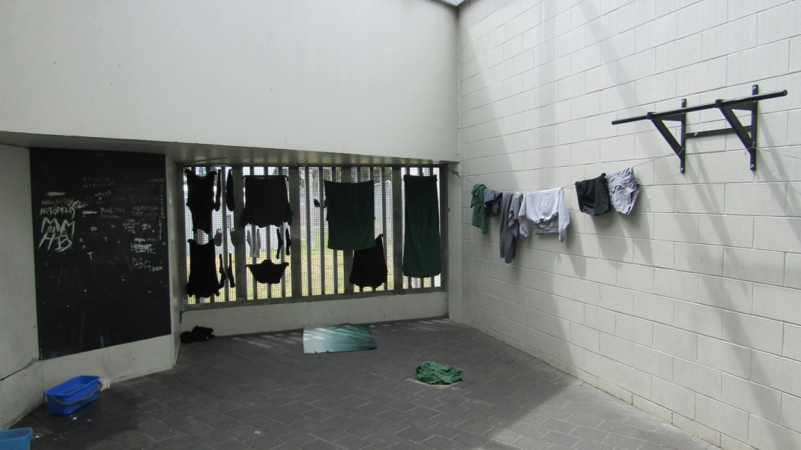 |  | 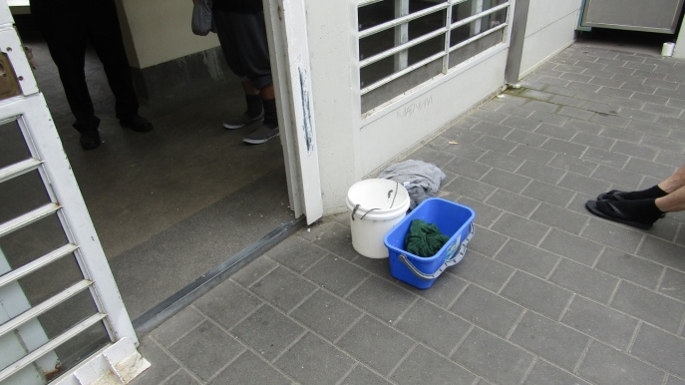
Figure 7: HM unit – improvised laundry |  | Figure 8: HM unit – improvised laundry
Back to contents.

Mattresses
Too many mattresses were in a poor state, stained, torn and worn thin, which indicated systemic weaknesses in the Prison’s process of inspection and replacement. Some prisoners had acquired three or four mattresses for their bed, which they stated was still inadequate. The Laundry Officer showed inspectors the inside of some mattress covers, which remained stained and apparently mouldy after they had been laundered. A number of locally produced mattresses, which the prisoners called ‘pink batts’ due to their similarity to wall insulation, had been manufactured as a pilot project to improve the situation. It would be prudent to obtain advice about the use of such mattresses in a residential, custodial setting for health and safety purposes.
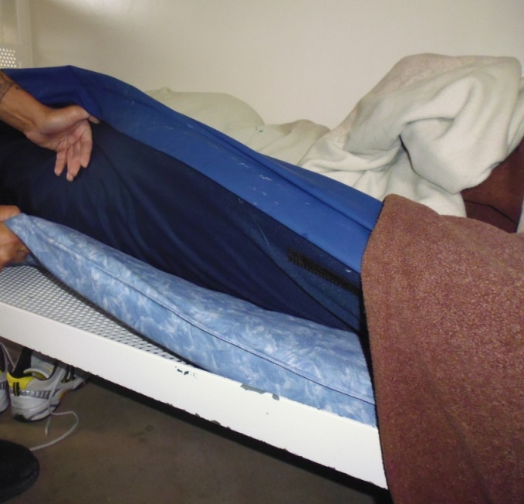 |  | 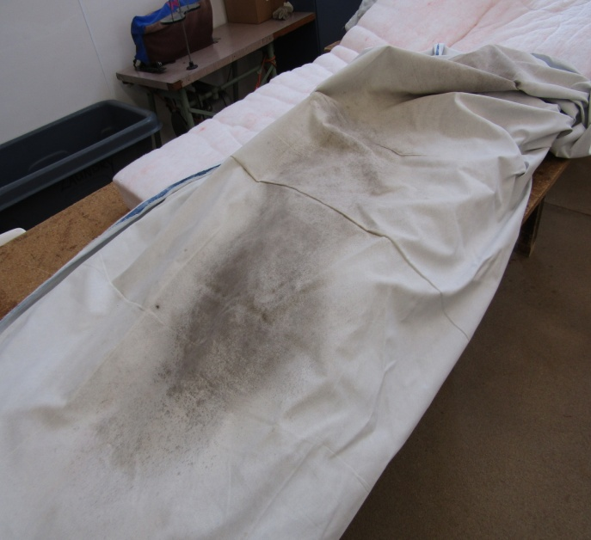
Figure 9: Multiple mattresses |  | Figure 10: Laundered mattress cover
Back to contents.

Accommodation—Hut units
Accommodation and facilities in the low-security units were generally of a higher standard. Cell standards were better, although Unit 7 cells were still in a generally poor state of repair following damage that occurred during a change of status from mainstream prisoners to voluntary segregation prisoners some eighteen months ago. Prisoners had made repeated requests to pursue improvements with little success.
One area of concern was excessive heat and a lack of ventilation in the cells, especially north facing cells in summer. Prisoners were frustrated by what they perceived to be a lack of interest and action to address the issue and voiced a degree of irritation that they were unable to purchase effective fans through the canteen (P119 system). It was reported that cold water taps were often run for prolonged periods in an attempt to lower the temperature in the cells, which occasionally resulted in flooding. The situation was expected to get worse over the Christmas and New Year period when the Prison operated a site-wide 8am to 5pm routine, meaning that low security prisoners would be locked up two hours earlier than normally.
Laundry arrangements in the low-security units were much better and the inspection team received fewer adverse comments from prisoners.
Back to contents.

Accommodation—Internal and External Self-Care Units
Accommodation and facilities in the Internal Self-Care Unit were of a high standard. The self-contained villas were clean and tidy and the prisoners had planted vegetable gardens to supplement their food, which they shopped for and cooked themselves. It was notable that the prisoners in Internal Self-Care all rated the meals as very good.
The external Self-Care Unit, which can house up to 20 prisoners, was closed at the time of the visit. Inspectors were informed that changes to suitability criteria for temporary release had reduced the number of prisoners eligible for the external Self-Care Unit, resulting in its closure.
The closure of the external Self-Care Unit at the Prison inhibited prisoners from following a clear rehabilitation and reintegration pathway. Motivated and engaged prisoners in the internal Self-Care Unit were frustrated at the removal of opportunities to demonstrate and support their rehabilitation through progression to the external unit. This frustration was echoed by Corrections staff.
Back to contents.

Accommodation—Te Whare Oranga Ake (TWOA)
Accommodation and facilities in the TWOA were of a similar standard to those in the internal Self-Care Unit. Prisoners appreciated the degree of freedom and opportunity they had to exercise personal responsibility and the opportunity to look forward to and prepare for release.
Back to contents.

Meal times
Rule 22 of the United Nations Standard Minimum Rules for the Treatment of Prisoners (the Nelson Mandela Rules) states:
Every prisoner shall be provided by the prison administration at the usual hours with food of nutritional value adequate for health and strength, of wholesome quality and well prepared and served. (emphasis added)
Meal times across the Prison did not reflect standard meal times. Inspectors observed breakfast being issued in HM A at 9.15am, and lunch delivered to the units around 11am, issued to and eaten by prisoners before they were locked up by 11.45am. The evening meal was delivered to the units as early as 2.55pm and was issued and eaten on some units at 3.30pm. All meals in the HM units were eaten before prisoners were locked up by 4.25pm. Notwithstanding the two slices of bread and margarine issued with the evening meal to serve as supper, it was a very long time between the evening meal and breakfast.
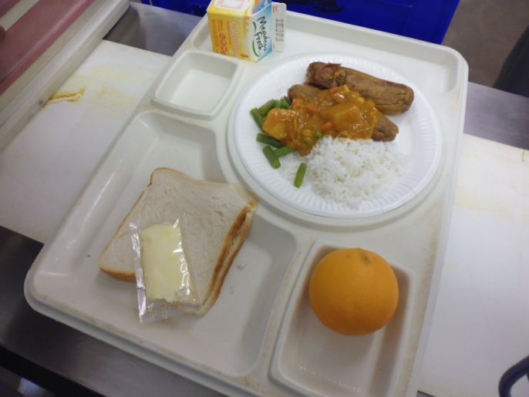 |  | 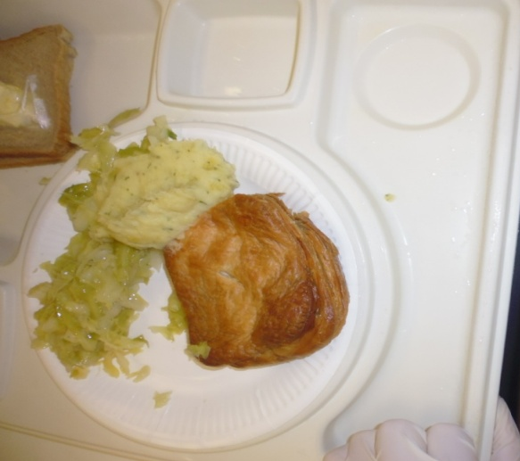
Figure 11: Standard dinner |  | Figure 12: Standard dinner
Dinner was provided on paper plates, which do not retain heat. Meals were no longer hot following transportation from the central kitchen to accommodation units, although kitchen staff reported that there have been no complaints of meals arriving cold.
Food was the subject of some criticism, with 39 percent of prisoners stating that the food was either bad or very bad. Inspectors were disappointed to observe that prisoners did not all have a cup and many had to resort to using milk cartons and other improvised containers. The inspection team could get no satisfactory explanation for this state of affairs.
Prisoners commented on the absence of jugs or thermos flasks in the Prison, which were provided or allowed in other prisons. Noodles were a very popular item on the P119 canteen list and widely used to supplement the meals. It was a source of frustration for prisoners that they did not have access to hot water after lock up to make themselves a snack or hot drink.
Back to contents.

P119—canteen purchases
Prisoners were especially vocal and consistent in their criticism of the P119 canteen system and prices. They had raised complaints, but were often dissatisfied with the responses they received. A brief comparison of a sample of products and prices is shown below.
Table 1: Canteen price comparison
Product | Hawke’s Bay Regional Prison | Waikeria Prison | Arohata Prison | Manawatu Prison
Instant Coffee (90g) | $6.00 | $2.75 | $2.75 | $4.25
Beef Noodles (5Pack) | $4.00 | $2.40 | $2.40 | $2.75
Powdered Milk | $8.50 | $8.00 | $8.00 | $7.95
Salt and Vinegar Chips | $3.30 | $2.15 | $2.15 | $2.85
Cream Biscuits | $4.00 | $3.60 | $3.60 | $4.00
Porridge | $4.00 (750g) | $3.65 (850g) | $3.65 (850g) | $4.90 (850g)
Inspectors raised prisoners’ concerns with the Prison Director who explained that when the Prison invited tenders to supply canteen goods, only one tender was received from a local supplier. Given the difficult financial circumstances of so many prisoners and their families, the limited opportunities to earn a wage in the Prison and the relatively low wages in comparison to prices, it was a concern that such wide variation in prices was tolerated.
Eighty-five percent of prisoners claimed the P119 was not meeting their dietary needs, citing too much sugar and salt and not enough protein in the food on offer.
Inspectors asked about access to jugs and flasks for prisoners and were told that they were not allowed at the Prison, which is inconsistent with prisoners’ experience in other prisons.
Back to contents.

Prisoners’ views on treatment
In the prisoner questionnaire, 71 percent of prisoners reported that there was a member of staff they could turn to for help. However, in the HM units only 56 percent of prisoners reported that they could approach a member of staff if they had a problem. Inspectors attributed this to the low levels of interaction between staff and prisoners on the HM units.
Seventy-four percent of prisoners stated that they were treated with respect by most staff.
Access to fresh air under sections 69(1)(a) and 70(1) of the Corrections Act 2004, prisoners (other than those engaged in outdoor work) are entitled to a minimum of an hour of physical exercise, in the open air if the weather permits.
Easy access to fresh air was a feature of the daily routine in the low-security units in the Prison. In most of the HM units, prisoners were typically unlocked after 8am and could spend their time in the internal exercise yard, which was a well-ventilated space. Daily routines were posted on prisoners’ notice boards and informed when prisoners would be allowed access to the larger external yards.
In HM A, the Prison operated up to six separate regimes. Providing access to fresh air was described as a challenge by staff, who could not provide assurance that prisoners were receiving their minimum entitlement.
Prisoners in the At Risk Unit (ARU) were not always allowed to spend an hour in the fresh air, due in part to the difficulties associated with operating a number of discrete regimes for different prisoner groups.
Recommendations—decency, dignity and respect
- I recommend that:
  - An Equality and Diversity Policy that ensures all prisoners’ rights are recognised and respected be implemented as a matter of urgency.
  - Worn and damaged mattresses and prisoner clothing are replaced and improvements made to ensure all prisoners have appropriate access to sufficient clean clothing and bedding.
  - Effective processes are implemented to ensure housekeeping, hygiene and cleanliness standards are improved and performance monitored.
  - Arrangements to improve ventilation in Hut units are implemented and monitored to ensure appropriate standards are consistently achieved.
  - Serving times of meals are standardised to normal hours, particularly on units that are not running an 8am to 5pm regime. This would involve lunch being served any time between midday and 1.30pm, and dinner to be served any time between 5pm and 7pm.
  - Prisoners have access to hot water after lock up to make themselves a hot drink. All prisoners are provided with cups.
  - Arrangements for the prisoners’ canteen (P119) be reviewed. As a standard, prices should be comparable with prices in the community.
  - All prisoners are able to spend at least one hour each day in the fresh air.

Corrections advised that it ‘partially accepted’ recommendation 2a. It noted that a working group has been initiated and a diversity and equality strategy will be developed by April 2017. It also stated that while Corrections does not presently have an equality and diversity policy, provisions are included throughout other policies.
Corrections accepted recommendations 2b, 2c and 2g.
Back to contents.
Corrections rejected recommendation 2d, and stated:
Corrections does not accept the criticisms in the Draft Report, but has reviewed, and will continue to review, the ventilation systems.
The Prison Director has reviewed the ventilation throughout the prison:
- The High Security areas have a forced air ventilation system.
- Low Security areas have windows.
- Self Care and Whare Oranga Ake have windows and air con/heat pumps.
Corrections’ property and facilities team will review the current system and provide a report on any areas that require maintenance or upgrade.
Prisoners are able to purchase fans through the canteen system. The national policy also allows prisoners to apply for a subsidy if they are not able to afford to purchase a fan themselves.
I note the ability to purchase fans through the canteen system does not address prisoner concerns that the fans purchased through the canteen were not effective.
Corrections rejected recommendation 2e, and stated:
Corrections considers the current meal times to comply with section 72 of the Corrections Act 2004, which stipulates that every prisoner is provided with ‘a sufficient quantity of wholesome food and drink based on the food and nutritional guidelines for the time being issued by the Ministry of Health’. There is no reference to the times food is served; rather, the focus is on quality and quantity. The current menus were developed with input from the Ministry of Health, Diabetes Life Education and the Heart Foundation in consultation with a clinical dietician.
Corrections are of the view that concerns about hunger between dinner and breakfast are mitigated by the provision of a sufficient quantity of nutritional food, the provision of supper with the evening meal, and the ability of prisoners to purchase additional food items to sustain them if necessary. It is the prisoner’s choice as to when they consume their supper; it is intended to be consumed between dinner and breakfast.
Corrections considers the current meal times at the Prison meet its operational requirements whilst taking into account staffing levels.
I note that while the Corrections Act does not stipulate the timing of meals, the Nelson Mandela Rules require food to be served at the ‘usual’ time. I consider it inappropriate for meals to be served at non-standard hours.
In commenting on recommendation 2f, Corrections stated:
This recommendation is not necessary as to the provision of cups. Reusable plastic cups are offered to prisoners when they enter the units and disposable cups are offered at meal times.
While this may be Correction policy, my inspectors' observations appear to demonstrate that it does not operate satisfactorily in practice. As stated above, a number of prisoners were without cups and had had to fashion themselves drinking vessels out of items such as milk cartons.
Corrections made the following further comments in response to recommendation 2f:
Corrections is vigilant about the provision and use of hot water at prisons due to the safety risks to prisoners and staff. The topic has been reviewed at a national level so that the needs of prisoners are balanced with the need to maintain safety.
Hot water is available in Low Security units via personal kettles. Prisoners in high security units have access to clean, hot (but not boiling) water prior to lockup. The Prison Director has restricted the provision of boiling water to high security prisoners due to the safety risks to the prisoners and staff.
Corrections has not addressed the central issue of inconsistency in practice across prisons in regard to access to hot water for high security prisoners.
Corrections did not accept recommendation 2h, and stated:
As observed [in] the Draft Report, it will not always be feasible to provide prisoners in an At Risk Unit (ARU) with an hour in the fresh are every day. To that extent, Corrections cannot accept this recommendation.
However, the Prison Director intends to investigate any ‘challenge’ to providing fresh air to other prisoners.
In response to Corrections comments, I emphasise that an hour of exercise, in the open air weather permitting, is a minimum legal entitlement under sections 69(1)(a) and 70 of the Corrections Act. There is no provision under the Act for this to be derogated from for operational reasons. Neither at risk prisoners nor other prisoners may be deprived of this right.
Back to contents.

Standard 3: Personal safety
Expected outcomes—personal safety
- The Prison takes all reasonable steps to ensure the safety of all prisoners.

Voluntary segregation
A significant proportion (29 percent) of the prisoner population had requested voluntary segregation (VS) under Section 59 of the Corrections Act 2004. It was generally held by staff and prisoners that not all prisoners on VS were particularly vulnerable and there was evidence of hierarchies within these groups of prisoners. At the time of the inspection 22 percent of low-security prisoners on voluntary segregation reported that they currently felt unsafe.
Inspectors were advised that difficult to manage prisoners on voluntary segregation could have their status reviewed and be returned to the mainstream units.
Inspectors noted that staff appeared to be busy with a range of tasks that precluded them from spending much time in the wings supervising prisoners, an inevitable result of which was to provide opportunities for bullying and standovers. Inspectors did not see evidence of an effective anti-bullying strategy; staff and prisoners advised that the default response to bullying was to ask for voluntary segregation.
As noted earlier, the Prison used to operate a Gateway Unit for new admissions but this had been discontinued due to muster pressures. Consequently, new admissions were dispersed within the Prison according to their category (remand accused, remand convicted, sentenced), security classification and risk. While an induction process was in place in the various units and a record of delivery made, more needed to be done to ensure that the processes were effective in providing prisoners with adequate clothing, toiletries, bedding, necessary information and access to support networks at a time of heightened anxiety and dislocation.
In commenting on the draft report, Corrections stated that it does not accept that voluntary segregation is being misused.
Our finding that voluntary segregation operates as a default response to bullying and standovers does not intend to suggest that voluntary segregation is being ‘misused’, but rather that a broader, preventative, approach to the issue of bullying is warranted to minimise the need for voluntary segregation requests.
Back to contents.

Deaths in custody
At the time of inspection there had been two deaths in the Prison in the previous two years, both of which were awaiting Coroner’s hearings. One was apparently due to natural causes; the other was an apparent suicide. Corrections’ Prison Inspectorate carried out investigations into both incidents.
Back to contents.

At-Risk Unit (ARU)
The ARU, conveniently located next to the Receiving Office and Health Centre, was sparsely furnished with limited communal space and cage-like exercise yards. Inspectors were surprised to find that, as a matter of course, prisoners who expressed thoughts of self-harm were initially located in one of the four dry rooms before moving to an at-risk cell. It was not clear why this was considered necessary in every case, although it was suggested by staff that the aim was to not make the prisoner’s experience in the ARU too comfortable, so they would return to mainstream units earlier.
In common with other ARUs, prisoners were constantly monitored by CCTV, even when using the toilet, which was unscreened. The camera feed was displayed on TV monitors in the respective unit office and master control. The monitors could be viewed by anyone entering the office and presented a significant privacy issue. Corrections’ policy for toilets in ARU cells to be unscreened gave prison staff (and others) the ability to observe prisoners, either directly or through camera footage, undertaking their ablutions or in various stages of undress. I consider this amounts to degrading treatment or punishment for the purpose of the Convention Against Torture. However I note that Schedule 2 Part C of the Corrections Regulations provides that cells for prisoners at risk of self harm must have ‘no privacy screening or other barrier that prevents a full view of the cell from the door window’, which constrains Corrections ability to fully address this issue.
Corrections has agreed to set up a comprehensive working party to address balancing the privacy rights of prisoners with prisoner observation, and engage with the Office of the Ombudsman to this end. I consider that amending Schedule 2 Part C should be considered in the context of this working party.
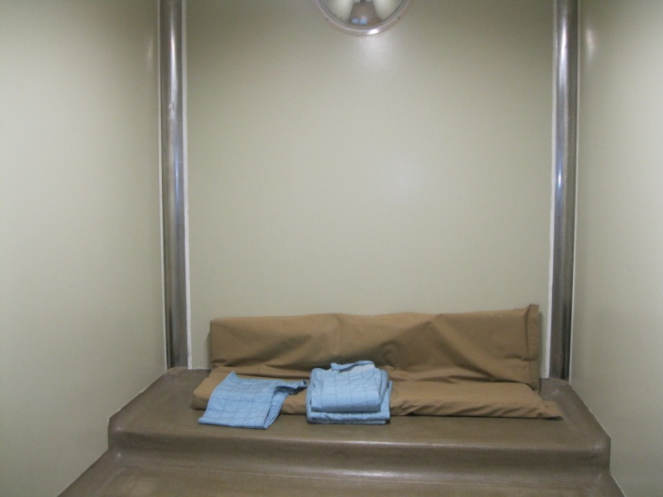 |  | 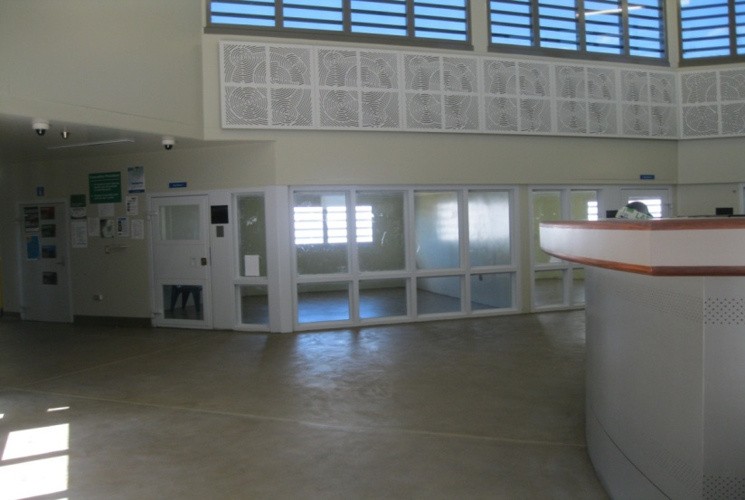
Figure 13: ARU - dry room |  | Figure 14: ARU - day room
Inspectors were pleased to observe a degree of flexibility in the care of such vulnerable prisoners; following a risk assessment, prisoners were allowed a limited degree of association and were allowed to wear clothing other than the rip-proof clothing which was the default (and often the only) option in other prisons.
Completed At-Risk Management Plans (M.05.03 Form 2) were identical in many instances, regardless of security classification or level of observation, and the section relating to specialist support was blank in most cases. Prisoners were not involved in the formulation of their management plan and did not receive a copy of the plan on its completion. A weekly multi-disciplinary team meeting took place to discuss the at- risk population. Prisoners did not attend these meetings, which seemed to be a missed opportunity.
Daily observation sheets lacked meaningful entries, such as when prisoners were engaged in activities outside their cells (showers, yard and telephone). There was clear evidence that when the Unit was full, not all prisoners received their minimum entitlement to one hour exercise in the open air.
In addition to providing a safe environment for prisoners assessed as being at risk of self harm or suicide, the ARU was used for the management of a range of behaviours, due to the lack of a Management Unit.
Prisoners who had been the subject of use of force were located in a dry room and remained there until they settled down and arrangements made for their relocation, which could take some days.
At the time of the inspection, one prisoner had been detained under Section 60 of the Corrections Act for four days on suspicion of concealing a ‘sim card’.
A prisoner with an intellectual disability (but not considered to be at risk) was waiting for a bed in the forensic service. He was remanded until March 2017 and staff thought that the ARU was the safest place for him. Inspectors acknowledged the pragmatism behind his placement and were impressed by staff efforts to manage him sensitively, but did not consider that the ARU was an appropriate environment for him. Staff advised that this was not the first time a prisoner with intellectual disabilities had been placed in the ARU. There was also one prisoner placed in the ARU while awaiting deportation.
Operating multiple prisoner regimes placed strain on the capacity of staff to deliver minimum entitlements and limited opportunities for positive interactions with prisoners at risk of self harm, which inspectors were told was to be a feature of a revised at-risk process.
The stated purpose of an ARU is to enable the observation and safe management of prisoners at risk of harming themselves. Its purpose was compromised by the placement of prisoners requiring a period of segregation for management purposes and was deemed detrimental to prisoners with severe mental health issues.
Back to contents.

Violence
Analysis of the returned questionnaires indicated that violence and bullying were significant issues in the Prison, and were not confined to the HM units. Two hundred and four prisoners (43 percent) stated that they had been assaulted in the Prison, with one in three assaults being unreported. While 48 percent of prisoners in the HM units stated that they had been bullied, the overall percentage for the Prison was 53 percent, suggesting that bullying was slightly more prevalent in the low-security areas. Similarly, 60 percent of the prisoners reported feeling unsafe at some time in the Prison with 29 percent reporting that they currently felt unsafe, including prisoners in voluntary segregation.
Corrections carried out an analysis of prisoner on prisoner violence (PPV) as part of their review of controls to prevent prisoner violence following events in Mount Eden Corrections Facility (MECF) in 2015. The Prison was one of eight similar prisons included in the review that looked at reported PPV over a four-month period. The overall rate of reported violence in the Prison was second highest, with a total of 99 violent events. The Prison also had the highest rate of notifiable incidents of violence (61) for that period. The Prison’s Violence Reduction Strategy did not appear to be effective.
While observing the daily routine from the staff base, inspectors witnessed prisoners sparring and conditioning on four occasions, three of which were brought to the notice of staff in the unit. Prisoners were then ordered to stop, which they did. It appeared from the prisoners’ response that the practices of sparring and conditioning were normally tolerated to a greater degree. This appeared to be contrary to the findings of the Corrections’ review of the adequacy of controls to prevent prisoner violence following events in MECF, where it was asserted that Prison Directors had given clear direction that sparring and similar activities among prisoners would not be tolerated and those involved in any such incidents would be subject to misconduct charges.
File note entries, incident reports and misconduct charges relating to the notified events were not completed. However, on another occasion, inspectors did see staff take prompt action to stop prisoners crashing into each other in the internal yard; it was disappointing that a note of the event was not made at the time.
Staff were often busy on a range of administrative tasks that precluded their interaction with prisoners to achieve an orderly and appropriately controlled environment. There also appeared to be reluctance by some staff to enter wings and engage with prisoners. Cells were typically unlocked and prisoners allowed free association in the wings with minimal supervision. While it was explained that the layout of the high-security units allowed a good level of supervision from the staff base, inspectors are aware of the findings of the Corrections’ review of controls to prevent prisoner violence: leaving prisoners unlocked and unsupervised for long periods, with access to unlocked cells, provides opportunities for organised fighting and bullying to occur.
Back to contents.

Gang management
It is universally accepted that there is a correlation between gang membership, criminal behaviour, imprisonment and reoffending. The main gangs represented in the Prison at the time of the inspection were:
Table 2: Gang numbers
Gang | Numbers
Mongrel Mob | 171
Black Power | 99
Killer Beez | 7
Head Hunters | 6
Others | 71
Total | 354

About 50 percent of the population in the Prison claimed some gang affiliation. The influence of gangs was most obvious in the HM units and, as mentioned earlier, was not confined to the mainstream regime, nor was it absent in the low-security units. The Prison operated a harmony regime in some of the low-security units where prisoners undertook to put aside rivalries and subscribe to a set of agreed behaviours.
Corrections has long recognised that ‘offenders who are gang members are reoffending at higher rates than non-gang affiliated offenders’ and have identified them as a particular focus for intervention. However, the inspection team found no active gang management strategy in place and was given to understand that this situation was not unique to Hawke’s Bay Regional Prison. Inspectors were informed that work was being done to develop and introduce a National Gang Strategy.
Recommendations—personal safety
- I recommend that:
  - The Prison develop and implement an anti-bullying strategy and gang management strategy that sits alongside the Prison’s violence reduction strategy; this to include identifying where prisoners feel least safe, and addressing the findings in an arena that includes prisoner representation.
  - There be greater consistency and frequency of staff interactions with prisoners to improve dynamic security and ensure an appropriately controlled environment.
  - The practice of routinely placing at-risk prisoners in dry rooms cease immediately.
  - Measures should be undertaken to better protect the privacy of prisoners in the ARU when they are naked, partially naked, or undertaking their ablutions
  - The process for management of prisoners at risk of self-harm reflects international best practice.
  - Prisoners who are not at risk of self-harm or suicide not be held in the ARU.

Corrections accepted recommendations 3a, 3b, 3c and 3d.
In response to the draft report, Corrections stated:
Corrections disagrees with the comments that prisoners are not involved in the formulation of their management plan. Staff in ARUs interact with prisoners on a day-to-day basis and the assessment of their needs is based on these interactions.
I disagree. The formulation of a formal management plan is different from day to day needs assessment. We reiterate our concerns that prisoners were not involved in the formulation of formal management plans.
Corrections further advised:
Corrections does not regard the absence of prisoners at the multidisciplinary meetings to be a missed opportunity... The meetings take place without prisoners being present so that effective risk management strategies can occur. Prisoners are given the opportunity to contribute into these meetings through their frequent interactions with staff.
I disagree, and consider a blanket policy of not including prisoners in these meetings to be a missed opportunity to engage with prisoners and assist in designing tailored strategies, with maximum prisoner buy-in. Personal attendance by a prisoner at a meeting about their management is very different from attendance by staff who interact with them.
Corrections purported to accept recommendation 3e, but advised that it considered that the process for management of prisoners at risk of self harm already reflects international best practice. I disagree.
Corrections also noted that it has carried out a national review of At-Risk Units and is currently planning a comprehensive programme of work to make practice improvements where practical. It said that as this work is in the initial planning stages, timeframes cannot be confirmed.
In response to recommendation 3(f), Corrections stated:
Prisoners are held in the ARU when it is considered to be the best option available in the prison for the prisoner’s safety and wellbeing.
Corrections agrees that prison is not the appropriate environment for the prisoner mentioned...
Back to contents.

Standard 4: Health and wellbeing
Expected outcomes—health and wellbeing
- The Prison takes all reasonable steps to ensure the health and wellbeing of all prisoners.

Governance arrangements
Health services were provided by the Department of Corrections. There was no analysis of annual health needs or health development planning to identify priorities and emerging trends to inform future health delivery.
There were clinical governance arrangements in place. The healthcare service had Cornerstone accreditation.
The health service manager was a registered nurse and provided effective leadership to a team of healthcare professionals, including the forensic health team. These staff were all based in the health centre, which supported joint working. The primary care team was available seven days a week. All staff had valid registration certification and mandatory training was well managed. The service had experienced difficulties in achieving service delivery standards due to staffing shortages across all areas, caused by vacancies and sickness. This had resulted in some nurse-led clinics having to be cancelled and delays in assessing new arrivals. Inspectors noted there was no substance misuse team.
Health services staff were clearly identifiable and interactions the inspections team observed were caring and professional.
Most health services were delivered from the health centre, which was clean and tidy, although the majority of medication was dispensed on individual units.
There was standard resuscitation equipment in the health centre, including an automated external defibrillator and oxygen.
Medtec records were subject to regular clinical audit, although care plans were not widely used.
There was no prisoner patient forum to seek views about health services. In the prisoner questionnaire, prisoners were slightly more satisfied with the overall quality of care provided than in the 2012 questionnaire (54 percent against 52 percent).
Health-related complaints were managed as part of the Prison’s general complaint system, which compromised patient confidentiality and resulted in unnecessary delays (the average response time was 14 days). There had been 87 healthcare complaints logged on the Integrated Offender Management System (IOMS) and nine with the Health and Disability Advocacy Service for the period 1 May to 31 October 2016, which accounted for 15 percent of the overall number of complaints for the Prison. The most common complaints related to access to the dentist, doctor and medication.
Health promotion materials were displayed in the health centre but not in the units. Health promotion activity was limited to one-on-one consultations. There was adequate smoking cessation support for new arrivals. Sexual health promotion was underdeveloped. A small number of prisoners (28 in the previous six months) had been referred for individual packages of care due to their complex needs. Ten were still waiting to be seen.
Back to contents.

Physical health
All new arrivals received a health screening, including mental health and substance misuse, by a registered nurse and appropriate referrals were made. On occasions, staff shortages impacted adversely on the timeliness of assessments. Secondary screenings were determined by the Triage Score Guide (between one and seven days). Inspectors observed good communication between healthcare staff and patients. Healthcare screening was carried out in a small room in the receiving office, which provided a degree of privacy.
There was no current GP service at the Prison, although a new provider was due to start on 15 January 2017. The new provider was providing limited cover in the interim. Waiting times, depending on urgency, were between two and three weeks. Out of hours cover was provided by the ‘on call’ nurse, and all emergencies were transported to the A&E department at Hawke’s Bay Hospital.
When asked how easy or difficult it was to see the doctor, 23 percent of prisoners said it was easy, 59 percent said it was difficult.
Health services were provided from 7am to 10pm seven days a week, with reduced staffing at weekends. Subject to available staffing, there were a limited number of nurse-led clinics, including for long-term conditions such as asthma and diabetes.
Nurses provided a daily triage clinic where patients were prioritised for treatment and referrals. Prisoner requests for health services were collected daily from the units by health staff. Movement of prisoners to clinics was co-ordinated by a Corrections Officer located in the health centre. The process was not particularly effective and visiting health professionals often had to wait lengthy periods between consultations. A lack of holding cells in the health centre and the complexity of the prisoner mix appeared to be contributing factors.
Patients in the ARU were visited daily by a nurse who dispensed medications.
Back to contents.

Pharmacy
Medicines were supplied by an external pharmacy under a system that seemed to work well. Prescriptions were faxed to the pharmacy when required and delivered the same day. A limited supply of stock medicines was kept in the dispensary but Standing Orders were not currently being used, due to the lack of a GP. The pharmacist was part of the clinical governance group and attended governance meetings. There was a draft (unsigned/undated) contract for the provision of pharmacy services.
Medications were securely stored in a room, access to which was restricted to health service staff.
Inspectors observed that the dispensing of controlled drugs in the morning did not meet Corrections’ Health Services Medicines Standard (policy and procedures section 11.2) and brought this to the attention of nursing staff. Controlled drugs were administered in the health centre. There were 14 prisoners on controlled drugs. Community Alcohol and Drug Services (CADS) did not routinely visit prisoners and were not part of the clinical governance forum.
Medications were stored in their original packaging and clearly labelled. The fridge used to store vaccines complied with national standards.
One area of particular concern was the significant amount of nursing time spent in carrying out protracted medication rounds, where inspectors saw unsafe practices and compromised patient confidentiality. Supervised and not in-possession medicines were administered three times a day in the units, from 7am to 8.45am, 3.15pm to 4.45pm, and 7pm to 7.45pm.
Nursing staff carried medication around the site in plastic (unlocked) boxes. Medication sheets were not routinely taken on medication rounds and prisoners were not routinely asked to identify themselves before medication was dispensed (as per the Medicines Policy and Procedures - section 8.2.2). Prisoners in high-security units were brought to the staff base for medication, which was not appropriate. There was no privacy for prisoners in any of the units when medications were being dispensed or during nurse consultations. Inspectors witnessed one such consultation that took place outside a double-bunked cell, in the presence of two Corrections Officers and the prisoner’s cell mate.
An inconsistency and source of frustration for prisoners was that, notwithstanding their medication in-possession status at other prisons, most prisoners transferred into the Prison were automatically put onto not in-possession medication.
Over the counter medication (Panadol) was issued in the units by Corrections Officers and recorded on log sheets (B.06.08.F1). The sheets were checked by nursing staff.
Back to contents.

Dental provision
An up-to-date copy of the dental service agreement was provided. Following assessment, healthcare staff assessed patients’ needs as urgent or non-urgent. The dentist provided one session per week (seven hours). Dental waiting times were lengthy, with some prisoners having to wait months. The waiting list at the time of the visit was 114.
When asked how easy or difficult it was to see the dentist, 65 percent of prisoners said it was difficult, 16 percent said it was easy and 16 percent didn’t know.
The dental suite was modern, met infection control standards, and was appropriately equipped. Dental equipment was maintained and serviced regularly. Good infection control measures were in place.
Back to contents.

Mental health
Mental health screening was undertaken on arrival at the Prison with referrals being made to the regional forensic team. The regional forensic psychiatric service (RFPS) was provided by Capital and Coast District Health Board. An unsigned, undated service-level agreement was provided.
Forensic liaison nurses (including a youth forensic nurse) worked out of the health centre and carried a relatively small case load. Referrals to the psychiatrist were generated by the forensic team. There were limited therapeutic interventions to support the mental health needs of patients in the ARU and limited mental health in-reach work taking place in the units.
Patients requiring a forensic bed were transferred to Te Korowai-Whariki Regional Forensic Psychiatric Service in Porirua. There was one patient transferred during the time of the inspection and one waiting for a bed in the intellectual disability service.
The forensic team routinely updated prisoner health records (Medtec) following consultations.
When asked if they made any emotional wellbeing/mental health issues, 36 percent of questionnaire respondents responded ‘yes’. When asked if they felt supported with these issues, 60 percent responded ‘no’.
Back to contents.
Recommendations—health and wellbeing
- I recommend that:
  - An annual health needs analysis be carried out to inform the health development plan.
  - There be a separate health complaints process to ensure patient confidentiality.
  - Processes for dispensing controlled medication be reviewed to comply with Corrections’ Health Services Medication Standards.
  - Arrangements for prisoners to attend clinics be improved.
  - Medication rounds be revised to meet policy standards, particularly in areas of unsafe practice, compromised patient confidentiality and identified inefficiencies.
  - The policy for in-possession medication be reviewed to provide a greater degree of consistency with other sites.
  - Dental provision be reviewed to address lengthy waiting lists.
  - The provision of mental health services be formalised.

Corrections accepted recommendations 4a, 4c, 4d, 4e, 4f, 4g and 4h.
Corrections purported to reject recommendation 4b, but in doing so stated that measures to better provide for confidentiality with respect to prisoner health complaints had been included in its revised complaints process implemented at all sites subsequent to the visit.
Back to contents.

Standard 5: Effective and humane exercise of authority
Expected outcomes—effective and humane exercise of authority
- The Prison performs the duties, both to protect the public by detaining prisoners in custody and to respect the individual circumstances of each prisoner, by maintaining order effectively, with courtesy and humanity.

Misconducts
Offences against prison discipline are described in Subpart 5 of the Corrections Act 2004, Sections 128–131. The adjudication process is prescribed in Section 133 of the Act. The inspections team accompanied the adjudicator on the rounds and reviewed the documentation and process, which were satisfactory. The procedure was formal and quasi-legal in format, and it was clear that not all prisoners understood or were fully engaged in the process.
Back to contents.

Security and searching
There had been one escape from a hospital escort in August 2016, which resulted in the Prison’s placement at the bottom of Corrections’ Performance Table.
Cell searches were carried out as directed but not in a consistent manner, as reflected in the generally poor cell standards and presence of gang-related paraphernalia. It was reported that when a targeted search was to be conducted in a unit, staff from other areas were deployed to carry it out.
Inspectors noted a lack of supervision and direction when rub-down searches were being carried out, which were typically inadequate to detect contraband or other prohibited articles.
The Prison did not yet have an operational Site Emergency Response Team (SERT), which was an initiative that emerged from Corrections’ review of the adequacy of controls to prevent prisoner violence following events in MECF in 2015.
Back to contents.

Segregation
The Prison did not have a purpose-built Management Unit where prisoners who were subject to Section 58 of the Corrections Act 2004 (directed segregation for the purpose of security, good order, or safety) might be located.
There were two Separates areas, which were designated separate cells for prisoners undergoing punishment of cellular confinement and directed segregation. The HM units Separates area consisted of four cells in which three prisoners were held on the first day of the inspection. The Unit 6 Separates area had six cells and also held three prisoners. Both areas were run down and widely tagged.
It was apparent that the prisoners were locked up and largely left to their own devices as there was no routine staff presence other than to issue meals, accompany the nurse during medication rounds and conduct hourly checks. Cells were subject to CCTV surveillance, although inspectors noted that in some cells, prisoners had used toilet paper to cover the cameras. When inspectors revisited the area some days later, some cameras were still covered. HM A was also used as an area to hold prisoners on directed segregation.
A remand accused prisoner on directed segregation was held in HM L to ensure necessary separation from convicted and sentenced prisoners.
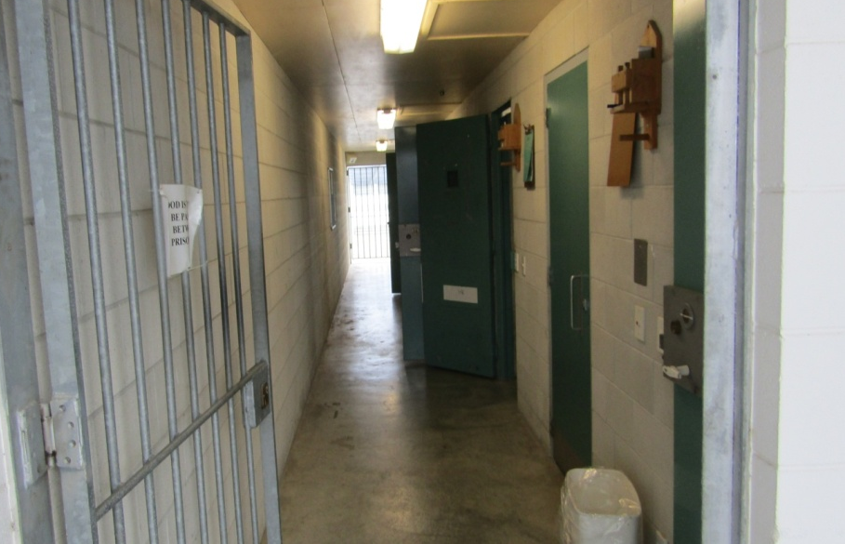 |  | 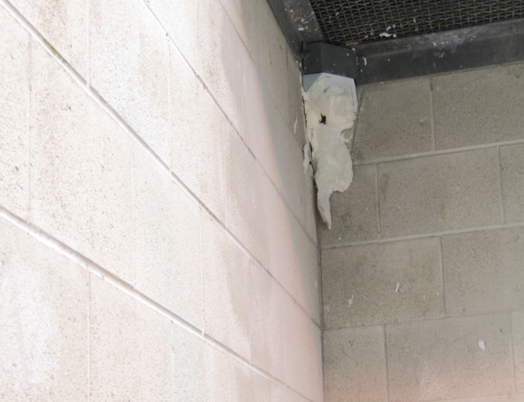
Figure 15: Unit 6 – Separates area |  | Figure 16: Paper blocking cell camera

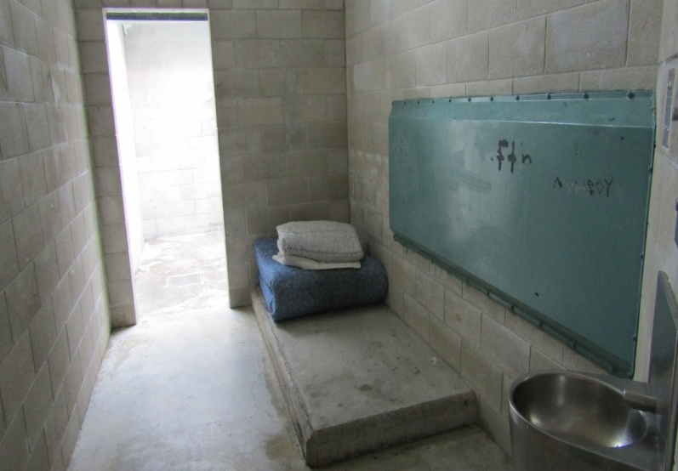 |  | 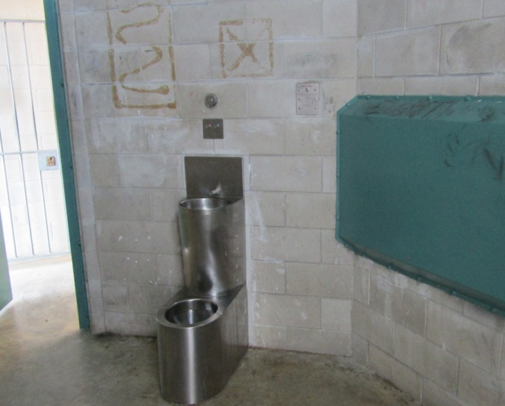
Figure 17: Separates area cell |  | Figure 18: Separates area cell
In the six months before the inspection, there were 86 instances when prisoners were segregated: 24 under Section 58(1)(a) of the Corrections Act where the security or good order of the Prison would otherwise be endangered or prejudiced, and 52 under Section 58(1)(b) of the Corrections Act where the safety of another prisoner or another person would otherwise be endangered. On four occasions, the Prison Director segregated prisoners for the purpose of protective custody under Section 59(1)(a) of the Corrections Act. There were six occasions when the Prison Director segregated prisoners for the purpose of medical oversight under Section 60 of the Corrections Act to ensure the prisoner’s physical or mental health.
Record keeping and assurance that processes were being followed and standards met was not always evident, as some documentation was unavailable at the time of the inspection. Management plans were identical in all instances, regardless of security classification. Prisoners were not involved in the formulation of their management plan and did not receive a copy.
The challenges of keeping such prisoners separate from others while providing minimum statutory entitlements were not consistently met. This was due in part to a lack of appropriate facilities but also due to a lack of effective policies to manage bullying, gangs and other unacceptable behaviours.
Back to contents.

Use of force
The use of force in prisons is regulated by Section 83 of the Corrections Act. Under Section 83 physical force can only be used in prescribed circumstances and if reasonably necessary. Additionally, the level of force used must be reasonable. Where force has been used, prisoners must be examined by a registered health professional.
Inspectors reviewed the Use of Force Register. There were 33 entries for the period 6 May to 31 October 2016. There were eight instances of planned force which were authorised by a manager, and 25 entries where spontaneous force was considered necessary.
There were a number of instances where prisoners were not examined by a suitably registered health professional, which is a requirement under the Corrections Act, and where paperwork was incomplete.
Consistency of approach with regards to record keeping, process compliance and timely review and follow up were areas requiring improvement.
Recommendations—effective and humane exercise of authority
- I recommend that:
  - The adjudication process be simplified to ensure that prisoners understand and can engage fully in the process.
  - Supervision of searching practices be improved.
  - The Prison be equipped with a purpose-built Management Unit. In the interim, current arrangements be reviewed to incorporate improved record keeping, supervision and surveillance, and engagement with segregated prisoners.
  - Processes for the use of force be reviewed and improvements made, particularly in areas of medical examination, record keeping and follow up.

Corrections accepted recommendations 5a, 5b and 5d.
Corrections stated that it ‘partially accepts’ recommendation 5c:
The Prison Director will review the segregation record keeping and processes on site against the national policy. This review will take place in March and April 2017 and an action plan to address issues will be implemented.
The possibility of a purpose-built Management Unit will be considered as part of that review, although construction of such a unit would obviously be subject to funding constraints.
Corrections’ current capital plan focuses on increasing capacity in response to the increasing prison population. The concerns raised in this Draft Report will be considered for future planning.
Back to contents.

Standard 6: Autonomy and protection against mistreatment
Expected outcomes—autonomy and protection against mistreatment
- Prisoners are encouraged to take responsibility for themselves and their future. Their rights to statutory protections and complaints processes are respected.

Confidentiality assessment
As previously mentioned in this report, the inspection team noted some poor practices in respect of medical confidentiality. Additionally, custodial staff informed prisoners within earshot of other prisoners about a range of issues, which were sometimes of a personal nature, as they were issuing meals. In the low security units, it was generally accepted that prisoners would peer through the windows of the staff base to see what there was to see. In some HM units, prisoners were allowed at the opened door of the staff base to enquire about a range of issues, where they might observe private information and CCTV coverage, and eavesdrop on staff conversations.
Back to contents.

Complaints process
Under Sections 152 and 153 of the Corrections Act there must be a fair, effective, comprehensive and prompt internal complaints system prominently displayed in each prison unit, including the right to seek assistance from an Inspector of Corrections or an Ombudsman. Under Section 154, assistance for prisoners to make complaints must be available.
A new complaints process was launched on 1 December 2016; however, information regarding the new system had not been displayed in the units at the time of inspection. The new procedure was unknown to most prisoners and many staff.
Most prisoners were distrustful, critical and dismissive of the complaints process. There were marked differences between respondents in the HM units and those in low security. Overall, only 27 percent of the prisoners expressed faith in the system, but fewer than six percent of respondents in the HM units trusted the process or were satisfied with the way their complaints were handled. Notices advising prisoners about the new process were not widely displayed.
Many prisoners told inspectors that there were consequences for complaining and believed it would negatively affect their chances of parole. One prisoner described the experience as ‘complaining about things that we’re supposed to be allowed and have had elsewhere to people who don’t want to do anything about it’.
The number of complaints made by prisoners from 1 May to 31 October 2016 was 518. The primary reasons for complaints were: delays in access to property (99 complaints); quality and timeliness of healthcare (87 complaints); quantity and quality of prison food (69 complaints); prison conditions (46 complaints); and staff conduct (38 complaints).
In response to the draft report, Corrections stated that it is ‘satisfied that there is no issue with the complaints process that compromises prisoners’ parole outcomes’. In support of this it says that there are posters in prisons that describe the avenues that prisoners can take and that staff are trained to support prisoners in understanding the complaints system.
These comments are insufficient to allay my concerns.
Despite prisoners voicing concerns about the complaints system, there are no associated recommendations as the new system was only launched on 1 December 2016. It is prudent to allow sufficient time to see if the new system effectively tackles the issues associated with the complaints process. This is an area that will be closely monitored in follow-up inspections.
Recommendation—autonomy and protection against mistreatment
- I recommend that:
  - Arrangements for maintaining privacy and security of information be improved.

Corrections accepted recommendation 6a.
Back to contents.

Standard 7: Purposeful activity
Expected outcomes—purposeful activity
- All prisoners are encouraged to use their time in prison constructively. The Prison provides a broad range of activities, opportunities and services based on the profile of needs of the prisoner population.
- Prisoners are consulted in planning the activities offered.
- Positive family and community relationships are maintained.

Activities, work opportunities and programmes
Corrections has identified that 55 percent of prisoners have been receiving a welfare benefit, 36 percent have a mental health condition, 47 percent have a drug or alcohol dependency, and 65 percent have not achieved NCEA Level 1 in literacy and numeracy.
The Prison is designated as a working prison, which Corrections describes as a prison ‘based on a structured environment where all prisoners take part in some form of work, education or rehabilitation programme. They also provide people with the skills and opportunities they need to take greater control of their life’.
The process used to identify the needs of the prisoner population was through Case Management. Case Managers completed assessments of prisoners to identify rehabilitation and reintegration needs in order to develop a plan that met the identified needs in areas of offending, behaviour, attitude and compliance, education and work, health and wellbeing, and housing, finance and victim-related issues.
Case Officers were Corrections Officers tasked with motivating and supporting the prisoner to work towards achieving the goals in the offender plan.
Offender plans for remand prisoners focused on reintegration needs such as accommodation and community support for their transition back into the community.
The inspection team welcomed this initiative and noted efforts to provide an integrated range of activities to encourage prisoners to make constructive use of their time in custody. The team commended the Prison’s efforts to engage with potential employers in the community to ensure the relevance of the opportunities it sought to provide (as described in its Industry, Treatment and Learning Plan). The Prison recognised that there were a number of challenges such as resourcing, data capture, and opportunities for prisoners to apply the skills they acquired and exercise greater personal responsibility in less restrictive conditions, and was exploring options and solutions.
Implementing this important project was a major ‘work in progress’ that would also require existing processes and current practices throughout the Prison to be reviewed, improved and integrated to establish a safer, decent environment in which prisoners believe they can exercise a greater degree of choice.
The inspection team noted from the information and data provided that the Prison operated eight industries across the site: joinery, timber processing, engineering, grounds maintenance, forestry, painting, laundry, and kitchen, with a capacity to employ up to 107 prisoners. Additionally, there were industry-based training programmes with a capacity of 59 prisoners per day. The capacity for Industry at the Prison is 166 offenders, but only 140 prisoners were employed at the time of the inspection.
Beekeeping was introduced in the Prison in 2014 and five prisoners were studying for a Certificate in Apiculture. The hives also provided a teaching tool for the prisoners enrolled on the National Certificate in Horticulture course.
Back to contents.

Case management
Case management was not considered meaningful by most high-security prisoners to whom inspectors spoke. They described the process as largely pointless as they saw few outcomes in the form of access to programmes, education or work. They were also dismissive of Right Track, saying that they rarely spoke with staff other than to ask for things that they did not get, such as bedding and clean clothes. HM prisoners who were on voluntary segregation were critical of the arrangements for access to the limited range of opportunities on offer.
The inspections team collated the returns from the prisoner questionnaire on purposeful activity for the Prison as a whole, and separated the results for the HM units, remand accused and low security prisoners. The differences were marked.
Table 3: Q6.1 Are you currently involved in any of the following activities? (Please tick all that apply)
 | All HM Units | Remand Accused Units | Low Security Units | Prison total
Vocational or skills training | 6% | 1% | 20% | 13%
Education (including basic skills) | 18% | 11% | 31% | 24%
Offending behaviour programmes | 7% | 4% | 37% | 22%
Prison job | 30% | 28% | 41% | 36%
Offender employment | 4% | 0% | 30% | 17%
Release to work | 0% | 0% | 6% | 6%
Not involved in any of these | 45% | 58% | 15% | 30%
Back to contents.

Job Expo
The Prison arranged a Job Expo to showcase the range of employment and training opportunities available to sentenced prisoners, and the connections between activities in the Prison and employment opportunities on release. The Expo was well attended and appeared very successful in providing information and motivating prisoners to use their time in custody to better effect. Inspectors commended the practice.
Back to contents.

Remand Prisoners
In 2013, the United Nations Subcommittee for the Prevention of Torture visited several New Zealand prisons, including Hawke’s Bay Regional Prison, and stated that limited time out of cell and the limited range and provision of constructive activities were issues for remand prisoners that should be addressed.
Apart from one remand prisoner undertaking an initial literacy and numeracy test, remand accused prisoners were not observed engaging in any form of constructive activity during the inspection. Brief Alcohol and Other Drug (AOD) programmes and correspondence school were available to remand accused prisoners, but there was little evidence of the prisoners accessing these opportunities.
A long-serving remand accused prisoner stated he had not been involved in any constructive activity during the 15 months he had already served on remand; his file notes supported this.
Remand prisoners’ time was spent on crowded high-security wings or on the external yards. An area that was previously used for recreation had been closed for construction as part of the muster expansion project. The designated Prison Activities Officer was not working with the remand population at the time of inspection, due to constraints around suitable areas for activities.
As remand prisoners were not classified they were managed as high-security prisoners by default. They were not allowed to visit the library, but could order books through a chit system. They were not allowed to attend chapel, although religious support and services could be provided to them in the high-security wings. Remand prisoners were not eligible to attend the Prison job expo.
The inspections team observed remand prisoners being served evening meals as early as 3.30pm and locked in their cells by 4.25pm; morning unlock took place between 8.15am and 8.30am.
Opportunities and conditions for remand prisoners at the Prison have not improved since the UN visit, and may have deteriorated further.
Back to contents.

Time unlocked
Typically, prisoners in the HM units did not spend much of the day out of their cells and only limited time out of the wings. There was limited provision of purposeful activity and prisoners were bored and frustrated. Some areas were worse than others due to the challenges of keeping different prisoner categories apart. Recent events had identified a need for staff to debrief at the end of their shift, which meant that prisoners could expect to be locked up five to ten minutes earlier each day. The average time out of cell for prisoners in the HM units was between two and five hours per day.
Prisoners in low security enjoyed a longer period of unlock, from about 7.15am to 7.15pm, but complained that their cells got very hot during the summer.
Back to contents.

Te Tirohanga
Te Tirohanga units were previously known as Māori Focus Units or MFUs. In 2009, Corrections evaluated the Māori Focus Units and the Māori Therapeutic Programme. In 2010 and 2011, the therapeutic outcomes of the units were evaluated. The reviews found that the units were not reaching their full rehabilitative potential. As a result, Corrections initiated the Māori Focus Unit Improvement Project to revitalise the therapeutic model operating in the units. In October 2013, the new model was implemented at the Prison. Inspectors saw two programmes in operation: Te Tirohanga and Mauri Te Pae.
Te Tirohanga was a six-phase programme that included whānau support, education and rehabilitation services. Whānau support was primarily delivered by pou arataki (previously whānau liaison officers), who were responsible for assessing and improving the quality of the relationship between prisoners and their whānau. Education and rehabilitation services were delivered through various organisations.
Mauri Tu Pae was a three-month, medium-intensity rehabilitation programme delivered by Māori service providers in the Te Tirohanga unit. It was designed to help prisoners alter the behaviours that led to their offending, and to help them develop strategies for maintaining positive change.
Inspectors spoke with the programme facilitators, who considered that the programme was not long enough. They expressed concern that after completing the programme, prisoners returned to the mainstream without adequate support, which could have the effect of undoing all the work that was done on the rehabilitation programme. They also wanted to see prisoners learning more trades.
The Unit Management Team also would have liked to see more interaction with Kaumatua, particularly for advice on Tikanga Māori and cultural practice in the unit, and opportunities for tane to seek advice of a spiritual nature if they wished.
Local delivery of the three-month intensive alcohol and other drug treatment programme was also a topic of discussion. It was felt that establishing such a programme at the Prison would prevent the disruption of transferring eligible prisoners to Te Tirohanga unit at Whanganui Prison.
Back to contents.

Visits and family contact—HM units
Visits took place from 9am to 10am, 10.30am to 11.30am, and 1.30pm to 2.30pm Monday to Thursday for prisoners located in the HM units. However, there were no visits on Tuesday afternoon due to a general lock up for staff training, and the Thursday afternoon session was designated as an overflow for sentenced prisoners as required or for ‘data entry’, which referred to updating approved visitors and records of visits taken. There were no visits on Fridays, which were also set aside for data entry. This meant a total of 10 sessions were normally available, which matched the ten separate categories of prisoners.
The schedule had recently been revised to incorporate the new child protection policy. The unintended consequences of this included reduced flexibility for friends and whānau to plan their visits, and identifying prisoners with child protection issues. Some of these prisoners, including those on voluntary segregation, described to us an increase in bullying from their peers. Anecdotally, we were told that the number of visits had dropped as a consequence. The timetable ensured that the statutory requirement to keep remand accused prisoners separate from remand convicted and sentenced prisoners was met. Another layer of complexity was the need to separate segregated and mainstream prisoners.
Visitors waited in their vehicles or in the gatehouse, where there were lockers for storage of items not permitted in the visits room. There were no vending machines or facilities for refreshment in the Gatehouse Unit or visits room, which was a short walk from the Gatehouse Unit.
Efforts had been made to brighten the environment and atmosphere in the visits room with murals and an activity corner for children with some books provided. However, the visits area required cleaning when inspectors observed the room.
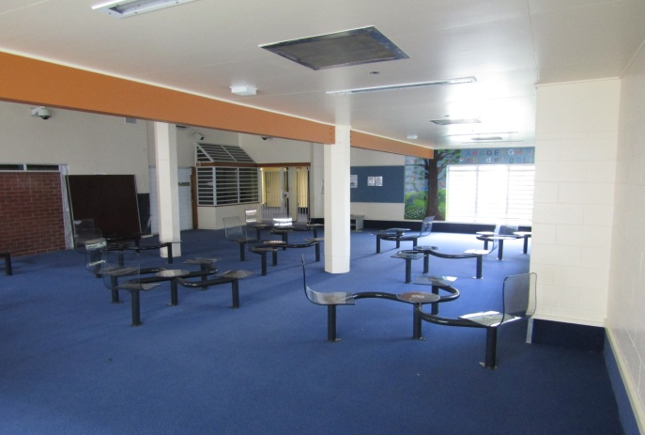 |  | 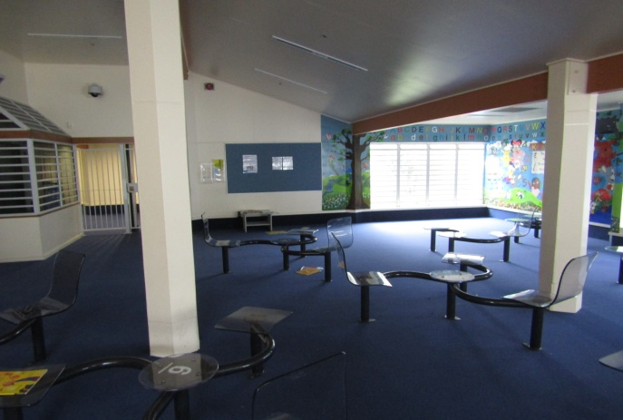
Figure 19: Visits room |  | Figure 20: Visits room
Prisoners wore orange overalls during the visits irrespective of their classification.
Corrections advises that this allows staff to easily distinguish prisoners from visitors, to reduce escapes, and prevent contraband during visits.
I consider that it would be appropriate for Corrections to review the blanket requirement for prisoners to wear the overalls during visits, irrespective of classification, noting that international inspectorates have found that prisoners should generally be allowed to wear their own clothing.
After visits, all prisoners were strip searched. Sections 98(6)(h) and (i) of the Corrections Act specify that prisoners ‘may’ be strip searched before and after any person visits or has visited the prisoner.
The blanket application of strip searching of prisoners after visits appears to be disproportionate to the risk of contraband being passed and secreted during a visit, as reflected in the very small amount of such contraband being found. My inspectors were made aware that drugs, tobacco and mobile phones have been found in the Prison, but it is reasonable to conclude that visits is not the primary route for their introduction. Deployment of finite staff resources to strip search every prisoner after visits appears inefficient, ineffective and inappropriate.
Back to contents.

Visits and family contact—low security units
Visits for low security prisoners took place on Saturday and Sunday from 1.15pm to 3.15pm in the units. Again, child protection arrangements had added a layer of complexity, and reduced flexibility for visitors in that each unit offered standard visits on one day and child protection visits on the other. Mainstream and segregated prisoners were located in separate units.
Low-security visitors were collected at the gatehouse and transported to the units. Visits in the low-security units took place in the large communal space that serves a number of functions. The atmosphere was generally more relaxed than the visits room for HM prisoners. Prisoners wore orange overalls during the visits. After visits, all prisoners were strip searched.
The Prison had recently run an event to address domestic violence, which was delivered with the assistance of respected community leaders and was well received by the prisoners.
Back to contents.

Communications – telephone and mail
At least three telephones were available in each of the low-security hut units. Each HM wing had a telephone in the dining/recreation area. Twenty-nine percent of prisoners stated that they experienced difficulties accessing telephones. Forty-seven percent of prisoners reported difficulties with the mail process.
Recommendations—purposeful activity and family contact
- I recommend that:
  - Arrangements to ensure that the range of regime activities and resources, including self-care, are fully reviewed to ensure equality of opportunity.
  - There be greater clarity around identified needs and access to interventions and purposeful activities.
  - The regime opportunities for remand accused prisoners be significantly improved to reflect their legal status.
  - The requirement that all Prisoners wear orange overalls at visits irrespective of classification be reviewed.
  - The policy of strip searching every prisoner after every visit be reviewed.

Corrections accepted recommendation 7e.
Corrections rejected recommendations 7a and 7b, and stated:
As acknowledged in the Draft Report, in 2016 a national initiative took place to develop Industry Training and Learning (ITL) plans for each prison in Corrections. Each prison developed plans to engage prisoners in constructive activity.
All prisoners are provided offender plans that identify their rehabilitative needs and the appropriate interventions to address them. Access to the interventions depends on availability. Where appropriate, all prisons endeavour to address these needs through the ITL plans.
As the external self care facility is situated outside the secure prison perimeter, prisoners are assessed for suitability before being placed in these units to reduce the risk to the public. At the time of the inspection, an insufficient number of eligible and suitable prisoners were available to operate this unit. However a nationally led initiative is underway to identify eligible prisoners from around the country. Eligible prisoners will be further assessed for their suitability on a case by case basis and transported to the Prison when the Prison Director is satisfied that their placement in the external self care unit is appropriate. This initiative will continue ongoing – timeframes are unable to be determined as the outcome depends on the eligibility and suitability of the prisoners.
Corrections' comments do not directly address my concerns about the need to ensure equality of opportunity, and the need for greater clarity around identified needs and access to interventions and purposeful activities.
Corrections rejected recommendation 7c, and stated:
The Prison offer a greater variety of programmes and activities than it did at the time of the United Nations Subcommittee visit.
New classrooms will be built at the prison by August 2017 which will increase the opportunities available
However, Corrections does not accept that the regime for remand accused prisoners is ‘impoverished...or that significant improvement is required.
However, the Prison Director is continuing to explore opportunities for remand prisoners. Remand prisoner opportunities present challenges due to these prisoners having to be managed as high security, and the increasing population of remand prisoners.
Corrections rejected recommendation 7d.
Back to contents.

Standard 8: Preparation for successful return to the community
Expected outcomes—preparation for successful return to the community
- Prisoners are prepared for their successful return to the community.

Guided release process
Guided Release aimed to provide long-serving prisoners with increased opportunities to address their basic reintegrative needs before release; prepare intensive release plans; and overall better equip them for their final release.
The Prison Director received advice from a multi-disciplinary advisory panel, which was made up of internal staff including community probation, psychological services, case management, industries, and intelligence; and external representatives including the Ministry of Social Development and New Zealand Police.
Inspectors attended an advisory panel meeting. The panel was chaired by a senior manager and consisted of six Prison staff; apologies were received from Psychology Services, Operational Intelligence, Offender Employment and Community Probation. There was no Police representative.
The panel considered seven applications. Three were approved, one was recommended subject to a satisfactory Psychologist’s report, one was deferred for six months, one was deferred until after the prisoner’s Parole hearing in February 2017, and one case was not approved due to a Parole Board recommendation and the prisoner’s imminent release in January 2017.
Back to contents.

Te Whare Oranga Ake
The Department of Corrections has two Te Whare Oranga Ake: one 24-bed unit at Hawke’s Bay Regional Prison and one 16-bed unit at Spring Hill Corrections Facility. Corrections provides custodial support for the Whare, and the management and day-to-day operation is contracted to a local service provider.
Te Whare Oranga Ake was located outside the secure perimeter of the prison and supported minimum-security prisoners with between three and six months left to serve. The aim was for prisoners to train for employment; find sustainable employment and accommodation on release; and form supportive networks with iwi, hapu and community organisations.
The Whare were similar to external self-care units. Prisoners did their own shopping, cooking and housework. Prisoners from other prisons who intended to reintegrate into the Hawke’s Bay or Waikato communities could be referred to participate in the programme.
Inspectors welcomed such reintegrative initiatives, including Release to Work, and encouraged efforts to increase the number of minimum-security prisoners engaged in activities outside the Prison. Inspectors also recognised the difficulties that result from some prisoners’ abuse of the opportunities afforded to them.
I have no recommendations to make under this section.
Back to contents.

Youth Unit
The Department recognises that to achieve a significant reduction in reoffending overall, it must improve outcomes for youth. The Department introduced its Youth Strategy in 2013 and, in 2015, increased its efforts through the Youth Strategy Acceleration Project which set aspirational goals to:
- develop Youth Units as centres of excellence;
- provide exceptional staff engagement with a focus on Youth Champions; and
- develop world-leading rehabilitation and reintegration services.
Hawke’s Bay Regional Prison has one of two Youth Units in New Zealand; the other is in Christchurch Men’s Prison.
Back to contents.

Accommodation
The Youth Unit at the Prison holds mainly 16 and 17 year olds, and can hold vulnerable youth until the age of 19. The Unit was refurbished following a serious incident in 2012, which caused considerable damage and highlighted some design weaknesses.
The Unit can accommodate 30 youths, and held 27 at the time of the inspection. There were two accommodation areas: high security comprised 15 single and two double cells in a secure house block, while low security comprised 11 cells in a separate hut unit. Two cells were closed due to damage.
The high-security accommodation and facilities were stark and gloomy, and communal areas needed an upgrade. Cells were of a reasonable size and cell standards were generally satisfactory and largely free of graffiti, although a number of cell doors had been tagged. Some prisoners complained that the communal areas were not clean but it was noted that cleaning materials were provided. The cells and common areas in the high-security wings were said to be very hot and stuffy due to broken fans. Prisoners reported that they ran the water at night to try to cool the cells down.
Back to contents.
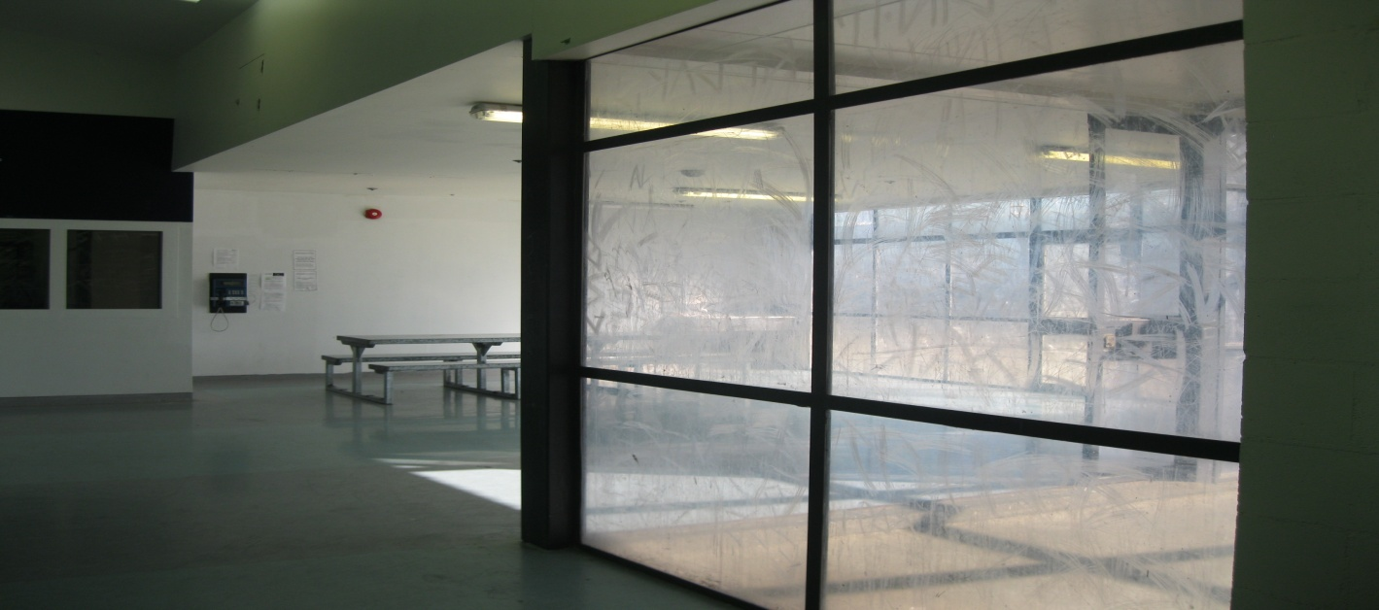
Figure 21: Youth Unit High Security area
The Huts (low security) were clean, tidy and reasonably maintained with adequate privacy screening and a means of raising the alarm if required. Showers for young people in low security were situated next to the huts and were clean and tidy. Low security prisoners had access to a common room/dining area which was adequately furnished. With the exception of the windows, there was little graffiti throughout the area. The communal areas were generally not as clean and tidy as the cells, and the fridge in particular was dirty and obviously had been for some time.
Of the 27 youth in the Unit during the inspection, 11 were remanded and 16 sentenced. Despite requests, inspectors were unable to view the necessary authorisations to allow different categories of youth to be mixed.
Back to contents.

Routine
Time out of cell varied, with high-security youth spending an average of four to five hours a day out of cell, while low-security youth were out of cell for around nine hours a day during the week. The routine was as follows:
- unlock 6am, breakfast 7am to 8am
- lockup 8am to 9am for multi-disciplinary staff hui
- unlock 9am for recreation programmes, lunch 11am to 11.45am
- lockup 11.45am to 1pm
- unlock 1pm for education programmes, Tikanga 3pm to 4pm, dinner 4pm to 4.45pm
- lockup 4.45pm for high-security prisoners
- lockup 7pm for low-security prisoners.

Decency, dignity and respect
Interactions between youth and staff appeared respectful and friendly. Youth reported that the staff interactions with them were positive. Sixty-seven percent said there was a member of staff they could turn to for help; this was slightly less than the overall prison population, which was 71 percent. Youth also expressed a wish to have more interaction with staff, which they felt would make for a busier day with less likelihood of boredom and subsequent unacceptable and risky behaviour such as sparring.
Youth said they could access showers daily but only 25 percent said they received clean sheets regularly. One young person claimed that he has a skin condition that was due to not being able to change his bedding regularly. Others complained that the pillows were inadequate.
During the week, lunch consisted of sandwiches and a hot lunch was provided at the weekends. All areas had a toasted sandwich maker and Milo was available at meal times. Youth reported portion size as good although 41 percent reported that the food was bad or very bad. They also reported that they played cards for food as the P119 prices were unaffordable.
Back to contents.

Personal safety
Sparring appeared to be an ongoing behaviour among the youth. Staff supervision and redirection of physical energy were tactics deployed to minimise this behaviour. A physical fitness programme and circuit was organised by staff to divert potentially risky behaviour and proved effective in shifting their focus. In the questionnaire, 25 percent of youth said they felt unsafe at the time of the inspection.
Back to contents.

Effective and humane exercise of authority
Offences against prison discipline are described in Subpart 5 of the Corrections Act 2004, Sections 128 to 131. The adjudication process is prescribed in Section 133 of the Act. Inspectors accompanied the adjudicator on the rounds and reviewed the documentation and process, which were satisfactory. The procedure was formal and quasi-legal in format and it was clear that the youth involved did not understand or fully engage in the process.
Staff had become aware of a potential conflict between two youth and had taken steps to keep them separate while they could engage in mediation with both youth to resolve the situation.
It was generally accepted that youth would peer through the windows of the staff base to see what there was to see.
Back to contents.

Autonomy and protection against mistreatment
Neither staff nor youth on the Unit were aware of the new complaints procedure. No notices were visible on the designated notice boards about the complaints process or approved 0800 numbers, although inspectors were advised that this information is made available in the Prisoner Information Booklet as part of the induction process.
Youth had a reasonable understanding of how to make a complaint and were able to briefly describe the complaints process.
An incentive scheme operated in the Unit. The youth, along with his case officer would select three ‘smart’ goals (good behaviour, cell standards, attending education). If he achieved all three, he would be rewarded with the use of a DVD player or radio one evening at the weekend.
Youth in the high-security area stated that they didn’t have enough to do and they needed some gym equipment. The outside area of the Youth Unit formerly had some physical fitness equipment that could be used, but was removed due to health and safety concerns.
Youth confirmed that they got access to more than one hour in the fresh air daily. High-security youth had access to the external field, one wing at a time at the weekends; the enclosed yard in the high security block was used during the week.
Back to contents.

Purposeful activity
The range of activities (physical activity, literacy and numeracy, computers, youth culture and horticulture) on the youth programme had increased since the last inspection. However, the average attendance hours of 7.4 hours per prisoner per week (202 hours over five days) was disappointing. When completing the questionnaire, 25 percent of youth stated they were not involved in any activities.
Recreation time for youth varied depending on their security status. Low-security youth were able to access a common room/dining room throughout the day. This room could easily accommodate 11 and had a snooker table, a small selection of books, a TV and a kitchenette. In contrast, high-security prisoners had a bench and TV, although the TV in Wing 2 was broken and had been for some time. Graffiti was much more prevalent in high security, especially on the Perspex windows.
Youth in the high-security area said that they lacked anything to do on a daily basis and that they mainly played cards most of the day.
Low-security youth said they enjoyed access to education and programmes.
The young people clearly enjoyed their tutor’s approach and teaching style. Youth were observed using the computer suite for various areas of study including a speed and accuracy skills test; NCEA English; and a personal piece of writing. Other activities included literacy and numeracy; driving theory; learning plans; alcohol and other drug education; men’s health; Tikanga; and the Youth Offender Programme (YOP).
The Unit had a reasonably sized classroom which was clean and well looked after. There was minimal graffiti on the chairs and none on the walls. The optimal class size was six youth at one time, with some youth receiving 1:1 tuition. Youth were locked in their cells if they did not wish to attend education.
The Tikanga programme was attended by seven low-security youth. The class was interactive and the youth were all engaged and presented as happy.
Other available activities included cooking, Bible studies, beekeeping and art. There was a library ‘run’ once a month. Youth also had access to table tennis, touch rugby, crossfit, medicine balls, physical education, art materials, music, board games and a basketball court. Cooking, Milo and time with staff were considered incentives for good behaviour.
A church service was available on Sundays in the Youth Unit from 9am to 10am. On average, 6 to 10 youth attended.
One initiative that took place during the inspection was to permit selected youth to participate in a Duke of Edinburgh Hillary Award and to spend time outside the fence on a local tramp and camping expedition. The prisoners had worked hard to achieve a sustained period of good behaviour and engagement to be considered for the opportunity, and appreciated the change to their normal routine.
Back to contents.

Visits and family contact
Research into the role of families in supporting and encouraging desistance suggests that they can be a key factor in change processes, particularly for youth. The existence of good-quality familial relationships can be a key factor in desistance. It is also widely recognised that, similar to peer groups, the positive impact of family relationships is highly dependent on the quality of that relationship. Where youth have experienced abuse and neglect, or other family members are themselves involved in crime, it is less likely that relationships will have a positive impact on desistance.
Visits for youth took place on Saturday and Sunday from 1.15pm to 3.15pm in the units. Visitors to the Youth Unit, which is situated near the gatehouse, were escorted to the visits room.
Youth wore orange overalls during the visits. After visits, all youth were strip searched.
The number of youth visits was described as low. This was attributed in part to the majority of young people in the prison not being from the Hawke’s Bay region. Only two youth were from the Hawke’s Bay region, while the other 25 were from other parts of the North Island. This obviously presented difficulties in terms of distance and expense for families to visit.
The Unit had an AVL suite, but this was not used much. Staff reported that this was a recent innovation and that families often found it difficult to get to a Probation Office to conduct AVL visits.
There were no complaints from youth about access to the telephone or sending and receiving mail.
Recommendations—Youth Unit
The following recommendations are specific to the Youth Unit. However, all general recommendations in the body of this report also apply to youth prisoners and the Youth Unit.
- I recommend that:
  - Greater access to education, rehabilitation programmes and constructive activities be provided.
  - Facility standards in the Youth Unit, particularly the high security area, be improved.
  - The Prison acquires the necessary authorisations to allow the different categories of youth to mix.

Corrections advised that it accepted recommendation 8a, and stated ‘please refer to the response to recommendation 7a’. However it rejected recommendation 7a, so it is unclear whether it intends to implement this recommendation.
Corrections accepted recommendation 8b, and stated:
The Prison Director has inspected the areas of the Youth Unit that are of concern. The Offender Employment Industries team and Corrections’ external facilities maintenance contractors are planning a programme of work to address the identified issues.
Corrections does not agree with the comment...that ‘communal areas need an upgrade’. Without the Draft Report being specific about the areas of concern, Corrections is not in a position to comment. However, Corrections notes that there is a programme of work in place to address the areas of the unit on an ongoing basis.
It is apparent that the communal areas need a general upgrade—I consider this should be undertaken as part of the improvement of facility standards that Corrections has agreed to undertake.
Corrections accepted recommendation 8c, and stated:
Corrections has an exemption in place for all youth units that allows remand accused youth to mix with other youth prisoners. The exemption is outlined in the POM.

Back to contents.

Acknowledgements
I appreciate the full co-operation extended by the Hawke’s Bay Regional Prison managers and staff to the inspections team during their visit to the Prison. I also acknowledge the work that would have been involved in collating the information sought.
Back to contents.

Consultation
A draft copy of this report was forwarded to the Prison Director and Corrections’ National Office for comment as to fact, finding or omission prior to finalisation and distribution.
Back to contents.

Publication of report
Under Sections 27 and 36 of the Crimes of Torture Act 1989, the Chief Ombudsman will present a copy of this report to Parliament before publication on the Ombudsman website.
Back to contents.
- Summary of recommendations

Recommendations—lawful and transparent custody
- I recommend that:
  - Arrangements for prisoners to access personal property be improved.
  - First night in custody arrangements, as previously offered by the Gateway Unit, be reintroduced, and an assurance process developed to assess and improve the effectiveness of the induction process in meeting prisoners’ needs and entitlements.
Back to contents.

Recommendations—decency, dignity and respect
- I recommend that:
  - An Equality and Diversity Policy that ensures all prisoners’ rights are recognised and respected be implemented as a matter of urgency.
  - Worn and damaged mattresses and prisoner clothing are replaced and improvements made to ensure all prisoners have appropriate access to sufficient clean clothing and bedding.
  - Effective processes are implemented to ensure housekeeping, hygiene and cleanliness standards are improved and performance monitored.
  - Arrangements to improve ventilation in Hut units are implemented and monitored to ensure appropriate standards are consistently achieved.
  - Serving times of meals are standardised to normal hours, particularly on units that are not running an 8am to 5pm regime. This would involve lunch being served any time between midday and 1.30pm, and dinner to be served any time between 5pm and 7pm.
  - Prisoners have access to hot water after lock up to make themselves a hot drink. All prisoners are provided with cups.
  - Arrangements for the prisoners’ canteen (P119) be reviewed. As a standard, prices should be comparable with prices in the community.
  - All prisoners are able to spend at least one hour each day in the fresh air.
Back to contents.

Recommendations—personal safety
- I recommend that:
  - The Prison develop and implement an anti-bullying strategy and gang management strategy that sits alongside the Prison’s violence reduction strategy; this to include identifying where prisoners feel least safe, and addressing the findings in an arena that includes prisoner representation.
  - There be greater consistency and frequency of staff interactions with prisoners to improve dynamic security and ensure an appropriately controlled environment.
  - The practice of routinely placing at-risk prisoners in dry rooms cease immediately.
  - Measures should be undertaken to better protect the privacy of prisoners in the ARU when they are naked, partially naked, or undertaking their ablutions
  - The process for management of prisoners at risk of self-harm reflects international best practice.
  - Prisoners who are not at risk of self-harm or suicide not be held in the ARU.
Back to contents.

Recommendations—health and wellbeing
- I recommend that:
  - An annual health needs analysis be carried out to inform the health development plan.
  - There be a separate health complaints process to ensure patient confidentiality.
  - Processes for dispensing controlled medication be reviewed to comply with Corrections’ Health Services Medication Standards.
  - Arrangements for prisoners to attend clinics be improved.
  - Medication rounds be revised to meet policy standards, particularly in areas of unsafe practice, compromised patient confidentiality and identified inefficiencies.
  - The policy for in-possession medication be reviewed to provide a greater degree of consistency with other sites.
  - Dental provision be reviewed to address lengthy waiting lists.
  - The provision of mental health services be formalised.
Back to contents.

Recommendations—effective and humane exercise of authority
- I recommend that:
  - The adjudication process be simplified to ensure that prisoners understand and can engage fully in the process.
  - Supervision of searching practices be improved.
  - The Prison be equipped with a purpose-built Management Unit. In the interim, current arrangements be reviewed to incorporate improved record keeping, supervision and surveillance, and engagement with segregated prisoners.
  - Processes for the use of force be reviewed and improvements made, particularly in areas of medical examination, record keeping and follow up.
Back to contents.

Recommendation—autonomy and protection against mistreatment
- I recommend that:
  - Arrangements for maintaining privacy and security of information be improved.
Back to contents.

Recommendations—purposeful activity and family contact
- I recommend that:
  - Arrangements to ensure that the range of regime activities and resources, including self-care, are fully reviewed to ensure equality of opportunity.
  - There be greater clarity around identified needs and access to interventions and purposeful activities.
  - The regime opportunities for remand accused prisoners be significantly improved to reflect their legal status.
  - The requirement that all Prisoners wear orange overalls at visits irrespective of classification be reviewed.
  - The policy of strip searching every prisoner after every visit be reviewed.
Back to contents.

Recommendations—Youth Unit
The following recommendations are specific to the Youth Unit. However, all general recommendations in the body of this report also apply to youth prisoners and the Youth Unit.
- I recommend that:
  - Greater access to education, rehabilitation programmes and constructive activities be provided.
  - Facility standards in the Youth Unit, particularly the high security area, be improved.
  - The Prison acquires the necessary authorisations to allow the different categories of youth to mix.
Back to contents.
- Corrections’ comments on recommendations which were accepted
Lawful and transparent custody
- I recommend that:
  - Arrangements for prisoners to access personal property be improved.
  - First night in custody arrangements, as previously offered by the Gateway Unit, be reintroduced, and an assurance process developed to assess and improve the effectiveness of the induction process in meeting prisoners’ needs and entitlements.

Corrections has accepted recommendation 1a, and commented as follows:
Corrections prisons receive close to 30,000 prisoner arrivals per year, with 1,645 of these being to Hawke’s Bay Regional Prison. This includes first time and returning prisoners and transfers between prisons. The procedures to transfer the property of these prisoners involve many safety, security and administrative considerations, which mean that there are legitimate reasons why prisoners may not be able to receive their property immediately upon arrival.
Nonetheless, the Prison Director has investigated the concerns raised in the report and has found that staffing levels and the processes to give prisoners access to their property could be improved.
Existing positions have been filled, and new positions have been recruited to ensure that enough staff are available to provide timely access to property. Over-time will also be used when required to increase the time available to process property.
The Principal Corrections Officers have been tasked with providing a solution by April 2017 to improve the process to reduce timeframes further. Once a new process is in place, the Reception and Movements Manager will monitor the progress and ensure performance improvement.
Corrections has accepted recommendation 1b, and commented as follows:
The High Security Manager will implement a revised practice in the gateway unit to ensure that prisoners’ immediate needs are met. This will involve reviewing practices at other prisons and adopting procedures that have proven to be effective. The Prison Director expects that the revised practice will have been determined, and implementation and training will be complete by July 2017.
Corrections has a range of quality and assurance systems and tools available to monitor compliance with our standards, including operational performance teams in each region. Once a new solution is in place, the Prison Director will determine a suitable method to monitor first night in custody arrangements.
As you will be aware, a new high security facility will be commissioned at the prison in October 2017. This facility will enable the prison to further improve first night in custody arrangements.
Back to contents.
Decency, dignity and respect
- I recommend that:
  - An Equality and Diversity Policy that ensures all prisoners’ rights are recognised and respected be implemented as a matter of urgency.
  - Worn and damaged mattresses and prisoner clothing are replaced and improvements made to ensure all prisoners have appropriate access to sufficient clean clothing and bedding.
  - Effective processes are implemented to ensure housekeeping, hygiene and cleanliness standards are improved and performance monitored.
  - Arrangements to improve ventilation in Hut units are implemented and monitored to ensure appropriate standards are consistently achieved.
  - Serving times of meals are standardised to normal hours, particularly on units that are not running an 8am to 5pm regime. This would involve lunch being served any time between midday and 1.30pm, and dinner to be served any time between 5pm and 7pm.
  - Prisoners have access to hot water after lock up to make themselves a hot drink. All prisoners are provided with cups.
  - Arrangements for the prisoners’ canteen (P119) be reviewed. As a standard, prices should be comparable with prices in the community.
  - All prisoners are able to spend at least one hour each day in the fresh air.

Corrections advised that it ‘partially accepted’ recommendation 2a. It noted that a working group has been initiated and a diversity and equality strategy will be developed by April 2017. It also stated that while Corrections does not presently have an equality and diversity policy, provisions are included throughout other policies.
Corrections further stated:
This recommendation has been discussed at a national level with custodial practice and learning and development experts. A range of options have been considered to address this issue, with the aim of building a culture amongst custodial staff that is sensitive and responsive to these needs. Options being considered are:
- Training subject matter experts in each region. These staff could be provided with intensive training on diversity and equality and act as a knowledge base in the region to share learnings with other staff in order to gradually build capability.
- Implementing a ‘diversity working group’ in each region to effect change where needed.
- Reviewing complaints made to the Chief Inspector to identify the areas to focus on.
- Providing support networks at prisons for staff of minority cultures, religions or identities. We believe that embedding this culture with staff will result in a follow on effect for the prisoners.
- Proving additional guidance material for staff on cultural and religious practices.
- In addition to the current engagement with the Human Rights Commission, engaging with the Race Relations Commissioner and other agencies to seek advice.
Corrections is in the process of developing a comprehensive work programme for the management of individuals who identify as transgender in prison. Corrections already has a transgender policy regarding placement of prisoners. The Management guidelines will provide specifically for transgender prisoners’ safety, dignity and privacy and their right to maintain their gender identity while in prison. Additionally, the guidance will provide staff with certainty about what they can and should provide transgender prisoners with when they are in our care. The guidelines will be implemented in June 2017.
Corrections accepted recommendation 2b, and stated:
The Prison Director accepts that some of the mattresses and prisoner clothing at the time of the inspection were below standard.
As advised to the inspector, a bulk purchase had been ordered but had not arrived at the time of the inspection.
At the time of writing approximately 200 new mattresses have arrived at the prison as well as a bulk order of new clothing. New washing machines are being installed in the high security area so that prisoners have an opportunity to wash their own clothing without having to use the prison’s usual laundry function.
Systems and processes are in place at the prison to ensure that stock is replenished routinely and that worn and damaged items are replaced as needed. The Prison Director has asked staff to ensure that these checks are carried out daily. Corrections request that this be noted in the final version of the Draft Report.
Corrections accepted recommendation 2c, and stated:
Corrections agrees that it is important that prisoners are provided with a clean and hygienic environment.
The Prison Director will review the existing hygiene and sanitation plans and make changes where necessary to address the issues. The changes will be implemented by April 2017. Corrections request that this be noted in the final version of the Draft Report.
External audit from an outsourced facilities management supplier and internal checks will occur routinely to ensure that an adequate standard of cleanliness is maintained.
Tagging and gang symbols are difficult to prevent in a prison environment, short of denying prisoners access to the means of marking prison property. Where tagging occurs, offenders are asked to remove if this can be carried out safely, eg, if the tagging is drawn on and can be wiped clean. If the damage is more permanent, it is painted over by offender employment work teams. This process is continuous.
As to the comments in the Draft Report as to the adequacy of communal areas Corrections acknowledges that double bunking in the high security wings has resulted in more prisoners using the communal areas. When the double bunking was planned, expert advice was sought and it was concluded that the space is sufficient for the number of prisoners.
Corrections accepted recommendation 2g, and stated:
Corrections is in the process of negotiating a new national canteen supplies agreement. The agreement will be in place on 1 April 2017 for 12 prisons. There will then be a staggered approach over the next six months to implementing the new arrangement across the remaining prisons, including Hawke’s Bay Regional Prison. Under the new agreement, there will be a nationally consistent prices for all P119 items.
Corrections is committed to provide consistency and value for money for prisoners on P119 items. Due to the goods being distributed in a prison environment there will always be additional costs that other organisations may not have to contend with. As a result, the prices will be comparable to local Four Square, rather than supermarket, prices.
Once the new Canteen Supplies arrangement is implemented across all Department sites (currently expected to be by the end of September), Corrections will review the product catalogue with a view to identifying healthier options. Corrections expects this review to be completed by the end of 2017.
Back to contents.
Personal safety
- I recommend that:
  - The Prison develop and implement an anti-bullying strategy and gang management strategy that sits alongside the Prison’s violence reduction strategy; this to include identifying where prisoners feel least safe, and addressing the findings in an arena that includes prisoner representation.
  - There be greater consistency and frequency of staff interactions with prisoners to improve dynamic security and ensure an appropriately controlled environment.
  - The practice of routinely placing at-risk prisoners in dry rooms cease immediately.
  - Measures should be undertaken to better protect the privacy of prisoners in the ARU when they are naked, partially naked, or undertaking their ablutions
  - The process for management of prisoners at risk of self-harm reflects international best practice.
  - Prisoners who are not at risk of self-harm or suicide not be held in the ARU.

Corrections accepted recommendation 3a. It noted that it is in the final stages of completing a five year Gang Strategy that aligns with the Whole of Government Gang Action Plan. It advises that the core of the strategy contains three pillars focussing on containment, disruption of gang activity, and reducing the harm of gangs. When the national strategy is agreed, the Prison Director will create a local policy to meet the needs of Hawke’s Bay Regional Prison.
It further noted that:
Strategies to enhance offender safety are continuously developed and reviewed under Corrections’ Everyone Safe Every Day governance group. The issues raised in this Draft Report will be tabled at the next governance meeting on 4 April 2017 to determine what steps are required. This may result in a smaller group being commissioned to carry out further investigation.
Prison Tension Assessment Tool (PTAT) was recently implemented at all prisons. The PTAT helps corrections officers to assess the overall level of tension in units – whether due to gang-related factors or not – based mainly on qualitative information and indicators from their observations, experiences and interactions with prisoners. This information is used to take any specific or site-wide actions.
Corrections accepted recommendation 3b. It advised:
The Prison Director and Corrections agree that regular staff interaction with prisoners is an important component of a safe and rehabilitative environment.
The concerns raised in the Draft Report have been discussed with residential managers, Principal Corrections Officers and Senior Corrections Officers. These managers have all been reminded of the importance of Corrections Officers being visible in the units and interacting with prisoners. Principal Corrections Officers will also monitor where staff are placed during shifts to ensure that prisoners can be adequately supervised and supported.
Back to contents.
Health and wellbeing
- I recommend that:
  - An annual health needs analysis be carried out to inform the health development plan.
  - There be a separate health complaints process to ensure patient confidentiality.
  - Processes for dispensing controlled medication be reviewed to comply with Corrections’ Health Services Medication Standards.
  - Arrangements for prisoners to attend clinics be improved.
  - Medication rounds be revised to meet policy standards, particularly in areas of unsafe practice, compromised patient confidentiality and identified inefficiencies.
  - The policy for in-possession medication be reviewed to provide a greater degree of consistency with other sites.
  - Dental provision be reviewed to address lengthy waiting lists.
  - The provision of mental health services be formalised.

Corrections accepted recommendation 4a, and stated:
Corrections agrees that health needs analysis would be an effective way to establish the health needs for Hawke’s Bay Regional Prison. The data would produce useful information for workforce development and also to establish the resources needed to maximise the health and well being of the prison population.
The Health Centre Manager for Hawkes Bay Prison, Clinical Quality Assurance Advisor (Lower North Island) and the Principal Health Advisor (National Office) will undertake a health status assessment of the Hawkes Bay Prison population. This work will commence in April and a health development plan completed by the end of June.
Screening for Sexually Transmitted Infections occurs in all prisons on reception, and proactive follow up takes place when necessary. This is supported by health promotion in the health centre and on the units. Standard sexual health information is available in the health centre and on all units.
Corrections accepted recommendation 4c, and stated:
The Health Centre Manager will review health staff practice to ensure it complies with the Controlled Drug section of the Medicines Policy by June 2017.
Health services staff will ensure that the nurse who issues the controlled medication is one of the nurses who checks and signs the controlled drug register.
Corrections accepted recommendation 4d, and stated:
The Health Centre Manger and Receptions and Movements Manager have formulated a new plan where extra movements staff have been allocated to the Health Unit on certain days to ensure multiple health clinics are able to run simultaneously. This has resulted in an increase in the numbers of patients being able to attend clinics. This plan will also reduce the likelihood that the movements staff will be deployed to other duties.
Corrections accepted recommendations 4e and 4f, and stated:
The national Corrections Health Medication Policy is currently under review. The revised policy will include standards of practice which will strengthen clinical practice in relation to medicine administration and ensure greater consistency across all sites.
Compliance with the new standards will be audited once the Policy review has been completed in June 2017.
Corrections accepted recommendation 4g, and stated:
The Prison Director allocated extra funding to enable two extra dental clinics to be completed in order to deal with the backlog.
The dental waiting list has reduced from 114 at the time of the inspection to 55, with 18 of these having already been seen recently and have been recalled for further treatment.
Where emergency dental care is required, this is always provided.
Corrections accepted recommendation 4h, and stated:
The Regional Clinical Director for Lower North will meet with the Clinical Lead of CCDHB Regional Forensic Service and renegotiate the current Service Level Agreement. This Service Level Agreement will be renegotiated and formalised by 31 May 2017.
Back to contents.
Effective and humane exercise of authority
- I recommend that:
  - The adjudication process be simplified to ensure that prisoners understand and can engage fully in the process.
  - Supervision of searching practices be improved.
  - The Prison be equipped with a purpose-built Management Unit. In the interim, current arrangements be reviewed to incorporate improved record keeping, supervision and surveillance, and engagement with segregated prisoners.
  - Processes for the use of force be reviewed and improvements made, particularly in areas of medical examination, record keeping and follow up.

Corrections accepted recommendation 5a, and stated:
A review of the Prosecution delivery at Hawke’s Bay Regional Prison will be conducted in March and April 2017. Findings and recommendations from this review will be incorporated into practice.
Corrections accepted recommendation 5b, and stated:
The Prison Director has arranged for residential managers and Principal Corrections Officers to provide assurance that the correct searching procedures are being followed, and that adequate supervision is in place. The policy and legislative requirements will be communicated to managers and staff. The managers will monitor compliance daily as part of their usual checks.
Site Emergency Response Team (SERT) will be deployed in Hawke’s Bay Regional Prison in later 2017. The SERT is a dedicated resource to support Corrections’ contraband strategy. The team will be trained to a higher level of searching capability and can be deployed for Intelligence driven searching requirements.
Corrections’ Electronic Security team are continuing to trial and test improvements to scanning and CCTV equipment. Solutions that prove to be effective some prisons can then be implemented across the rest of the prison estate.
Corrections accepted recommendation 5d, and stated:
The Prison Director has raised the requirement regarding medical examination with the prison management team. The issue will be monitored at the prison to ensure that processes and record keeping are carried out in accordance with the Corrections Act.
Corrections are reviewing and updating the use of force manual, including the instructions for medical examination, record keeping and follow up. This will be completed by September 2017.
Back to contents.
Autonomy and protection against mistreatment
- I recommend that:
  - Arrangements for maintaining privacy and security of information be improved.

Corrections accepted recommendation 6a, and stated:
The Prison Director has discussed the privacy issues raised in the Draft Report with the prison management team. The issue will continue to be monitored at the prison to ensure that staff are complying with privacy requirements.
Back to contents.
Purposeful activity and family contact
- I recommend that:
  - Arrangements to ensure that the range of regime activities and resources, including self-care, are fully reviewed to ensure equality of opportunity.
  - There be greater clarity around identified needs and access to interventions and purposeful activities.
  - The regime opportunities for remand accused prisoners be significantly improved to reflect their legal status.
  - The requirement that all Prisoners wear orange overalls at visits irrespective of classification be reviewed.
  - The policy of strip searching every prisoner after every visit be reviewed.

Corrections accepted recommendation 7e and stated:
Corrections agrees that not every prisoner should be strip searched after every visit and the Prison Director has communicated Corrections’ policy to all staff at Hawke’s Bay Regional Prison
The Chief Custodial Officer sent a practice reminder on strip searching to all prison directors on 7 February 2017.
Back to contents.
- Breakdown of prison population
Please note: the following figures were supplied by the Prison and any errors are their own
Status | Under 18 years | 18-20 year olds | 21 and over | %
Sentenced | 9 | 30 | 434 | 70%
Recall | - | - | -
Convicted sentenced | 3 | 15 | 67 | 13%
Remand accused | 8 | 4 | 106 | 17%
Civil prisoners | - | - | -
Awaiting deportation | - | - | -
Total | 20 | 49 | 607 | 100%

Sentence length | Under 18 years | 18-20 year olds | 21 and over | %
Less than 12 mths | 1 | 6 | 39 | 9%
12 mths to less than 2 yrs | 2 | 12 | 83 | 20%
2 yrs to less than 4 yrs | 4 | 6 | 100 | 22%
4 yrs to less than 10 yrs | - | 6 | 129 | 27%
10 yrs and over (not life) | 1 | - | 31 | 7%
Preventative Detention | 1 | 2 | 17 | 4%
Life |  |  | 52 | 11%
Total | 9 | 32 | 451 | 100%

Age | Number of prisoners | %
Under 18 years | 20 | 3%
18 years to 21 years | 68 | 10%
22 years to 29 years | 209 | 31%
30 years to39 years | 174 | 25%
40 years to49 years | 124 | 18%
50 years to59 years | 60 | 9%
60 years to69 years | 19 | 3%
70 years to79 years | 5 | 1%
80 years and over | - | -
Total | 679 | 100%

Ethnicity | Under 18 years | 18 yrs – under 21 | 21 and over
Pākehā | 2 | 7 | 130
Māori | 23 | 22 | 422
Pasifika | 2 | 5 | 32
Asian | - | - | 5
Other | - | - | 6
Total | 27 | 34 | 595

Security category | Under 18 years | 18-20 year olds | 21 and over
Minimum | - | 5 | 160
Low | 3 | 12 | 97
Low-Medium | 3 | 9 | 127
High | 3 | 5 | 51
Maximum | - | - | -
Total | 9 | 31 | 435

Main offence | Under 18 years | 18-20 year olds | 21 and over
Violence against the person | 5 | 14 | 222
Sexual offences | 3 | 13 | 104
Burglary | 4 | 5 | 97
Robbery | 3 | - | 47
Theft & handling | 1 | - | 6
Fraud and forgery | - | 2 | 9
Drug offences | 3 | 9 | 53
Total | 19 | 43 | 538

Gangs (including affiliated) | Under 18 years | 18-20 year olds | 21 and over | %
Black Power | 2 | 6 | 91 | 15%
Head Hunters MC | - | - | 6 | 1%
King Cobras | - | - | - | -
Bandidos | - | - | 1 | -
Hells Angels MC | - | - | 1 | -
Highway 61 MC | - | - | - | -
Mongrel Mob | 4 | 13 | 154 | 25%
Nomads | - | 1 | 4 | 1%
Tribesmen MC | - | - | 2 | -
Killer Beez | 1 | - | 6 | 1%
Other | 3 | 6 | 53 | 9%
Total | 10 | 26 | 318 | 51%
- Inspection team (the Team)
Jacki Jones Chief Inspector
Eric Fairbairn Team Leader
Emma Roebuck Inspector
Tessa Harbutt Inspector
Wayne McIver Seconded Inspector
Simon Latimer Disability Advisor
Edward Twist Māori Advisor
Sue Silva Social Worker

Back to contents.
- Prisoner questionnaire results

Section 1: About you
Q1.1 How old are you? Tick one
Under 21 | 22-29 | 30-39 | 40 – 49 | 50 - 59 | 60 – 69 | 70 and over
13% | 31% | 26% | 18% | 9% | 3% | 1%
Q1.2 What is your ethnicity? Please specify
NZ European (21%)
NZ Māori (71%)
Pasifika (6%)
Other (2%)

Q1.3 Are you sentenced/on remand? Tick one
Sentenced | Remand - accused | Remand - convicted
70% | 17% | 13%

Q1.4
 | Yes | No
Is this your first time in prison? | 26% | 74%
Do you have children under 18? | 66% | 34%
Back to contents.

Section 2: Respect and dignity
Q2.1 Please answer the following questions about the wing/unit you are currently living on:
 | Yes | No
Are you normally offered enough clean, suitable clothes for the week? | 28% | 72%
Are you normally able to have a shower every day? | 99% | 1%
Do you normally receive clean sheets every week? | 56% | 44%
Do you normally get cell cleaning materials every week? | 91% | 8%
Can you normally get your stored property, if you need to? | 51% | 49%

Q2.2
 | Very good | Good | Average | Bad | Very bad
What is the food like here? | 3% | 9% | 49% | 20% | 19%

Q2.3
 | Yes | No
Does the shop (P119) sell a wide enough range of goods to meet your needs? | 15% | 85%
Back to contents.

Section 3: Complaint process
Q3.1
 | Easy | Difficult | Don’t know
Is it easy or difficult to get a complaint form (PCO1)? | 32% | 41% | 27%

Q3.2
 | Yes | No
Do you know how to make a complaint? | 76% | 24%
Have you made a complaint in this prison? | 44% | 56%
Do you feel complaints are dealt with fairly? | 24% | 76%
Do you feel complaints are dealt with promptly? (within three days) | 29% | 71%
Do you have faith in the complaints system? | 27% | 73%
Would you make a complaint if the situation warranted it? | 76% | 24%
Back to contents.

Section 4: Safety
Q4.1
 | Yes | No
Have you ever felt unsafe in this prison? | 60% | 40%
Do you feel unsafe in this prison at the moment? | 29% | 71%
In which areas of this prison do you/have you ever felt unsafe?
Q4.2
 | Yes | No
Have you been victimised or bullied in this prison? | 53% | 47%
If yes, was it another prisoner? | 86% | 14%
If yes, was it a group of prisoners? | 73% | 27%
If yes, was it staff? | 40% | 60%
What did the incident(s) involve/what was it about?

Q4.3
 | Yes | No
Have you been assaulted in this prison? | 46% | 54%
Did you report the incident? | 34% | 66%
Have you been sexually assaulted while in prison? | 5% | 95%
Did it happen at this prison? | 57% | 43%
Did you report the incident? | 7% | 93%
If you did not report the assault, why not?

Q4.4 Please answer the following questions about staff in this prison:
 | Yes | No
Is there a member of staff you can turn to for help if you have a problem? | 71% | 29%
Do most staff treat you with respect? | 74% | 26%
Back to contents.

Section 5: Health
Q5.1 How easy or difficult is it to see the following people?
 | Don’t know | Easy | Difficult
The doctor | 18% | 23% | 59%
The nurse | 15% | 43% | 42%
The dentist | 16% | 16% | 65%

Q5.2 What do you think of the quality of the health service from the following people?
 | Don’t know | Good | Bad
The doctor | 23% | 54% | 23%
The nurse | 11% | 63% | 26%
The dentist | 37% | 37% | 27%

Q5.3 What do you think of the overall quality of health service?
 | Don’t know | Good | Bad
Overall Quality | 19% | 54% | 27%

Q5.4 Physical disability
 | Yes | No
Do you have a physical disability? | 25% | 75%
Do you feel supported with your disability needs? | 23% | 77%

Q5.5 Emotional/mental health issue
 | Yes | No
Do you feel you have emotional well being/ mental health issues? | 36% | 64%
Do you feel supported with your emotional/mental health needs? | 40% | 60%
Back to contents.

Section 6: Purposeful activity
Q6.1 Are you currently involved in any of the following activities? (Please tick all that apply)
 | HM Units | Low Security Units | Prison total
Prison job | 30% | 41% | 36%
Vocational or skills training | 6% | 20% | 13%
Education (including basic skills) | 18% | 31% | 24%
Offending behaviour programmes | 7% | 37% | 22%
Offender Employment | 4% | 30% | 17%
Release to Work | 0% | 6% | 6%
Not involved in any of these | 45% | 15% | 30%
Q6.2 Cultural/ Religious Services
 | Yes | No
Are you able to access Cultural activities? | 43% | 57%
Are you able to access Religious activities? | 60% | 40%

Q6.3 Fresh air
 | Yes | No
Do you get one hour’s fresh air daily? (minimum entitlement) | 88% | 12%
If no, please state why?

Q6.4 Library
 | Don't want to use it | Never | Less than once a week | Once a week | More than once a week
How often do you use the library? | 9% | 49% | 25% | 11% | 5%

Q6.5 Gym
 | Don't want to use it | Never | 1 to 2 | 3 to 5 | More than 5
On average how many times do you go to the gym each week? | 10% | 58% | 7% | 10% | 16%

Q6.6 Time out of cell
 | Less than 2 hours | 2 to less than 4 hours | 4 to less than 6 hours | 6 to less than 8 hours | 8 hours plus
On average how many hours do you spend out of your cell on a weekday? (Please include hours at education, at work, showers etc) | 16% | 9% | 15% | 17% | 42%

Q6.7 External communication
 | Yes | No
Have you had any problems with sending or receiving mail? | 47% | 53%
Have you had any problems getting access to the telephones? | 29% | 71%
Are you able to book/access visits weekly? | 76% | 24%
Back to contents.

Appendix 5. Good practice
The following areas were considered good practice by the inspection team:
- The Prison arranged a job exposition to showcase the range of employment and training opportunities available to sentenced prisoners, and the connections between activities in the Prison and employment opportunities on release.
- The Prison had recently run an event to address domestic violence, which was delivered with the assistance of respected community leaders and was well received by the prisoners.
- Low security youth prisoners said they enjoyed access to education and programmes. Selected youth are participating in a Duke of Edinburgh’s Hillary Award Scheme.
Back to contents.
- Overview of OPCAT—Prisons
In 2007 the New Zealand Government ratified the United Nations Optional Protocol to the Convention against Torture and Other Cruel, Inhuman or Degrading Treatment or Punishment (OPCAT). The objective of OPCAT is to establish a system of regular visits undertaken by an independent national body to places where people are deprived of their liberty, in order to prevent torture and other cruel, inhuman or degrading treatment or punishment.
The Crimes of Torture Act 1989 (COTA) was amended by the Crimes of Torture Amendment Act 2006 to enable New Zealand to meet its international obligations under OPCAT. Section 16 of COTA identifies a ‘place of detention’ as:
…any place in New Zealand where persons are or may be deprived of liberty, including, for example, detention or custody in…
(a) a prison …
(c) a court cell.
Pursuant to section 26 of COTA, an Ombudsman holding office under the Ombudsmen Act 1975 is designated a National Preventive Mechanism (NPM) for certain places of detention, including prisons and court cells.
Under section 27 of COTA, an NPM’s functions, in respect of places of detention, include:
- to examine, at regular intervals and at any other times the NPM may decide, the conditions of detention applying to detainees and the treatment of detainees; and
- to make any recommendations it considers appropriate to the person in charge of a place of detention:
  - for improving the conditions of detention applying to detainees;
  - for improving the treatment of detainees; and
  - for preventing torture and other cruel, inhuman or degrading treatment or punishment in places of detention.
Under COTA, NPMs are entitled to:
- access all information regarding the number of detainees, the treatment of detainees and the conditions of detention;
- unrestricted access to any place of detention for which they are designated, and unrestricted access to any person in that place;
- interview any person, without witnesses, either personally or through an interpreter; and
- choose the places they want to visit and the persons they want to interview.
Back to contents.
Document Ends.

Acting under delegation of the National Preventive Mechanism, Chief Ombudsman Judge Peter Boshier.
Our inspection methodology is informed by, but not limited to, the Standard Minimum Rules for the Treatment of Prisoners (the Nelson Mandela Rules), the Association for the Prevention of Torture’s publication Monitoring Places of Detention, the NZ Bill of Rights Act (NZBORA) and the Corrections Act and Regulations.
Corrections’ comments on recommendations 1a and 1b can be found in Appendix 2.
Dynamic security occurs when Corrections Officers interact and engage with prisoners during the course of their work. The concept rests on the notion that engaging with prisoners and getting to know them can enable staff to anticipate and better prepare themselves to respond effectively to any incident that may threaten the security of the prison and the safety of staff and prisoners.
Equality for prisoners is provided for in the Prison Operations Manual (POM). Section F.01.01 states that Prisoners must be provided with, as far as practical in the circumstances, food and drink that makes allowance for the various religious and cultural needs. Under the POM, prisons are also expected to manage and develop educational and recreational resources in a culturally appropriate environment, suitable for each prison site (see section F.04 Prison library services policy). There are also requirements regarding special religious services and spiritual development to ensure that all prisoners’ activities are consistent with their religious practices (see section F.11 Special religious services).
Corrections’ comments on recommendations 2a, 2b, 2c and 2g can be found in Appendix 2.
The Prison Director may restrict or deny the opportunity of a prisoner to associate with other prisoners if the prisoner requests and it is in his best interests, and if the Prison Director is satisfied that the prisoner’s safety has been put at risk, and there is no other way to ensure his safety.
Using intimidation or threat of violence to coerce others into submission or compliance.
ARUs are designed to enable the observation and safe management of prisoners at risk of harming themselves.
Cells for the management of at-risk prisoners in the privately operated Auckland South Corrections Facility afford prisoners an appropriate degree of privacy and dignity.
The use of force in prisons is regulated by Section 83 of the Corrections Act. Under Section 83 physical force can only be used in prescribed circumstances and if reasonably necessary.
Segregation for the purpose of medical oversight.
Chief Inspector’s Phase Two Report into: Circumstances surrounding organised prisoner on prisoner fighting (Fight Club) and access to cell phone contraband in New Zealand prisons other than MECF June 2016.
Number of reported violence incidents/prison population.
Number of serious violent incidents/prison population.
Conditioning is an activity whereby individuals repeatedly strike each other on specific body areas to build up strength and tolerance to pain.
Corrections’ Strategic Plan 2016-17.
Corrections comments on recommendations 3a and 3b can be found in Appendix 2. In accepting recommendation 3d, Corrections stated that it was ‘already in place’. However it also stated that the Prison Director has raised these concerns with the ARU staff and will regularly monitor compliance.
The nurse who came on duty at 7am checked (and signed) the controlled drugs out and left them on the counter for two nurses to check, dispense and sign at 7.30am.
A prisoner transferred from another prison was prescribed Loxamine (an anti-depressant) and had been permitted to have it in his possession. It was withdrawn on his arrival at Hawke’s Bay Regional Prison.
Corrections’ comments on recommendations 4a, 4c, 4d, 4e, 4f, 4g and 4h can be found in Appendix 2.
Corrections full comments follow: Corrections reviewed the prisoner complaints process and policy in December 2016 and made a number of changes, including implementing a specialised complaints 0800 support team Confidentiality of health information was considered as part of the review. If the complaint is about a health matter, and private health information has been included, the specific pieces of private information are not to be recorded in the Integrated Offender Management System (IOMS), in order to protect patient confidentiality. Complaints about health services must be referred to the health centre manager who will arrange an interview within seven days of being notified. While the complaints are triaged together, they are managed separately. A free phone contact number for the Health and Disability Commission is provided to prisoners if they have any concerns.
The Custodial Performance table calculates the performance grade for each prison based on the results for the quarter, together with the results from the previous three quarters (to give a rolling 12-month period of historic performance results). The Department of Corrections, 2016.
Corrections was of the view that the toilet paper may have been removed by staff and replaced by prisoners in the intervening period.
Corrections’ comments on recommendations 5a, 5b and 5d can be found in Appendix 2.
Corrections’ comments on recommendation 6a can be found in Appendix 2.
Corrections’ Strategic Plan 2016-2017.
Corrections’ Strategic Plan RR25 Reducing Reoffending – Year one.
The Right Track framework is a structured approach to Corrections’ active management concept and ‘stages of change’ model.
Cleaners for communal areas in Units.
Practice: The NZ Corrections Journal Volume 4 Issue 2 December 2016.
See eg, the UK Inspectorate HMIP report on HPM Whatton.
Corrections’ comments on recommendation 7e can be found in Appendix 2.
Practice: The NZ Corrections Journal Volume 4 Issue 2 December 2016
Practice: The NZ Corrections Journal Volume 4 Issue 2 December 2016
Practice: The NZ Corrections Journal Volume 4 Issue 2 December 2016.
Sparring is pre-fight training and rehearsing, which could be considered as a forerunner of organised fights.
Maruna, S and Farrell, S (2004) ‘Desistance from Crime: A Theoretical Reformulation’.
Equality for prisoners is provided for in the Prison Operations Manual (POM). Section F.01.01 states that Prisoners must be provided with, as far as practical in the circumstances, food and drink that makes allowance for the various religious and cultural needs. Under the POM, prisons are also expected to manage and develop educational and recreational resources in a culturally appropriate environment, suitable for each prison site (see section F.04 Prison library services policy). There are also requirements regarding special religious services and spiritual development to ensure that all prisoners’ activities are consistent with their religious practices (see section F.11 Special religious services).

