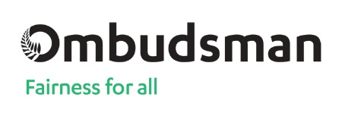

‘Whistle-blowing’: a guide to the Protected Disclosures Act
Easy Read

What is in this book?
Before you start Page 3
What is a whistle-blower? Page 4
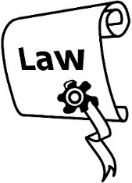
What is serious-wrongdoing? Page 7
How does the Public Disclosures
Act protect you? Page 9
Are you thinking about
speaking up? Page 12
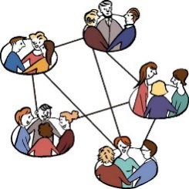
How can the Ombudsman
help you if you want
to speak up? Page 18
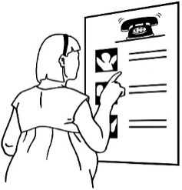
Other places you
can talk to about your
protected disclosure Page 20
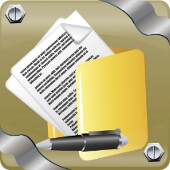
Contact us Page 22
More information about
the Ombudsman Page 24

Before you start
This is a long document.
While it is written in Easy Read it can be hard for some people to read a document this long.
Some things you can do to make it easier are:
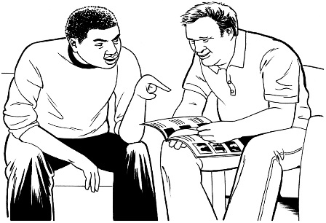
- read it a few pages at a time
- have someone to assist you to understand it.

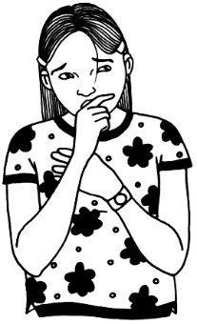
What is a whistle-blower?
Sometimes very bad things can happen at work.
It might happen to you or somebody you work with.
When something very bad happens this is called serious-wrongdoing.
If something very bad happens at your work you might want to report it.
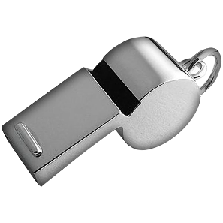
This means you tell somebody about what has happened.
When you do this you are called a whistle-blower.
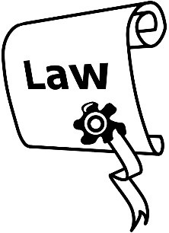
There is a law to help keep whistle-blowers safe.
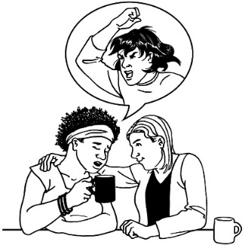
This law is called the Protected Disclosures Act (the Act).
Disclosure means telling somebody about what has happened.
Protected disclosure means you are kept safe if you decide to speak up about serious-wrongdoing at your work.
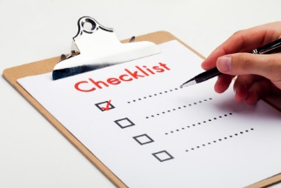
The Act tells people what to do if they are going to tell somebody about something very bad that has happened at work.
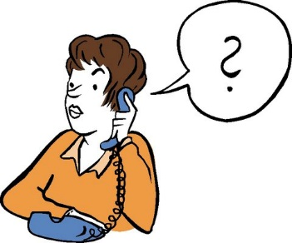
You can contact the Ombudsman for advice if you are thinking about reporting something very bad that has happened at work.
The Ombudsman can tell you:
- what you need to think about
- how you can speak up.

What is serious-wrongdoing?
Serious-wrongdoing is when something very bad happens at your work.
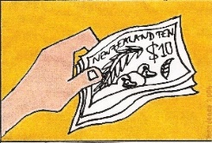
Very bad things can be:
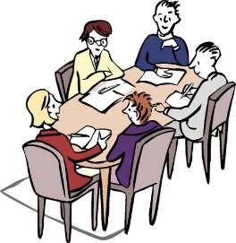
- using public money for the wrong reason
- putting people in danger at work
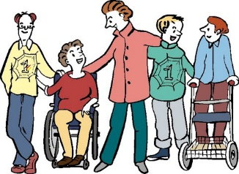
- putting members of the public in danger
- putting the environment in danger
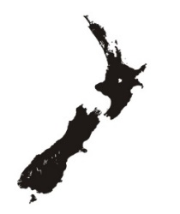
- putting the country in danger
- breaking the law
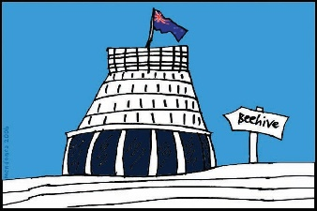
- very bad behaviour by a public official.
A public official is somebody who works for a government agency.
A government agency reports to the Government.

How does the Protected Disclosures Act protect you?
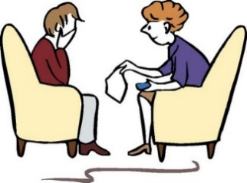
When you tell somebody about something very bad that has happened at your work this means you are making a protected disclosure.
A protected disclosure is when:
- you speak up when something very bad has happened
and
- you do not get into trouble because you have told somebody about it.

You can only tell someone about the very bad thing that happened if you:
- are working at the agency where something wrong was done
- used to work at the agency where something wrong was done.
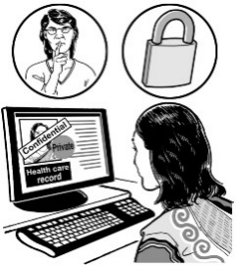
You will be protected from getting in trouble if you speak up when:
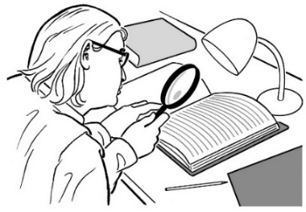
- you think that the information you have about the very bad things that have happened is true
- you want somebody to look into what has happened.

Are you thinking about speaking up?
If you want to speak up about something very bad that has happened at your work there are people you can talk to.
It is a good idea to talk to somebody first to find out more information.
You can talk to the Ombudsman.
We can look into complaints made about government agencies.
We can give you information to help you decide if you want to be a
whistle-blower.
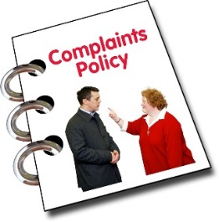
Find out if your workplace has a way to tell people about very bad things that happen.
This might be called a:
- protected disclosures policy
or
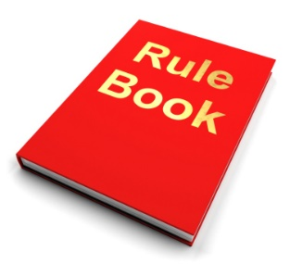
- whistle-blowing policy.
This information will be able to tell you how to speak up about the very bad thing that happened at your work.
It is important to do what the policy says to make sure you are protected by the Act.
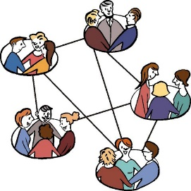
It will tell you how to tell the right people at your work about what happened.
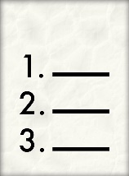
In some cases another agency will be able to help you.
There is a list of these agencies on page 20.
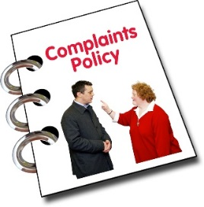
Sometimes you do not need to follow the protected disclosures or whistle-blowers policy.
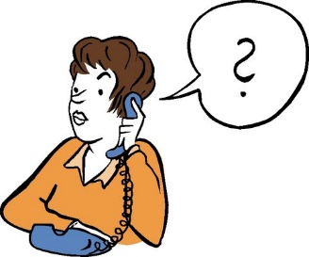
The Ombudsman can tell you if you do not have to follow it.
Call us to find out if you need to follow the policy.
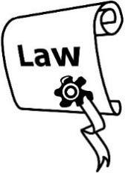
The Protected Disclosures Act protects you if you decide to tell somebody about something very bad that has happened at work.
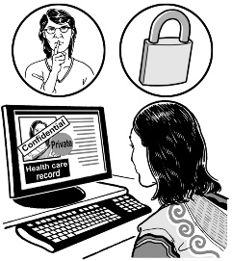
This usually means no one will be able to find out that it was you who talked about what happened.

Sometimes your name will have to be given to somebody else.
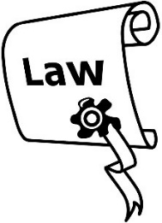
The Act says your name can only be given to somebody if:
- you say you do not mind if other people know it was you who told people about the very bad thing
- it is the only way the problem can be looked into
- there is a serious worry about the safety of the public
- there is a serious worry about the safety of the environment.
The Act says that you should not lose your job because you are a whistle-blower.
The Act also says that whistle-blowers must not be victimised.
Being victimised means being:
- punished in some way
- treated badly.

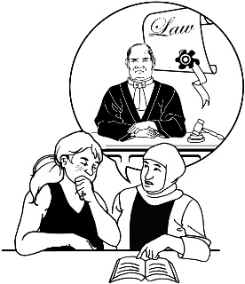
Talk to the Ombudsman to see if you will be protected by the Act if you speak up.
The Ombudsman might be able to help you if you want to speak up.

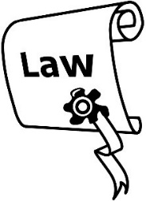
How can the Ombudsman help you if you want to speak up?
The Act says that the Ombudsman can give you information about:
- what things you can speak up about that are protected by the Act
- how to tell somebody about the very bad thing that has happened
- who to tell if you want to speak up
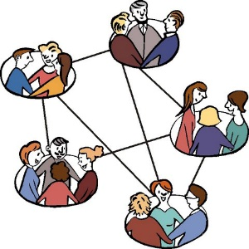
- which places can help you
- how you are kept safe if you decide to tell somebody about a very bad thing that has happened.

Other places that you can talk to about your protected disclosure
Other places we might tell you to contact are the:
- Commissioner of Police
- Controller and Auditor General
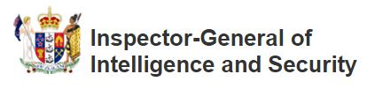
- Director of the Serious Fraud Office
- Inspector-General of Intelligence and Security
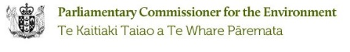
- Parliamentary Commissioner for the Environment
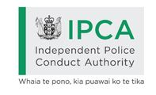
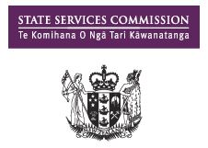
- Independent Police Conduct Authority
- State Services Commissioner
- Health and Disability Commissioner

- Solicitor-General
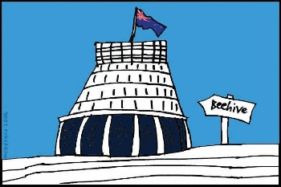

- Head of every government agency.

You can also contact the heads of some private sector organisations.
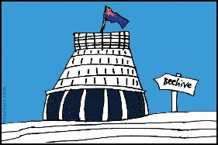
Private sector organisations are organisations that do not have to report to the Government.

Contact us
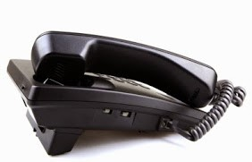
Contact us to find out about what we do and if we can help you.
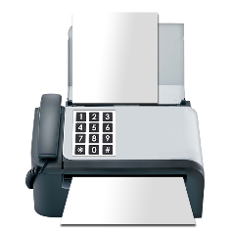
Free Phone: 0800 802 602
Fax: 04 471 22 54
Website: www.ombudsman.parliament.nz
Send an email: info@ombudsman.parliament.nz
Write a letter and post it to:
The Office of the Ombudsman
P.O. Box 10152
Wellington 6143
Our offices are open:
8:30am to 5pm Monday to Friday.
Call to make a time if you need to come and see us.
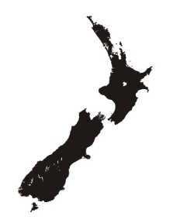
There is an Ombudsman office in Auckland, Wellington and Christchurch:
Auckland
Level 10, 55–65 Shortland Street,
Auckland 1010
Wellington
Level 7, 70 The Terrace,
Wellington 6011
Christchurch
Level 2, 138 Victoria Street, Christchurch 8013

More information about the Ombudsman
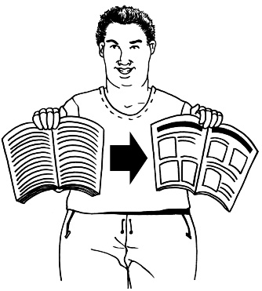
We have made other booklets that tell you about our work.
They are all in Easy Read.
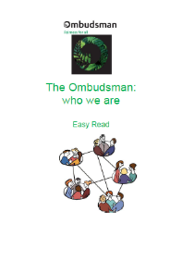
The other booklets we have are about:
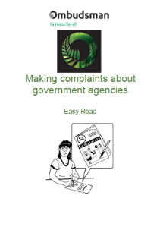
The Ombudsman: who we are
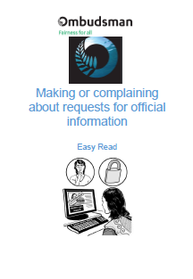
Making complaints about government agencies
Making or complaining about requests for official information
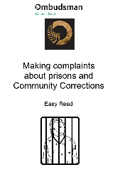
Making complaints about prisons and Community Corrections
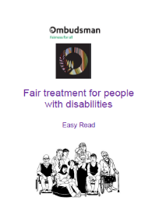
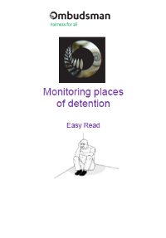
Monitoring places of detention
Fair treatment for people with disabilities.

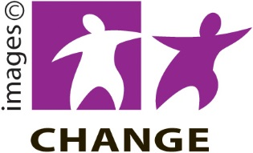
This information has been translated into Easy Read by
People First New Zealand Inc.– Ngā Tāngata Tuatahi

